Name: Alex McNurlin Mark _____________________/50

## Brief introduction __/3

My main feature is Physics. This includes detecting the collision of objects and managing the movement of falling objects. When moving objects run into other objects, they will stop moving and not be allowed to move through each other. Falling objects will fall with constant acceleration.

## Use case diagram with scenario __14

### Use Case Diagrams

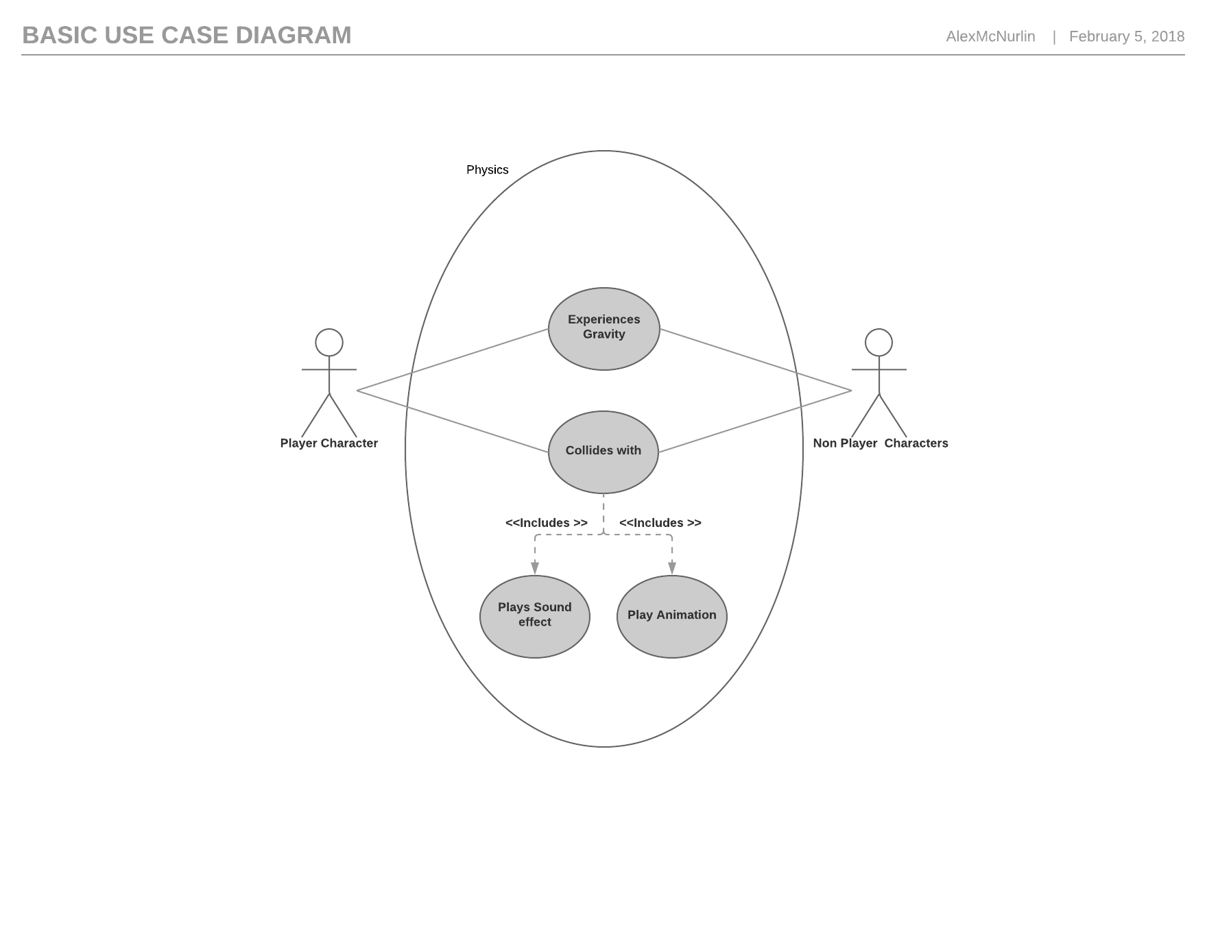

### Scenarios

**Name:** Detect Collision

**Summary:** Objects are not allowed to move through each other.

**Actors:** Player Character, Wall

**Precondition:** The player has loaded a level that contains a wall

**Basic sequence:**

**Step 1:** The player moves towards a wall

**Step 2:** The player moves into the wall

**Step 3:** The player stops in place and does not move through the wall

**Exceptions:**

**Step 1:** The player jumps onto a platform: The player does not fall through the platform

**Name:** Falling object.

**Summary:** Falling objects fall with constant acceleration.

**Actors:** Player Character

**Precondition:** The player has loaded a level.

**Basic sequence:**

**Step 1:** The player jumps.

**Step 2:** The player character's velocity changes at a constant rate.

**Exceptions:**

**Step 1:** If the player jumps into a platform from below: The player's y velocity is set to zero. Acceleration remains constant.

**Name:** Jumping does not affect x velocity of player.  
**Summary:** Jumping does not affect x velocity of player.

**Actors:** Player Character

**Precondition:** The player has loaded a level.

**Basic sequence:**

**Step 1:** The player character moves to the right.

**Step 2:** The player character jumps.

**Step 3:** The player character's x velocity remains constant.

## Data Flow diagram(s) from Level 0 to process description for your feature _______14

### Data Flow Diagrams

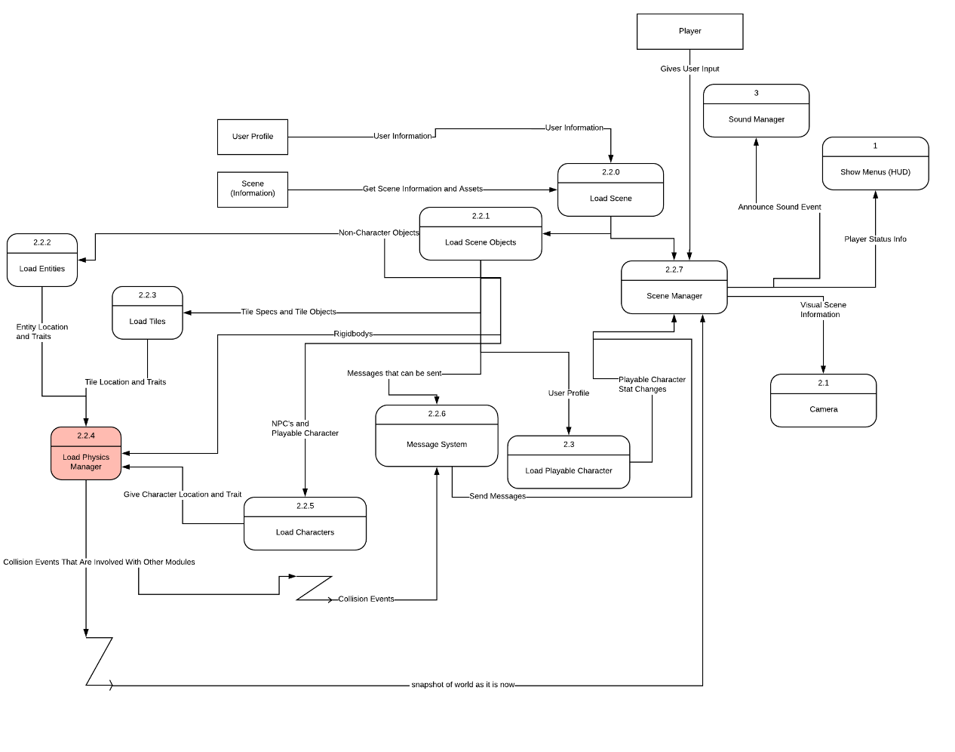

### Process Descriptions

Collision detection:

WHILE the player character is moving

IF the player is going to collide with an object next frame

THEN stop moving

END WHILE

Physics

WHILE the player is in the air

IF the player will hit the bottom of an object above the player

THEN set the y velocity of the player to 0

Decrease they player's velocity by a fixed amount each frame

END WHILE

## Acceptance Tests ________9

When the player character jumps, he returns to the ground with constant acceleration

The player does not fall through the floor

If the player attempts to move through walls, he will stop moving before he hits the wall.

If the player attempts to move through enemies, he will stop moving before he hits the enemies, and the appropriate actions are triggered.

## Timeline _________/10

### Work items

|  |  |  |
| --- | --- | --- |
| Task | Duration (PWks) | Predecessor Task(s) |
| 1. Requirements Collection | 3 |  |
| 1. Scene Design | 2 |  |
| 1. Character Movement | 1 | 2 |
| 1. Programming for Physics Engine | 2 | 1, 3 |
| 1. Testing | 1 |  |

### Pert diagram

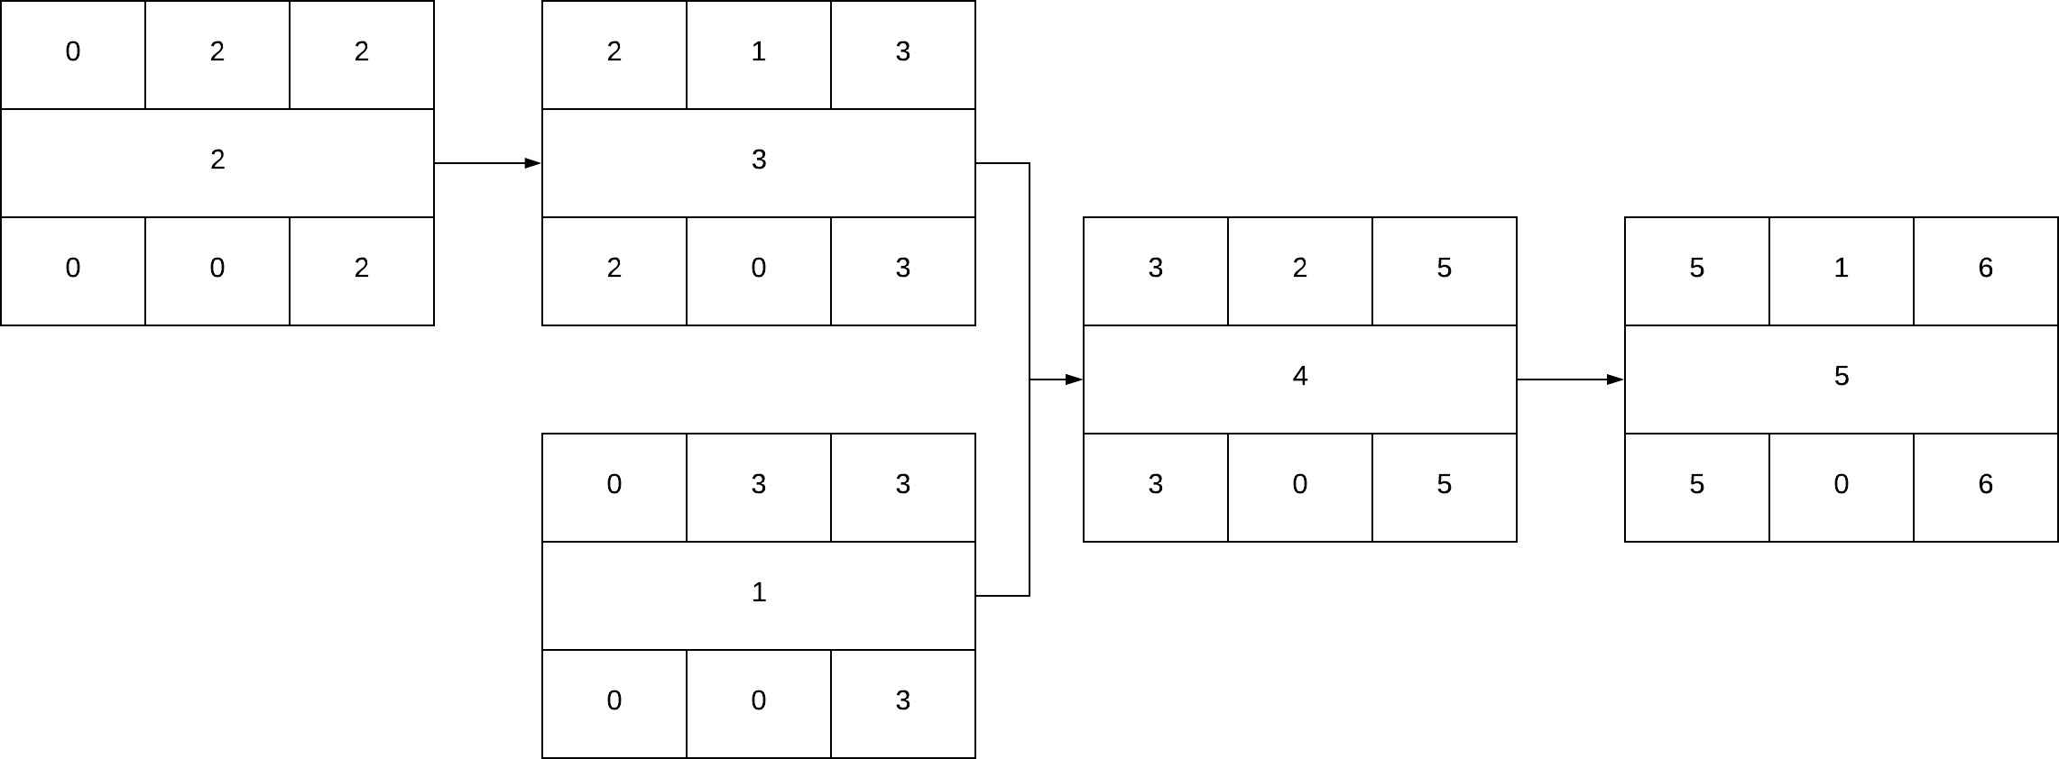

### Gantt timeline

