**Statement of Work**

# Introduction:

This Statement of Work is an agreement between the software engineering clients: Josue Espinosa, Jorge Olivas, Alex McNurlin, Zane Durkin, Simon Barnes, Hayden Lepla, Tori Overholtzer, Julie Beeston and Team Zero (Josue Espinosa, Jorge Olivas, Alex McNurlin, Zane Durkin, Simon Barnes, Hayden Lepla, Tori Overholtzer) to perform the services described herein.

**Project Scope:**

The purpose of this project is to develop and provide the specified two-dimensional platform game: Sad Pancake. This project will be developed for the software engineering clients (Josue Espinosa, Jorge Olivas, Alex McNurlin, Zane Durkin, Simon Barnes, Hayden Lepla, Tori Overholtzer, Julie Beeston). The scope of this project shall include meeting, determining requirements, analyzing and modeling the system, preparing complete documentation and providing a functional final product. The final product will serve to provide entertainment; however, the process of producing the product will provide opportunities for research and education.

**Project Description:**

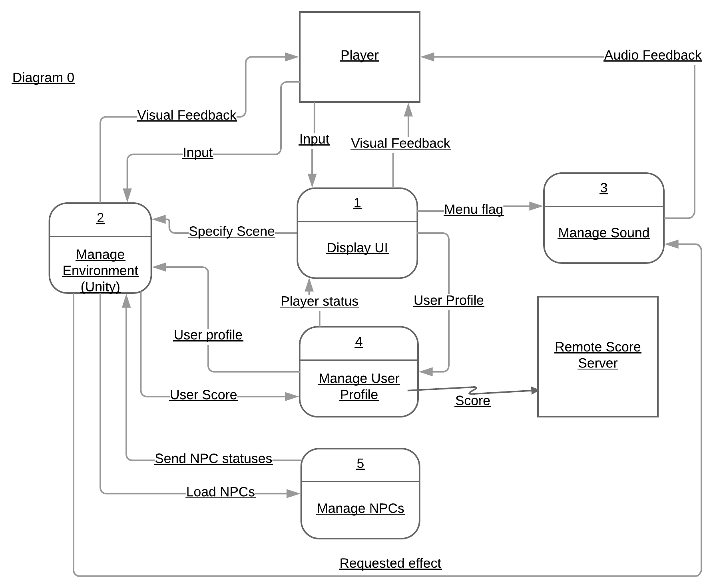

Data Dictionary:

**Manage Environment:** Management of the environment the player interacts with. This includes the contents of each level, enemies, bosses, ect.

* Specify Scene: Tell the game engine which level should be loaded.

**Display UI:** Display the user interfaces. This includes menus.

**Manage Sound:** Play sounds and audio during gameplay.

* Requested Effect: The desired sound effect to be played.

**Remote Score Server:** A server hosted remotely that keeps track of the player's score.

**Manage User Profile:** Manage user specific information, like username, saved settings, and scores.

**Manage NPCs:** Manage where to load NPCs and their respective states and roles (friendly, hostile, quest-giver, inventory/money/health update, conversation etc).

Level 0 Diagram:

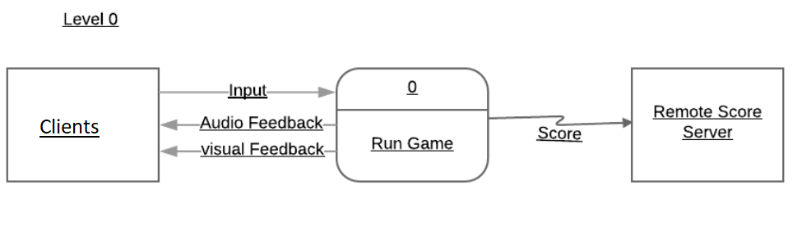

**Project plan**

The following deliverables shall be provided as part of the required documentation for this project.

**Request for Proposal (RFP):** The RFP is a document that explains technical goals, creates a budget, and allows for the establishment of communications between the clients and the suppliers. The RFP shall include the project description, explain the reason for the project and discuss opportunities involved with the development of the project; it shall establish project objectives, explain user and outside system interaction, provide constraints to development, generate a proposed project schedule and specify any similarities between the proposed system and current systems already on the market.

**Champion Documents:** The champion documents are documents that explain the main features of the system and describe how these features relate to other features in the system or their role in the overall product. This document should contain an introduction to the feature, a use case diagram with an extended explanation that shows how clients interact with the system and how the elements of the system function with the given feature.

**Software Analysis Power Point Presentation:** The presentation should introduce the product and introduce the development team including the roles of everyone regarding the creation of the product. The presentation shall display and explain a global use case diagram featuring all the features of the product, with their relations to each other. The presentation shall also break down the global context diagram into user case diagrams for each feature and explain the features priority and complexity.

**Critical Analysis Documentation:** Create several documented reviews of other product presentations and provide constructive feedback about the overall project, its features and the overall presentation.

**Class Diagram:** Create a class diagram to analyze, model and design the proposed system. It shall include proper formatting and break down the needed object classes and the interactions needed for each feature.

**Gantt Timeline:** The Gantt timeline shall show the project schedule with the estimated time to complete each component of the system. This includes estimated start and end dates, as well as indicating which components rely on other components to be finished first.

**Budget:** The budget describes the costs of all elements of the project, including development costs and equipment.

**Test Plan:** This is a document describing the scope and methods for testing the project. It identifies the type of testing that will be used, the testing environment, testing schedule, and testing guidelines.

**Document of Coding Standards:** The document of coding standards is a document containing guidelines for code style, formatting code, and documentation. This includes program design, naming conventions of variables and functions, formatting conventions, and conventions for documentation.

**User Manual:** The user manual gives instructions on how to use the final game. This includes controls, features of the game, and navigation of the menus.

**Finalized Coding Project:** The final project includes all of the documentation outlined above, as well as a running program that meets the requirements stated in the Request for Proposal.

**Signatures**

**For Team Zero:**

Tori Overholtzer: 2/5/18

Simon Barnes: 2/5/18

Alex McNurlin: 2/5/18

Hayden Lepla 2/5/18

Jorge Olivas 2/5/18

Zane Durkin 2/5/18

Josue Espinosa 2/5/18

**For clients: Josue Espinosa, Jorge Olivas, Alex McNurlin, Zane Durkin, Simon Barnes, Hayden Lepla, Tori Overholtzer, Julie Beeston:**

Tori Overholtzer Date: 2/5/2018