Introduction to Physics

*Created by : Alex Dodge*

*July, 6 2014[1]*

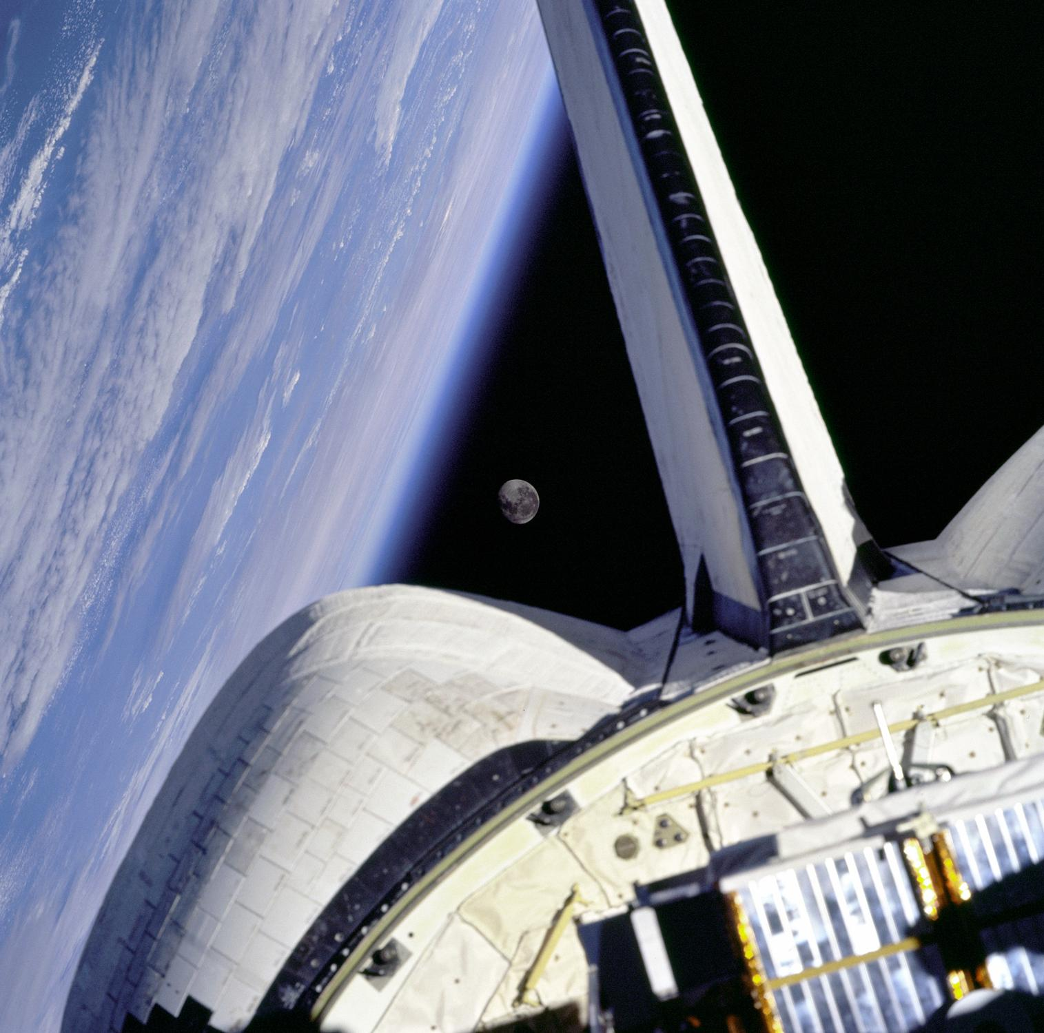

**INTRODUCTION**

You wake up from a long sleep and pull yourself out of bed. Your alarm clock is buzzing. You swing your arm over and slap the sleep button and the noise instantly stops. As you stand up a deep gurgle resonates in your stomach, you only have a short period of time before you head off to school and you desperately need something to eat. You rush down the stairs, slipping on the last. If only socks and hardwood worked a little better together. As you move into the kitchen you see your school bag packed with a lunch sitting next to it, your mother was busy this morning! You grab an apple, your bag, and rush out the door. As you step outside your stomach sinks. Torrential downpour. You cover your head and start on your way to school, luckily it’s only a couple of blocks away. As you make it to the front entrance you hear a huge clap of thunder, and just shortly after a fork of lightning erupts from the clouds.

What common themes does this story have? Hint: Every single part of it can be described with physics. Physics is not just the study of how objects move, or what happens when two things collide. Physics describes everything in our universe from the brief moments after the big bang, to the electricity flowing through your alarm clock. In this course we’re going to look into the origins of physics, and how it affects us in our everyday life.

**ACTIVITY**

First, everyone should sign in on their computers and open up this document (if you haven’t already). In this class we’ll be using an online discussion forum which is hosted on the school moodle server.

NOTE: If your school does not have access to such a server, then later I will detail setting up the document using google docs. If the school does not have computers, this could be completed using handouts and sticky notes. The adaptations are endless.

Wherever you choose to post, write down the places where you think physics is occurring in the initial story. Afterwards, if you already know any information about physics then feel free to share it. If not, share some experiences in your life which you think could be described by physics.

**VIDEO INTRODUCTION**

Once everyone has posted take some time to watch a couple of these videos. This is a channel on YouTube which focuses around short physics videos which have a certain twist. Veritasium is another channel which focuses primarily around physics videos. Big Think has videos surrounding many scientific areas, usually with a slight focus on celebrity appearances (scientific celebrities). There is great content on all these channels, and a lot of fun things to look in to.

|  |  |
| --- | --- |
| What is the Universe? | <https://www.youtube.com/watch?v=nrTsvn9usVQ> |
| What is Matter? | <https://www.youtube.com/watch?v=Fxeb3Pc4PA4> |
| Every Force in Nature | [https://www.youtube.com/watch?v=3_RhISgoXUs](https://www.youtube.com/watch?v=Fxeb3Pc4PA4) |
| What is a Force? | [https://www.youtube.com/watch?v=GmlMV7bA0TM](https://www.youtube.com/watch?v=Fxeb3Pc4PA4) |
| The Universe in a Nutshell | [https://www.youtube.com/watch?v=0NbBjNiw4tk](https://www.youtube.com/watch?v=Fxeb3Pc4PA4) |

You have most likely found some interesting content from the videos, but also some similar themes. The power of physics is that at its core, everything is connected. Well, almost connected. The incredible and most exciting thing, much like many other scientific ideas, is that we do not fully understand everything. It is our jobs as humans to keep searching, discussing, and documenting everything we can about our lives, because everything could changed at any second.

**ACTIVITY**

Now we’re all going to break into groups and keep in mind everything we just discussed. I want every group to come up with what you think might be some topics in this course. Think about how things might group together, and try to come up with names for the group.

Some examples of topics might be,

* Motion (Kinematics)
* Electricity
* Magnetism
* Sound
* Light

After everyone has finished discussing we’ll get together and come up with a list of topics. Then relate all of these topics to the actual curriculum. With very knowledge, or some basic knowledge of physics, we were able to come up with the topics for this course. So everyone already has a great intuitive sense about what physics is, because it is in our life every single day.

Setting up in Google Documents Webspace

If the school does not have a moodle or server space where discussion forums can be hosted it is possible to use a plethora of other online software. By just searching online discussion tools many different websites will come up. If this cannot be accomplished, then it could be possible to set up a google account through the school with the students depending on permission and other factors. This would allow students to not only view google documents (which can be done without an account), but also make comments.

To set up your own google document with the ability for students to comment (not edit), first login to your google account, then search google docs.

1. You will first find yourself in google drive, the online cloud server which is the place you can save those documents.
2. In the top left corner you will find the **create** button, click it and select the blue document.
3. Within the google document we need to do some setup. First click on the **top left title**. This will allow you to change the name to whatever you wish.
4. Next click on the blue **share** button in the top right corner. In this menu at the top you can copy the link for the document. You can also change what external users can do. By clicking **change** you have three options: edit, comment, and view. These allow users to edit the document, comment, or just simply view it.
5. Comments on the document appear to the left and are highlighted in yellow. Feel free to visit this document online to see what it looks like. <https://docs.google.com/document/d/1s7SbWWo3pRSaX5y5X00VLeduk_11_CqxUzj6Q4JxLDo/edit?usp=sharing>
6. After this step you are ready to go. Simply post the link where you would like the students to find it, and enjoy!

**FEATURES OF GOOGLE DOCS**

In this document a number of features have been used to help with the presentation of it.

**FONT** : This is a very important part of any document. To change the font simply click the drop down box located below Add-ons. It will already have a familiar font selected such as Arial, or Times New Roman. If you click *more fonts* you will be given the choice to add fonts to your own font library.

**BOLD, ITALICIZE, UNDERLINE :** Much like microsoft word, or other word processors, these features are located at the top bar and are represented with the B, I and underlined U.

**IMAGES** : These can be easily inserted by clicking *insert* and then clicking *image*. In this menu you will be able to select images from the google drive gallery, or upload ones from your hard drive. Remember to ensure that all photography is credited. To change the border of this document simply click on it, look to the far right of the menu bar and you will see four icons relating to the line color, width, and type. You will also have the ability to crop the image.

**FOOTNOTES** : These can be added by placing your cursor where you want to insert a reference, clicking on *insert*, and then *footnote.* It will automatically jump you down to the location of the footnote.

**ALIGNMENT** : All text in this document is mostly justified. To change text alignment, select one of the four buttons at the top which are to the right of the bold and italicize buttons. The buttons allow you to either left, right, center, or justify the text you have selected.

**INDENTATION :** To change the indentation level of certain text, highlight the text you wish to indent, then look to the top right of the menu bar. The two buttons have arrows which point left and right. To increase indentation right, click the button with the right arrow, and the same for left indentation.

**TABLES** : To insert a table, click on *table* above the main menu bar. It will give you the option *insert table* which allows you to choose the size of your table on a little grid. To adjust the color and size of the lines, simply select individual cells, or the whole table, right click, and select format. This menu will give you multiple different choices surrounding the document.

**BULLETS, NUMBERING** : To create a numbered or bulleted list, look for the two buttons on the main menu bar which are left of the indentation options. The two are clearly labeled. Simply click on the desired list and a bullet will appear. When you want to jump to the next line and create a new bullet simply hit enter.

**HYPERLINK** : To create links to external sites, copy the desired html link. Paste it in the document wherever you choose, then look for the small chain link in between the alignment and bold features. This make the link active and allow visitors to click on the links.[2]

1. Image obtained from <http://grin.hq.nasa.gov/IMAGES/MEDIUM/GPN-2000-001090.jpg>. NASA has a large archive of free images available for use in the public domain.
2. This document is freely available to all who wish to use it in any capacity. For any other questions feel free to email me at alex.mdodge@gmail.com