Project: Webservers

The main goal of this project is to show how we can install, and manage web servers with Ansible. The Server-diagram for this project is shown below.

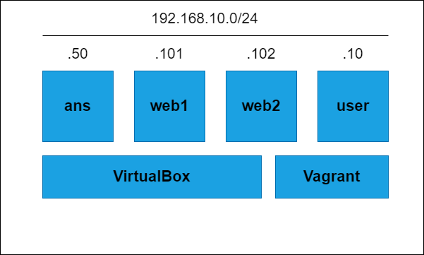

We have four virtual machines: ‘ans’, ‘web1’, ‘web2’, and ‘user’. The ‘ans’ virtual machine is AlmaLinux 8. Virtual machines ‘web1’ and ‘web2’ are CentOS 9 and finally, ‘user’ has an Ubuntu machine.