Alexander Ferrari Miller  3549 North D Street  San Bernardino, CA 92405-2103  +1 (323) 681-7588  Alexander.Ferrari.Miller@gmail.com  https://AlexanderFerrariMiller.com | 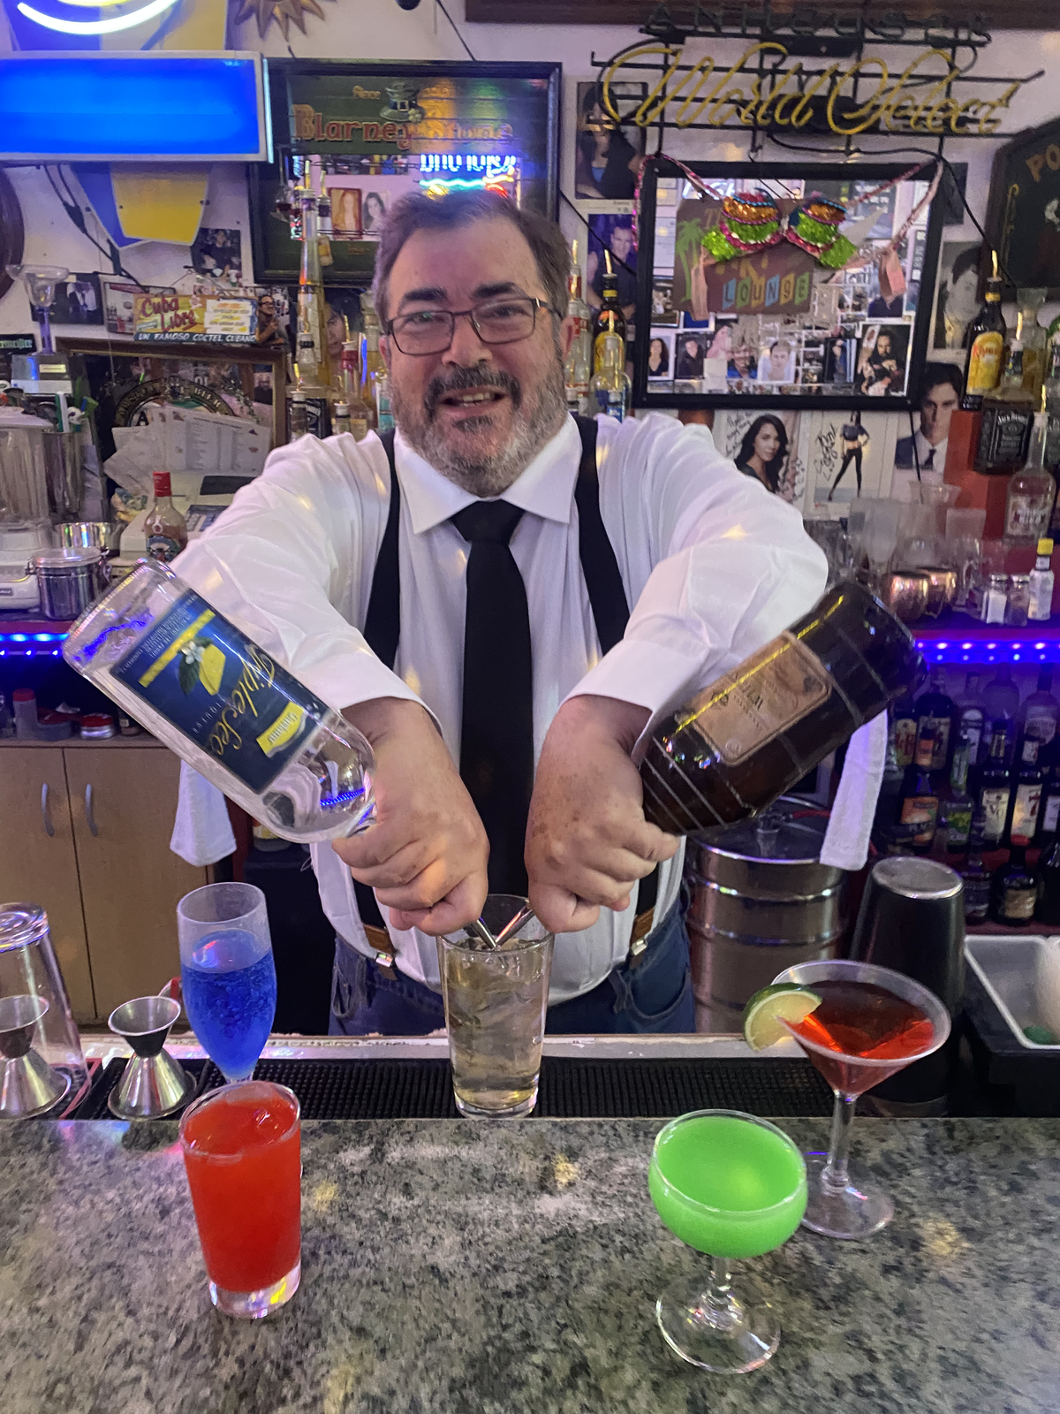

BARTENDER

Bartending Summary
Bartender and hospitality professional with experience in high-volume performing-arts venues at the Los Angeles Music Center. Experienced in complete bar setup and breakdown, guest service, concentrated intermission rushes, preparation of classic cocktails, beverage service, and maintaining an organized workstation under time pressure.

Bartending Experience

Bartender — Patina Restaurant Group
Los Angeles Music Center, Los Angeles, CA — April 24, 2018–approximately July 23, 2019
- Worked as a bartender supporting performances and events at major Los Angeles Music Center venues.
- Set up complete working bars from scratch before service.
- Served large numbers of theater and concert patrons during concentrated intermission rushes.
- Prepared classic mixed drinks including martinis, Manhattans, White Russians, and other standard cocktails.
- Provided direct guest service in a fast-paced performing-arts hospitality environment.
- Maintained an organized and functional bar throughout service.
- Completely broke down and cleaned the bar after service.

Venues
- Dorothy Chandler Pavilion
- Ahmanson Theatre
- Walt Disney Concert Hall

Related Customer-Service Experience

ArcLight Cinemas
Los Angeles, CA
- Worked in multiple customer-facing functions including ticket sales, concessions, ushering, and guest greeting.
- Assisted large numbers of patrons in a busy entertainment environment.
- Worked as part of a coordinated front-of-house team.

Bartending & Hospitality Skills
Full bar setup, bar breakdown, high-volume service, intermission service, guest interaction, classic cocktails, martinis, Manhattans, White Russians, beverage service, workstation organization, hospitality, customer service, entertainment-venue service, teamwork, and communication.

Education
Oberlin College — Bachelor of Arts, Russian/Soviet Studies
This is a placeholder bartender resume. Additional employment dates, duties, certifications, and relevant experience will be added as the full work chronology is completed.

