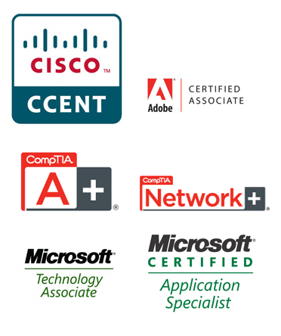
Personal Profile
An enthusiastic and motivated individual, determined to succeed in the IT industry.
As a proficient CompTIA and MTA certified technician, I am constantly pushing to expand my skill set and knowledge base.
I deal with and solve complex IT and Networking problems, remotely, working as part of a team, or individually. I communicate effectively with others and use my range of skills to reach solutions logically and efficiently.
I’m a passionate and determined individual; resourceful and flexible, with a full driving licence and car.
Education
Date  2017 - Present | School/College  Queen Mary University London | Qualifications  BA Hispanic Studies and Politics
2011-2012 | Pearson in Practice ATA | Level 3 Diploma in Professional Competence for IT and Telecoms Professionals  Level 3 Extended Diploma in ICT Systems and Principles  Level 2 Key Skills Communication  Level 2 Key Skills Application of Number  Level 2 Skills Information and Communication Technology  Level 2 Award in Work Skills for Effective Learning and Employment
2007-2011 | Robert Smyth Academy | AS Level Computing  A2 Level Music Technology  A2 Level Psychology  GCSES (9) A*-C
Technical Qualifications
CompTIA A+ (220-701 & 220-702)
Microsoft Technology Associate (MTA): Networking Fundamentals (98-366)
Microsoft Technology Associate (MTA): Windows Operating System Fundamentals (98-349)
Skills
Microsoft Windows XP, Vista, 7, 8 & 10
Microsoft Windows Server 2003, Server 2008, Server 2012 & SBS
Microsoft Exchange 2003, 2007, 2010 & Office 365.
DHCP
Active Directory
Kaspersky Antivirus administration and deployment
ESET Antivirus administration and deployment
AVG Cloudcare administration and deployment
Employment History
IT3000 Ltd Apr 2014 – Sep 2016
I am currently part of the technical support team where I remotely monitor customer’s networks and provide technical support/assistance to their employees.
My responsibilities include some of the following.
- Backup monitoring over a wide variety of solutions including Symantec, Unitrends, Acronis and Windows Backup. Assigning backup tickets to fellow colleagues.
- Building/Configuring customers servers/workstations prior to deployment.
- Managing customers email solutions whether on site or cloud based.
- Deploying Antivirus solutions via the cloud.
- On site on boarding of customers, network auditing and documentation.
- Monitoring alerts generated on customers networks and dealing with them pro-actively.
Cornerstone International Advisory Services Ltd Feb 2014 – July 2014
Working at Cornerstone International Advisory Services I was contracted to complete an email migration from on premises Microsoft Exchange server to Office365. I am now continuing to support any issues they face with Office365 out of business hours.
Doherty Associates Ltd Nov 2013 – Feb 2014
Working at Doherty Associates I was contracted as an engineer to manage the IT network on site at one of their largest clients, supporting over 300 employees.
Reynolds & Reynolds Infosystems Mar 2012 – Nov 2013
I was employed as part of the helpdesk team, providing technical support for customers who require assistance.
Pearson in Practice ATA | Sep 2011 – Mar 2012
I was employed as an IT apprentice where I completed my apprenticeship and gained various qualifications and vendor qualifications.
Foxton Locks Inn | Jun 2010 – Mar 2012
Barman
Interests
References
References are available on request.

