Creative & Cognition 2019 Proposal: “Separated families: An Interactive Storytelling Website”

# Abstract

The Association for Computing Machinery, Inc. 2 Penn Plaza, Suite 701 New York, New York 10121

Copyright © 2019 by the Association for Computing Machinery, Inc. (ACM). Permission to make digital or hard copies of portions of this work for personal or classroom use is granted without fee provided that the copies are not made or distributed for profit or commercial advantage and that copies bear this notice and the full citation on the first page in print or the first screen in digital media. Copyrights for components of this work owned by others than ACM must be honored. Abstracting with credit is permitted.

This sample paper describes the interactive, design and audience for Separated families: An interactive storytelling website. The purpose of this website is to educate and bring awareness to the amount families being separated at the border between Mexico and the United States. Many of them are put under difficult circumstances and are never reunited.The website addresses a very difficult issue in a friendly way through nice graphics, color choices and information facts to educate and aware the wide audience.

# Author Keywords

Immigration; deportation; separation of families; children; education, research; awareness.

# ACM Classification Keywords

H.5.m. Information interfaces and presentation (e.g., HCI): Miscellaneous; See<http://acm.org/about/class/1998> for the full list of ACM classifiers. This section is required.

# Introduction

The goal of the separated families: an interactive storytelling website is to educate people on the horrible conditions and circumstances these families and kids undergo.

# Target Audience

The target audience for this specific project varies. We aim to reach those who are concerned about the family separation and immigration so that they feel supported but we also hope to reach those who are unsure about what to think of immigrants and see them very negatively. The ages vary from middle school aged kids to the elderly.

# Design Strategies

The website includes a home page where the user is able to select the “begin journey” button to began the storytelling scenes.

# Interaction

The interaction in the website begins in the first scene where the user is able to hover over the different objects and people on the site. This causes the objects to move in different directions providing animated graphics.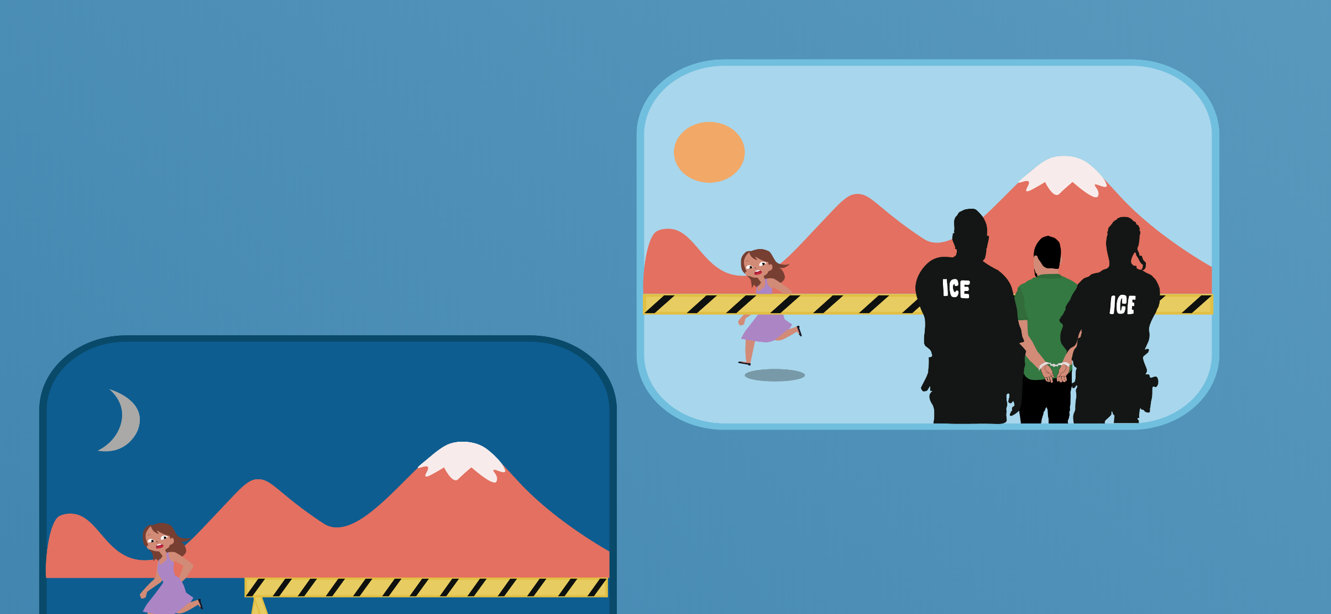

**Figure 1**: This screenshot demonstrates the beginning process of the graphics for the website. These graphics demonstrate a process of a girl being separated from her father as the ICE agents take him away at the deserted border where the child becomes really scared and frightened.

# References

1. Thousands more migrant kids separated from parents. Retrieved February 26, 2019 from <https://www.nbcnews.com/politics/immigration/thousands-more-migrant-kids-separated-parents-under-trump-previously-reported-n959791>