Overview
Purpose | The purpose of this document is to define the standardized procedure for configuring the Advanced Process Control (APC) system following successful installation within approved virtual machine (VM) environments and associated supporting platforms. This document ensures that APC software components are configured in a controlled, consistent, and compliant manner based on the selected APC solution to support engineering validation and production readiness.
Scope | This SOP applies to the configuration of the APC system across Medtronic manufacturing sites. It establishes a standardized, global approach for configuring APC platform components deployed within approved VM environments, as well as associated APC applications installed on external engineering or production systems, to ensure system integrity, interoperability, and readiness for execution.  In Scope:  - Configuration of APC system components deployed within approved VM environments based on the selected APC solution.  - Configuration of supporting APC applications installed outside the APC VM, as applicable to the selected APC solution.  - APC system backup and restore activities.  - Verification of configuration completion and documentation of configuration readiness.  Out of Scope:  - Installation of APC software components.  - Verification of software installation  - Operational use of the APC system in production.  - Process-specific execution logic beyond baseline configuration.
Roles | Manufacturing Engineer, System Engineer, Process Engineer, Quality Engineer, Quality Application Specialist

Table of Contents
Terms and Definitions 3
Process Overview 4
Process Detail 5
1. Configuration Prerequisites 5
2. APC Solution Configuration 6
2.1 Closed-Loop Correction (CLC) – Solution Configuration 6
3. Other APC Applications Configuration 50
3.1 Import Configuration 51
3.2 Measurement UI 52
4. APC System Backup and Restore 54
4.1 Backup Strategy 55
4.2 Restore Strategy 64
5. Configuration Verification 77
6. APC System Update and Import Management 78
References 79
Quality Records 79

Terms and Definitions
Term | Definition | Source
ACW | Asset Configuration Worksheet | Medtronic
APC | Advanced Process Control | Medtronic
CCW | Control Criteria Workbook | Medtronic
Change Management | Process by which qualified representatives from appropriate disciplines review proposed or actual changes to a computer system. The objective is to document the changes and ensure the system maintains its state of control and its validation status. | Medtronic
CHMI | Compact Human Machine Interface | ABB
CLC | Closed Loop Correction | Medtronic
Development Team | Qualified individuals from functional areas who are directly responsible for planning, executing, or providing required deliverables for APC development and system implementation including Process Owner, and Technical Leads or Subject Matter Experts (SMEs).  See below for examples:  - Manufacturing Engineer / System Engineer/ Process Engineer  - Quality Application Specialist / Quality Engineer  - IT Technical Analyst  - Engineering Technician / CNC Programmer | Medtronic
DOC | Dynamic Offset Calculation | Medtronic
DOCW | Dynamic Offset Calculation Workbook | Medtronic
Document Author | The member of the Development Team who is responsible for writing the document, in collaboration with the team (e.g., Document Owner). | Medtronic
Independent Reviewer | Any individual (typically part of the Development Team), other than the Author, who has expertise to perform an effective, impartial technical review of the document. | Medtronic
OPC UA | Open Platform Communications Unified Architecture | Medtronic
PCW | Product Configuration Workbook | Medtronic
Quality  Representative | Any individual in Quality who is qualified to review the document content for compliance to regulations, and QMS standards and internal requirements. | Medtronic
SINC | Smart Integrated Normalized Communication | Medtronic
Tester | Individual who is responsible for performing the verifications that are required to execute a Verification Record. | Medtronic
TSDB | Timescale Database | Medtronic
UI | User Interface | Medtronic
VM | Virtual Machine | Medtronic

Process Overview
- Approved APC system installation
- Selected APC Solution
- Required configuration artifacts (licenses, configuration files)
- Configured APC system aligned to the selected APC solution
- Configuration backups
- Completed Configuration Verification Checklist

Process Detail

Configuration Prerequisites
Step | Role | Action
 | Manufacturing Engineer, System Engineer, Process Engineer | This section defines the minimum prerequisites required prior to initiating configuration of the Advanced Process Control (APC) system.
 |  | Verify that APC system installation has been completed and approved in accordance with APC System Installation (D01555599), including completion and approval of the Installation Verification Checklist (D01555616), and that the approved APC virtual machine (VM) is operational, accessible, and approved for configuration activities.
 |  | Confirm that the approved APC System Version and the APC solution to be configured (e.g., Closed-Loop Correction) have been identified and documented.
 |  | Confirm that configuration activities are authorized through the approved change control mechanism (RCH workflow) in accordance with APC System Change Management (D01458108), when applicable. Confirm that configuration activities are authorized through the approved change control mechanism in accordance with APC System Change Management (D01458108), when applicable.

APC Solution Configuration
Step | Role | Action
 | Manufacturing Engineer, System Engineer, Process Engineer | This section defines the standardized steps required to configure an Advanced Process Control (APC) solution following successful system installation and installation verification.
 |  | Configuration activities are performed based on the selected APC solution (e.g., Closed-Loop Correction) and include platform configuration, application integration, external system enablement, and solution-specific setup activities.
 |  | Detailed configuration steps are defined in the applicable solution subsections. Completion of this section establishes an operational APC solution ready for configuration verification and execution preparation.

Closed-Loop Correction (CLC) – Solution Configuration
Step | Role | Action
 | Manufacturing Engineer, System Engineer, Process Engineer | This section defines the configuration steps required to implement the Closed-Loop Correction (CLC) APC solution using the installed APC platform components.
 |  | Configuration activities include deviceWise setup, Dynamic Offset Calculation (DOC) configuration, CNC connectivity enablement, data collection and analytics configuration, CHMI/APC UI integration, and supporting network connectivity.
 |  | Each CLC solution component is configured in the subsections below. All subsections must be completed as applicable based on the deployed machines, assets, and process requirements.

Asset Configuration Worksheet (ACW)
Step | Role | Action
 | Manufacturing Engineer, System Engineer, Process Engineer | This section defines the use of the Asset Configuration Worksheet (ACW) (D01555802) to document machine asset parameters required for the deployment and configuration of the Closed-Loop Correction (CLC) solution. The ACW serves as the engineering reference for defining machine identifiers, network configuration, and communication parameters used by APC system components.
 |  | Complete the ACW to document all CNC machines and equipment assets that will interface with the APC system. Each ACW shall correspond to a single asset family (e.g., CITIZEN_M32_IV, CITIZEN_L20X_IV). All assets listed within the worksheet shall belong to the same asset family to ensure consistent machine configuration and driver compatibility across the APC solution. Multiple ACWs may exist for a site if different machine platforms are deployed.
 | Manufacturing Engineer, System Engineer, Process Engineer | Populate the required fields within the ACW including, but not limited to:  - Machine Name  - Site  - Machine IP Address  - Communication Port  - CNCnetPDM Driver or DLL Name (if applicable)  - Asset Family (e.g., CITIZEN_L20E_IV, CITIZEN_L20X_IV)
 |  | Verify that the machine asset identifiers defined in the ACW align with the asset naming conventions that will be used within APC system components including deviceWise, CNCnetPDM, Dynamic Offset Calculation (DOC), and Equipment Network Connectivity configurations.
 |  | Route the completed Asset Configuration Worksheet (ACW) for review and approval in accordance with APC System Change Management (D01458108), as applicable.
 | TSDB Admin | Identify the ACW files routed for deployment. Prior to import, verify that the change record has completed required approvals within the approval workflow and is authorized for implementation in accordance with APC System Change Management (D01458108) and 028-WI216 Manage Records.
 | TSDB Admin | Retrieve approved configuration files from change control.
 |  | Launch the Import Configuration application and authenticate with appropriate access.
 |  | If Unable to Login is indicated, verify user credentials and required access permissions, restart the application, and escalate to system administration support if the issue persists.
 |  | Select the Asset Configuration (ACW) import tab and load the approved ACW file for deployment.
 |  | Preview the imported data and verify that machine assets, network parameters, and asset family definitions are correctly detected.
 |  | Load the ACW data into the TSDB and review the application status to confirm successful registration of machine asset records.
 |  | Verify successful deployment by exporting or reviewing the database asset records to confirm that all machine definitions have been correctly registered.
 | Manufacturing Engineer, System Engineer, Process Engineer, Quality Engineer, Quality Application Specialist | Use the completed ACW as the authoritative reference when configuring machine assets, communication drivers, and asset mappings within subsequent APC system configuration sections.
 |  | Ensure ACW deployment activities are performed in accordance with APC System Change Management (D01458108), when applicable. Maintain the approved ACW as part of the APC system engineering documentation and configuration records.

User Guide
This section provides guidance for completing the Asset Configuration Worksheet (ACW) using the approved template. The ACW defines the machine asset configuration required for deployment of the APC Closed-Loop Correction (CLC) solution.
The instructions define how to populate the ACW tabs used to configure machine identification, asset status, network connectivity parameters, and machine communication settings required by APC system components including deviceWise, CNCnetPDM, Dynamic Offset Calculation (DOC), and Equipment Network Connectivity.
Each ACW shall correspond to one Asset Family, and all machines listed in the worksheet shall belong to the same machine platform to ensure consistent machine communication configuration and APC solution alignment.

ACW Tab
This subsection describes how to populate the ACW tab, which defines machine identification, asset status, and network connectivity parameters used by APC system components.
Header Configuration
The header section of the ACW tab establishes traceability, and deployment context for the ACW. Populate the header fields as follows:
- Site – Select the manufacturing site where the APC configuration will be deployed.
The currently supported site codes are:
  - MCR – Alajuela, Costa Rica
  - MFW – Fort Worth, Texas
  - MPR – Humacao, Puerto Rico
  - MWR – Warsaw, Indiana
- Asset Family – Enter the asset family corresponding to the machine platform being configured. Each ACW shall contain machines belonging to only one asset family.
The correct Asset Family shall be determined by referencing the CNC machine identification plaque and matching the machine model listed on the plaque to the corresponding Asset Family as defined below:
- CITIZEN_L12_IV: L12-1M7
- CITIZEN_L20E_IV: L20E-2M10
- CITIZEN_L20X_IV: L20X-1M10, L20X-L20X, L20X
- CITIZEN_L20E_V: L20E-3M10
- CITIZEN_M32_IV: M32-4M8
- CITIZEN_M32_V: M32-5M8
- ACW File # – Enter the unique document identifier assigned to the ACW.
- Revision – Enter the current revision level of the ACW.
- Change ID – Enter the applicable change record identifier.

Asset Configuration Table
Populate the Asset Configuration table to define machine identification and network connectivity parameters used by the APC system.
- Active (Y/N) – Set the Active flag to “Y” to indicate the row is active and applicable for use within the APC system. When set to “N”, the row shall be treated as inactive and no additional fields in the row shall be populated. Inactive rows are ignored by APC import logic.
- Change Action – Select the configuration action for the asset.
Valid options include:
- Add – Register a new asset
- Update – Modify an existing asset configuration
- Retire – Remove an asset from active use
- No Change – No configuration changes required; record retained for reference
- Machine Name – Enter the unique machine identifier used for APC system configuration. The machine name shall match the asset identifier used within deviceWise and other APC system components.
- Location – Enter the physical location associated with the asset. This field represents the building, module, or physical area where the asset is installed.
- IP Address – Enter the network IP address assigned to the machine asset controller or communication interface used by the APC system. The IP address must match the configuration defined within CNCnetPDM and the site network configuration.
- MAC Address – Enter the MAC address of the network interface associated with the machine communication connection.
- Port – Enter the network port used for communication with the asset.
- CNCnetPDM Required? – This field is automatically populated based on the selected Asset Family. Only machine platforms requiring CNCnetPDM communication will populate this field.
- DLL Name – This field is automatically populated based on the selected Asset Family. The value represents the communication driver DLL required for CNCnetPDM configuration.

deviceWISE
Step | Role | Action
 | Manufacturing Engineer, System Engineer, Process Engineer | This section defines the steps required to configure the deviceWise Workbench software components on the approved APC virtual machine (VM) to support the selected CLC solution
 |  | Verify that the approved deviceWise configuration packages, projects, and supporting files required for the selected APC solution are available from the designated APC configuration repository (\\MSPM7AAPPS0342.cfrf.medtronic.com\Shared\APC\Deployment Resources) or from an approved site-controlled backup location, and correspond to the approved APC solution release baseline.
 |  | Confirm that all prerequisite APC platform components required by deviceWise (including CNCnetPDM, CHMI/APC UI, and external APC applications) have been installed and verified per APC System Installation (D01555599).
 |  | Perform deviceWise configuration activities in accordance with the applicable subsections below, based on the selected APC-CLC solution and deployed equipment.
 |  | Upon completion of all applicable deviceWise configuration subsections, proceed to APC Configuration Verification to verify configuration completeness and readiness for APC System Execution (D01552864).

deviceWise – Base Platform Setup
Step | Role | Action
 | Manufacturing Engineer, System Engineer, Process Engineer | This section defines the steps required to configure the deviceWise base platform on the APC virtual machine (VM) to support the Closed-Loop Correction (CLC) solution. This subsection establishes the foundational deviceWise services, licensing, and OPC UA exposure required prior to solution-specific integrations.
 |  | Verify that the approved CLC deviceWise Workbench configuration packages are available on the designated APC configuration repository (\\MSPM7AAPPS0342.cfrf.medtronic.com\Shared\APC\Deployment Resources) or from an approved site-controlled backup location, and correspond to the approved APC solution release baseline.
From the Administrator Page, navigate to the Packages tab and add the following packages:
- OPC UA Server
- OPC UA Client Driver
- FileWatcher
- CNCnetPDM
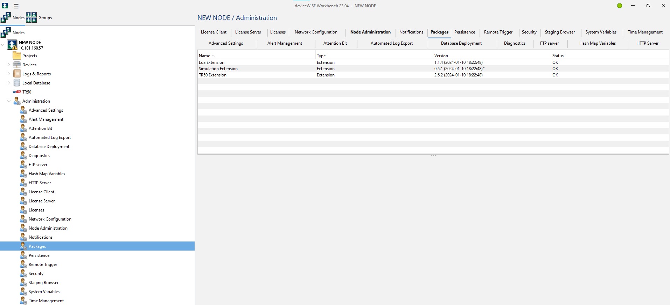
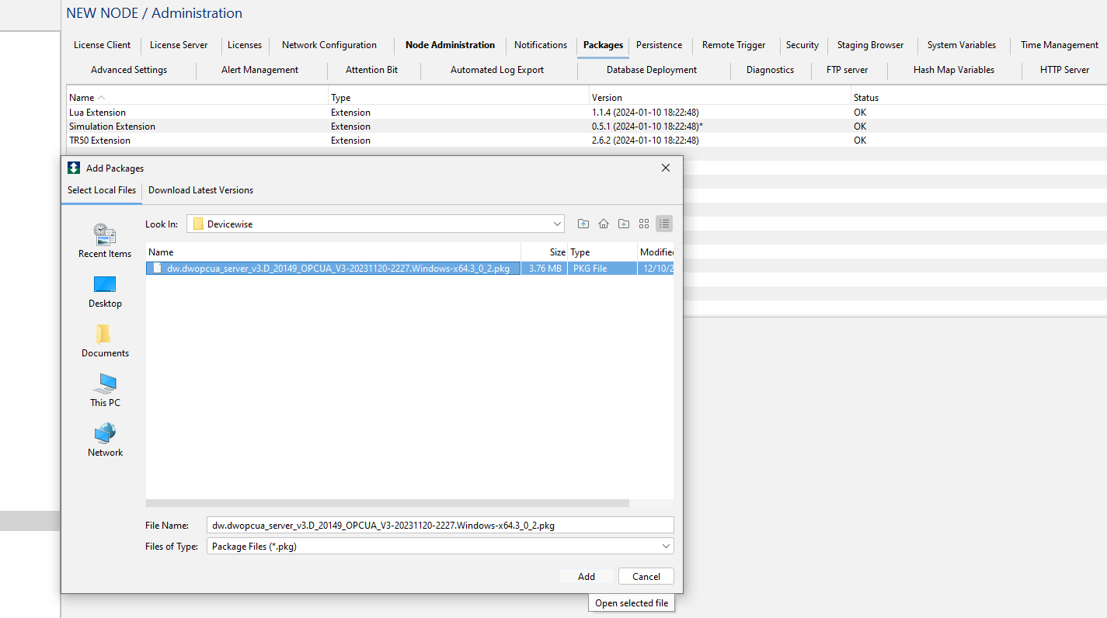
 | Manufacturing Engineer, System Engineer, Process Engineer | Verify that all selected packages are queued for installation.  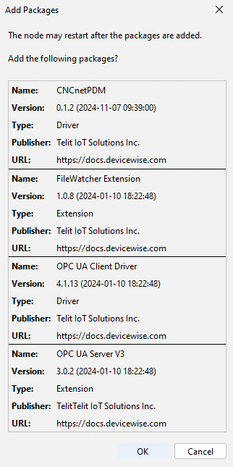
Allow the system to complete package installation. The deviceWise Gateway will automatically restart upon completion.
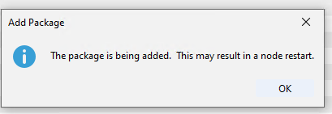
 | Manufacturing Engineer, System Engineer, Process Engineer | From the Administration Page, navigate to the License Client tab. Add the deviceWise License Manager address:  MSPM7AAPPS0342.cfrf.medtronic.com  Set the connection to True and select Save.  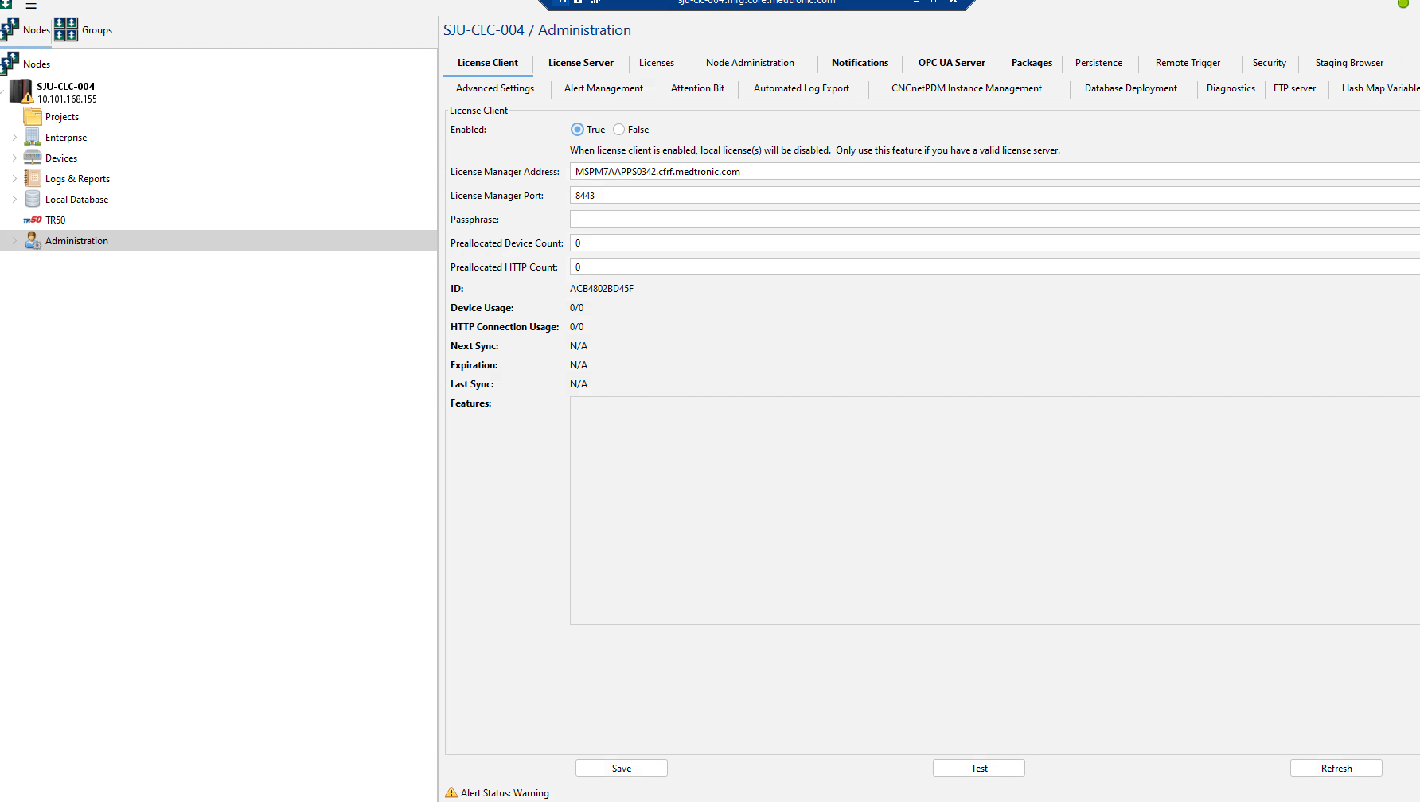
Navigate to the Devices page. Right-click and select Import, then import the approved OPC UA tag definition files for the CLC solution.
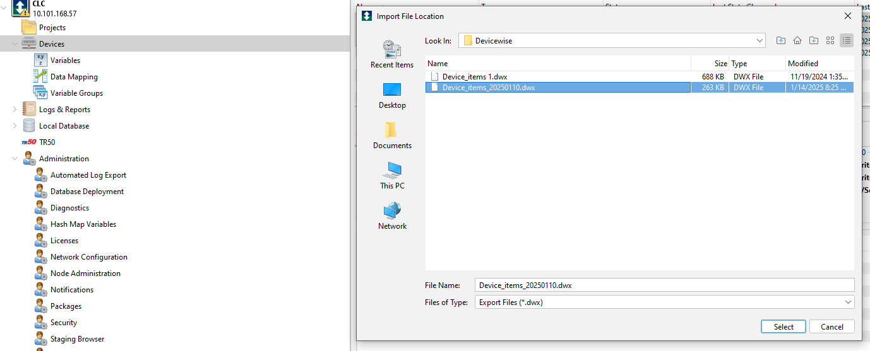
Navigate to Devices subtab under the OPC UA Server Tab within the Administration Page. Configure to have CNC1, CNC2 and CNC3 selected to be exposed.
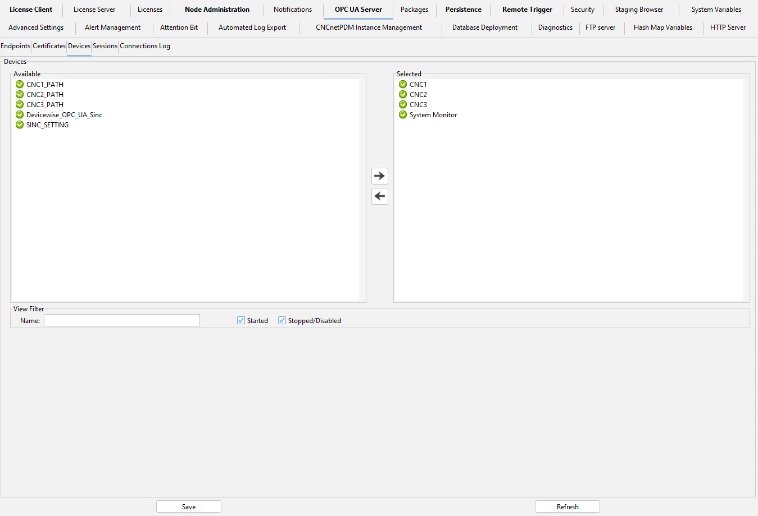
 | Manufacturing Engineer, System Engineer, Process Engineer | Navigate to the Endpoint sub-tab under OPC UA Server.  Configure the endpoint with the following settings:  - Port: 48020  - Enable all Security Modes  - Enable all Security Policies except the last policy  - Set User Authentication = True  - Set Allow Anonymous = True  Select Start to activate the endpoint.  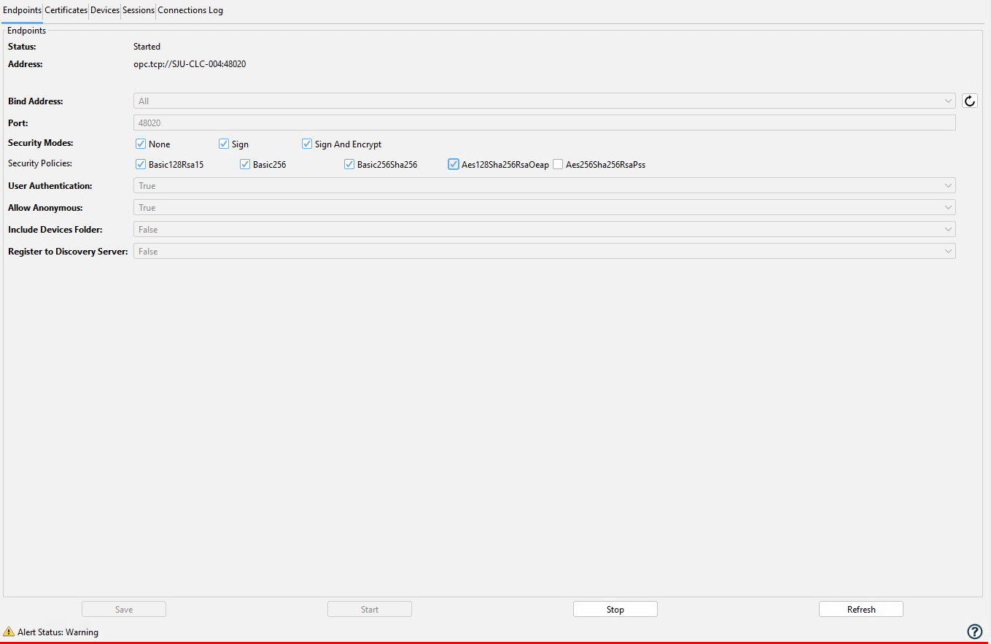
Navigate to Devices → Variables. Under CNC1, locate the CNCAsset and CNCType variables and enter the required configuration values as follows:
- CNCAsset – Enter the logical machine identifier used by operators and downstream APC logic (e.g., machine name or asset ID).
- CNCType – Enter the machine model/type used to drive solution behavior (e.g., Citizen L20, Citizen L20E, Citizen M32, etc.).
These values establish the operator-facing machine identity and determine how APC logic, offsets, and integrations behave for the selected CNC platform.
Repeat this step for CNC2 and CNC3, as applicable.
 |  | Stop Point: deviceWise base platform configuration for the CLC solution is complete. Proceed within Section 2.1.1 (deviceWise) to the applicable integration subsections (e.g., CNCnetPDM, CHMI, SINC, external clients) as required by the selected CLC deployment.

deviceWise – CHMI Integration
Step | Role | Action
 | Manufacturing Engineer, System Engineer, Process Engineer | This section defines the steps required to integrate CHMI-related deviceWise logic by importing the approved CHMI deviceWise project into the APC platform.
 |  | Verify that the approved deviceWise CHMI project package is available on the designated APC configuration repository (\\MSPM7AAPPS0342.cfrf.medtronic.com\Shared\APC\Deployment Resources) or from an approved site-controlled backup location, and correspond to the approved APC solution release baseline.
 |  | Navigate to the Projects page in deviceWise Workbench. Right-click and select Import.
 |  | Import the approved CHMI deviceWise project file for the CLC solution and confirm the import completes without errors.
Verify that the following CHMI-related project components are present and Loaded:
- CNC1_Control_PartMachined_Monitor
- CNC1_Control_PartRequired_Monitor
- CNC1_PATH_PartMachined_Monitor
- CNC2_Control_PartMachined_Monitor
- CNC2_Control_PartRequired_Monitor
- CNC2_PATH_PartMachined_Monitor
- CNC3_Control_PartMachined_Monitor
- CNC3_Control_PartRequired_Monitor
- CNC3_PATH_PartMachined_Monitor
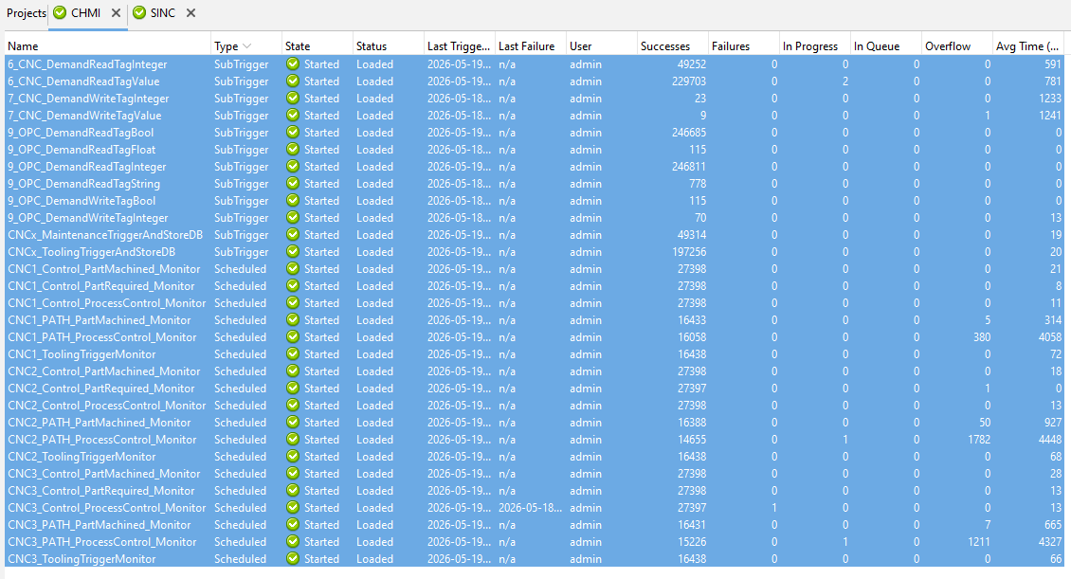

 | Manufacturing Engineer, System Engineer, Process Engineer | Verify that the following supporting trigger and system components are present and Started:  - 6_CNC_DemandReadTagInteger  - 7_CNC_DemandWriteTagInteger  - 7_CNC_DemandWriteTagValue  - 9_OPC_DemandReadTagBool  - 9_OPC_DemandReadTagFloat  - 9_OPC_DemandReadTagInteger  - 9_OPC_DemandReadTagString  - 9_OPC_DemandWriteTagBool  - 9_OPC_DemandWriteTagInteger  - CNCx_MaintenanceTriggerAndStoreDB  - CNCx_ToolingTriggerAndStoreDB
Confirm that all required CHMI-related Scheduled and SubTrigger components show Status = Loaded and State = Started.
If any required component is not started, start it and confirm successful transition to the Started state.
 |  | Stop Point: CHMI integration with deviceWise is complete. Proceed to the next applicable deviceWise integration subsection as required by the selected CLC solution.

deviceWise – SINC Integration
Step | Role | Action
 | Manufacturing Engineer, System Engineer, Process Engineer | This section defines the steps required to integrate the SINC project within the deviceWise Workbench environment for the Closed-Loop Correction (CLC) solution.
 |  | Verify that the approved SINC deviceWise project files are available on the designated APC configuration repository (\\MSPM7AAPPS0342.cfrf.medtronic.com\Shared\APC\Deployment Resources) or from an approved site-controlled backup location, and correspond to the approved APC solution release baseline.
 |  | Navigate to the Projects page in deviceWise Workbench. Right-click and select Import, then import the approved SINC project files. After import, confirm that the SINC project loads successfully without errors.
Verify that the following SINC-related componentsare present, loaded, and in a Started state:
- 0_DefaultConfiguration
- 0_MasterReset
- 0_ReadConfiguration
- 1_DetectNewFileAtWatcher
- 2_MonitorNewFileAtWatcher_CNC1
- 2_MonitorNewFileAtWatcher_CNC2
- 2_MonitorNewFileAtWatcher_CNC3
- 3_StartProcessCSVFile_Current
- 3_StartProcessCSVFile_Newer
- 5_StartWriteTagToCNC
- 6_CNC_DemandReadTagValue
- 7_CNC_DemandWriteTagValue
- 8_OPCUA_FileFormat
- 8_OPCUA_ResetAllValues
- 8_OPCUA_RollbackValue
- 8_OPCUA_UpdateValue
- 9_OPC_DemandReadTagBool
- 9_OPC_DemandReadTagString
- 9_OPC_DemandWriteTagBool
- 9_OPC_DemandWriteTagString
- 9_OPC_WriteTagString
- 9_OPC_WriteTagValue
- 10_SendEmail
- 11_CheckFolderExists
- 11_GetLastUpdatedTime
 | Manufacturing Engineer, System Engineer, Process Engineer | Verify that the following Master Reset components are present, loaded, and in a Started state:  - TRIGGER_MASTER_RESET_CNC1  - TRIGGER_MASTER_RESET_CNC2  - TRIGGER_MASTER_RESET_CNC3
 |  | Confirm that all required SINC-related Watch Directory, SubTrigger, and On-Demand components show Status = Loaded and State = Started.
Select 0_DefaultConfiguration, click Edit, navigate to Local Variables, and configure the EMAIL_TO variable with the required email distribution list for receiving SINC error and alert notifications
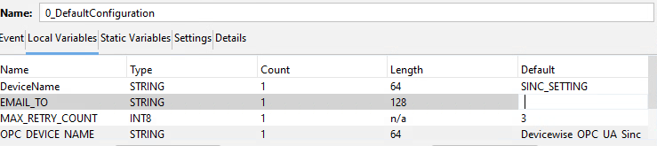
 |  | Navigate to Local Database → Tables → CNC_ASSET_Management. Insert or edit rows to map each CNC (e.g., CNC1, CNC2, CNC3) to the correct CNC_NODE, CNC_ASSET, and CNC_TYPE values as defined for the cell.
Navigate to Local Database → Tables → CNC_Settings. Insert or edit rows to define CNC-specific SINC settings using the following fields, aligned per CNC instance (e.g., CNC1, CNC2, CNC3):
- ASSET_NAME = CNC identifier (e.g., CNC1, CNC2, CNC3)
- ALARM_TAG = 1,599
- ALARM_VALUE = 1.0
- ALARM_PATH = PATH
- WAIT_TIME = 15000
- RETRY_COUNT = 3
- NOTES = N/A
Ensure that each row accurately reflects the required alarm behavior for the corresponding CNC asset and matches the approved SINC configuration baseline.
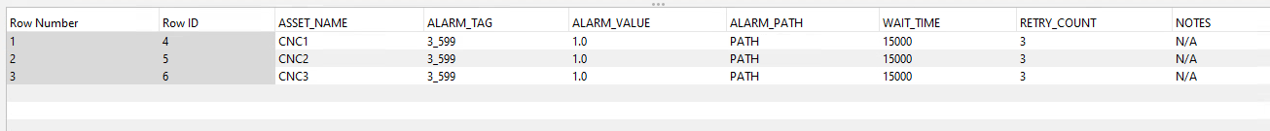
 | Manufacturing Engineer, System Engineer, Process Engineer | Confirm that the configured CNC mappings, settings, and triggers align with the CNCnetPDM machine definitions and the established CNC paths (e.g., CNC1_Path, CNC2_Path, CNC3_Path).
Navigate to the deviceWise staging directory on the APC VM: C:\Program Files\deviceWISE\Gateway\staging\SINC\
Create a folder corresponding to the configured CNC asset (e.g., CNC1).
Within the CNC folder, create the following subfolders:
- Processing
- DoneSuccess
- DoneError
The resulting directory structure shall be:
C:\Program Files\deviceWISE\Gateway\staging\SINC\CNC1\
├─ Processing
├─ DoneSuccess
└─ DoneError
Repeat this structure for additional CNC assets (e.g., CNC2, CNC3) as applicable.
 |  | Stop Point: SINC integration with deviceWise is complete. Proceed to the next applicable deviceWise integration subsection as required by the selected CLC solution.

deviceWise – CNCnetPDM Integration
Step | Role | Action
 | Manufacturing Engineer, System Engineer, Process Engineer | This section defines the steps required to integrate CNCnetPDM with the deviceWise platform to support CNC connectivity and machine context for the Closed-Loop Correction (CLC) solution.
 |  | Prerequisite: CNCnetPDM must be installed and configured prior to executing this section. CNCnetPDM configuration is performed in Section 2.1.3 – CNCnetPDM Configuration and establishes the approved machine definitions used by deviceWise.
 |  | From deviceWise Workbench, navigate to the Administration Page and select the CNCnetPDM Instance Management tab.
Select Add, paste the approved CNCnetPDM installation folder path, and select Add to register the CNCnetPDM instance with deviceWise.
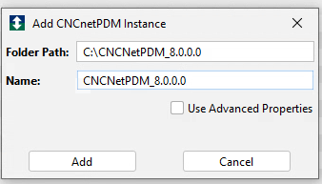
Verify that the CNCnetPDM instance status indicates Connected and that the number of detected machines matches the approved CLC system configuration.
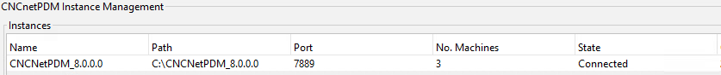
Navigate to the Devices page. Locate and edit the CNCX_Paths configuration object to associate CNCnetPDM paths with the registered CNC machines.
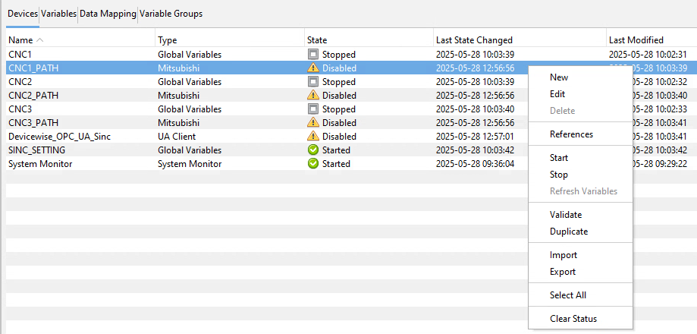
 | Manufacturing Engineer, System Engineer, Process Engineer | Select the appropriate machine configurations established in CNCnetPDM and explicitly pair each CNCnetPDM machine instance with its corresponding deviceWise CNC path as follows:  - CNCnetPDM machine configured for CNC1 → map to CNC1_Path  - CNCnetPDM machine configured for CNC2 → map to CNC2_Path  - CNCnetPDM machine configured for CNC3 → map to CNC3_Path  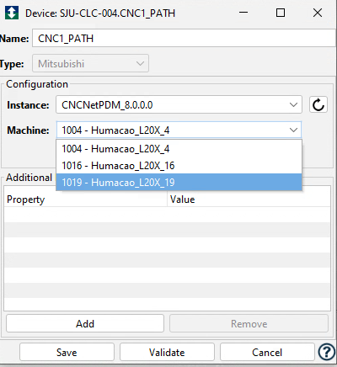  Ensure that each CNC asset is correctly aligned with its corresponding path to maintain deterministic routing of machine data, offsets, and APC logic.  Select Save to finalize the association.
 |  | Verify that CNC machines are correctly represented within deviceWise and available for downstream APC components (DOC, CHMI/APC UI).
 |  | Stop Point: CNCnetPDM integration with deviceWise is complete. Proceed to the next applicable deviceWise integration subsection as required by the selected CLC solution.

deviceWise – External Client Enablement (DOC / Others)
Step | Role | Action
 | Manufacturing Engineer, System Engineer, Process Engineer | This section defines the steps required to enable secure external client access (e.g., DOC, analytics tools, or other APC applications) to the deviceWise OPC UA Server for the selected APC solution.
 |  | Navigate to the Administration page and select the Security tab, then open the Users sub-tab.
Select New to create a dedicated OPC UA user for external client access.
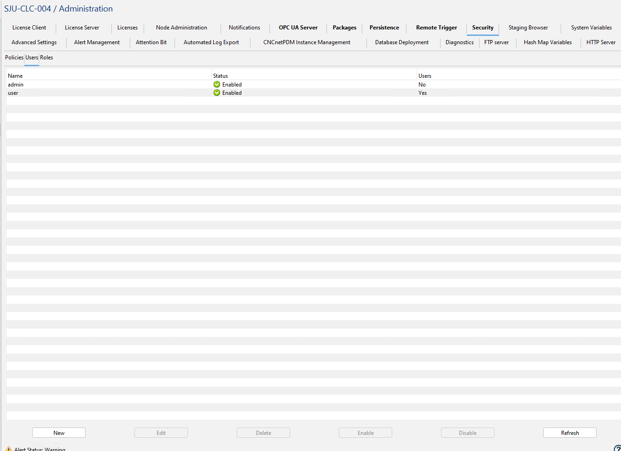
Enter the credentials for the external OPC UA service user (MedtronicSU) using the credentials maintained by the APC Team in accordance with the APC credential management process. If credential access is required, contact the APC Team.
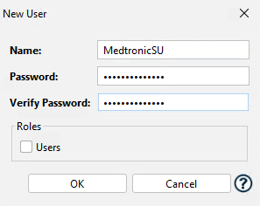
 |  | Confirm the user is successfully created and visible in the Security → Users list.
 |  | When the external client (e.g., DOC) attempts to connect for the first time, navigate to Administration → OPC UA Server → Certificates.
 | Manufacturing Engineer, System Engineer, Process Engineer | Locate the pending client certificate request and select Trust to approve the external client connection.  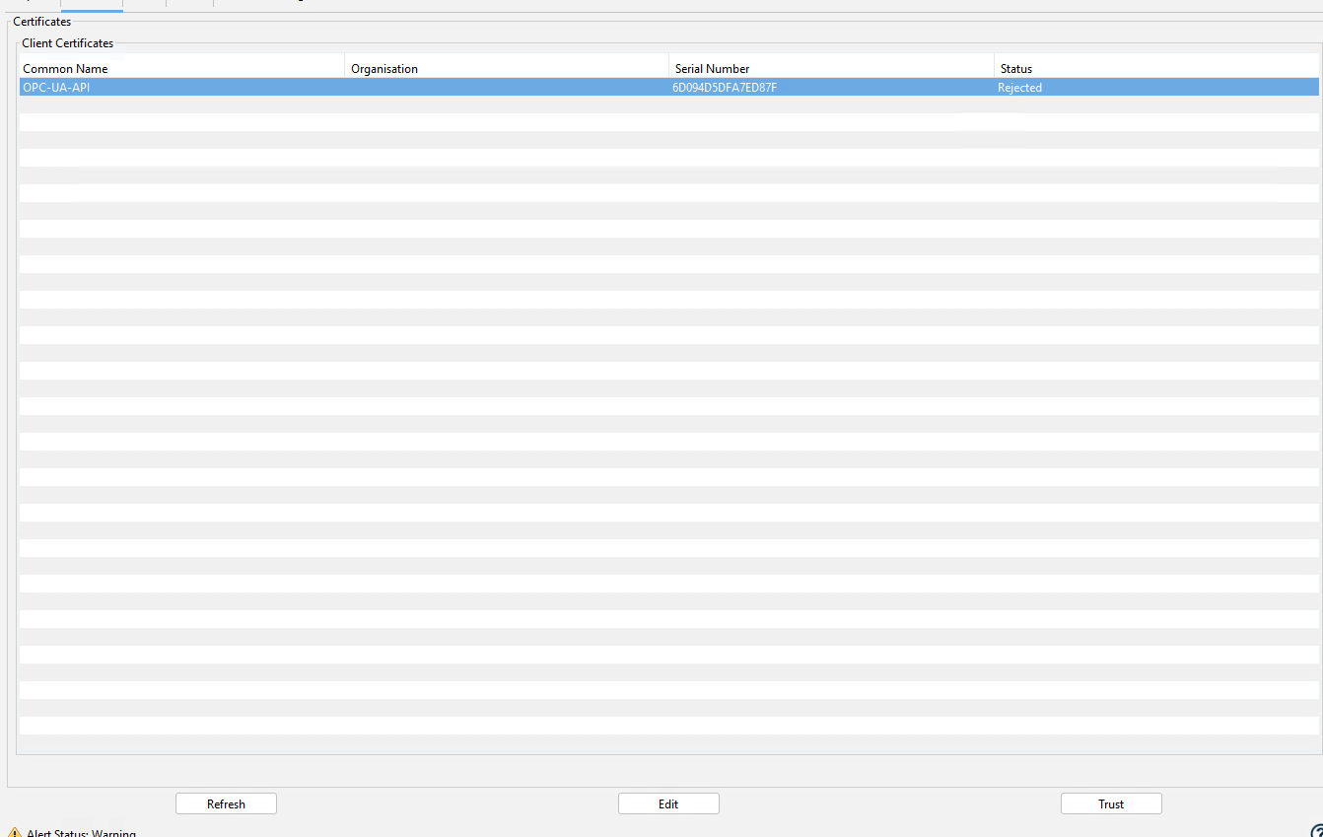
 |  | Verify that the trusted certificate appears in the trusted certificate list and that the external client connection state transitions to connected.
 |  | Stop Point: External client access to the deviceWise OPC UA Server is enabled. Proceed to application-specific configurations.

Timescale Database (TSDB)
Step | Role | Action
 | Manufacturing Engineer, System Engineer, Process Engineer | This section defines the steps required to configure the TimescaleDB database for use within the APC system. Configuration includes database access setup, user and role creation, database initialization, TimescaleDB extension enablement, connection configuration, and schema deployment.
 |  | Navigate to the PostgreSQL data directory (e.g., C:\Program Files\PostgreSQL\17\data) and locate the pg_hba.conf file.
Update the PostgreSQL host-based authentication configuration. Open the pg_hba.conf file located in the PostgreSQL data directory (e.g., C:\Program Files\PostgreSQL\17\data). Add the following IPv4 local connection entry to allow connections from all addresses: host all all 0.0.0.0/0 md5
Save and close the file.
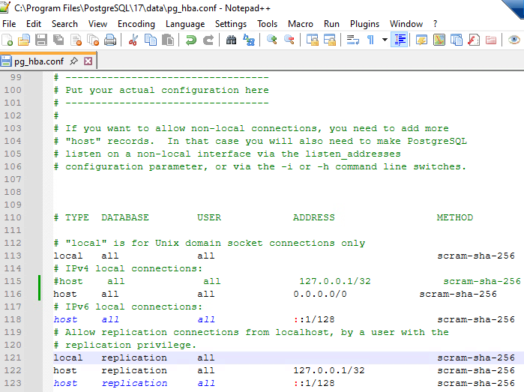
Restart the PostgreSQL service to apply configuration changes. Navigate to Start → Services, locate the service postgresql-x64-17, then stop and start the service to complete the restart.
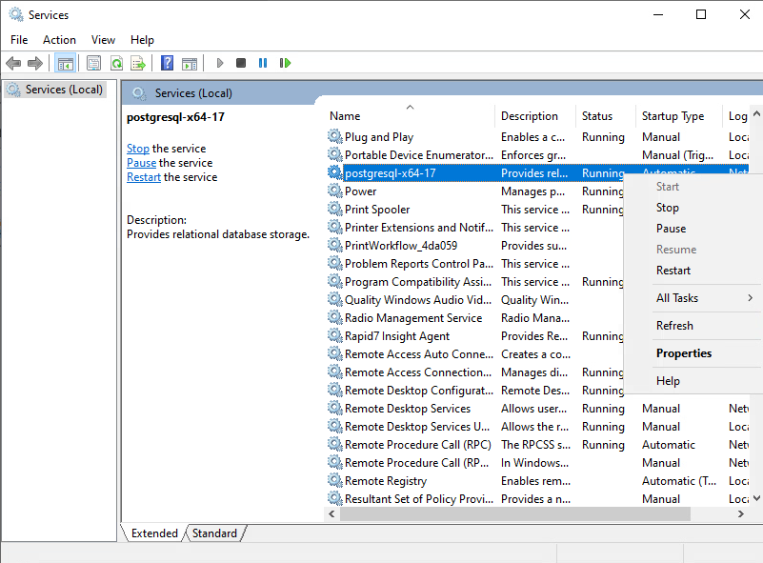
 | Manufacturing Engineer, System Engineer, Process Engineer | In pgAdmin 4, create a new database user. Navigate to Login/Group Roles, right-click and select Create → Login/Group Role. Enter the username apcuser and configure the password using the credentials maintained by the APC Team in accordance with the APC credential management process. If credential access is required, contact the APC Team.  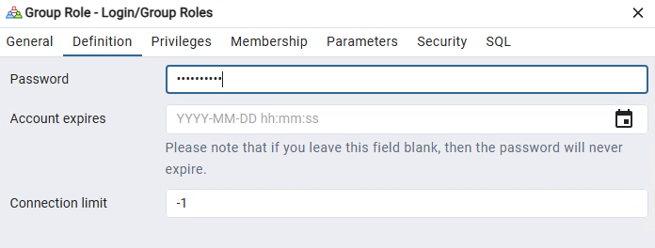
Assign required privileges to the user apcuser. In the Privileges tab, configure the following settings:
- Can login? → Enabled
- Superuser? → Enabled
- Create roles? → Enabled
- Create databases? → Enabled
- Inherit rights from parent roles? → Enabled
- Can initiate streaming replication and backups? → Disabled
- Bypass RLS? → Enabled
Click Save to apply the configuration.
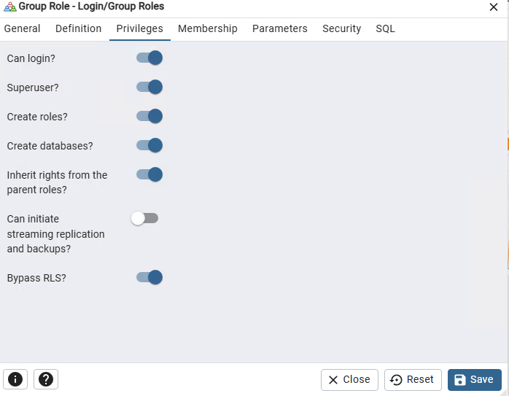
 | Manufacturing Engineer, System Engineer, Process Engineer | Create a new database for TimescaleDB usage. In the object explorer, right-click Databases and select Create → Database. Enter the database name (TimescaleDB) and assign the appropriate owner (apcuser), then click Save.  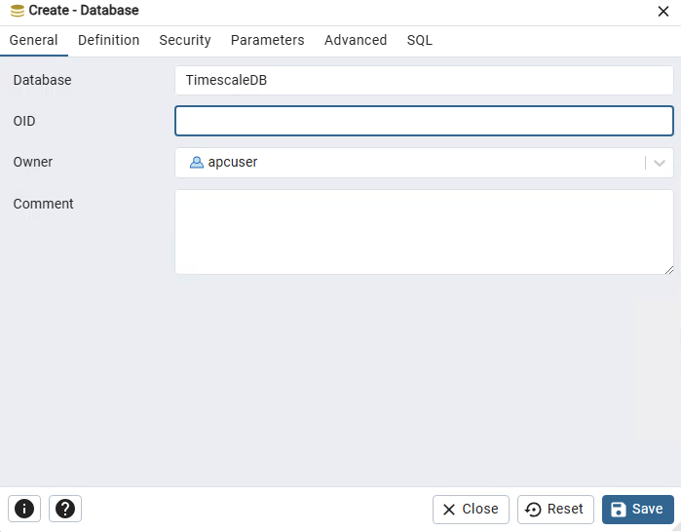
In pgAdmin 4, select the database TimescaleDB and launch the Query Tool by right-clicking the database and selecting Query Tool, or by using the shortcut (Alt + Shift + Q).
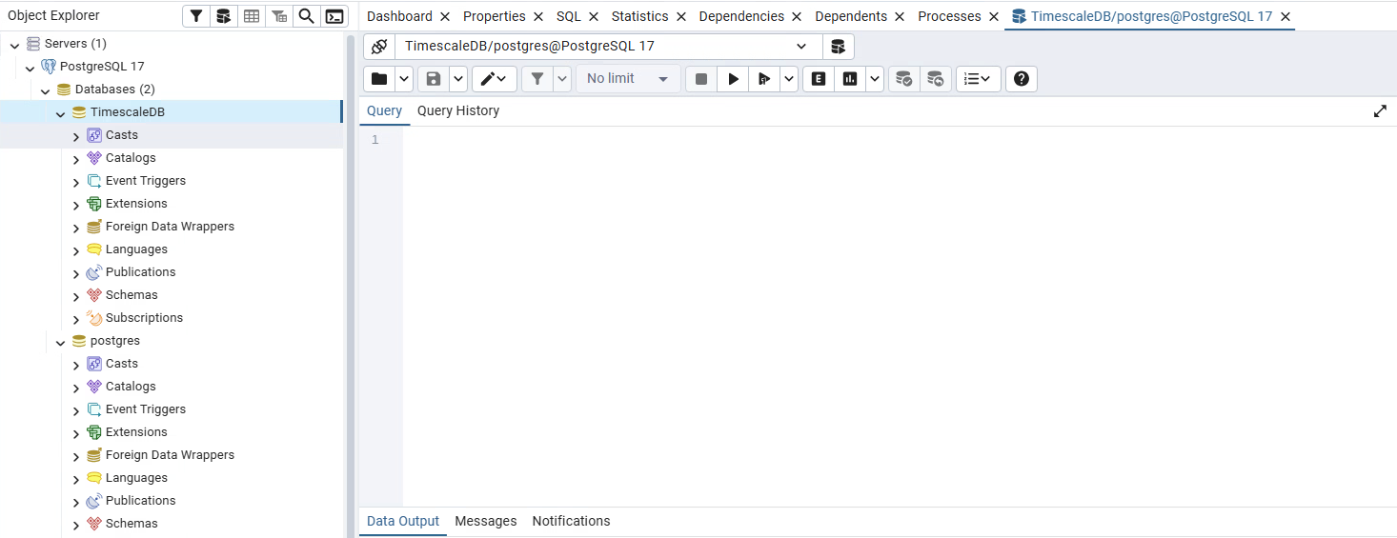
In the Query Tool, execute the following SQL script to enable the TimescaleDB extension and create a validation table:
CREATE EXTENSION IF NOT EXISTS timescaledb;
CREATE TABLE conditions (
time TIMESTAMPTZ NOT NULL,
location text NOT NULL,
temperature DOUBLE PRECISION NULL
);
SELECT create_hypertable('conditions', by_range('time'));
Press execute script.
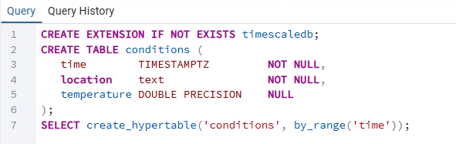
 | Manufacturing Engineer, System Engineer, Process Engineer | In the left panel (Browser), Right-click on Servers and Click Register → Server  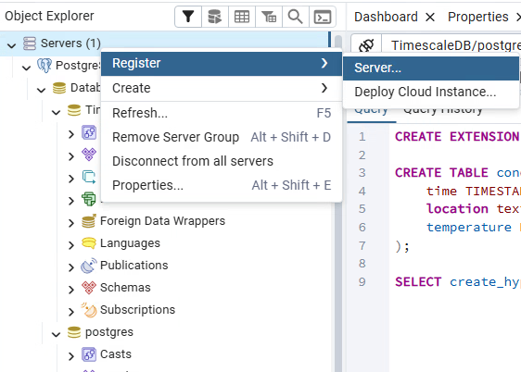
In the General tab, enter the following:
- Name: Enter the VM name (e.g., SJUM7APPD0017)
Click on the Connection tab to continue.
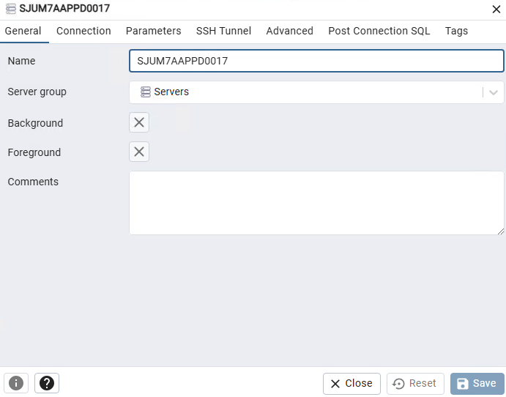
In the Connection tab, enter the following configuration:
Host name/address: Enter the VM name (e.g., SJUM7APPD0017)
Port: 5432
Maintenance database: TimescaleDB
Username: apcuser
Password: Enter the password using the credentials maintained by the APC Team.
Save password: Enabled
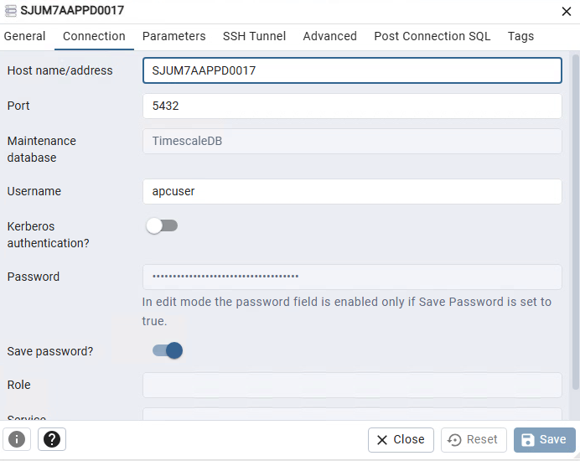
 | Manufacturing Engineer, System Engineer, Process Engineer | Generate the required database tables by verifying that all approved database schema script files (e.g., SPC, CCW, PCW, CHMI, DOCW, and related APC schema scripts) are available on the designated APC installer/backup server and correspond to the approved APC system release. From the target APC VM, open pgAdmin 4, select the TimescaleDB database, and launch the Query Tool (Alt + Shift + Q). For each approved schema script file, open the file, copy the full contents, paste into the Query Tool, and click Execute Script. Repeat this process for all required schema files in the approved execution sequence. Confirm that each script completes successfully without errors and verify that all required tables, views, and database objects are created in the public schema.
 |  | Launch pgAdmin 4 and verify that the database, user, and server connection are configured correctly. Successful connection and visibility of all required tables confirm proper configuration.
 |  | Install the PostgreSQL ODBC driver package (psqlodbc-setup) on the APC VM. Verify that the approved installer version is obtained from the designated APC installer/backup server or approved software repository corresponding to the validated APC system release. Complete the installation using default settings.
Configure the PostgreSQL ODBC connection for APC applications. Launch ODBC Data Source Administrator from the Windows Start menu. In the System DSN tab, click Add.
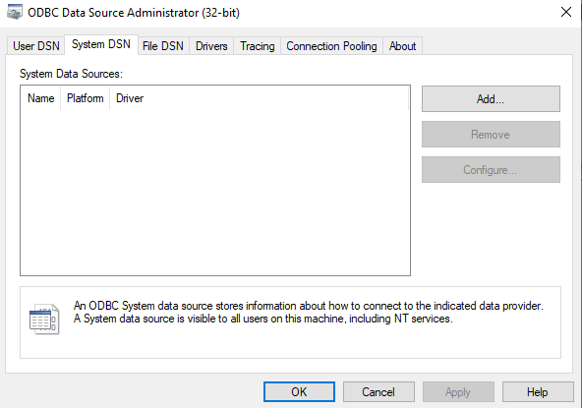
In the Create New Data Source window, select PostgreSQL ANSI (x86) and click Finish.
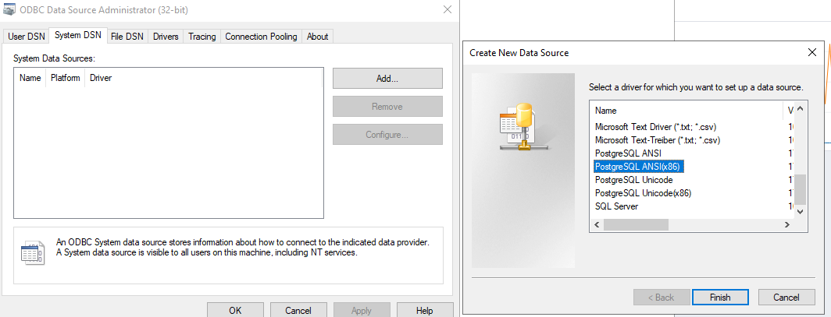
 | Manufacturing Engineer, System Engineer, Process Engineer | In the PostgreSQL ANSI/Unicode ODBC Setup window, enter the following configuration:  - Data Source: PostgreSQL30  - Database: TimescaleDB  - Server: localhost  - Port: 5432  - User Name: apcuser  - Password: Enter the password using the credentials maintained by the APC Team.  - SSL Mode: disable  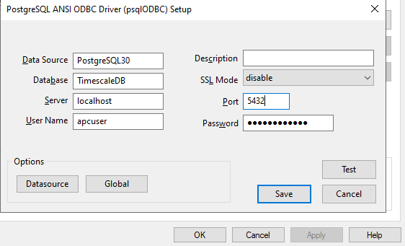
Click Test to verify the connection. A “Connection successful” message shall be displayed. Click Save to complete the configuration.
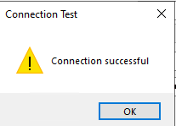
 |  | TimescaleDB configuration and ODBC connection setup are complete. The database is ready for APC system integration and application connectivity.
 |  | Stop Point: TimescaleDB configuration and ODBC connection setup are complete. The database is ready for APC system integration and application connectivity. Proceed to application-specific configurations.

Dynamic Offset Calculation (DOC)
Step | Role | Action
 | Manufacturing Engineer, System Engineer, Process Engineer | This section defines the steps required to configure the Dynamic Offset Calculation (DOC) software for the Closed-Loop Correction (CLC) solution. Configuration includes updating database connectivity and asset mappings for each installed DOC instance.
 |  | Verify that the required DOC instances have been installed on the APC VM in accordance with APC System Installation (D01555599). Each DOC instance corresponds to a specific CNC asset configured in deviceWise (e.g., CNC1, CNC2, CNC3).
 |  | Perform the configuration steps described in this section for each installed DOC instance to ensure that the database connections, asset mappings, and external integrations are correctly aligned with the corresponding CNC asset defined in deviceWise.
 |  | Navigate to: C:\Medtronic\DOC X\DOC_II\
 |  | Review and update all XML configuration files required for the deployed APC solution, including but not limited to: DocDb.xml, SpcDb.xml, DOC_II.xml, IqsDocSpcDataCollector.xml, and PartLookup.xml. Configure each file in accordance with the approved APC solution baseline, site deployment requirements, and the corresponding CNC asset mapping established in deviceWise.
- s |  | Open the DocDB.xml file. In the Connection String section, verify that the database connection parameters are correctly configured to connect to the TimescaleDB instance on the APC VM using the apcuser database account. Do not modify these values unless instructed by the APC Team.
Open the DOC_II.xml file. Verify that the CSVFileOutputPath parameter is configured to route generated measurement files to the deviceWise SINC staging directory corresponding to the associated CNC asset.
Example:
C:\Program Files\deviceWISE\Gateway\staging\SINC\CNCX\{AF}-{AN}-{BN}-{PF}-{PN}-{PSN} {DS} {TS}.csv
Ensure the CNCX value corresponds to the CNC asset mapped to the DOC instance.
 | Manufacturing Engineer, System Engineer, Process Engineer | Open the PartLookup.xml file. In the Connection String section, verify that the database connection parameters are correctly configured to connect to the TimescaleDB instance on the APC VM using the apcuser database account. Do not modify these values unless instructed by the APC Team.
In PartLookup.xml, verify the following parameter:
- <LoadMatrixRevision>MAX</LoadMatrixRevision>
This ensures the DOC instance retrieves the latest available matrix revision from the database.
 |  | Navigate to: C:\Medtronic\DOC X\DOC_II\Plugins\IQS
 |  | Open the SpcDB.xml file. In the Connection String section, verify that the database connection parameters are correctly configured to connect to the TimescaleDB instance on the APC VM using the apcuser database account. Do not modify these values unless instructed by the APC Team.
Open the IqsDocSpcDataCollector.xml file. In the Asset Configuration section, configure the CNC asset identifier to match the corresponding CNC asset (e.g., DOC 1 → CNC1, DOC 2 → CNC2, DOC 3 → CNC3) as defined in deviceWise.
Populate the asset fields to exactly align with the deviceWise configuration for the corresponding CNC asset:
- <DBId> shall match the CNCAsset value configured in deviceWise
- <Name> shall retain the fixed prefix Primary, with only the bracketed portion updated to reflect the configured CNC asset name
- <Family> shall match the CNCType value configured in deviceWise (e.g., Citizen M32, Citizen L20E, Citizen L20X)
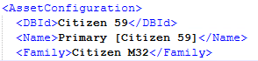
Save all configuration changes.
 | Manufacturing Engineer, System Engineer, Process Engineer | Launch the Dynamic Offset Calculation (DOC) application for each configured DOC instance, as applicable based on the CNC-to-operator mappings established in deviceWise.  Verify that the following connection indicators display green for each instance:  - DOC DB – Indicates successful connection to the APC TSDB  - SPC – Indicates successful connection to the SPC data source or APC TSDB  - OPC – Indicates successful connection to the OPC UA server  If any indicator does not display green, perform the following checks:  - OPC indicator not green: Verify that deviceWise external client enablement is correctly configured and that the OPC UA security user and certificates are properly trusted.  - DOC DB or SPC indicator not green: Verify that the APC service account configured in DocDB.xml has appropriate database access and that required firewall ports are open. If the issue persists, coordinate with local IT.  Successful green status for all applicable indicators confirms connectivity configuration.
 |  | Stop Point: Dynamic Offset Calculation (DOC) instances are configured and successfully connected to required external services. Proceed to application-specific configurations.

CNCnetPDM
Step | Role | Action
 | Manufacturing Engineer, System Engineer, Process Engineer | This section defines the steps required to configure CNCnetPDM to enable connectivity between the APC system and CNC machines. CNCnetPDM provides the interface layer used by APC to communicate with Citizen CNC machines.
Request a perpetual CNCnetPDM license for the APC VM. Provide the APC VM name and the current CNCnetPDM license number to the APC Team to obtain the approved perpetual license for the system.
To obtain the current license number:
- Ensure the CNCnetPDM service is running.
- Launch the CNCnetControl application.
- Select License → View/Edit and copy the current license number.
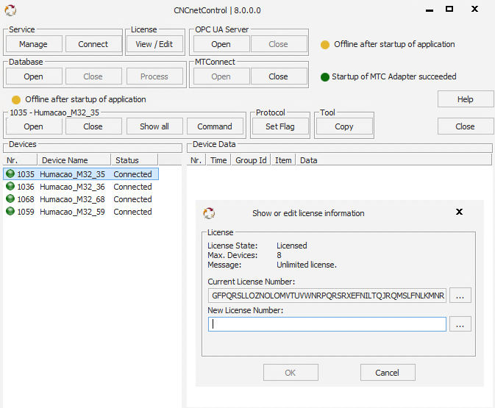
Once the perpetual license is received:
- Launch the CNCnetControl application.
- Select License → View/Edit.
- Paste the new perpetual license number into the license field and save.
- Verify that the license is accepted without errors before proceeding with further configuration.
 |  | Navigate to the CNCNetPDM_8.0.0.0 installation directory and open the CNCnetPDM.ini file.
 | Manufacturing Engineer, System Engineer, Process Engineer | In the RS232 section of the CNCnetPDM.ini file, add or update CNC machine entries using the required 16-field format shown below. Populate machine-specific fields according to the selected CNC model and site configuration. Default fields shall be set as specified.  Format:  Line Id = Device Nr; Baud; Databits; Parity; StopBits; Machine Name; IP; Port; Method; DNS-Name; Mitsubishi Nr.; PLC Addr.(Counter); Share; Logfile Name; Logfile Version; DLL Name
Verify and populate each of the 16 CNCnetPDM configuration fields as defined below, ensuring correct CNC indexing, driver selection, and consistency with APC and deviceWise mappings.
Field Definitions:
- Device Nr – Machine-specific unique identifier
- Baud – Set to default (19200).
- Databits – Set to default (8)
- Parity – Set to default (N)
- StopBits – Set to default (1)
- Machine Name – Site-specific descriptive CNC name.
- IP – CNC machine IP address.
- Port – Set to default (683).
- Method – Set to default (0).
- DNS-Name – Set to default (localhost).
- Mitsubishi Nr. – Must match the CNC index (e.g., 1 = CNC1)
- PLC Addr. (Counter) – Set to default (none).
- Share – Set to default (none).
- Logfile Name – Set to default (none).
- Logfile Version – Set to default (0).
- DLL Name – Select based on CNC API:
- Citizen API → CitizenM.dll
- Mitsubishi API → MitsubishiM.dll
Ensure the DLL exists in the CNCnetPDM directory and the name matches exactly.
Open the melcfg.ini configuration file. In the [HOSTS] section, configure CNC network mappings:
TCP1 = <IP>,<Port> → CNC1
TCP2 = <IP>,<Port> → CNC2
TCP3 = <IP>,<Port> → CNC3
Ensure each TCP entry corresponds to the same Mitsubishi Nr. defined in CNCnetPDM.ini.
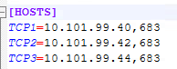
 | Manufacturing Engineer, System Engineer, Process Engineer | Verify and rename CNC driver files as required. Locate the machine-specific CNC driver files (e.g., citizenm_CNC1.dll, mitsubishim_CNC1.dll) and update the CNC identifier portion of the filename to match the assigned DeviceNr defined in CNCnetPDM.ini (e.g., rename citizenm_CNC1.dll to citizenm_1068.dll). Ensure the renamed file exactly matches the DLL name configured for the corresponding CNC entry.
Confirm consistency between CNCnetPDM.ini, melcfg.ini and machine-specific CNC driver files for:
- Machine name
- DeviceNr / Mitsubishi Nr.
- IP address and port
- Selected DLL driver
 |  | Save all configuration changes and restart CNCnetPDM services. Verify CNCnetPDM initializes without errors.
 |  | Stop Point: CNCnetPDM is configured with valid machine definitions, correct CNC driver selection, and consistent CNC indexing. Proceed to deviceWise CNCnetPDM integration and other application-specific configurations.

Data Collection and Analytics Configuration
Step | Role | Action
 | Manufacturing Engineer, System Engineer, Process Engineer | This section defines the steps required to configure the Data Collection and Analytics software components on the approved APC virtual machine (VM) to support the selected Closed-Loop Correction (CLC) solution.
 |  | Confirm that all prerequisite APC platform components required by the Data Collection and Analytics applications (including TimescaleDB, deviceWise, CNCnetPDM, and other external APC applications) have been installed and verified per APC System Installation (D01555599).
 |  | Perform Data Collection and Analytics configuration activities in accordance with the applicable subsections below, based on the selected APC-CLC solution and deployed measurement systems.
 |  | Upon completion of all applicable Data Collection and Analytics configuration subsections, proceed to APC Configuration Verification to verify configuration completeness and readiness for APC System Execution (D01552864).

File Manager
Step | Role | Action
 | Manufacturing Engineer, System Engineer, Process Engineer | This section defines the steps required to configure the Data Collector File Manager for the Closed-Loop Correction (CLC) solution. Configuration is limited to defining file routing paths between source instruments and the APC local processing environment.
 |  | Navigate to the File Manager installation directory on the APC VM (e.g., C:\Medtronic\Data Collector File Manager\).
 |  | Open the configuration file (e.g., FileManager.exe.config or equivalent XML configuration file).
Configure mismatch data validation within the <CNCSettings> section of the configuration file:
- Set <CheckMismatchData> to true for each configured CNC asset.
This ensures that files with mismatched Part Number, Batch/Lot Number, Process Name, or Sample Number are not processed by the File Manager.
 |  | Locate the existing <Paths> configuration section. The configuration file contains predefined <Path> entries for each supported measurement instrument (e.g., CMM, CTSCAN, BENCH, CONTRACER).
 |  | For each <Path> entry, configure the required routing parameters. All predefined instrument paths shall be configured to maintain system flexibility.
Configure the following parameters within each <Path> configuration block:
Source Path (Shared Folder)
- <Path> shall be configured as the shared network directory where the instrument drops measurement files.
- Ensure the APC VM has read access to this directory.
Destination Path (Local Processing Folder)
- <NewPath> shall be configured as a local directory on the APC VM where files will be routed for downstream processing by the Data Collector.
- Example: C:\Medtronic\DataCollector_Data\CMM
Error Path (Rejected File Handling)
- <ErrorPath> shall be configured as a local directory where files are routed when a mismatch or processing error is detected.
- Example: C:\Medtronic\DataCollector_Data\CMM\DoneError
- Files routed to this location shall not be processed further.
 | Manufacturing Engineer, System Engineer, Process Engineer | For each configured <NewPath>, manually create the corresponding directory on the APC VM if it does not already exist.  - Organize directories by data source (e.g., CMM, CTSCAN, BENCH, CONTRACER).  - Verify the application has read and write permissions to these folders.
Configure the file completion condition for each <Path> entry:
- Set <EndFileString> to NA to allow processing of all files without enforcing a specific end-of-file validation condition.
- This ensures compatibility across multiple product file formats and avoids rejection due to format variability.
 |  | Save the configuration file after all <Path> entries have been updated.
 |  | Launch the Data Collector File Manager application and verify the application starts without errors.
 |  | Verify that files placed in the configured shared source directories are detected and routed to the corresponding <NewPath> destination folders.
If file routing does not function as expected, perform the following checks:
- Verify network connectivity and permissions to shared source folders.
- Confirm local destination folders exist and are accessible.
- Ensure correct path formatting in the configuration file.
- Confirm no file locks or incomplete file writes are occurring at the source.
 |  | Stop Point: File routing from instrument shared folders to APC local directories is successfully configured. Proceed to other application-specific configurations.

Data Collector
Step | Role | Action
 | Manufacturing Engineer, System Engineer, Process Engineer | This section defines the steps required to configure the Data Collector application for the Closed-Loop Correction (CLC) solution. Configuration is limited to defining database connectivity and local file processing paths used for measurement data ingestion and storage.
 |  | Navigate to the Data Collector installation directory on the APC VM (e.g., C:\Medtronic\Data Collector\).
 |  | Open the Data Collector configuration file (e.g., DataCollector.exe.config or equivalent XML configuration file).
 |  | Locate the <AppSettingsSection> and verify that the database connection parameters are correctly configured to connect to the TimescaleDB instance on the APC VM using the apcuser database account. Do not modify these values unless instructed by the APC Team.
 |  | Locate the <DataTypeSettings> section. This section contains predefined configuration blocks for each data source (e.g., CMM, BENCH, CTSCAN, CONTRACER).
For each data source configuration block, update the following parameters:
Check Path
- <CheckPath> shall be configured as the local directory monitored by the Data Collector for incoming files routed from the File Manager.
Archive Path
- <ArchivePath> shall be configured as the directory where processed measurement files will be archived after processing.
Broadcast File Paths (MES Integration)
- <BroadcastFilePaths> defines the location where processed measurement files will be copied for integration with external systems such as MES.
- If MES integration is not used, configure the path value as NA.
 | Manufacturing Engineer, System Engineer, Process Engineer | Ensure the directories defined in <CheckPath>, <ArchivePath>, and any configured <BroadcastFilePaths> locations exist on the APC VM or corresponding network locations. Verify the application has read and write permissions to these folders.
Configure the file completion condition for each <Path> entry:
- Set <EndFileString> to NA to allow processing of all files without enforcing a specific end-of-file validation condition.
This ensures compatibility across multiple product file formats and avoids rejection due to format variability.
 |  | Save the configuration file after all required updates have been completed.
 |  | Launch the Data Collector application and verify that it starts without errors.
 |  | Verify that files routed from the File Manager appear in the configured <CheckPath> directories and are successfully processed by the Data Collector. Confirm that processed files are archived in the configured <ArchivePath> directories.
 |  | Stop Point: Data Collector configuration is complete and measurement data processing is operational. Proceed to subsequent APC application configurations.

Data Analyzer
Step | Role | Action
 | Manufacturing Engineer, System Engineer, Process Engineer | This section defines the steps required to configure the Data Analyzer application for the Closed-Loop Correction (CLC) solution. Configuration is limited to defining database connectivity and OPC communication parameters used for retrieving processed measurement data and generating SPC and control logic events.
 |  | Navigate to the Data Analyzer installation directory on the APC VM (e.g., C:\Medtronic\Data Analyzer\).
 |  | Open the Data Analyzer configuration file (e.g., DataAnalyzer.exe.config or equivalent XML configuration file).
 |  | Locate the <appSettings> section of the configuration file.
 |  | Verify that the database connection parameters are correctly configured to connect to the TimescaleDB (TSDB) instance on the APC VM using the apcuser database account. Do not modify these values unless instructed by the APC Team.
Update the site identifier used in the OPC process configuration parameters to match the site where the APC system is deployed. The site code appears in the process naming convention (e.g., _MCR$) and shall be updated accordingly within the following parameters:
- Opc_FirstRunProces
- Opc_VerificationProcess
- Opc_ProductionProcess
Use the appropriate site code as defined below:
- MCR – Alajuela, Costa Rica
- MFW – Fort Worth, Texas
- MPR – Humacao, Puerto Rico
- MWR – Warsaw, Indiana
 |  | Do not modify internal Data Analyzer logic parameters, including queue intervals, worker thread duration, event processing configuration, or SPC rule definitions unless explicitly instructed by the APC Team. These parameters are predefined as part of the APC solution baseline.
 |  | Save the configuration file after verification and required updates are completed.
 | Manufacturing Engineer, System Engineer, Process Engineer | Launch the Data Analyzer application and verify the application starts without errors.
 |  | Confirm that the Data Analyzer successfully connects to the TimescaleDB (TSDB) database and the OPC UA server.
 |  | Stop Point: Data Analyzer configuration is complete and SPC analysis processing is operational. Proceed to subsequent APC application configurations.

CHMI / APC UI
Step | Role | Action
 | Manufacturing Engineer, System Engineer, Process Engineer | This section defines the steps required to configure OPC UA trust, certificates, and connectivity between the deviceWise OPC UA Server and the Compact HMI (System 800xA) environment. Certificate lifecycle management for OPC UA Connect and OPC UA Client Connection Services is performed using the UA Management Portal.
Launch the UA Management Portal from: ABB Start Menu → ABB System 800xA → System → Tools → UA Management Portal.
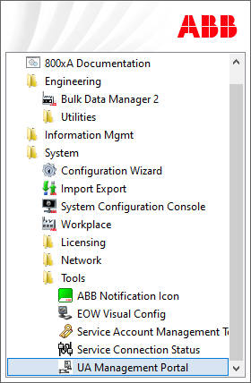
In the UA Management Portal, select Create… to open the Create New Root Certificate dialog, then select Create Root Certificate.
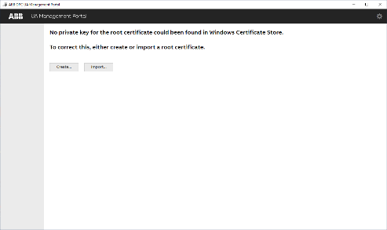
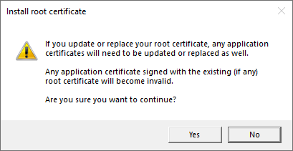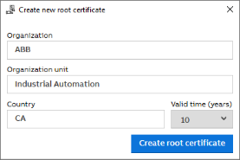
 | Manufacturing Engineer, System Engineer, Process Engineer | Select Connect… to open the Connect to OPC UA Application dialog. Choose 800xAOpcUaConnect and click Connect…. When prompted, authenticate using the 800xAService account credentials.  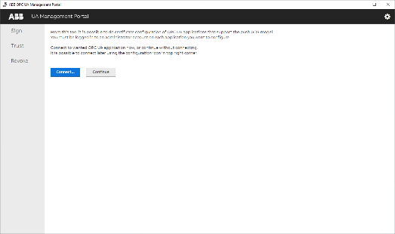  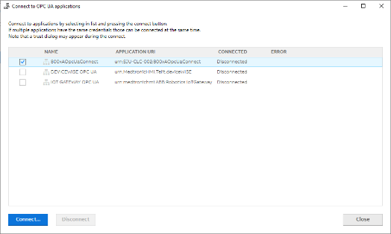
With 800xAOpcUaConnect selected, click Update Application Certificates… to regenerate and align application certificates.
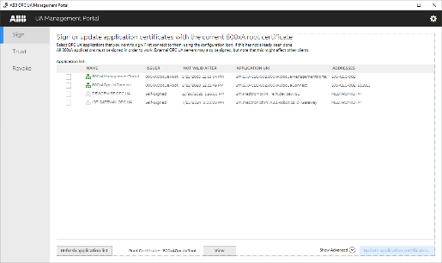
 | Manufacturing Engineer, System Engineer, Process Engineer | Verify that the Issuer for both 800xAManagementPortal and 800xAOpcUaConnect is set to 800xAOPCUARoot.  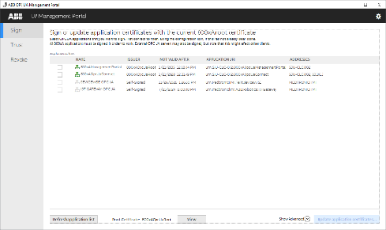
 |  | Proceed to configure deviceWise OPC UA Client Connection within the Compact HMI environment.
 |  | Launch Engineering Workplace from the ABB Workplace Login dialog and select Engineering Workplace → Open
Navigate to: Node Administration Structure → All Nodes → DeviceWISE OPC UA, OPC UA Server Node → DeviceWISE OPC UA, OPC UA Server → OPC UA Server Info Aspect → General tab.
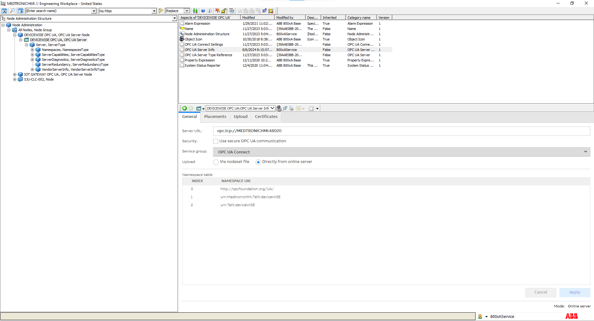
 | Manufacturing Engineer, System Engineer, Process Engineer | Update the Server URL to match the deviceWise OPC UA Server address defined in deviceWise Workbench: opc.tcp://<Computer Name>:<port Number>  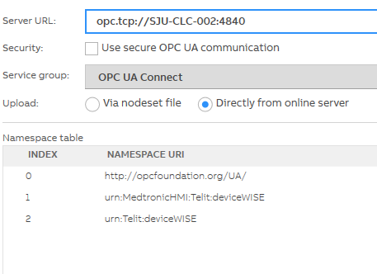  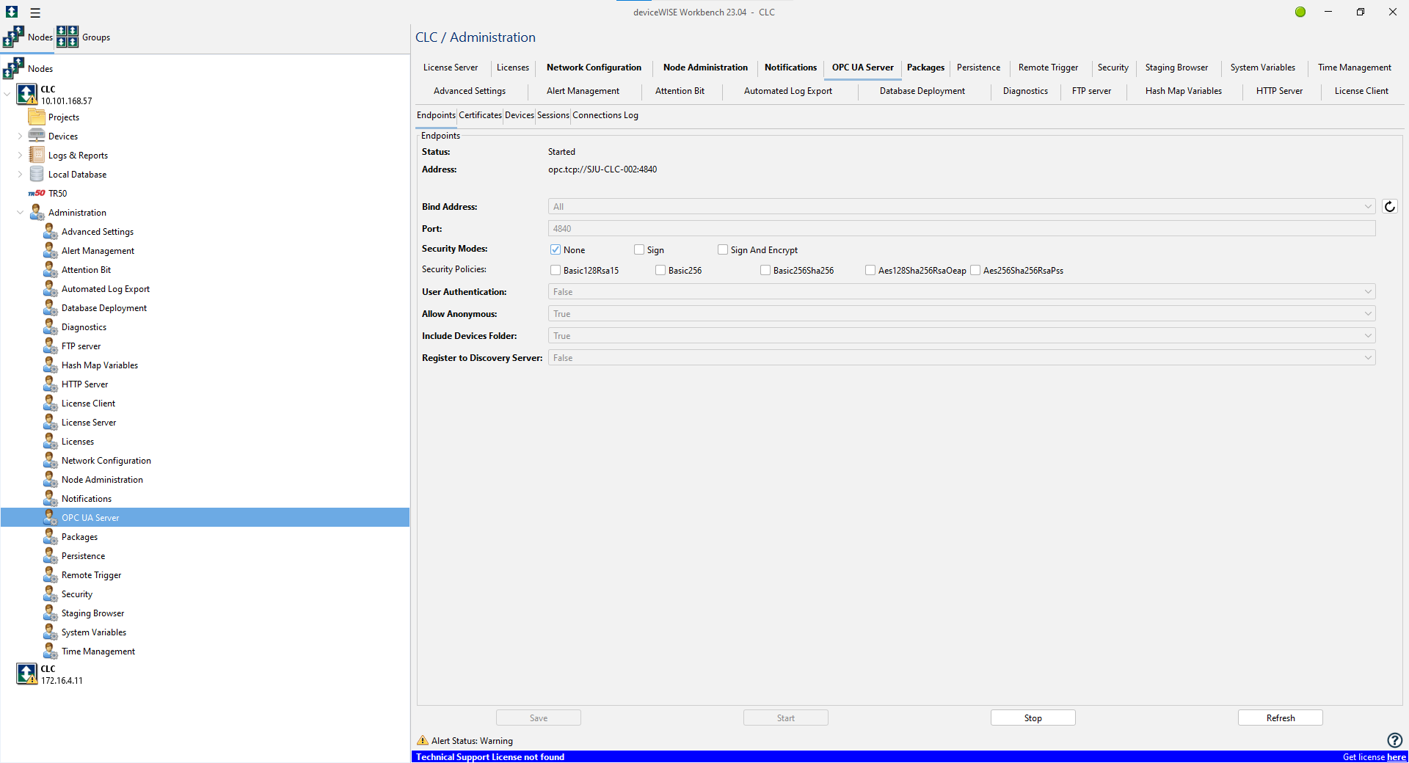  (Reference: deviceWise Workbench → Administration → OPC UA Server → Address).
Remove any undesired or legacy UA node placements by selecting the node and choosing Remove Placement.
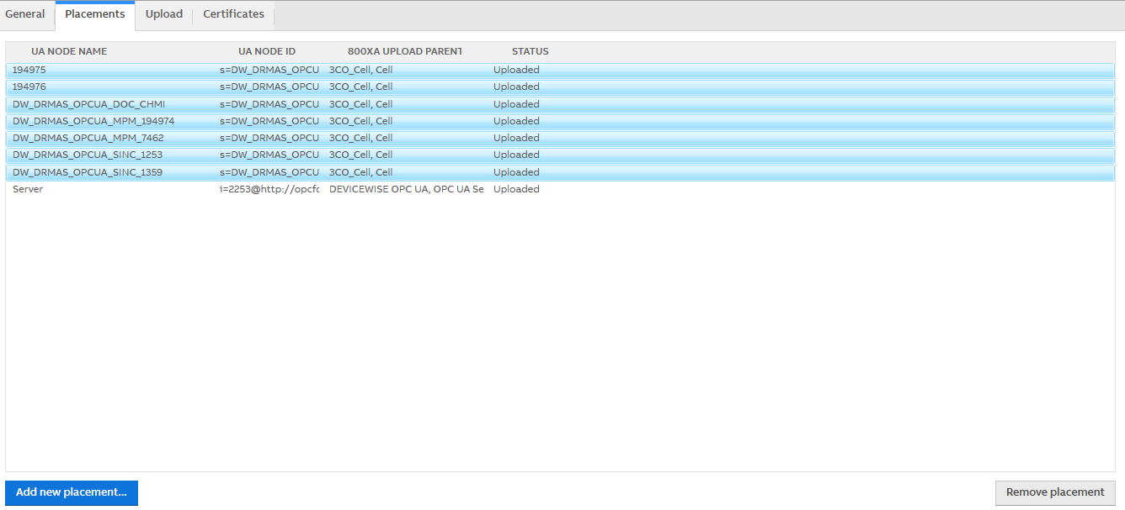
 | Manufacturing Engineer, System Engineer, Process Engineer | Click Add New Placement…, select the required OPC UA placements, click Add Selected Placement, then select OK to validate connectivity  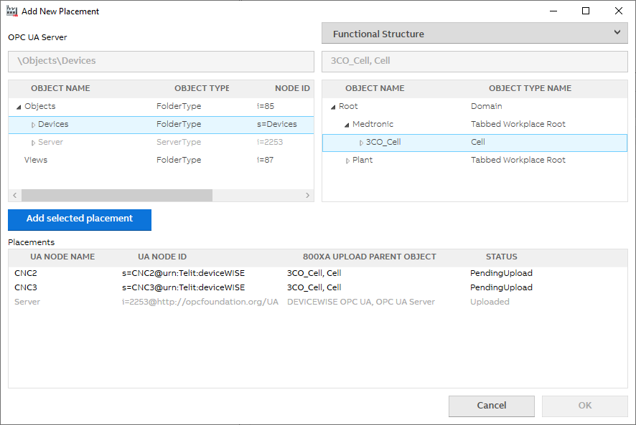
Navigate to the Upload tab and select Upload to 800xA to deploy the OPC UA configuration to the Compact HMI system.
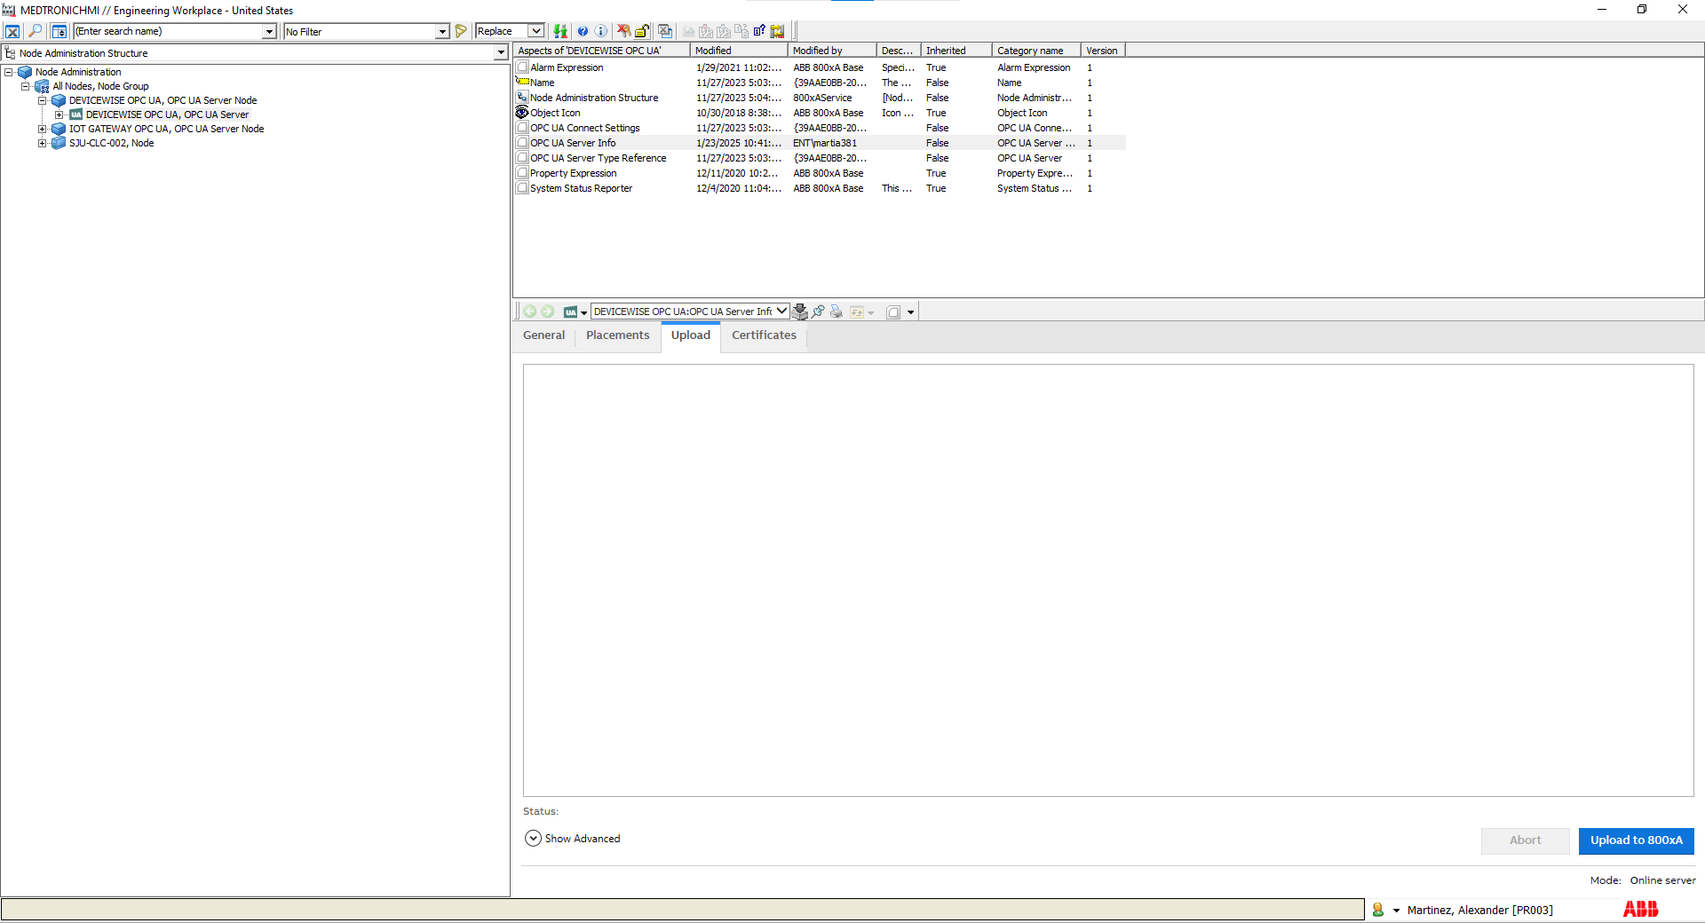
Verify the Node Status indicates Uploaded with no errors.
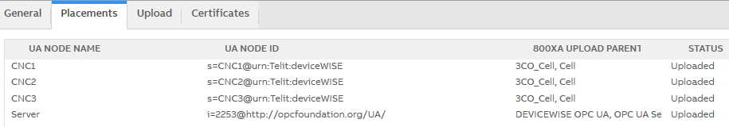
 |  | Navigate to Functional Structure → Medtronic → CNCX_Cell. Confirm a child object named CNC OPC exists. If the uploaded node name differs (named like the uploaded nodes), rename it to OPC for consistency with Medtronic APC standards.
 |  | Stop Point: CHMI / APC UI OPC UA certificate trust and connectivity configuration is complete. Proceed to other solution-specific configuration activities.

Equipment Network Connectivity
Step | Role | Action
 | Manufacturing Engineer, System Engineer, Process Engineer | This section defines the requirements for network connectivity between the APC virtual machine (VM) and CNC equipment required for APC solution execution. Network configuration activities are performed by IT through formal change and ticketing processes.
 |  | Identify the APC VM IP address and the CNC machine IP addresses configured for APC use (e.g., CNC1, CNC2, CNC3), as defined during deviceWise and CNCnetPDM configuration.
 |  | Create an IT firewall exemption rule ticket requesting firewall rule exceptions to allow communication from the APC VM to each CNC IP address using the required CNC communication port. TCP Port: 683. Refer to APC-CLC Systems Network architecture for additional connectivity details.
 |  | Review and implement firewall rule exceptions in accordance with site network security policies, ensuring bidirectional communication where required for CNC connectivity.
 |  | Verify with IT that firewall changes have been implemented and approved. Document the ticket number and approval reference in the configuration records.
 |  | Stop Point: Network connectivity requirements between the APC VM and CNC equipment are approved and implemented. Proceed to other application configurations and/or Configuration Verification activities as applicable.

Other APC Applications Configuration
Step | Role | Action
 | Manufacturing Engineer, System Engineer, Process Engineer | This section defines configuration activities for supporting APC applications that are not hosted on the APC virtual machine (VM) but are required to enable APC configuration, execution, or production use.
 |  | These applications may be installed on engineering workstations, inspection equipment, or production systems depending on the selected APC solution and site deployment model.
 |  | Configuration and verification activities for these applications are performed in alignment with the APC solution requirements and are documented in the applicable configuration checklist.

Import Configuration
Step | Role | Action
 | Manufacturing Engineer, System Engineer, Process Engineer | This section defines the steps required to configure the Import Configuration application for the Closed-Loop Correction (CLC) solution. Configuration is limited to verifying database connectivity and ensuring the application is properly connected to the TimescaleDB (TSDB) instance used by the APC system.
 |  | Navigate to the Import Configuration installation directory on the APC VM (e.g., C:\Medtronic\Import Configuration\).
 |  | Open the Import Configuration configuration file (e.g., ImportConfiguration.exe.config or equivalent XML configuration file).
 |  | Locate the <appSettings> section of the configuration file.
 |  | Verify that the database connection parameters are correctly configured to connect to the TimescaleDB (TSDB) instance using the appropriate database account. Ensure the database server, port, and database name correspond to the deployed APC system configuration. Do not modify these values unless instructed by the APC Team.
 |  | Save the configuration file after verification and required updates have been completed.
 |  | Launch the Import Configuration application and verify that the application starts without errors.
 |  | Confirm that the Import Configuration application successfully connects to the TimescaleDB (TSDB) database.
 |  | Stop Point: Import Configuration setup is complete. Proceed to APC System Execution (D01552864) to perform engineering execution activities, including PCW, CCW, and DOCW development, import, deployment, and verification.

Measurement UI
Step | Role | Action
 | Manufacturing Engineer, System Engineer, Process Engineer | This section defines the steps required to configure the Measurement UI application for integration with the APC Closed-Loop Correction (CLC) solution. These steps shall be performed for each measurement system (e.g., CMM, CTSCAN) that will connect to and participate in the APC-CLC solution. Configuration includes measurement system identification and workstation-to-OPC UA endpoint mapping. Process-specific inspection logic and execution behavior are excluded from this section.
Launch the Measurement UI application on the target inspection workstation. Confirm that the application opens without errors.
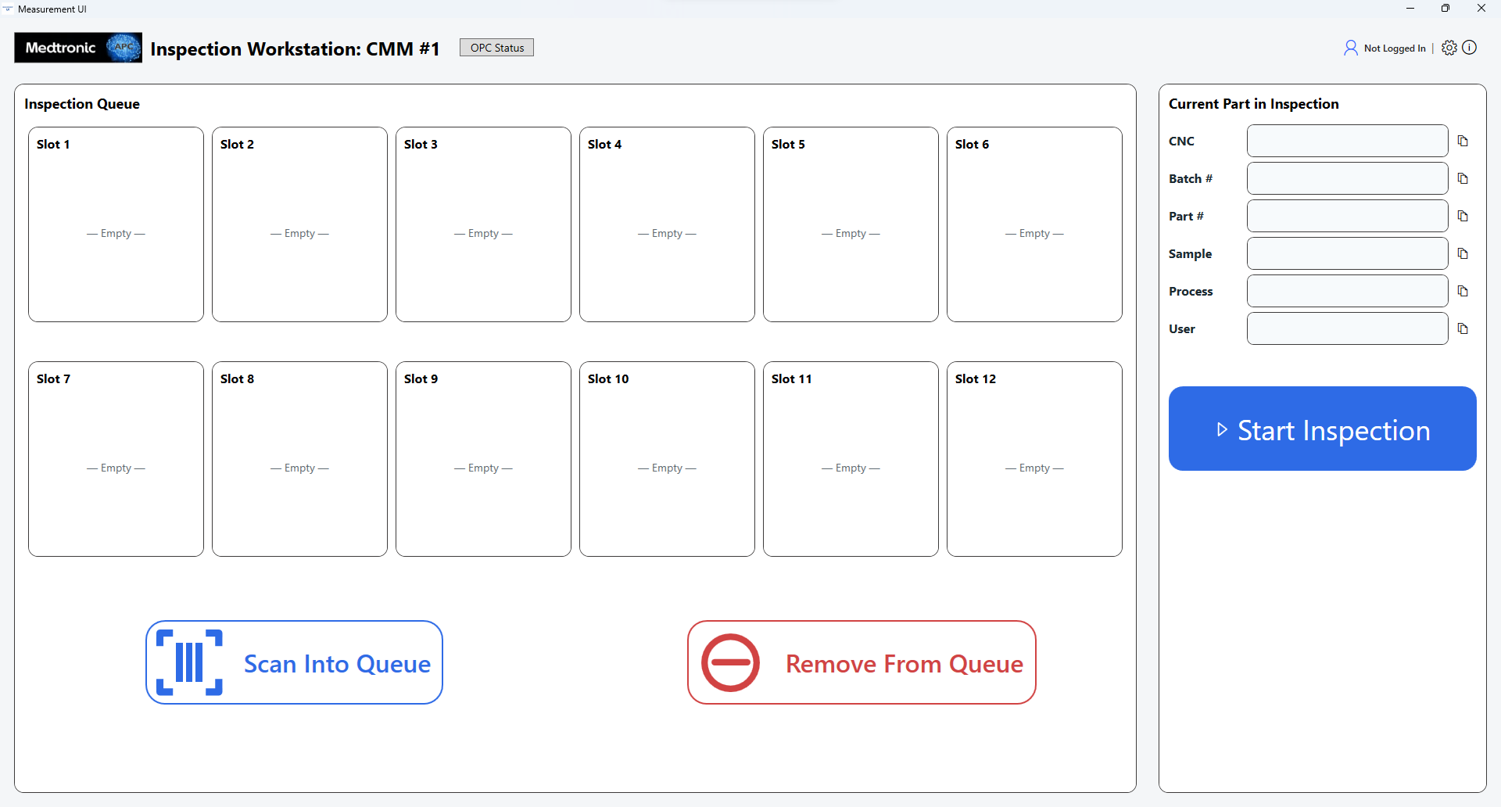
Navigate to Settings → Manage Measurement System and configure the following fields:
- Measurement System Name – Enter a unique, descriptive name for the inspection equipment (e.g., CMM #1). This name is used for identification and traceability within the APC solution.
- Measurement System Type – Select the appropriate system type (e.g., CMM, CTSCAN, CONTRACER). This field categorizes the inspection equipment and supports standardized handling within APC workflows.
- Aging (minutes) – Enter the aging threshold used to promote parts that have been waiting beyond the defined time limit. The value is defined per site or process requirements.
Select OK to save the measurement system configuration.
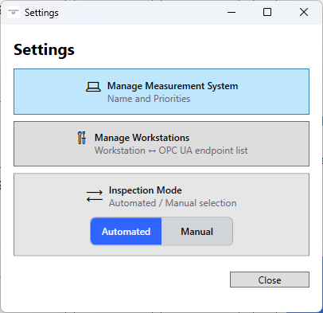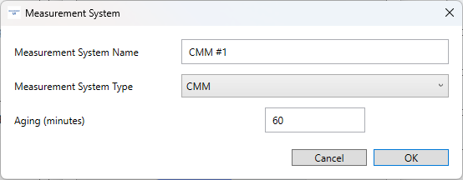
 | Manufacturing Engineer, System Engineer, Process Engineer | Navigate to Settings → Manage Workstations. Select Add to define a workstation-to-OPC UA endpoint mapping for the Measurement UI instance.  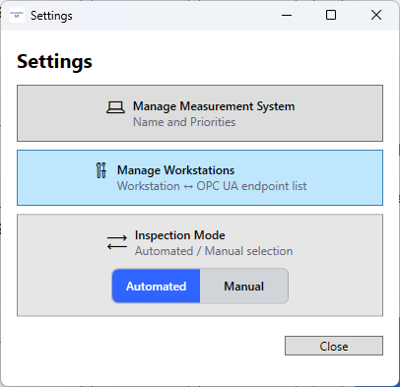
Enter the Workstation Name (e.g., WS-01). Configure the OPC UA Endpoint using the approved deviceWise OPC UA Server address (e.g., opc.tcp://<APC-VM-Hostname>:4840). Each workstation shall map to one OPC UA server exposing CNC tag sets (e.g., CNC1, CNC2, CNC3). Select OK to save the mapping.
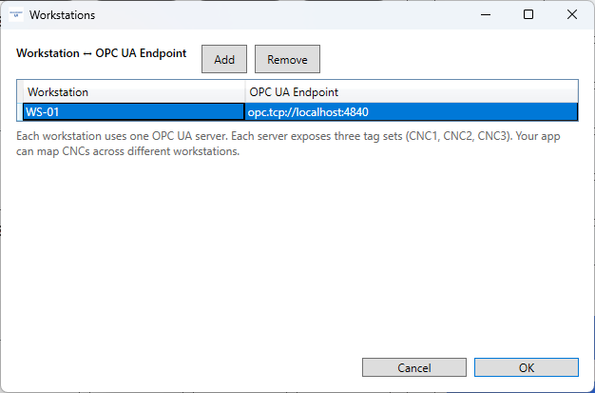
 |  | Verify that the workstation mapping appears in the workstation list and that the configured OPC UA endpoint corresponds to the approved APC deviceWise OPC UA Server for the CLC solution
 |  | Save all configuration changes and close the Settings window.
 |  | Stop Point: Measurement UI configuration is complete for the identified measurement system. Repeat this section for each additional measurement system required for the APC-CLC solution.

APC System Backup and Restore
Step | Role | Action
 | Manufacturing Engineer, System Engineer, Process Engineer | This section defines the requirements for performing backup and restore activities for the APC system to ensure system recoverability, configuration integrity, and controlled recovery following failures, system updates, or approved change activities.
 |  | APC system backup and restore activities shall be performed in accordance with APC System Change Management (D01458108) and documented using the APC System Backup Form (D01555621), when applicable.
 |  | Backup activities are intended to preserve the system state prior to configuration changes, software updates, infrastructure modifications, or corrective actions that may impact APC system functionality.
 |  | Restore activities shall be executed only when required to recover the APC system following approved recovery scenarios.
 |  | Backup and restore activities may include platform-level system images, application configuration backups, and supporting component recovery, depending on the scope of the APC solution and the nature of the recovery activity.
 |  | Perform backup and restore activities in accordance with the applicable subsections below.

Backup Strategy
Step | Role | Action
 | Manufacturing Engineer, System Engineer, Process Engineer | This section defines the backup strategy for the APC system to ensure system recoverability, configuration integrity, and compliance prior to configuration changes, system updates, or corrective actions.
 |  | APC system backups shall be performed only in conjunction with the APC System Backup Form (D01555621) and in accordance with APC System Change Management (D01458108), when applicable.
 |  | The Backup Form serves as the authoritative record documenting what components included, storage location, verification status, and associated change record (if applicable).
Backups shall be performed after to any of the following activities:
- Initial APC configuration completion
- Configuration updates or corrections
- CHMI / APC UI updates
- APC platform or application updates
 |  | Backup scope may include platform-level backups, application configuration backups, and supporting data components, as defined by the selected APC solution and documented in the Backup Form.
 |  | Backup execution, verification, and approval shall be completed prior to proceeding with update, or execution activities.

Platform-Level Backup
Step | Role | Action
 | Manufacturing Engineer, System Engineer, Process Engineer | Platform-level backup consists of creating a full virtual machine (VM) image or snapshot to preserve the complete APC system state, including operating system, installed software, and base configurations.
 |  | Platform-level backups shall be performed in accordance with the site-approved system image backup procedure and local IT infrastructure standards.
 |  | Platform-level backups are suggested for new APC installations and for changes that may impact multiple APC components or overall system stability.
 |  | Document the platform-level backup details using the APC System Backup Form (D01555621) and ensure alignment with APC System Change Management (D01458108), when applicable.

Application Configuration Backups
Step | Role | Action
 | Manufacturing Engineer, System Engineer, Process Engineer | This section defines the requirements for performing backups of APC application configurations on the approved APC virtual machine (VM). Application configuration backups preserve system configuration files, application settings, communication parameters, and supporting resources required to restore the APC system following system recovery, infrastructure replacement, or approved change activities.
Verify that all APC application components requiring configuration backup are identified. These components include, but are not limited to:
- deviceWise configuration projects and network settings
- Dynamic Offset Calculation (DOC) instances and configuration files
- Data Collection and Analytics components (File Manager, Data Collector, Data Analyzer)
- CNCnetPDM machine communication configuration files
- CHMI / APC UI system configuration.
 |  | Perform application configuration backup activities in accordance with the applicable subsections below based on the installed APC solution components and deployed system configuration.
 |  | Upon completion of all applicable application configuration backups, store the generated backup files in the site-approved backup location and document the backup details in APC System Backup Form (D01555621) in accordance with APC System Change Management (D01458108) when applicable.

deviceWise
Step | Role | Action
 | Manufacturing Engineer, System Engineer, Process Engineer | This section defines the steps required to back up the deviceWise application configuration (projects and applicable network settings) on the APC virtual machine (VM). deviceWise backups provide a recoverable baseline to support restoration, troubleshooting, and approved change activities.
Log in to the APC virtual machine using an authorized engineering or service account. Launch the deviceWise Workbench on the APC VM.
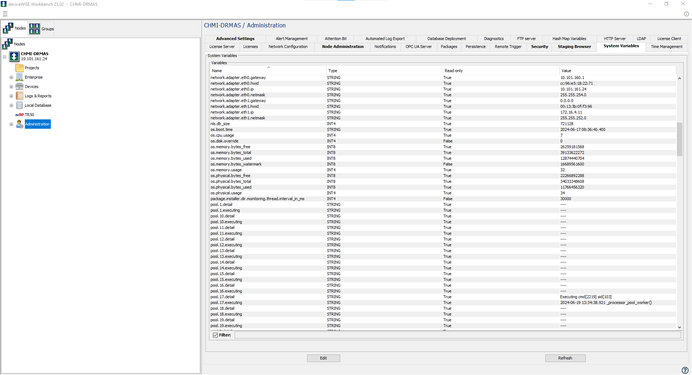
 |  | Navigate to the Projects view and identify the approved deviceWise project to be backed up.
Right-click the desired project and select Backup.
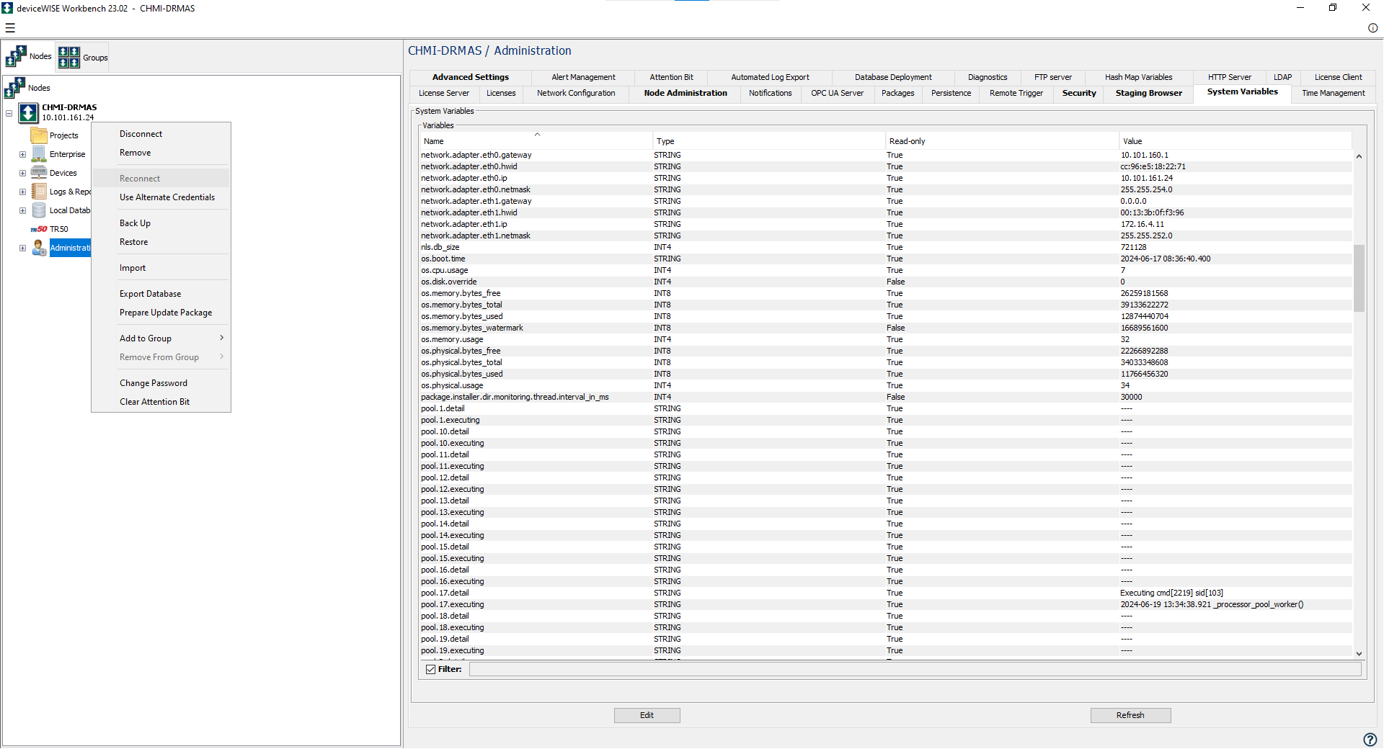
When prompted, select Yes to include Network Settings in the backup.
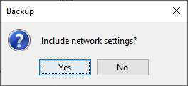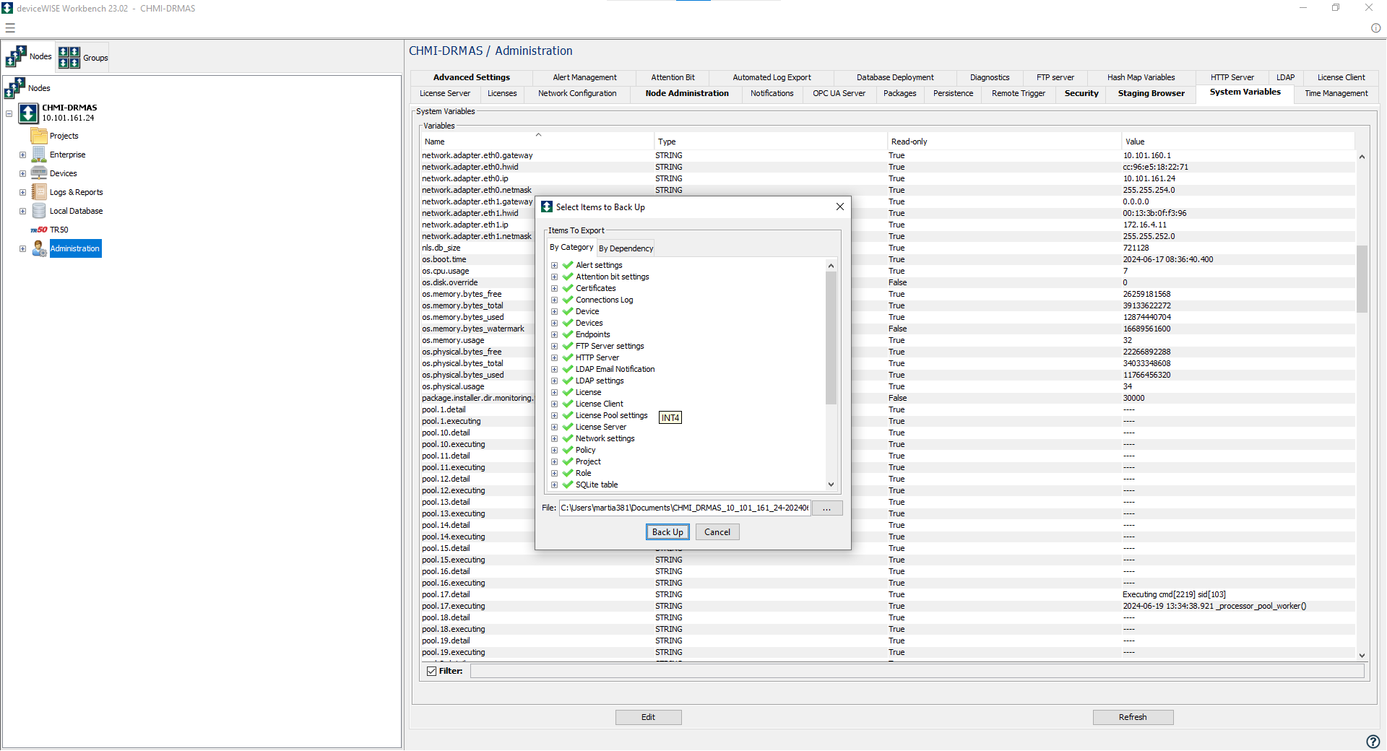
 | Manufacturing Engineer, System Engineer, Process Engineer | Allow the backup process to complete and verify that the system indicates Backup completed successfully.  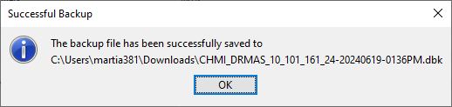
 |  | Store the generated backup file in the site-approved backup location and document the backup details in the APC System Backup Form (D01555621). Backup activities shall be performed in accordance with the APC System Change Management (D01458108), when applicable.

DOC, Data Collection and Analytics Components
Step | Role | Action
 | Manufacturing Engineer, System Engineer, Process Engineer | This section defines the steps required to back up Dynamic Offset Calculation (DOC), Data Collection, and Data Analytics application configurations on the APC virtual machine (VM). This backup preserves all application instances, configuration files, plugins, and supporting resources required for system recovery or approved change activities.
 |  | Log in to the APC virtual machine using an authorized engineering or service account.
 |  | Navigate to the C:\ drive and locate the Medtronic directory that contains all DOC instances, data collection components, analytics plugins, configuration files, and supporting resources.
 |  | Copy the entire Medtronic folder, ensuring all subfolders and files are included (e.g., DOC 1, DOC 2, DOC 3 instances and Data Collection and Analytics Components configuration files).
 |  | Store the generated backup file in the site-approved backup location and document the backup details in the APC System Backup Form (D01555621). Backup activities shall be performed in accordance with APC System Change Management (D01458108), when applicable.

CNCnetPDM
Step | Role | Action
 | Manufacturing Engineer, System Engineer, Process Engineer | This section defines the steps required to back up CNCnetPDM application configuration files on the APC virtual machine (VM). This backup preserves machine communication settings, driver configurations, and supporting files required to restore CNC connectivity.
 |  | Log in to the APC virtual machine using an authorized engineering or service account.
 |  | Navigate to the C:\ drive and locate the CNCnetPDM installation directory (e.g., C:\CNCnetPDM)
 |  | Copy the entire CNCnetPDM folder, ensuring all configuration files, driver DLLs, initialization files (e.g., .ini files), and supporting subdirectories are included.
 |  | Store the generated backup file in the site-approved backup location and document the backup details in the APC System Backup Form (D01555621). Backup activities shall be performed in accordance with APC System Change Management (D01458108), when applicable.

CHMI / APC UI Full System Backup
Step | Role | Action
 | Manufacturing Engineer, System Engineer, Process Engineer | This section defines the steps required to perform a full Compact HMI (CHMI) / APC UI system backup using the Engineering Workplace backup functionality. This backup captures the complete System 800xA system state required for full restoration.
 |  | Log in to the APC virtual machine using a System Administrator or approved 800xA service account.
 |  | Launch Engineering Workplace from: ABB Start Menu → ABB System 800xA → System → Workplace
 |  | In Engineering Workplace, navigate to the Maintenance Structure.
 |  | Expand Object Backup Definitions and select the Backup Definition aspect.
 |  | In the Backup Definition aspect, select the Full Backup option.
 |  | Navigate to the Summary and Start Backup tab.
 | Manufacturing Engineer, System Engineer, Process Engineer | When prompted, select OK to confirm and begin the backup process. Monitor the backup status as progress is displayed within the Engineering Workplace interface.
 |  | Verify that the backup process completes successfully and that the status indicates Backup process completed successfully.
 |  | Store the generated backup file in the site-approved backup location and document the backup details in the APC System Backup Form (D01555621). Backup activities shall be performed in accordance with APC System Change Management (D01458108), when applicable.

Backup Storage and Documentation
Step | Role | Action
 | Manufacturing Engineer, System Engineer, Process Engineer | This section defines the storage and documentation requirements for APC system backups to ensure traceability, controlled storage, and recoverability across sites.
 |  | APC system backups shall be stored in a site-approved secure backup location with controlled access in accordance with applicable site IT procedures and data retention policies. Local workstation or APC virtual machine (VM) storage shall not be used as the sole backup location.
 |  | Backup storage structure, naming conventions, and repository management shall be defined and maintained in accordance with site-specific backup procedures or IT-managed backup practices.
 |  | Complete the APC System Backup Form (D01555621) for each backup event per APC VM, documenting all components included in the backup. The form shall reference the exact storage location and backup identifier or storage path used within the approved backup location. Backup activities shall be performed in accordance with APC System Change Management (D01458108) when applicable.
 |  | If a later update impacts only a subset of components (e.g., deviceWise configuration only), complete a new Backup Form documenting the updated component(s) and associated backup location.

Restore Strategy
Step | Role | Action
 | Manufacturing Engineer, System Engineer, Process Engineer | This section defines the restore strategy for the APC system to ensure controlled recovery of system functionality following system failures, data loss, corrective actions, or approved rollback activities.
 |  | APC system restores shall be performed only in conjunction with an approved APC System Backup and in accordance with APC System Change Management (D01458108), when applicable.
 |  | Restore activities shall be initiated only after confirming that the selected backup corresponds to the correct APC VM, APC system version, and APC solution configuration being recovered.
Restore activities may be performed for any of the following scenarios:
- System failure or corruption
- Rollback following unsuccessful configuration or update
- Recovery after infrastructure or application issues
 |  | Restore scope may include platform-level restores, application configuration restores, and supporting data/component restores, as defined by the selected APC solution and documented in the applicable restore activity records.
 |  | All restore activities shall be followed by appropriate verification and documentation in accordance with APC System Change Management (D01458108). Verification activities may include configuration verification, functional checks, and/or execution readiness assessments, as applicable to the scope of the restore. The APC system shall not be returned to engineering or production use until all required verification activities have been completed and formal approval has been obtained in alignment with the defined APC lifecycle governance.

Platform-Level Restore
Step | Role | Action
 | Manufacturing Engineer, System Engineer, Process Engineer | This section defines the steps required to restore the APC system using a platform-level virtual machine (VM) system image.
 | Manufacturing Engineer, System Engineer, Process Engineer | Identify and gather the approved system image backup files to be restored from the approved site-controlled backup location, and correspond to the approved APC solution release baseline.
 |  | Verify that the selected system image backup corresponds to the correct APC VM being recovered, including VM name, site, and solution context.
 |  | Log in to the target VM using Administrator credentials.
 |  | Restore the VM system image in accordance with the site-approved system image restore procedure and local IT infrastructure standards.
 |  | Monitor the restore process until completion and confirm that the restore operation completes without errors.
 |  | Verify successful system image restore by confirming VM availability, operating system startup, and accessibility of the APC environment
 |  | Stop Point: Platform-level restore is complete. Ensure all restore activities, verification results, and system disposition are documented and aligned with APC System Change Management (D01458108) prior to proceeding with configuration verification or system execution.

Application Configuration Restore
Step | Role | Action
 | Manufacturing Engineer, System Engineer, Process Engineer | This section defines the general approach for restoring application-level configurations for APC system components following a failure, rollback, migration, or approved corrective action.
 |  | Confirm that the appropriate application configuration backups are available and correspond to the APC system version, solution type, and deployment context being restored.
 |  | Verify that any prerequisite platform services, system licenses, and base software installations required by the application are present and operational prior to restoration.
 |  | Restore application configurations using the component-specific restore procedures defined in Sections 4.2.2.1 through 4.2.2.3, as applicable to the APC solution.
 | Manufacturing Engineer, System Engineer, Process Engineer | Ensure all restoration activities align with APC System Change Management (D01458108) and that the restored system state is suitable for subsequent configuration verification or engineering execution activities.

deviceWise
Step | Role | Action
 | Manufacturing Engineer, System Engineer, Process Engineer | This section defines the steps required to restore deviceWise application configuration from an approved backup as part of an APC system recovery.
 |  | Verify that the approved deviceWise project backup files are available on the the approved site-controlled backup location, and correspond to the approved APC solution release baseline.
Launch the deviceWise Workbench on the APC VM.

 |  | In the Workbench, locate the target deviceWise project to be restored.
Right-click the desired project and select Restore.

 |  | Browse to and select the appropriate deviceWise backup file.
When prompted, select Yes to confirm import of the Network configuration.
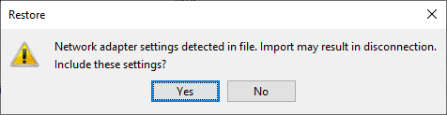
 | Manufacturing Engineer, System Engineer, Process Engineer | Select Restore to initiate the restore operation.  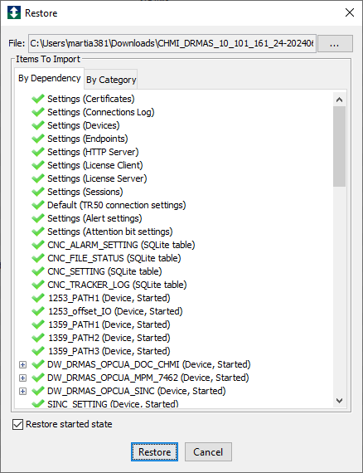
 |  | Monitor the restore process and confirm that it completes without errors.
 |  | Verify that the restored project loads successfully and that expected devices, triggers, variables, and project components are present.
 |  | Stop Point: deviceWise configuration restore is complete. Ensure all restored instances operate as expected and confirm alignment with APC System Change Management (D01458108) before proceeding to additional component restores or configuration verification activities.

DOC, Data Collection and Analytics Components
Step | Role | Action
 | Manufacturing Engineer, System Engineer, Process Engineer | This section defines the steps required to restore Dynamic Offset Calculation (DOC) and associated Data Collection and Analytics components (File Manager, Data Collector, Data Analyzer) from an approved backup.
 |  | Confirm the restore scope, including which DOC instances are required (e.g., DOC 1, DOC 2, DOC 3), based on the configured CNC assets and operator–machine mappings established in deviceWise.
 |  | Verify that the approved Medtronic folder backup files are available on the the approved site-controlled backup location, and correspond to the approved APC solution release baseline.
 |  | Restore the backed-up Medtronic folder by copying the approved backup contents to the target directory, replacing existing files as required. This restores DOC executables, instance folders, configuration files, and supporting analytics components.
 |  | Stop Point: DOC and Data Collection and Analytics component restore is complete. Ensure all restored instances operate as expected and confirm alignment with APC System Change Management (D01458108) before proceeding to additional component restores or configuration verification activities.

CNCnetPDM
Step | Role | Action
 | Manufacturing Engineer, System Engineer, Process Engineer | This section defines the steps required to restore the CNCnetPDM application and machine communication configuration following a system recovery, migration, or approved change to the APC system.
 |  | Verify that the CNCnetPDM backup folder corresponding to the target APC workstation or virtual machine is available on the on the approved site-controlled backup location and matches the intended APC solution baseline and CNC configuration (e.g., CNC1, CNC2, CNC3).
 |  | Log in to the target system using an account with local administrator privileges. Navigate to the CNCnetPDM installation directory (e.g., C:\CNCnetPDM_8.0.0.0).
 |  | Restore the CNCnetPDM application by copying the backed-up CNCnetPDM directory from the backup server to the target system, replacing the existing directory if present.
 |  | Verify that all required configuration files are present, including CNCnetPDM.ini, melcfg.ini, machine-specific configuration files, and CNC driver DLLs (e.g., CitizenM.dll, MitsubishiM.dll). Confirm that machine-specific DLL files are correctly renamed to match the restored Device Nr / Mitsubishi Nr assignments (e.g., citizenm_1068.dll).
 |  | Open CNCnetPDM.ini and melcfg.ini to verify that all restored machine definitions, IP addresses, ports, Device Nr / Mitsubishi Nr mappings, and selected DLL drivers match the approved machine configuration. Launch the CNCnetControl application and confirm CNCnetPDM initializes without errors and establishes communication with all configured CNC machines.
 |  | Stop Point: CNCnetPDM component restore is complete. Ensure all restored instances operate as expected and confirm alignment with APC System Change Management (D01458108) before proceeding to additional component restores or configuration verification activities.

APC UI Full System Restore
Step | Role | Action
 | Manufacturing Engineer, System Engineer, Process Engineer | This section defines the steps required to fully restore a APC UI system using an approved system backup. This restore method is used for APC system recovery.
 |  | Log in to the APC virtual machine using an account with System Administrator privileges. Ensure no active production or engineering activities are in progress prior to restoration. Obtain the APC UI system on the approved site-controlled backup location and correspond to the approved APC solution release baseline.
Launch the Configuration Wizard from:
ABB Start Menu > ABB System 800xA > System > Configuration Wizard
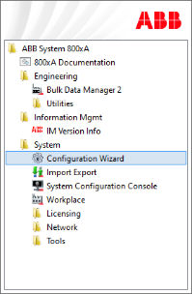
Click OK.
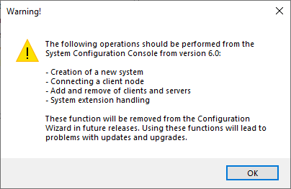
Select System Administration and click Next.
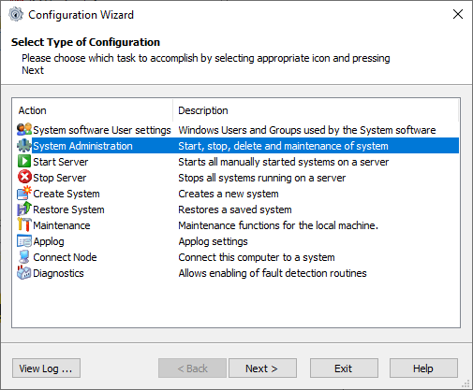
 | Manufacturing Engineer, System Engineer, Process Engineer | Select the system to be stopped and click Next.  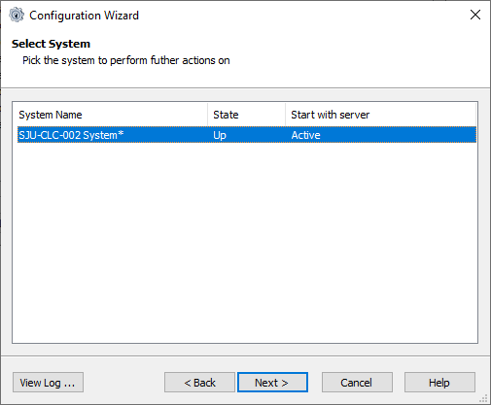
Select Systems and click Next.
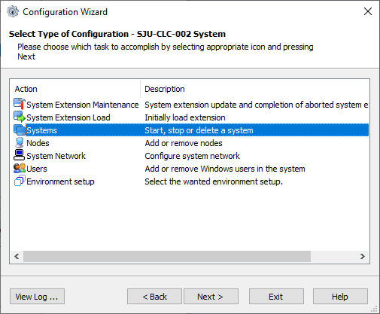
Select Stop, click Next, and then click Finish to stop the system.
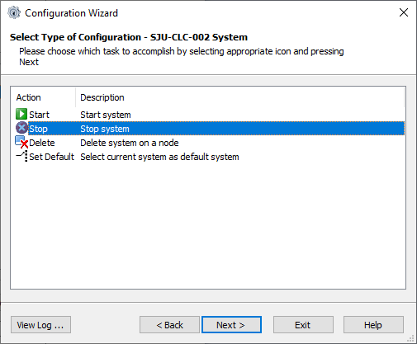
 | Manufacturing Engineer, System Engineer, Process Engineer | In the Configuration Wizard, select System Administration and click Next.  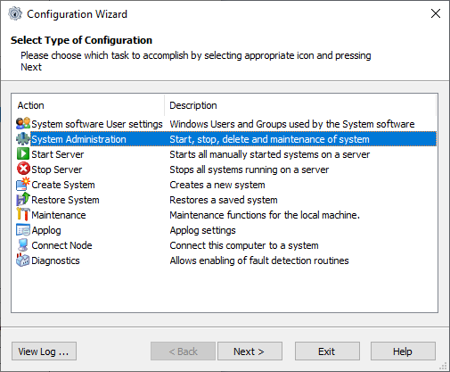
Select the system to be deleted and click Next.
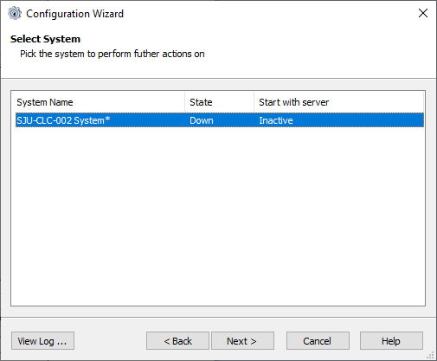
Select Systems and click Next.
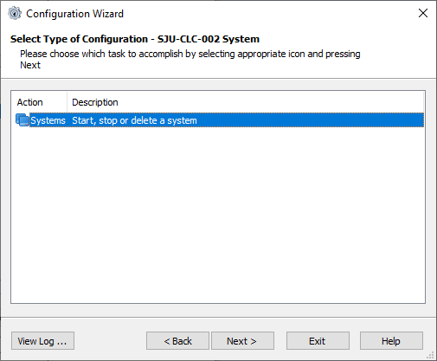
 | Manufacturing Engineer, System Engineer, Process Engineer | Select Delete, click Next, then select the system and click Next to proceed with system deletion.  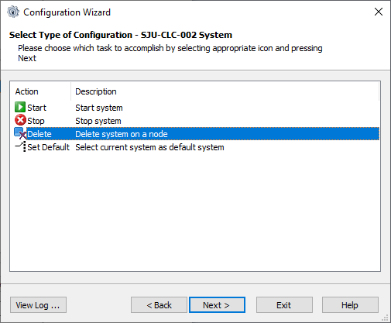
Select the system to be deleted and click Next.
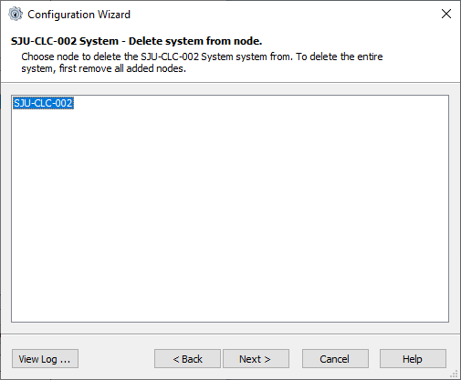
Click Finish in the Apply Settings dialog box to confirm system deletion.
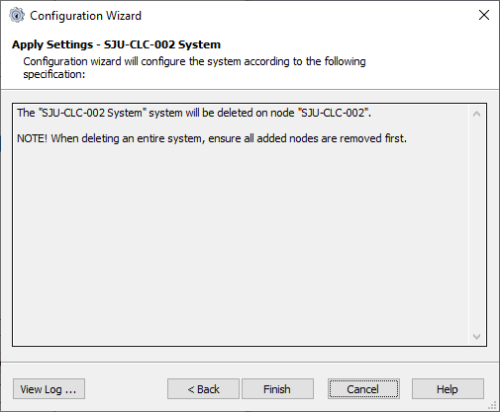
 |  | Wait several minutes for the deletion process to complete. When the Configuration Wizard reappears and the system dialog is displayed, system deletion is complete.
 | Manufacturing Engineer, System Engineer, Process Engineer | Launch the Configuration Wizard from:  ABB Start Menu > ABB System 800xA > System > Configuration Wizard  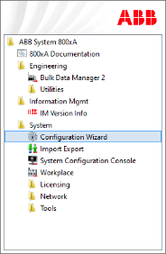
Select OK to proceed.

Select Restore System and click Next.
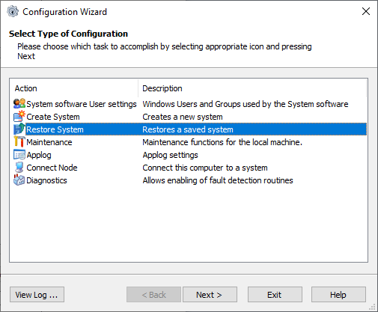
On the Restore Selection screen, select Select Path, choose the backup path created earlier, select the desired backup, and click Next.
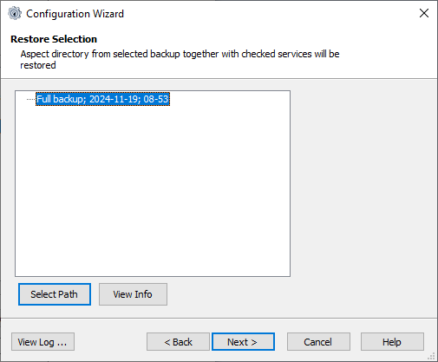
 | Manufacturing Engineer, System Engineer, Process Engineer | On the System Directories Selection screen, select Use the same system ID and click Next.  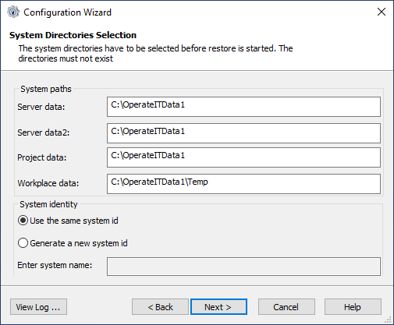
On the Node Configuration screen, rename the first Aspect Server to the last Aspect Server if required. Click Next, then Finish to complete the restore process.
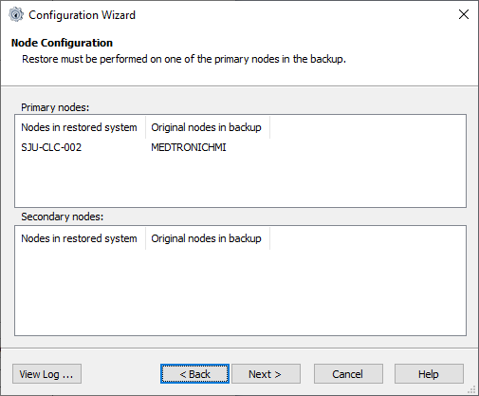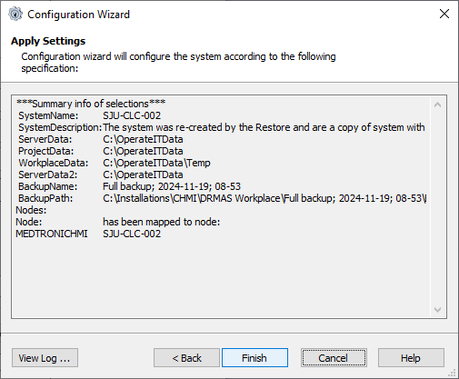
 |  | Once the restore is complete, reboot the APC virtual machine to ensure all services, licenses, and system components initialize correctly.
 |  | After reboot, log in and verify successful CHMI / APC UI restoration by launching Engineering Workplace and confirming system structures, nodes, and core functions are present.
 |  | Stop Point: APC UI component restore is complete. Ensure all restored instances operate as expected and confirm alignment with APC System Change Management (D01458108) before proceeding to additional component restores or configuration verification activities.

Configuration Verification
Step | Role | Action
 | Manufacturing Engineer, System Engineer, Process Engineer | This section defines the steps required to verify completion and correctness of APC system configuration activities prior to engineering execution or production use.
 |  | Confirm that all configuration activities defined in the applicable APC Configuration Procedure have been completed for the selected APC solution.
 |  | Verify that configuration aligns with the approved APC solution scope (e.g., CLC), including component integration, asset mapping, and interface readiness.
 |  | Perform configuration verification using the APC Configuration Verification Checklist, completing all applicable sections.
 |  | Identify, document, and resolve any configuration gaps, deviations, or issues prior to system progression.
 |  | Stop Point: Configuration Verification is complete. Proceed to APC System Execution (D01552864) to perform engineering execution activities, including PCW, CCW, and DOCW development, import, deployment, and verification.

APC System Update and Import Management
Step | Role | Action
 | Manufacturing Engineer, System Engineer, Process Engineer | This section defines the steps required to update an existing Compact HMI (CHMI) / APC UI system instance on an APC virtual machine (VM). Updates may be required due to APC platform changes, solution enhancements, licensing updates, or corrective actions. All updates shall be performed in accordance with approved APC Change Management and system backup requirements.
 |  | Confirm that a verified and restorable APC system backup exists prior to performing any update activities.
 |  | Gather the approved CHMI / APC UI update files to be imported from the approved APC repository (\\MSPM7AAPPS0342.cfrf.medtronic.com\Shared\APC\Deployment Resources). Verify that the files correspond to the approved APC system version.
 |  | Launch the ABB Start Menu on the APC VM.
Navigate to ABB System 800xA → System → Import Export to open the Import/Export utility.
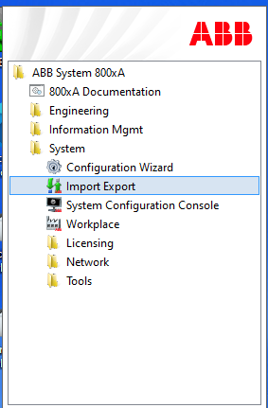
When the Import/Export tool opens, verify the target system context is correct.
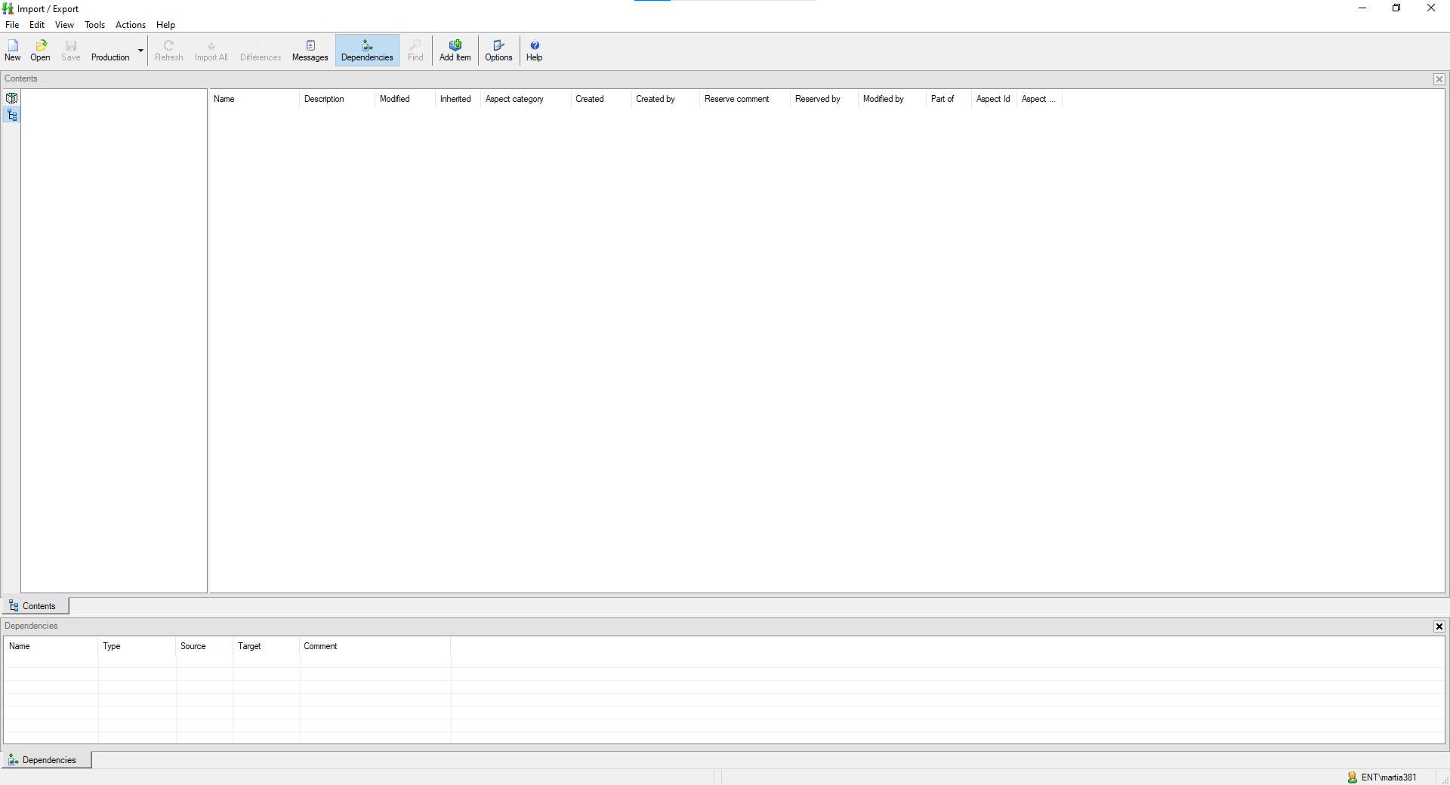
 | Manufacturing Engineer, System Engineer, Process Engineer | Select Import and browse to the location containing the approved update files
 |  | Select the files or aspects to be imported and confirm selection
 |  | Execute the import operation and monitor progress until completion.
 |  | Verify that the import completes without errors and that all expected aspects are present in the system structure.
 |  | Stop Point: CHMI / APC UI update and import activities are complete. Proceed to document the change in accordance with APC System Change Management (D01458108) and complete the Configuration Verification Checklist to confirm system readiness, as applicable.

References
Number | Title
028-WI216 | Manage Records
D01317961 | APC System Overview
D01555599 | APC System Installation
D01552864 | APC System Execution
D01558131 | APC System Operation
D01558132 | APC System Administration
D01458108 | APC System Change Management

Quality Records
Quality Record | Required Approvals
Asset Configuration Worksheet (ACW) (D01555802) | Refer to APC System Change Management (D01458108)
Configuration Verification Checklist (D01555624)
APC System Backup Form (D01555621)

