Ionospheric Sounder Using Software-Defined Radio

Alex Morris, alexmorrisak@gmail.com
University of Alaska
19 September 2014

This is a work in progress..
Table of Contents
1. Introduction 4
1.1 Introduction 4
1.2 General Features of Digital System 4
1.3 General Features of Analog System 4
II. General Hardware Description 5
2.1 Overview 5
2.2 The Ettus Research USRP 6
2.3 Host Computer 6
2.4 Transceiver 6
2.5 Transmit Antenna 6
2.6 Receive Antennas 7
III. Operation 8
3.1 Software Organization 8
3.2 Transmit Waveform Generation 8
3.3 Receive Signal Processing 8
3.4 Services Available to Client by Server 9
3.5 Files Included in Server 9
IV. Antenna Descriptions 11
1. Receive Antennas 11
2. Transmit Antenna 12
V. Transceiver Description 15
1. Receiver Front End 15
2. Transmitter 16

List of Figures
Figure 1 - General Hardware Overview 5
Figure 2 - Receive Antenna 11
Figure 3 - Receive Antenna Beam Pattern at 1 MHz 12
Figure 4 - Receive Antenna Beam Pattern at 9 MHz 12
Figure 5 - Low Band Transmit Antenna 13
Figure 6 - Low Band Transmit Antenna Vertical Gain vs Frequency 13
Figure 7 - High Band Transmit Antenna 14
Figure 8 - High Band Transmit Antenna Vertical Gain vs Frequency 14

1. Introduction

1.1 Introduction

The following document describes the design and construction of a low-power ionospheric sounder. The system may be divided into two parts: the digital system (USRP and host computer) and the analog system (antenna and transceiver).
The keystone of the instrument is the Ettus Research Universial Software-defined Radio Peripheral (USRP), which generates transmit waveforms, samples the received signals, and generates high time precision digital control signals for T/R switching and scope synchronization. The USRP is controlled by a general-purpose computer (or embedded computer on the USRP unit for the USRP E-series) over data bus. The computer performs software-based processing of the transmit and receive waveforms.
The instrument is completed with a low power transceiver and an inexpensive, low footprint antenna.

1.2 General Features of Digital System

- Operation from DC to 30 MHz
- Coherent integration of multiple pulses
- High range resolution, phase-coded pulse operation
- O- and X-mode discrimination
- 100 MHz 14-bit ADC, +10 dBm full scale input
- 400 MHz 16-bit DAC, +10 dBm full scale output
- Configurable FIR taps for receive filtering

1.3 General Features of Analog System

- One transmit channel with 10 W peak power
- Two receive channels
  - 5th order receive bandpass filter with selectable cutoff frequencies
  - Selectable amplification of 5 dB to 20 dB in 5 dB increments
- “Combination” transmit antenna height less than 50 ft.
- Gain in zenith direction better than -3 dBi for all frequencies 2 MHz to 20 MHz
- 20 ft tall crossed receive antennas
- Mainlobe for both transmit and receive antennas is in zenith direction for all frequencies 1 MHz to 30 MHz

II. General Hardware Description

2.1 Overview

The host computer is either a stand-alone unit or an embedded unit within the USRP device case. For the stand-alone computer, the computer communicates with the USRP via 1 Gbps Ethernet/LAN. For the embedded computer, the computer communicates with the USRP over data bus on the circuit board.
The USRP has three RF connections: one transmit port and two receive ports. The USRP generates HF waveforms directly and sends them to the transceiver via the transmit port. The USRP samples the HF spectrum directly via two receive ports and the transceiver's receiver front end. The USRP also sends control signals to the transceiver over parallel bus to select receive filter response and amplifier gain.
The transceiver amplifies the transmit signal to 10 W peak and sends it to either the lower-band transmit antenna or the upper-band transmit antenna depending on the logic signal provided by the USRP. The transceiver amplifies the two receive waveforms from the two receive antennas, filters them, and passes them on to the USRP.
The transmit antenna is composed of a combination of two antennas – one lower-band antenna and one upper-band antenna. The two antennas are mounted on the same ~50 ft tower/mast and oriented orthogonally so that they do not interfere with one another. The two transmit antennas are never operated simultaneously, so in a sense they may be viewed as a single “combination” antenna. The two receive antennas are mounted on a single ~20 ft tower/mast and oriented orthogonally so that they can sample both components of the incoming circularly-polarized waves.
Host Computer
USRP
Transceiver
1 Gbps Ethernet
RF Coax
RF Coax
Crossed Receive Antennas
Dual-Band Combination Transmit Antenna
Parallel Bus

Figure 1 - General Hardware Overview

2.2 The Ettus Research USRP

The USRP is a “software-defined radio peripheral” that is meant to be a link between the radio frequency spectrum and software-based processing on a general purpose computer. Included in each unit are high-speed ADC's, high-speed DAC's, mixing and sample rate conversion housed on an FPGA, and a large-bandwidth Ethernet connection (or similar data bus for E-series) for passing data samples and control information between the unit and the host computer.
The high-speed ADC's and DAC's are capable of sampling the entire HF spectrum directly. In receiving signals, the requested passband is digitally mixed to baseband in the FPGA's NCO. It is then filtered and downsampled to the user's requested sample rate before being transferred to the host computer over Ethernet.
The transmit signal processing is essentially the same as the receive signal processing but reversed.
The user may request signals of arbitrary bandwidth, with the maximum bandwidth limited by the 1 Gbps Ethernet capacity and the minimum bandwidth limited by the greatest decimation rate achieved by the USRP's FPGA. For 16 bit samples, the maximum bandwidth translates to roughly 25 MHz of continuous bandwidth shared between transmit and receive streams. The smallest bandwidth that may be requested is roughly 200 kHz, as this is the maximum decimation rate achievable by the USRP.
All components in the USRP are referenced to the same master clock signal, and the user has the ability to send “timed commands” to the USRP. This means that transmission, reception, and digital logic signals may be activated at specific and precise times. This makes it possible to operate all radar functions in a time-coherent fashion.
For more information visit the Ettus Research website.

2.3 Host Computer

The host computer is either a stand-alone unit or an embedded computer on the USRP device itself (USRP E-series). The performance demands in this ionospheric sounding are not that terrible; a basic desktop or laptop computer with modest processing power have been found to be suitable.
The computer must have a dedicated 1 Gbps Ethernet link, and for software the computer must run the Linux OS, have the Universal Hardware Driver (UHD) and its dependencies for controlling the USRP, and of course have the ionosonde operational code.

2.4 Transceiver

The transceiver is composed of two transmit amplifiers and two receive bandpass filters and amplifiers.
The transmit signal input for each of the two transmit amplifiers is a 50 ohm +10 dBm signal. The USRP has two transmit output ports, and a software switch determines which output port is active based on the operating frequency. Each transmit amplifier is connected to its own transmit antenna, either the lower-band or upper-band antenna. The low power signal is amplified to 10 W peak power by one of the two amplifiers and the output is connected to the amplifier's antenna.
The receive signals from each of the two receive antennas are fed to the inputs of the receiver front ends via 50 ohm coax. The signals are amplified and bandpass filtered before being fed to the input of the USRP. The receiver front ends have a selectable low-pass cutoff frequency, high-pass cutoff frequency, and gain based on the control signals provided by the USRP over the parallel bus.

2.5 Transmit Antenna
Ionospheric sounding requires operation on long wavelengths and a frequency range spanning several octaves, making it very difficult to achieve an antenna design with reasonable height that performs with decent efficiency, SWR, and vertical gain across the entire operating range. By employing two transmit antennas instead of one, it is much easier to stabilize the performance across the entire operating frequency range. And, since since both transmit antennas may be mounted orthogonally on the same tower or mast, using two antennas instead of one only slightly increases the complexity and cost.
The first of the transmit antennas is a fan-dipole type antenna, with the feed point at the top of the tower/mast at 50 ft. and the legs extending to the ground about 100 ft. to each side (200 ft. total width). According to NEC simultaions, this antenna performs well up to about 7 MHz, above which the gain pattern starts to exhibit significant off-zenith lobes. For operation above 7 MHz, a second antenna is used that has good efficiency and consistent gain pattern up to about 20 MHz. The second antenna is a delta type antenna with apex at the top of the mast, feed-point at the bottom several meters above ground and a resistor at the apex.

2.6 Receive Antennas

The receive antennas do not need the efficiency that the transmit antennas require due to atmospheric noise levels being at the very least 20 dB (and usually over 40 dB) greater than the thermal noise floor. The noise figure of the antenna can be quite large before it makes a significant contribution to the overall noise. Therefore it is acceptable to use an electrically small antenna with poor efficiency but wide bandwidth.
The favored design is a delta type antenna with apex at the top of the mast, feed-point at the bottom several meters above ground and a resistor at the apex. Two identical receive antennas may be mounted orthogonally on the same 20 ft mast.

III. Operation

3.1 Software Organization

The operational code is divided into two parts of a client-server model: the high-level control client and the server which controls the USRP. This helps to make a logical separation between the high-level logic that decides the parameters of sounding such as center frequency, bandwidth, integration time, etc. and the low-level logic that controls the USRP, allocates memory for transmit and receive samples, filters waveforms, etc.
An additional benefit of the client-server model is the future possibility of distributed operation over wide geographic areas using TCP/IP protocol. A single control program client would operate many USRP servers remotely.

3.2 Transmit Waveform Generation

The transmit waveform pulse is based on a simple rectangular pulse or one of several phase-modulated codes requested by the control program. In general, the phase codes are complementary pairs, so there are two waveforms created for a single integration period.
In choosing what pulse code to use, there are a two sets of competing factors: SNR vs first detectable range, and range resolution vs. dispersiveness of the target. A longer pulse transmission yields more transmit energy and ultimately a better SNR of the received signal, but this comes at the expense of having to wait longer between the start of the pulse and being able to receive any possible reflections. Increasing the bandwidth of the pulse (more “chips” for a given transmission interval) yields better nominal range resolution, but for ionospheric sounding a larger bandwidth means more dispersion and range spreading. The server program chooses the transmit pulse length and what pulse code to use based on the first range gate of interest and the minimum (nominal) range resolution.
The basic pulse sample values are oversampled to the desired rate (~500 kHz) and then low-pass filtered. The length of the sample vector is then buffered with zeros to fill the listening interval: During the listening interval after a pulse, zero-valued samples are transmitted until the next pulse samples are transmitted. By having the transmit stream and receive stream operate using a continuous array of samples for the entire integration period rather than stop and start for every pulse, the phase rotations of the NCO's are kept continuous and the phase-coherence between pulses is maintained in simple fashion.
The first of the two vectors of samples (the first phase code in the complementary pair) is then transmitted using the USRP's timed commands. On the next pulse, the second vector of samples is transmitted. This process repeats for the entire integration period.

3.3 Receive Signal Processing

A receive interval lasts for the entire integration period, producing one contiguous array of samples for each of the two antennas.
The first step in the processing is to fold the two arrays of samples A and B that correspond to linearly polarized orthogonal waves into two arrays of samples that correspond to circular polarizations of opposite sense. This is done simply by rotating each sample in vector B by +90 degrees and adding it to the samples of vector A, yielding circular polarization O. Similarly each sample in vector B is rotated by -90 degrees and added to the samples of vector A, producing circular polarization X.
Next, each of the two vectors O and X are divided (collated?) into two sub-arrays corresponding to the first and second code in the pair of phase-modulated pulses, yielding O₀, O₁, X₀, X₁. Each sub-array is re-organized into a range-pulse grid. Moving along one axis of the grid corresponds to moving across pulse number (“slow time dimension”) and moving across the other axis of the grid corresponds to moving across range bin number (“fast time dimension”).
Depending on the transmit frequency, pulse repetition interval, and pre-defined maximum acceptable unambiguous Doppler velocity, range-bins from adjacent pulses will be added together. It is assumed that any Doppler-induced phase shift among the summed range bin neighbors will be insignificant and so returned signals will add constructively. This stage is effectively a boxcar filtering and decimation stage that reduces the slow-time dimension by a factor equal to the number of adjacent pulses that are summed.
Next, the two range-pulse grids are processes in the fast-time dimension by low-pass filtering and decimation. The resulting range-Doppler grids have the same slow-time dimension, but the fast-time dimension is reduced by a factor equal to the decimation rate.
The matched filtering stage (or decoding stage) operates on the range-pulse grids again in the fast-time dimension. The first grid for each polarization is processed by its corresponding pulse code and its complementary grid is processed by the complementary pulse code. After filtering each grid by its respective pulse code, the two complementary grids are summed together.
To do the final summing of the signal power related to all pulses, zero phase shift across the slow time dimension is not assumed. Therefore, the samples across the slow-time dimension in a single range-bin are zero-padded and the FFT is performed, which effectively places any significant sinusoidal power into a single FFT bin. The “DC” component of power (the power that is common to every range bin in a single frequency bin) is calculated and removed from each frequency bin. This helps to remove narrow-band interference from the signal of interest.
The program then simply finds the largest signal power in each range bin. Also, the program finds the Doppler velocity corresponding to that range-Doppler bin. The resulting record is a measure of returned signal power as a function of range, and the Doppler velocity at each range.

3.4 Services Available to Client by Server

EXIT: Disconnect and close message socket.

LISTEN: The server returns a power spectrum of the requested frequency range.

SEND: A sounding (one integration period) is performed according to the requested parameters from the client. Raw data is collected and held in the server program's memory.

PROCESS: The receive signal is processed to create the desired data product: signal power and Doppler velocity as a function of range. This is a separate command from SEND only because it allows for flexibility in future code development. For example, it might be desirable for the client to ask for raw samples and perform processing on the client side. Maybe it is possible for the client to issue a SEND command before the PROCESS command on the previous integration period has returned, allowing the server to collect samples and process samples simultaneously.

GET_DATA: The data product is sent to the client.

3.5 Files Included in Server

main.cpp: Defines main() function, which initializes USRP and performs high-level logic related to communicating with client process. Also includes set_frontend_parms() function, which sets the GPIO state for the particular operating frequency, and choose_pcode() function, which chooses the optimal pulse code modulation to use for the given parameters.

lp_filter.cpp: Defines lp_filter() function, which performs low-pass filtering and decimation of vectors of samples.

matched_filter.cpp: Defines matched_filter() function, which performs decoding of pulse-compressed waveforms.

doppler_process.cpp: Defines doppler_process() function, which converts time-domain range-pulse grid to frequency-domain range-Doppler grid, exposing sinusoids in the data.

transceive.cpp: Defines transceive() function, which sends and receives samples from the USRP in non-blocking fashion. Also operates GPIO pins for T/R gate signal, etc.

utils.cpp: Defines utilities for creating tcpsockets, sending and receiving data, etc.

capture_spectrum.cpp: Defines capture_spectrum() function, which gathers samples from the USRP, performs the FFT multiple times, and averages the absolute value of the data to produce a power spectrum across the desired frequencies.

IV. Antenna Descriptions

1. Receive Antennas

There is a fundamental trade-off in antenna design between size, efficiency, and bandwidth. The goal of this design is to minimize the size of the antenna yet still achieve some minimum acceptable level of performance.
Atmospheric noise in the HF spectrum is 20 dB greater than the thermal noise floor and often exceeds 40 dB greater than the noise floor. Therefore it is acceptable to have relatively poor efficiency (noise factor) since any thermal noise resulting from inefficiency will be insignificant compared to atmospheric noise if it is, say, 10 dB smaller. That gives us a minimum acceptable efficiency of 10% for 20 dB of excess atmospheric noise, 1% efficiency for 30 dB, etc. A conservative estimate is that there is only 40 dB of excess atmospheric noise at 1 MHz and 20 dB of excess thermal noise at 30 MHz. Therefore the efficiency (or mainlobe gain) should be at least about -30 dBi at 1 MHz and -10 dBi at 30 MHz.
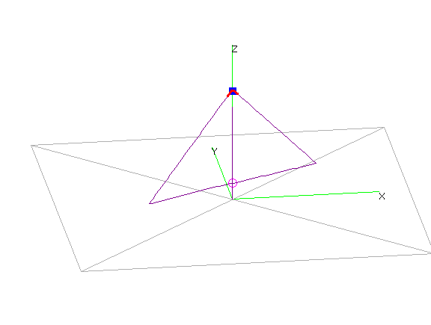
An antenna that (almost!) satisfies these requirements is a 20 foot tall delta-shaped antenna.
Figure 2 - Receive Antenna

The bottom edge of the antenna is 1 meter off the ground and the apex is at a height of 6 meters. The antenna feed-point is at the bottom of the antenna, and the apex is joined with a 600 ohm resistor. A 10:1 balun is suitable to match the feed-point impedance to 50 ohms.
At the low end of the frequency range the antenna shows a very broad beam pattern with peak gain in the zenith direction and poor but tolerable efficiency.

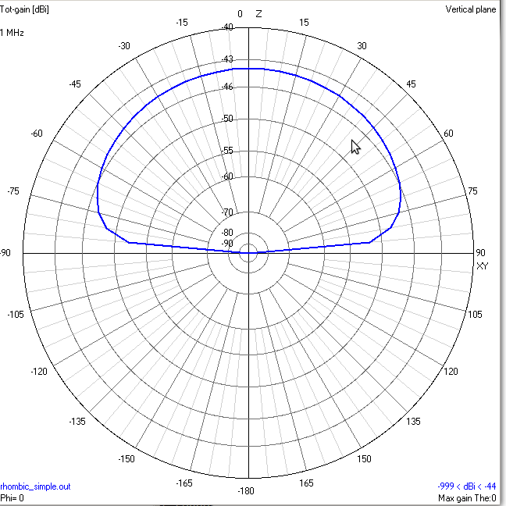
Figure 3 - Receive Antenna Beam Pattern at 1 MHz

As the frequency increases the beampattern narrows and the efficiency increases.

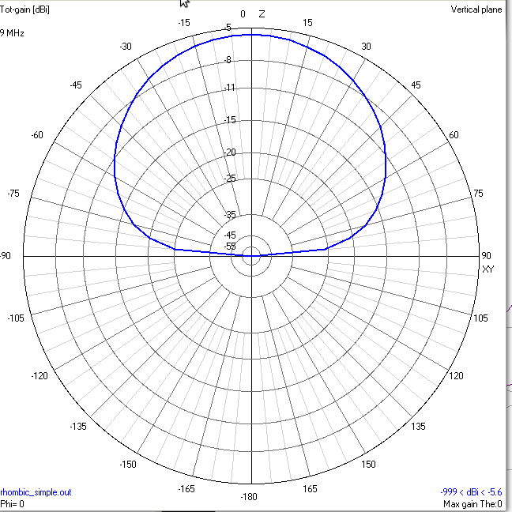
Figure 4 - Receive Antenna Beam Pattern at 9 MHz

The ionosonde system employs two of these antennas in a cross configuration mounted on the same 20 ft mast. The orthogonal orientation allows the antennas to sample both components of circularly-polarized incoming waves.

2. Transmit Antenna

The goal is to minimize the size of the transmit antenna while still achieving the goals of high efficiency, high directivity in the zenith direction, and tolerably low SWR at the antenna feed-point. It has been found that it is extraordinarily difficult to achieve maximum directivity in the zenith direction across the entire operating frequency range with a single small transmit antenna, even though the goals of high efficiency and low SWR can be achieved. The simplest solution is to employ two transmit antennas that have good and flat characteristics across their respective (smaller) frequency ranges. The two antennas can be mounted orthogonally on the same 50 ft antenna tower such that they do not interact with one another and the combined cost of the two antennas is comparable to that of a single antenna.
The low frequency band antenna is a fan-dipole type antenna driven by a 6:1 balun at the apex that handles frequencies from 1 MHz up to 7 MHz. The legs of the antenna are connected to ground through a resistor. It may be good in the future to tweak the lengths of the antenna legs, resistor values, etc. to optimize performance.

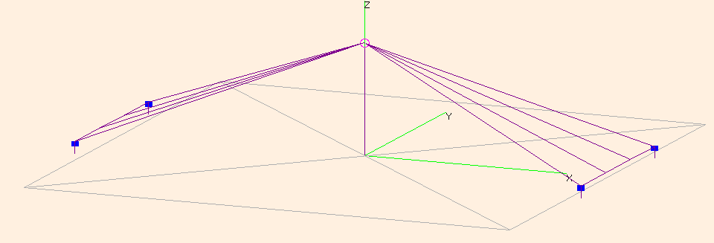
Figure 5 - Low Band Transmit Antenna

According to NEC simulation, the mainlobe of the low band antenna is in the zenith direction from 1 MHz to 7 MHz, and the gain exceeds 0 dBi from 2.5 MHz to 6.5 MHz. The simulated SWR is below 3 from 1 MHz to 7 MHz.
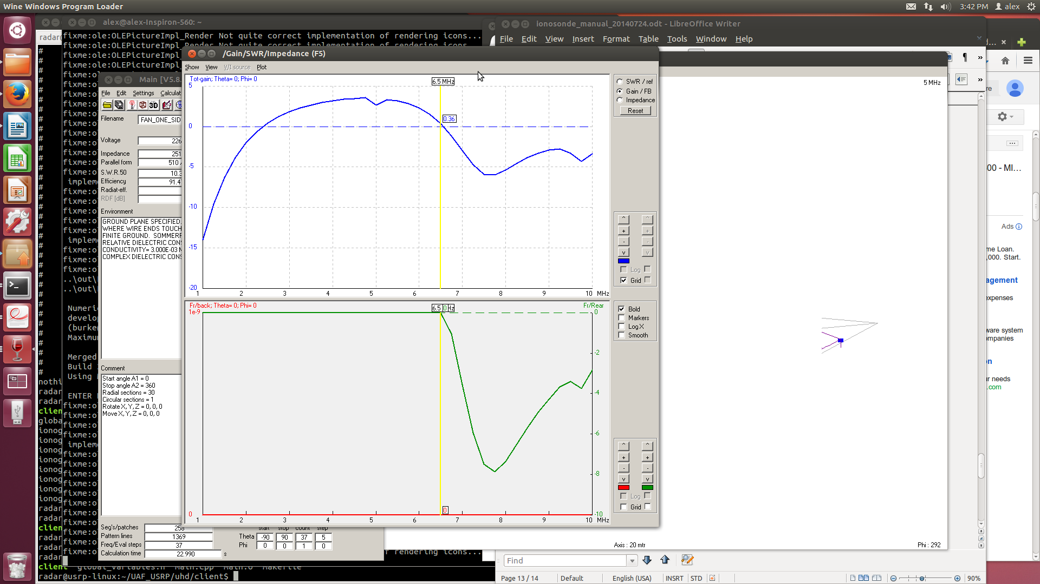
Figure 6 - Low Band Transmit Antenna Vertical Gain vs Frequency

The high frequency band antenna is a delta-shaped antenna that handles frequencies from 7 MHz up to 20 MHz and beyond. The antenna shape is the same as that of the receive antennas but the transmit antenna is larger, and instead of having a 600 ohm resistor at the apex it has a 1000 ohm resistor at the apex.

The simulated performance of the high band antenna complements the low band antenna by providing even gain that exceeds 0 dBi from 8.5 MHz to 20 MHz. The simulated SWR is below 3 from 7 MHz to 20 MHz.
Figure 7 - High Band Transmit Antenna
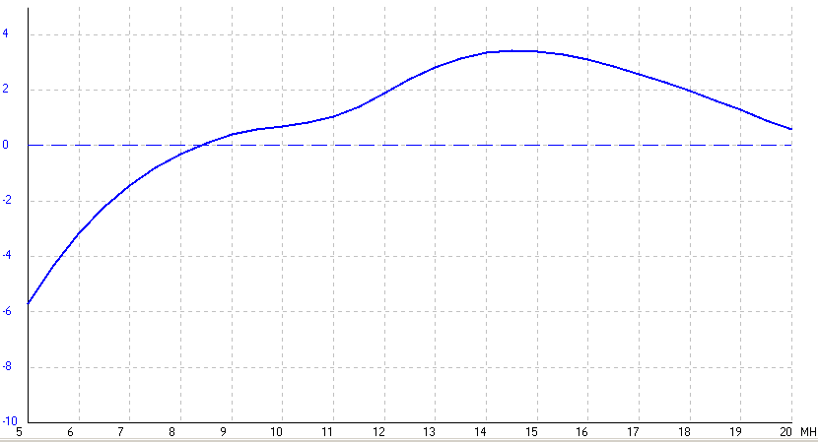
Figure 8 - High Band Transmit Antenna Vertical Gain vs Frequency

V. Transceiver Description

1. Receiver Front End

The goals of the receiver front end are to increase the power of the analog signal to a level that makes the quantization noise power insignificant after digitization, filter signals outside the Nyquist bandwidth to prevent aliasing, and, if necessary, filter strong broadcasters and/or attenuate the incoming signal to prevent saturation of the digitizer.
The USRP N200 has a 14-bit, 100 MHz ADC with full scale input power of +10 dBm. The power of the least significant bit is -74 dBm, and the quantization noise is roughly 10 dB greater than this, or -64 dBm. Considering the sampling rate is 100 MHz, and assuming the input signal is adequately dithered or “whitened”, the quantization noise density is -144 dBm/Hz. The thermal floor is -174 dBm/Hz with atmospheric noise being at least 20 dB greater than this. The actual level of atmospheric noise entering the receiver front end will very greatly depending on actual atmospheric noise (depends on frequency, time, and location) and antenna efficiency (depends on frequency).
So in one case the antenna might be close to 100% efficient and the atmospheric noise might be 40 dB above the noise floor (-134 dBm), which is 10 dB greater than the quantization noise level. No gain is needed to reduce the effects of quantization noise. In another case, the antenna might have only 0.01% efficiency and the atmospheric noise is only 20 dB above the noise floor, meaning the noise floor at the receiver front end is actually determined by thermal noise. In this case 40 dB of gain is needed to make the quantization noise insignificant. This is a very rare case, since the frequencies at which the antenna or least efficient are also the bands where atmospheric noise is most powerful. 30 dB of maximum gain is chosen as a suitable trade-off between minimizing quantization noise and minimization the risk of ADC saturation. NOTE (-9/19/2014): only 20 dB of gain was achieved. The opamp was unstable for larger gains..
To prevent high frequency energy from aliasing into the Nyquist bandwidth (50 MHz for the USRP N200) the default high frequency cutoff is 32 MHz.
The dynamic range of the ADC is limited to a nominal 84 dB. In the event that a strong signal in an adjacent frequency band saturates the ADC, it becomes necessary to attenuate the received signal. This comes at the expense of increased quantization noise after digitization, but at least it might still be possible to detect the signal of interest. The receiver front end has four attenuation settings in steps of 5 dB (0 dB, 5 dB, 10 dB, 15 dB).
It is possible to reduce the risk of saturation by filtering out frequencies that outside the operating frequency. The default high pass cutoff frequency is 1 MHz, so AM broadcast stations in the MF ranges will be attenuated without affecting the sounder's operations above 1 MHz. In the event that a strong signal exists in the sounder's normal operating range (1 MHz to 30 MHz), it is possible to change the LP and HP filter cutoff frequencies to one of four different values. This way when operating on frequencies relatively far from an interferer, it is possible to attenuate the interfering signal and prevent saturation without diminishing the quality of the signal of interest. Available HP cutoff frequencies are 1 MHz (default), 2 MHz, 4 MHz, and 8 MHz. Available LP cutoff frequencies are 32 MHz (default), 16 MHz, 8 MHz, and 4 MHz.
Since separate transmit and receive antennas are used, a transmit/receive switch is unnecessary. However, if large transmit powers are used and the antennas are closely spaced, then significant power may be coupled into the receiver front-end. A SPST PIN diode switch provides an open circuit to incoming signals when the T/R signal is high. It has been tested to handle 5 W input power. Furthermore, the first multiplexer on the receive circuitry is disabled on T/R high, providing more isolation from the transmit signal.

2. Transmitter

There are two transmitters, one for each of the transmit antennas. The inputs of the transmitters are fed by the two TX ports from the USRP. For frequencies below 7 MHz (or whatever the XOVER_FREQ is), the subdev spec is set to “A:A” for daughterboard A, antenna A, and for frequencies above 7 MHz the subdev spec is set to “A:B.”
The transmitters are a two-stage design – the first stage is a class A amplifier and the second stage is a class B push-pull amplifier. Coupling between stages is done with wide-band transformers. The input to the transmitter must be fed with a power of +17 dBm for adequate drive level, so a mini-circuits amplifier is placed between the transmitter and the USRP. The output power of the transmitter is designed for 10 W peak power, although it is capable of 100 W power. (Is this description correct? Jon Klein's transmitter design..)

