Medical Care Platform

DS Assignment 1 – Motioc Alexandru

Database Diagram

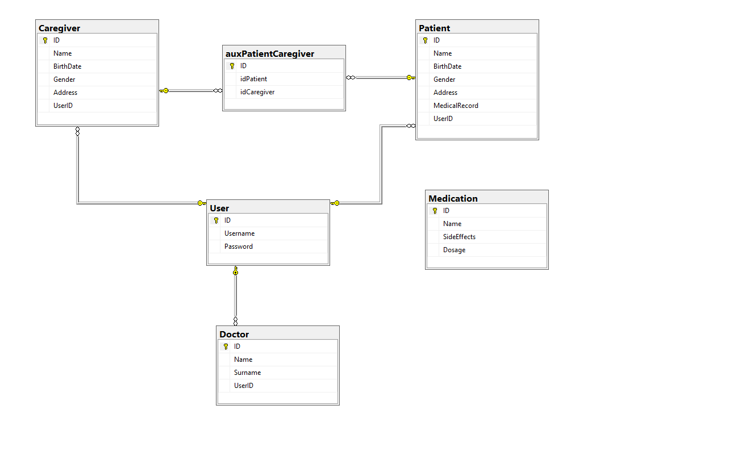

We use a many-to-many relationship between Caregiver and Patient table using an auxiliary table, in order to assign connections between patients and caregivers. A user can have the roles: Patient, caregiver, doctor. It is not excluded that a user can have multiple roles.

Conceptual Architecture Diagram for the Distributed Systems

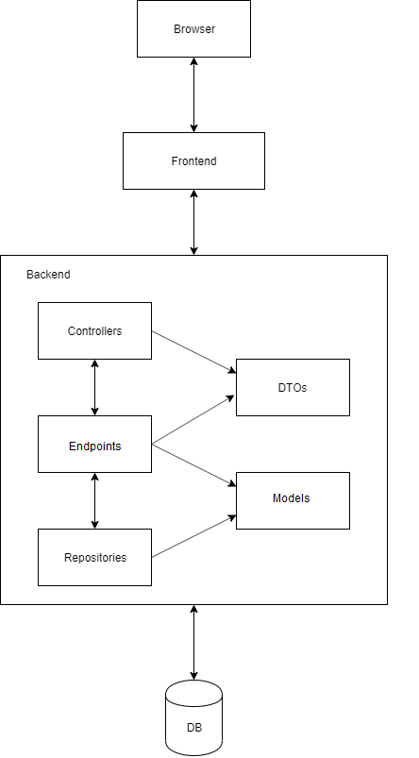

Implementation Diagram

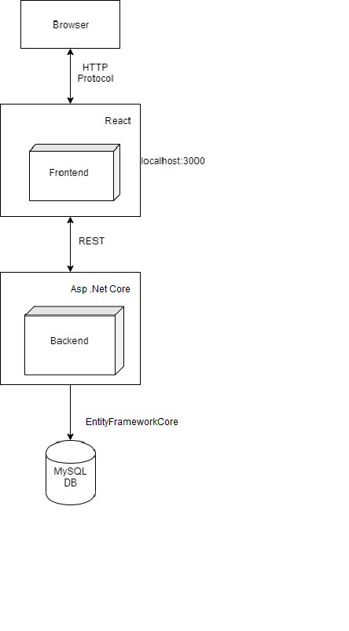

Deployment description

Deploying ASP.NET Core Web Api locally on Internet Information Service (IIS) requires a few steps prepare for deployment environment. First, it is needed to install Dot Net Core Runtime 3.1.5 (Hosting Bundle on Windows) into the local windows server.

Afterwards, Web IIS feature must be enabled on our Windows server. From Windows Server, open Server Manager > IIS > Manage and select “Turn Windows features on or off”.

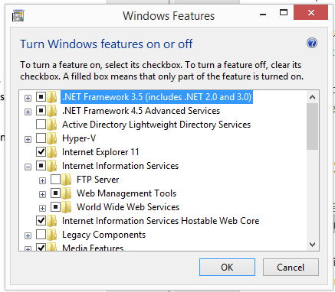

Because we are working with a Dot Net Core application, in order for it to work under IIS we have to create a new application pool.

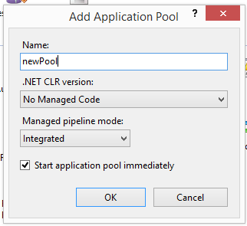

Since we have the application pool ready, now we need to create a new website under IIS Sites. So from the left-side menu of IIS manager, right-click on sites, then choose ‘Add Website’ .

Before proceeding further, we need to publish our Web Api Project in a local folder.

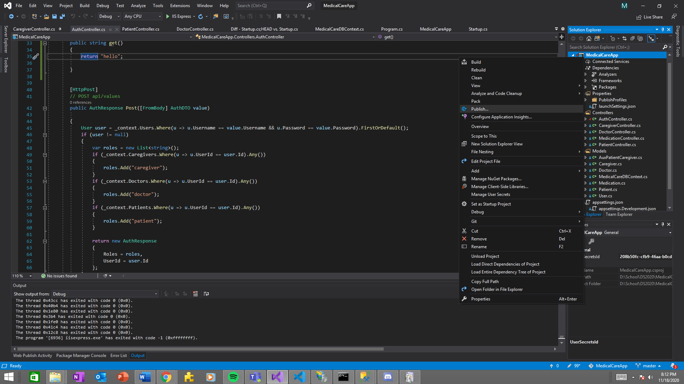

With the following settings for the target framework and runtime, continue by clicking Publish.

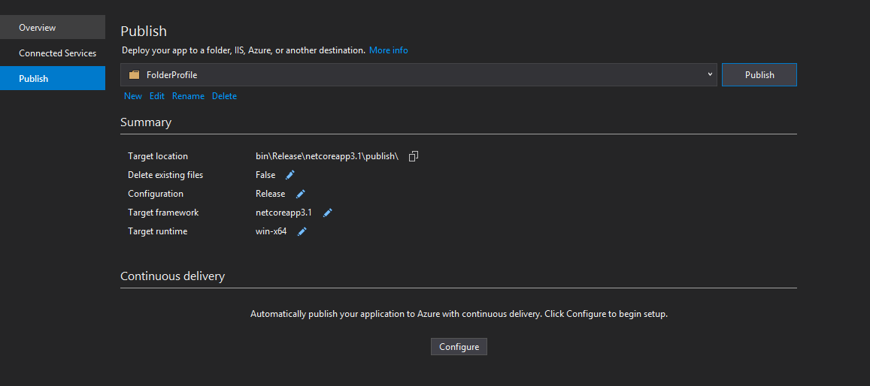

Set the physical path in the new IIS website with the target location described in Visual Studio publisher, and Run the IIS website.