Software Design Document

Weather APP
Version 2.0

Prepared by Alexandru Marian Motocu
S.C SWC Solutions S.R.L

26.01.2019
TABLE OF CONTENTS
1. | INTRODUCTION | 3
1.1 | Purpose | 3
1.2 | Scope | 3
1.3 | Reference Material | 3
1.4 | Definitions and Acronyms | 3
2. | SYSTEM OVERVIEW | 3
3. | SYSTEM ARCHITECTURE | 4
4. | DATA DESIGN | 5
4.1 | Data Description | 5
5. | HUMAN INTERFACE DESIGN | 7
5.1 | Overview of User Interface | 7
5.2 | Screen Objects and Actions | 9
6. | REQUIREMENTS MATRIX | 9

- INTRODUCTION

1.1 Purpose

This document provides a description of the technical design for the Weather APP. The purpose of this document will describe the technical details of the APP. This document provides an overview of the different functions of the APP.

1.2 Scope

This document is targeted to technical staff
• Development Team
• Support Staff.

1.3 Reference Material

- https://openweathermap.org/api
- https://kivy.org/#home
- https://www.python.org/about/
- https://technologyadvice.com/blog/information-technology/how-to-use-an-api/

1.4 Definitions and Acronyms

APP – Application
DB – Database
Temp – Temperature
Min – Minimum
Max - Maximum
API - Application Programming Interface

- SYSTEM OVERVIEW

The purpose of this APP is to provide a quick and fast solution to users to check current weather forecast in any location of the world. The goal was to create a single APP that can run on any operating system available today. This way, it is very easy to maintain and improve when there is only one version of the APP available.

- SYSTEM ARCHITECTURE

The backbone of the APP is the python (.py) file. In this file , all the code is written.
Then there is the Kivy language (.kv) file. This file contains the layout for the GUI.

The development of the APP included Python as a programming language and Kivy as a helpful library that can make python programs run on any platform.

Python is an interpreted, object-oriented, high-level programming language with dynamic semantics. Its high-level built in data structures, combined with dynamic typing and dynamic binding, make it very attractive for Rapid Application Development, as well as for use as a scripting or glue language to connect existing components together. Python's simple, easy to learn syntax emphasizes readability and therefore reduces the cost of program maintenance. Python supports modules and packages, which encourages program modularity and code reuse. The Python interpreter and the extensive standard library are available in source or binary form without charge for all major platforms, and can be freely distributed.

Kivy is an open source Python library for developing mobile apps and other multi touch application software with a graphic user interface (GUI). It can run on Android, iOS, Linux, OS X, and Windows.

The framework contains all the elements for building an application such as:
- extensive input support for mouse, keyboard, and OS-specific multitouch events
- a graphic library using only OpenGL ES 2, and based on Vertex Buffer Object and shaders.
- a wide range of widgets that support multitouch
- an intermediate language (Kv) used to easily design custom widgets.

System Specifications:

- IDE: PyCharm
- Operating System: Windows 8.1
- API: https://openweathermap.org/api
- Python v 3.7.2
- Kivy library

The installation of Kivy library should be done following the steps from the following documentation: https://kivy.org/doc/stable/installation/installation-windows.html
The dependencies need to be installed in order for Kivy to run properly. The following dependencies are needed:
- gstreamer for audio and video
- glew and/or angle (3.5 only) for OpenGL
- sdl2 for control and/or OpenGL.
Kivy uses a specific language called KV language.

The KV language (sometimes called kvlang, or kivy language), allows you to create your widget tree in a declarative way and to bind widget properties to each other or to callbacks in a natural manner. It allows for very fast prototyping and agile changes to your UI. It also facilitates a good separation between the logic of your application and its User Interface.
A Kv source constitutes of rules, which are used to describe the content of a Widget, you can have one root rule, and any number of class or template rules.
The root rule is declared by declaring the class of your root widget, without any indentation, followed by : and will be set as the root attribute of the App instance:
Widget:
A class rule, declared by the name of a widget class between < > and followed by :, defines how any instance of that class will be graphically represented:
<MyWidget>:
Rules use indentation for delimitation, as python, indentation should be of four spaces per level, like the python good practice recommendations.
There are three keywords specific to Kv language:
- app: always refers to the instance of your application.
- root: refers to the base widget/template in the current rule
- self: always refer to the current widget
One of aims of the Kivy language is to Separate the concerns of presentation and logic. The presentation (layout) side is addressed by your kv file and the logic by your py file.

The code goes in py files. The layout of the UI goes in kv files.

- DATA DESIGN

4.1 Data Description

- The purpose of this APP is to get weather data using an API and format them in a way that is easy to read and understandable by the user.

- The weather data is available in JSON form. The app must retrieve this data and then parse the data in order to extract what is important.

- The conversion from metric to imperial is also done with specific formulas.

- Typical weather data formats are numbers that represent the temperature values, city ID’s, postal code, as well as strings that represent the city name.

API Response :

{"coord":
{"lon":145.77,"lat":-16.92},
"weather":[{"id":803,"main":"Clouds","description":"broken clouds","icon":"04n"}],
"base":"cmc stations",
"main":{"temp":293.25,"pressure":1019,"humidity":83,"temp_min":289.82,"temp_max":295.37},
"wind":{"speed":5.1,"deg":150},
"clouds":{"all":75},
"rain":{"3h":3},
"dt":1435658272,
"sys":{"type":1,"id":8166,"message":0.0166,"country":"AU","sunrise":1435610796,"sunset":1435650870},
"id":2172797,
"name":"Cairns",
"cod":200}

Parameters:
- coord
  - coord.lon City geo location, longitude
  - coord.lat City geo location, latitude
- weather (more info Weather condition codes)
  - weather.id Weather condition id
  - weather.main Group of weather parameters (Rain, Snow, Extreme etc.)
  - weather.description Weather condition within the group
  - weather.icon Weather icon id
- base Internal parameter
- main
  - main.temp Temperature. Unit Default: Kelvin, Metric: Celsius, Imperial: Fahrenheit.
  - main.pressure Atmospheric pressure (on the sea level, if there is no sea_level or grnd_level data), hPa
  - main.humidity Humidity, %
  - main.temp_min Minimum temperature at the moment. This is deviation from current temp that is possible for large cities and megalopolises geographically expanded (use these parameter optionally). Unit Default: Kelvin, Metric: Celsius, Imperial: Fahrenheit.
  - main.temp_max Maximum temperature at the moment. This is deviation from current temp that is possible for large cities and megalopolises geographically expanded (use these parameter optionally). Unit Default: Kelvin, Metric: Celsius, Imperial: Fahrenheit.
  - main.sea_level Atmospheric pressure on the sea level, hPa
  - main.grnd_level Atmospheric pressure on the ground level, hPa
- wind
  - wind.speed Wind speed. Unit Default: meter/sec, Metric: meter/sec, Imperial: miles/hour.
  - wind.deg Wind direction, degrees (meteorological)
- clouds
  - clouds.all Cloudiness, %
- rain
  - rain.1h Rain volume for the last 1 hour, mm
  - rain.3h Rain volume for the last 3 hours, mm
- snow
  - snow.1h Snow volume for the last 1 hour, mm
  - snow.3h Snow volume for the last 3 hours, mm
- dt Time of data calculation, unix, UTC
- sys
  - sys.type Internal parameter
  - sys.id Internal parameter
  - sys.message Internal parameter
  - sys.country Country code (GB, JP etc.)
  - sys.sunrise Sunrise time, unix, UTC
  - sys.sunset Sunset time, unix, UTC
- id City ID
- name City name
- cod Internal parameter

- HUMAN INTERFACE DESIGN

5.1 Overview of User Interface

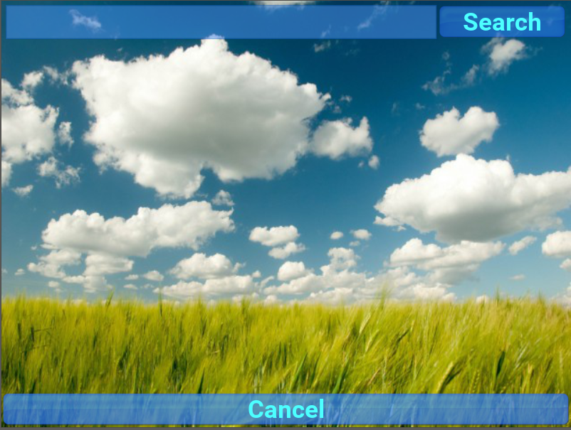

Fig.1 First screen of the APP as seen by the user

The first screen (Fig.1) will be displayed when the APP is started. It has a search field on top, a search button on the right, and a cancel button on the bottom of the screen.



Fig.2 Pop-up messages that lets you know the action you
performed had completed successfully

After you enter a city name in the search field, a pop-up message (Fig.2) shows up that lets you know the city has been found. A short tap on the message will make it disappear.



Fig. 3 A list showing all the possible locations that match the details entered

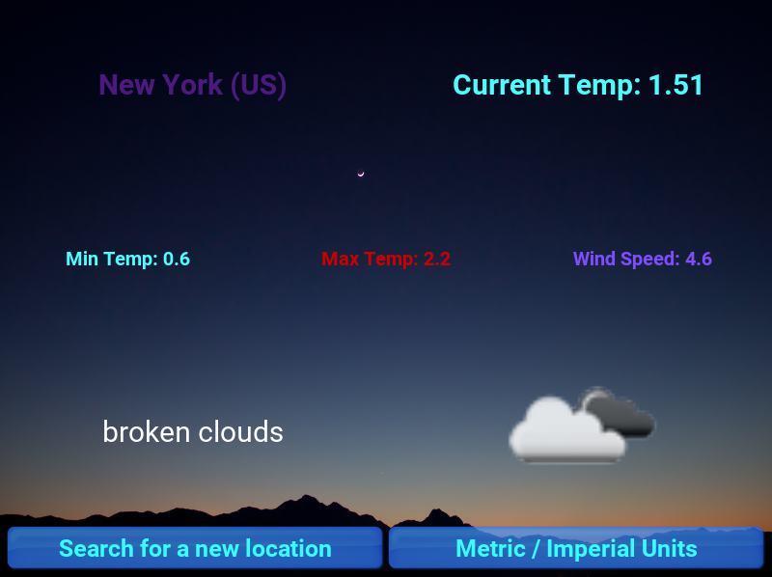

Fig.4 The last screen where the actual weather information is showed

The last screen (Fig.4) is where the actual weather information is displayed. According to the specifications, the following details are displayed: Current temperature, minimum temperature, maximum temperature, wind speed, location, and weather status alongside an icon that shows the sky status. There are also 2 buttons in the lower part of the screen. One to search for a new location and the other one to convert the measurement unit from metric to imperial.

5.2 Screen Objects and Actions

- Pop-up Messages

There are many situations where there is a need for an app to show a quick message to the user, without necessarily waiting for the user to respond. For example, when a user performs an action like sending an email or deleting a file, the app should show a quick confirmation to the user.
Often the user doesn't need to respond to the message. The message needs to be prominent enough that the user can see it, but not so prominent that it prevents the user from working with your app.
In the WeatherAPP, the user receives these kind of Pop-up messages that confirm him an action has been completed successfully. He then has to tap on the message to make it disappear. See Fig.2

- Buttons

There are 4 buttons in total. 2 on the first screen and 2 on the final screen. On the first screen we have a “search” button and a “cancel” button. On the final screen there is a “Search for a new location” button and a “Metric / Imperial Units” button.
See Fig.1 and Fig.4

- REQUIREMENTS MATRIX

Unique ID | Requestor | Description | Requirement ID
ID_1 | Client | The app must work on any operating system. | WA_F_REQ_1
ID_2 | Client | Adapt to any screen size | WA_F_REQ_2
ID_3 | Client | Provide weather details | WA_F_REQ_4, WA_F_REQ_5
ID_4 | Client | APP should perform with no stuttering or lag on any device. | WA_P_REQ_1
ID_5 | Client | APP should provide weather details in maximum 2 seconds | WA_P_REQ_3
ID_6 | Client | APP should convert weather data from metric to imperial and backwards | WA_F_REQ_6
ID_7 | Client | APP should have a button to search for a new location | WA_F_REQ_7

