Software Requirements Specification

Weather APP
Version 2.0

Prepared by Alexandru Marian Motocu
S.C SWC Solutions S.R.L

26.01.2019
Table of Contents
Table of Contents ii
Revision History ii
1. Introduction 1
1.1 Purpose 1
1.2 Document Conventions 1
1.3 Intended Audience and Reading Suggestions 1
1.4 Product Scope 1
1.5 References 1
2. Overall Description 1
2.1 Product Perspective 1
2.2 User Classes and Characteristics 2
2.3 Operating Environment 2
2.4 User Documentation 2
2.5 Assumptions and Dependencies 2
3. External Interface Requirements 2
3.1 User Interfaces 2
3.2 Hardware Interfaces 4
3.3 Software Interfaces 4
4. System Features 4
4.1 Functional Requirements 4
5. Other Nonfunctional Requirements 5
5.1 Performance Requirements 5
5.2 Safety Requirements 5
5.3 Security Requirements 5
5.4 Software Quality Attributes 5

Revision History
Name | Date | Reason For Changes | Version
Alexandru Motocu | 03.11.2018 | Initial revision | 1.0
Alexandru Motocu | 15.12.2018 | Bug fix + added functionality | 1.1
Alexandru Motocu | 25.01.2019 | Working revision | 2.0

Introduction

Purpose
This project is a prototype for a weather application that will be available for the public to use on any platform available today: Windows Phone, Android, iOS, Linux, Windows.

Document Conventions
APP – Application
DB – Database
Temp – Temperature
Min – Minimum
Max - Maximum
API - Application Programming Interface

Intended Audience and Reading Suggestions
The intended audience of this application is every person that owns a smartphone or a PC, using any of the available operating systems today. This application is build to run on all operating systems known today: Linux, Windows, Android, iOS etc. Developers, users, testers as well as marketing staff should read this document to get familiar with the functionalities of the APP.

Product Scope
The purpose of this APP is to provide a quick and fast solution to users to check current weather forecast in any location of the world. The goal was to create a single APP that can run on any operating system available today. This way, it is very easy to maintain and improve when there is only one version of the APP available. Our business strategy is to provide the best priced and most meaningful software to our users, software that is easy and fast to use.

References
- https://openweathermap.org/api
- https://kivy.org/#home
- https://www.python.org/about/
- https://technologyadvice.com/blog/information-technology/how-to-use-an-api/

Overall Description

Product Perspective
The Weather APP is a new, self-contained product. It was designed to be user-friendly, very simple to use, light on system requirements and also offer the possibility to be free of charge with some restrictions that will apply.

User Classes and Characteristics
Users of the Weather APP should be able to retrieve information about weather forecast , minimum temperature, maximum temperature, as well as current temperature from any location in the world.

The system will support 2 types of users: the free user, and the paid subscription user.

The free user should be able to do the following:
- Check weather information up to 20 times per day.

The paid subscription user should do the following:
- Check weather information from any location in the world, as many times as he likes.

Operating Environment
Operating environment for the Weather APP system is as listed below.

- client/server system
- Operating system: Windows, Linux, Android, iOS, Windows Mobile
- Programming language used: Python
- framework: Kivy

User Documentation
Every user that will download the Weather APP will receive the following:

- a user manual,
- on-line help and tutorials

After the download, the user will receive an email that will contain a user manual and links to on-line help tutorials that describe how to use the APP.

Assumptions and Dependencies
The Weather APP has one important dependency: internet connection.
If there is no internet connection, the weather forecast, temperature and all other functions of the APP are not available.

External Interface Requirements

User Interfaces
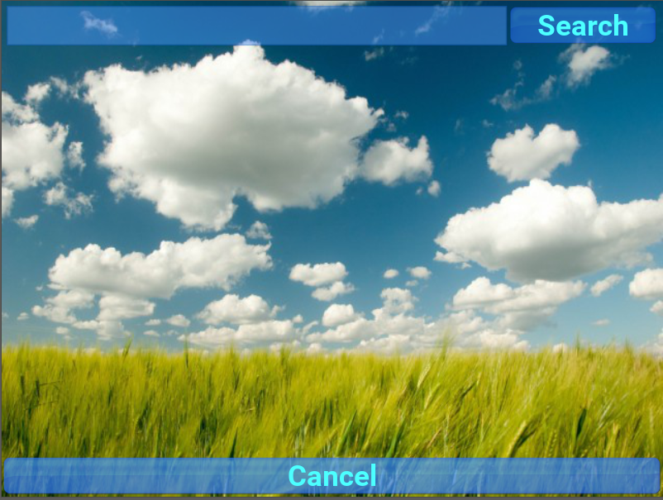

Fig.1 First screen of the APP

The first screen (Fig.1) will be displayed when the APP is started. It has a search field on top, a search button on the right, and a cancel button on the bottom of the screen.



Fig.2 Pop-up messages that lets you know the action you
performed had completed successfully

After you enter a city name in the search field, a pop-up message (Fig.2) shows up that lets you know the city has been found. A short tap on the message will make it disappear.



Fig. 3 A list showing all the possible locations that match the details entered
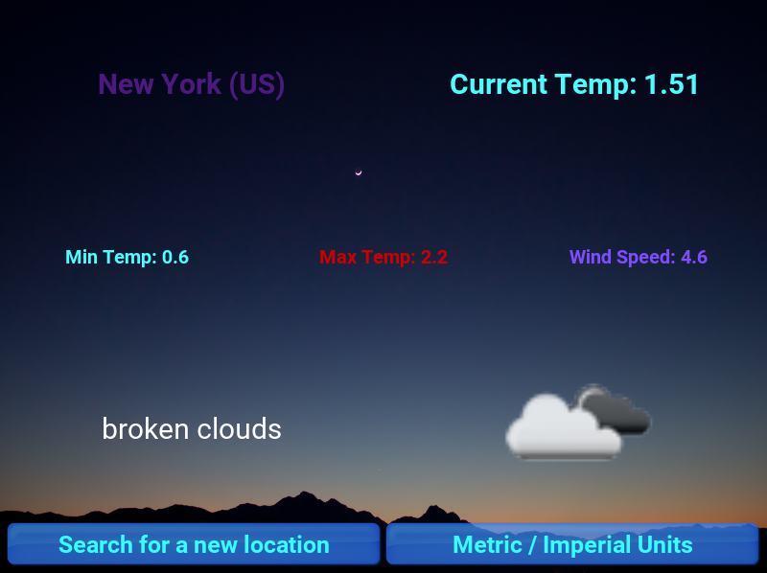

Fig.4 The last screen where the actual weather information is showed

The last screen (Fig.4) is where the actual weather information is displayed. According to the specifications, the following details are displayed: Current temperature, minimum temperature, maximum temperature, wind speed, location, and weather status alongside an icon that shows the sky status. There are also 2 buttons in the lower part of the screen. One to search for a new location and the other one to convert the measurement unit from metric to imperial.

Hardware Interfaces
Because of the type of framework used, this APP can work with any device, PC or smartphone available today. It can also work on devices with touchscreen as well as on computers that use a mouse and keyboard.

Software Interfaces
Programming language used: Python version 3.7.2
Framework used for the UI: Kivy
Operating system used for development: Windows 8
API used for weather information: https://openweathermap.org/
Weather data format retrieved from the server: JSON

System Features

Functional Requirements

WA_F_REQ_1: The APP should work on all available operating systems
WA_F_REQ_2: The APP should be able to adapt to any device and any screen size available
WA_F_REQ_3: The APP should have a search box available on the first screen, where the user can enter the search details
WA_F_REQ_4: The user should be able to search the weather database by entering one of the following details: city name, country name, postal number.
WA_F_REQ_5: The APP should provide the following weather specific details: current temperature, minimum temperature, maximum temperature, wind speed, weather status.
WA_F_REQ_6: The APP should have the possibility to provide weather information in metric measurement units and also in imperial measurement units.
WA_F_REQ_7: After a location is chosen, a button should be available in the lower part of the screen that should give the user the possibility to search for a new location.

Other Nonfunctional Requirements

Performance Requirements
WA_P_REQ_1: The APP Should perform flawlessly, with no stuttering or lag on any device it is used on
WA_P_REQ_2: The APP should adapt to any screen size of any device it is used on.
WA_P_REQ_3: The APP should provide the weather details in maximum 2 seconds after the search button is pressed.

Safety Requirements
There are no specific safety requirements.

Security Requirements
There are no specific security requirements.

Software Quality Attributes
Software quality attributes of this APP must be: adaptability, availability, correctness, flexibility, maintainability, portability, reliability.

