Alex Navarro ajn853 Machine Learning Assignment 3

**Gaussian Processes**

**Introduction**

Regression is a useful tool in the world of machine learning. Using regression, whether linear or otherwise, it is possible to make informed estimates of the output of a process or function given enough sample data. The most common type of regression is linear regression in which the data is modeled as a function of the form , and the regression process creates estimates for the parameters *m* and *c*. However, another more powerful form of regression is known as a Gaussian Process.

When using Gaussian Processes, or GP’s, there is no assumption made on the model of the data. Each data point is assumed to be normally distributed around some mean function value, and the regression curve or function is created based on its proximity to nearby datapoints. Using this method, it is possible to not only create an estimate of the function value at arbitrary test points but to also determine the uncertainty of that estimate based on the uncertainties and relative spread of the data points.

**The Data**

Provided were motion capture datasets from 12 individuals. Each individual was asked to trace their finger according to a certain target trajectory while data was recorded. The data itself consists of 50 different tracker trajectories in the X, Y, and Z directions. In addition to each of the 50 trackers, the resolved trajectory for the individual’s head and finger trajectories are included in the data.

Figure : Target trajectory for the individuals to follow

Each individual performed the motion 5 times, giving a total of 60 trajectories with 50 timeseries of over a thousand data-points each. Not all of the data is used for this assignment. In particular, the 5 runs of a single individual are used, the first four to generate mean and standard deviations for the movements, and the fifth as a test data set to quantify the validity of our gaussian regression.

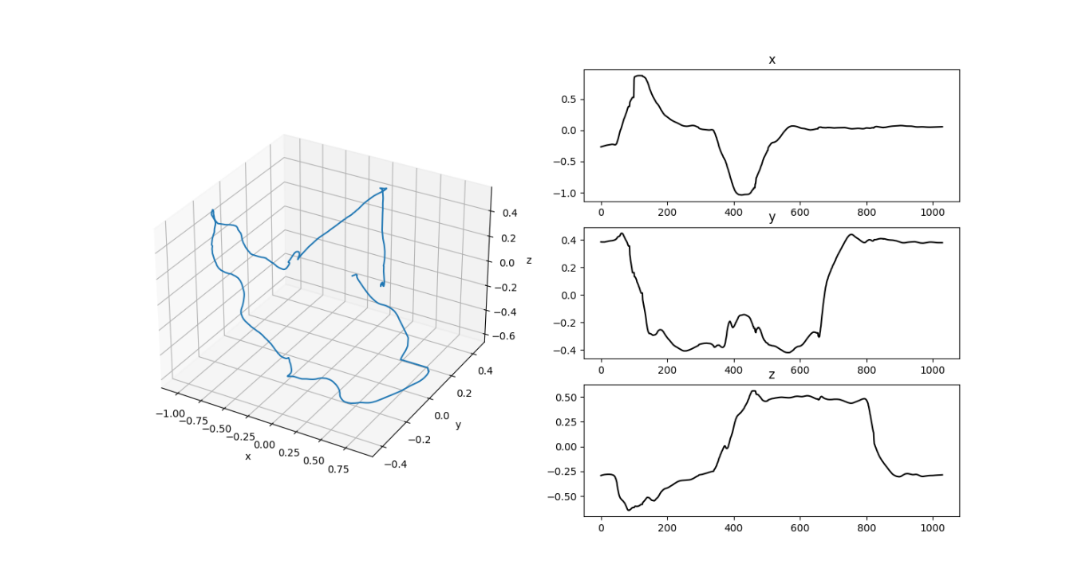

Figure 2: Average trajectory of the first individual

**Method**

Regression

The GP regression algorithm is built around the kernel function chosen. In our case, we are using the squared exponential kernel function

where and are hyperparameters to be determined. Additionally, there is always noise in real world data, and so the kernel function should also incorporate that. This is done with addition of an additional noise hyperparameter . In this way, the kernel function ends up looking like

Now consider a case in which we have a data vector **y** along with its independent variable **x**. Let us also assume that we have the variance data for the **y** vector such that for a given datapoint “” in the **y** vector, . Then, if we want to determine the value of y at some arbitrary test point , we know that the underlying distribution is joint Gaussian of the form

where K is a matrix of the form

and additionally and .

And since we have the entire **y** dataset, we can condition the probability of based on the data present in **y**. This gives use the final form of the gaussian regression equation

Hyperparameters

The hyperparameters and are used to characterize the data of the Gaussian regression. The term characterizes the variance of the data, while , the length parameter, is a measure of how close two data points have to be in order to have a significant effect on the estimates of one another. The term is the noise term and accounts for the variability due to noise. It has a very similar effect on the fit to , but unlike its counterpart, can be measured if the variability of the input data is known.

Other than , these hyperparameters cannot be known in advance and so it is necessary to calculate them. They can, of course, be fit manually, but that is a long and tedious process that gives suboptimal results. The better course of action is the solve the maximization problem on the log likelihood of the data values conditioned on the independent variable **x**

This maximization problem was solved with the use of the scipy.optimize library function minimize, which uses the BFGS multivariable optimization algorithm. In order to convert the problem from a maximization problem to a minimization problem, the sign of the objective function was simply switched, such that the final problem was of the form

**NB:** This function is much reduced compared to the original function as constant terms and scaling factors have been removed.

**Results**

We will be looking at two different methods of fitting this data with a Gaussian regression. The first method assumes that the entire data can be appropriately fitted with a single set of hyperparameters. As such, the entire dataset of 1030 points will be fitted as one in a single calculation. For testing purposes, only the mean x-direction trajectory of the first participant is used. In the following section, blue represents the original trajectory, and orange represents the Gaussian regression curve.

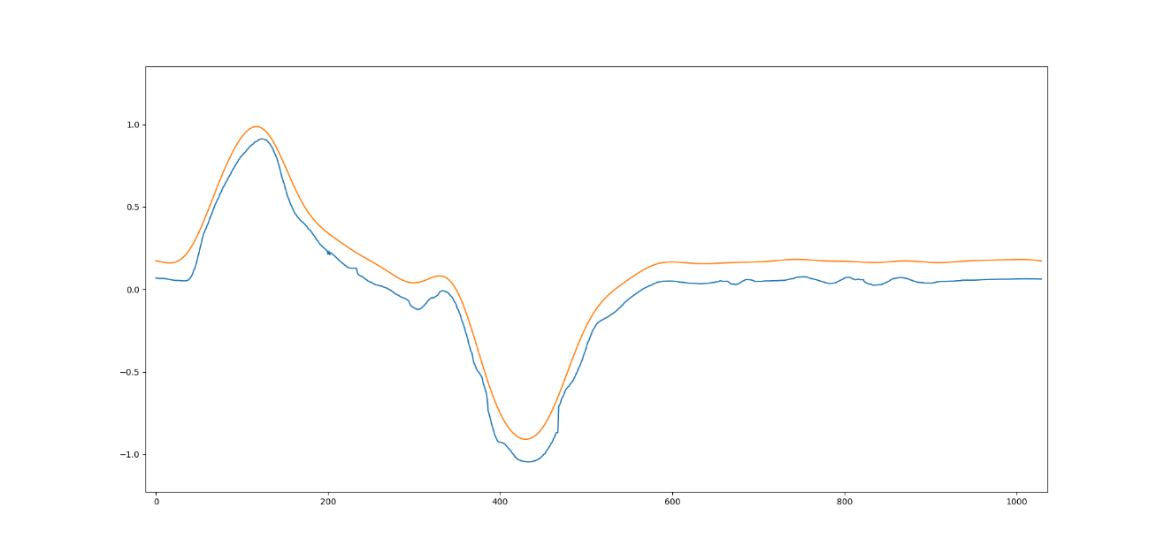

We can see that the resulting fit is fairly good, but it does not lie quite as close to the curve as we would like. Additionally, the uncertainty of the regression is so high that it is not visible on the plot, and generally lies at around the mark.

The other method is the sliding window method. In this method, the reality that a single set of hyperparameters may not work on all the data universally is addressed. Instead, the data is fitted according to a moving window such that only the first n points are fitted, followed by the n+x points, where n is the size of the window, and x is the movement in the window after each calculation. This allows the hyperparameters to be locally optimal, while still fitting the entire dataset.

In this case we can see that the estimate is much improved. The error between the real data and the estimated data is significantly reduced, and the uncertainty, while still large, is much more reasonable. There are some noticeable “artifacts” in the both the mean and uncertainty estimates. These are caused by discontinuities between the different window hyperparameters meeting. This could be fixed with a little more work by solving the hyperparameter learning algorithm as a boundary value problem instead of a simple optimization problem, but for the sake of this assignment they have been left as they are.

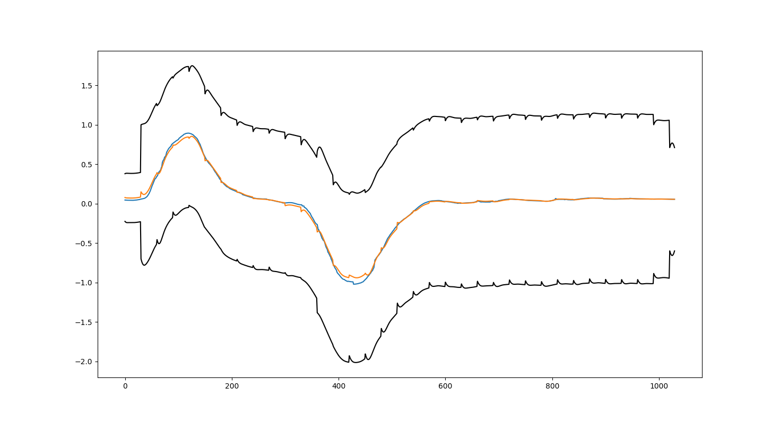

Of interest to us is the way in which the hyperparameters varied throughout the regression process. The algorithm only resolved the hyperparameter optimization if the negative log likelihood increased from one window to the next.

We can see that for the first part of the problem, where variability was high, the Gaussian model retained a fairly low length parameter to account for rapid movement between successive points. However, later in the trajectory, where the curve regressed to a flat line, the optimal length parameter was much higher to account for the fact the further and further points were correlated with the current estimate.