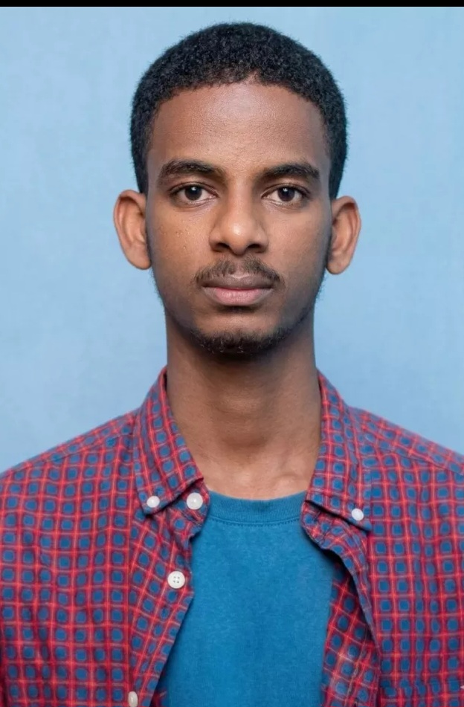 | ALEX NEGA  4th-Year Information Technology Student  NETWORKING & IT INFRASTRUCTURE  Frontend Development | Cybersecurity | Software Development  Email: alexnega8100@gmail.com | Phone:+251991005780/+251973498384 | Location: Ethiopia  GitHub: github.com/alexnega8100-stack | LinkedIn: [ADD LINKEDIN]

PROFESSIONAL SUMMARY
4th-year Information Technology student with a primary focus on networking and IT infrastructure. Designed and simulated secure organizational network topologies for banking, enterprise, and hotel environments, and gained practical internship experience at Tsedey Bank, contributing to rack installation, rack organization, and cable management across two branches. Completed cybersecurity training through ISC2 and holds multiple technical certificates. Also brings frontend and software development experience, programming knowledge, and hands-on training in mobile phone service and repair.

Core Technical Focus
NETWORKING | IT INFRASTRUCTURE | CYBERSECURITY | FRONTEND | SOFTWARE | MOBILE

NETWORKING & IT INFRASTRUCTURE
Primary technical specialization
Network Design  - Network topology design  - Organizational network design  - Secure network architecture  - Network simulation | Network Infrastructure  - Rack installation  - Rack organization  - Cable management  - Physical network infrastructure  - Networking equipment | Networking Concepts  - Routing  - Switching  - Network segmentation  - Network security concepts  - Access control concepts
Tools & technologies: [ADD NETWORKING TOOLS] | [ADD SIMULATION SOFTWARE] | [ADD NETWORK TECHNOLOGIES]

NETWORKING EXPERIENCE
Tsedey Bank — Networking / IT Internship
2 months from July 8, 2026 - September 5, 2026 G.C
Hands-on internship focused on networking and physical IT infrastructure, contributing to rack installation across two branches:
- Rack installation
- Rack organization
- Cable management
- Physical network infrastructure
- Networking equipment
- Practical IT infrastructure environments

NETWORK DESIGN PROJECTS
01 · Secure Tsedey Bank Network Topology
Secure network design and simulation project for a banking environment.
Space reserved for: topology diagram, VLANs, routing, ACLs/security, server segmentation, IP addressing, network security details

02 · Enterprise Network Design
Network design and simulation for an enterprise environment.

03 · Hotel Network Design
Network design and simulation for a hotel environment.

04 · Additional Network Project
[ADD PROJECT NAME / DETAILS]

SOFTWARE & DEVELOPMENT PROJECTS
Automated Examination System
Java
GitHub: github.com/alexnega8100-stack/Automated-Examination-System

Distributed To-Do List
Java
GitHub: github.com/alexnega8100-stack/distributed-to-do-list

Campus Helper / Reminder Application
Mobile application development project
Technologies: [ADD TECHNOLOGIES]
GitHub: [ADD GITHUB] Demo: [ADD DEMO]
Features: [ADD FEATURES]

CERTIFICATIONS & TRAINING
ISC2  3 Certificates | eSHE  7 Certificates | TVET  Mobile Phone Service & Repair

ISC2 — Cybersecurity Training
- ISC2 — Domain 1
- ISC2 — Access Control Concepts / Domain 3
- ISC2 — Network Security
Foundational cybersecurity training covering core security domains and access control concepts.
eSHE Certificates
- eSHE Certificate 01 — [COURSE NAME]
- eSHE Certificate 02 — [COURSE NAME]
- eSHE Certificate 03 — [COURSE NAME]
- eSHE Certificate 04 — [COURSE NAME]
- eSHE Certificate 05 — [COURSE NAME]
- eSHE Certificate 06 — [COURSE NAME]
- eSHE Certificate 07 — [COURSE NAME]
For each certificate: institution, date, certificate ID, and verification link to be added.
TVET — Mobile Phone Service and Repair
Institution: Hello Institute of Technology
Date: August 23,2025 G.C-November 25,2025 G.C

TECHNICAL SKILLS
Secondary specialization and supporting technical areas
Frontend Development  - Frontend development  - HTML: [ADD]  - CSS: [ADD]  - JavaScript: [ADD]  - Frameworks: [ADD]  - Libraries: [ADD]  - Tools: [ADD] | Programming  - Java  - PHP  - C++  - C# | Mobile Development  - Mobile application development  - Campus Helper / Reminder App

Productivity Tools  - Microsoft Excel  - Microsoft Word  - [ADD OTHER MICROSOFT OFFICE SKILLS] | Hardware / Mobile Repair  - Mobile phone service and repair  - TVET-certified training | Video Editing  - Video editing  - Software:capcut

EDUCATION
Bachelor's Degree in Information Technology
Bahir Dar University — Bahir Dar Institute of Technology, Ethiopia
4th Year | Expected Graduation: [ADD YEAR]

Alex Nega · alexnega8100@gmail.com · github.com/alexnega8100-stack · Ethiopia

