Computer Science Forum

**Functional Requirements Template**

**1.** **Introduction and Context**

Finding solutions and algorithms to problems that we have on our assignments can be difficult. Looking online for these solutions can lead to very different answers that we may or may not understand and may or may not be able to incorporate into the solutions to our assignments. Also, a lot of times, it is difficult for teachers to communicate with students on specific issues that students because there aren’t any well organized area for CS students to ask questions on problems that they have.

In our forum, users will be able to create threads to ask questions in regards to their specific classes or assignment needs. For example, they can ask a question about assignment #2 of CS 3450 class. Other users will be able to give them feedback regarding to the questions. They can also facilitate searching for related problems and topics. The forum will provide students an opportunity to share their ideas and solutions to problems, to show off projects that they have and get feedback.

The user and the goals are described more thoroughly in Section 2. Section 3 describes functional requirements that are needed for a proposed set of software features, which will satisfy the user goals.The software will be built using an incremental development process, constrained by the non‐functional requirements enumerated in Section 4. Section 5 describes future features, that might be needed for further process.

**2.** **Diagrams**

**2.1 – Use Cases**

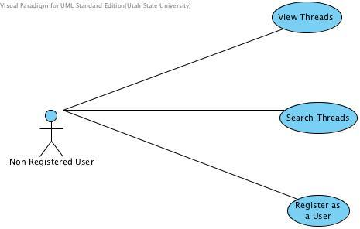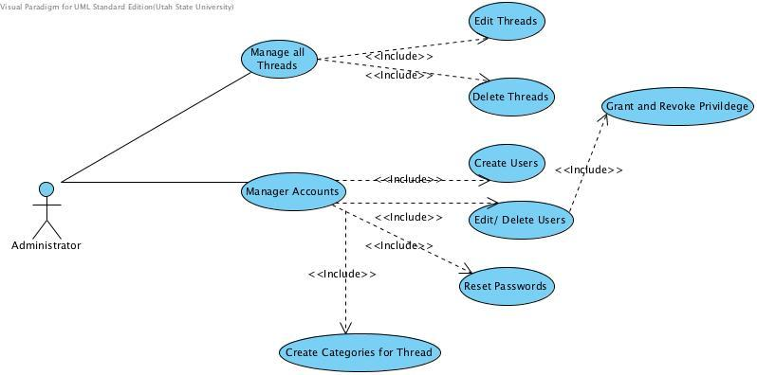

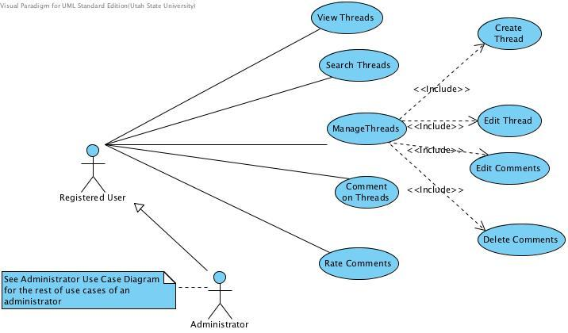

**2.2 – Class Diagrams**

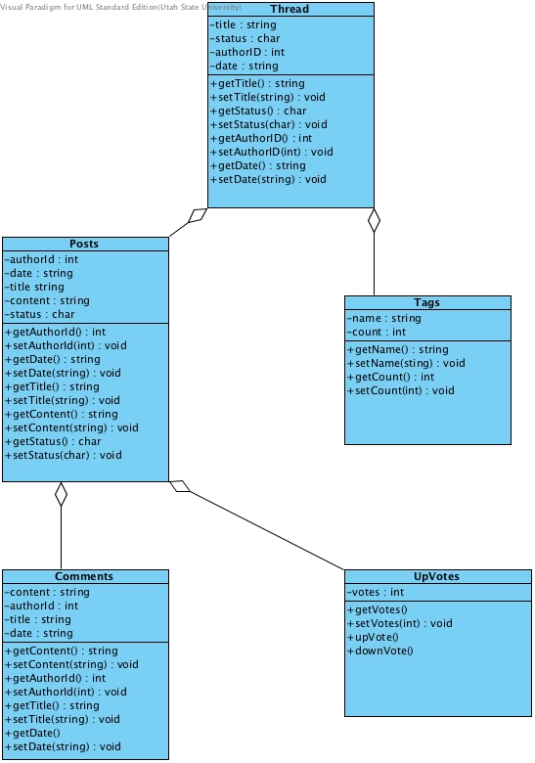

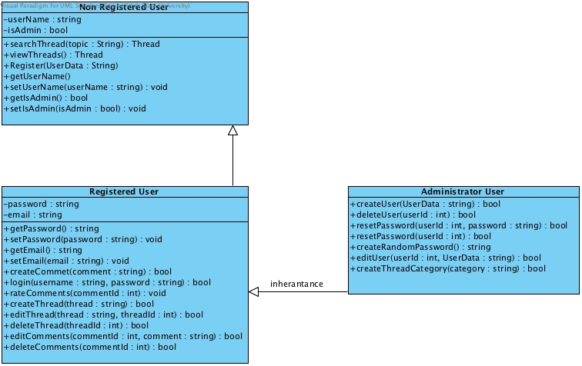

**2.3 – Data Diagram**

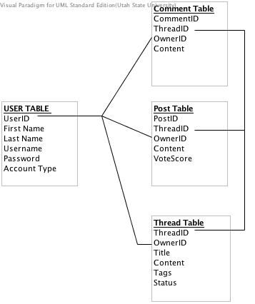

**2.4 – Interaction Diagrams**

User viewing a thread

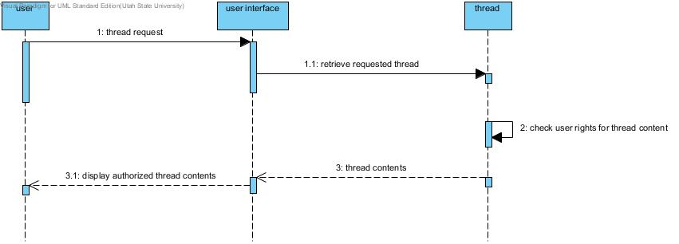

User creating a thread

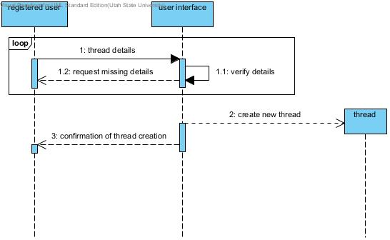

User replying to a thread

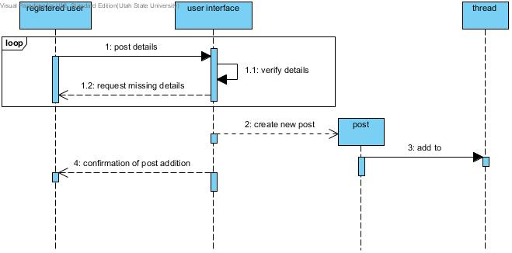

Editing User Details

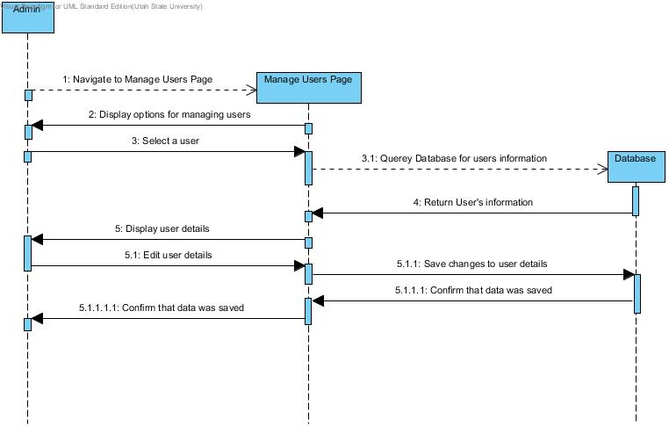

Registering a User

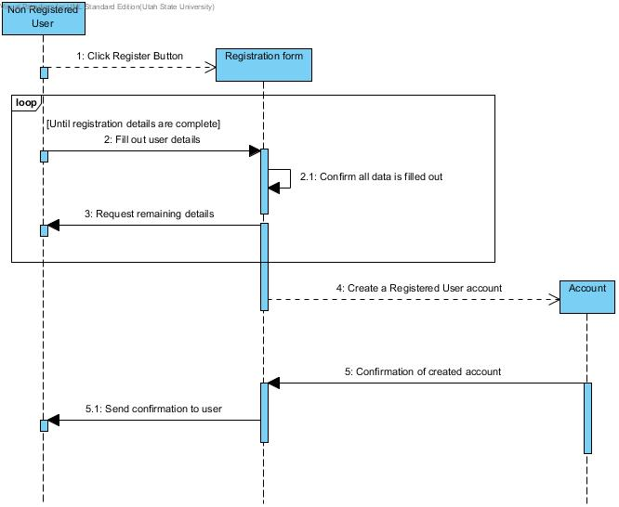

**3.** **Functional Requirements**

1. **Non-Registered User**
   1. **View threads/posts** - Non-registered users must be able to navigate the forum, viewing threads and posts without the ability to create or reply to them. The system will present threads to the user sorted by category, by number of votes, and/or chronologically (most recent first). The system will display posts within a thread sorted by the number of upvotes they have received and/or chronologically..
      1. **Search threads/posts** - Non-registered users must have access to the search feature of the forum, allowing them to search for specific threads or posts to view. The system will display a search bar in the banner/header section that allows this search from anywhere within the forum.
   2. **Register as a user** - Non-registered users must be able to access a registration form where they can enter the necessary information to become a registered user. The system will provide a link that takes the user to a page where this form may be completed.
2. **Registered User**
   1. **Can view threads/posts**
   2. **Can create a new Thread**
      1. Must have a title (must be unique, can only use upper/lowercase letters, coma, period, …)
      2. Must have category
      3. Class number (optional)
      4. Must have content (can write anything, except content that violates the “Terms of Use”)
      5. Must have at least 3 tags
   3. **Can change the Thread status as “Resolved”**
      1. Must be the author of the Thread
   4. **Can write a new Post in a Thread**
      1. Post must contain content that doesn’t violate the “Terms of Use”
   5. **Can vote on a Thread**
      1. Must not be his/her own Thread
   6. **Can vote on a Post**
      1. Must not be his/her own Post
   7. **Can flag a Post as inappropriate**
      1. Must give a reason in an entry box
3. **Admin**
   1. **Manage Accounts -** An Admin will need to have the ability to manage the accounts for the system. The system will provide an admin page that is accessible to only those users who have been granted Admin privileges. From this page the Admin will have the ability perform the tasks that are listed below.
      1. **Edit Users -** An Admin will have the need at times to manually enter information about a particular user. From the admin page they will have the ability to edit any of the user’s information and then save it.
         1. **Create Users -** An Admin will have the ability from the Admin page to create a new user manually. There will also be a public page where Non-Registered Users will have the ability to create a new user. From this page the Admin will be able to enter in information regarding the new user.
         2. **Delete Users -** From the section in the system where you edit the users you will have the ability to delete the user as well.
         3. **Grant / Revoke Privileges -**  Privileges can be granted and or revoked when editing a user.
         4. **Reset Passwords -** Within the edit users section the admin will have an option to reset the particular user’s password.
   2. **Manage Threads -** Admins will need to have the ability to manage threads that get posted into the forum. The system will provide an admin the ability to browse the threads and have different options to manage the threads.
      1. **Create thread categories -** The system will provide the ability to an admin to create categories and subcategories for different threads where registered users will be able to post their threads.
      2. **Edit threads -** Administrator will have the ability to edit threads content.
      3. **Delete threads** - Administrator will have the ability to delete entire threads.

**4.** **Non-functional Requirements**

1. **Implementation**
   1. Divide up the project into different categories.
      1. Database Design
      2. Queries
      3. Web Page Design and Coding
      4. Setting up Server
2. **Testing**
   1. Utilize customers that we have used in planning and preparing to aid in testing.
   2. Test different browsers and operating systems
      1. Mobile & Desktop
      2. Windows, Linux, & Mac

**5.** **Future Features**

1. Account verification via email.
2. Add an account type for a moderator.
   1. Take some of the responsibilities from the administrators.
   2. Can edit and remove comments, threads, and posts.
3. Connecting A numbers to accounts for identification.
4. Different formatting of posts depending on user.
   1. Teachers have a unique format.
   2. A users own comments and threads have a special format.
5. Adding a teacher level user
   1. Create a class specific thread and have admin type access to that thread.
   2. View user accounts
   3. Create class specific threads

**6.** **Glossary**

* **Forum** - An **Internet forum**, or **message board**, is an [online](http://en.wikipedia.org/wiki/Online) discussion site where people can hold conversations in the form of posted messages.[[1]](http://en.wikipedia.org/wiki/Internet_forum#cite_note-vBfaqFORUM-1) They differ from [chat rooms](http://en.wikipedia.org/wiki/Chat_rooms) in that messages are often longer than one line of text, and are at least temporarily archived.
* **Thread** - A *thread* (sometimes called a *topic*) is a collection of posts, usually displayed from oldest to latest, although this is typically configurable: Options for newest to oldest and for a threaded view (a tree-like view applying logical reply structure before chronological order) can be available. A thread is defined by a title, an additional description that may summarize the intended discussion, and an opening or original post (common abbreviation *OP*, which can also mean *original poster*), which opens whatever dialogue or makes whatever announcement the poster wished. A thread can contain any number of posts, including multiple posts from the same members, even if they are one after the other.
* **Post** - A *post* is a user-submitted message enclosed into a block containing the user's details and the date and time it was submitted. Members are usually allowed to edit or delete their own posts. Posts are contained in threads, where they appear as blocks one after another. The first post starts the thread; this may be called the TS (thread starter) or OP (original post). Posts that follow in the thread are meant to continue discussion about that post, or respond to other replies; it is not uncommon for discussions to be derailed.
* **Admin** - Short for *Administrator*. The *administrators* manage the technical details required for running the site. As such, they may promote (and demote) [members](http://en.wikipedia.org/wiki/Internet_forum#Member) to/from [moderators](http://en.wikipedia.org/wiki/Internet_forum#Moderators), manage the rules, create sections and sub-sections, as well as perform any [database](http://en.wikipedia.org/wiki/Database) operations ([database backup](http://en.wikipedia.org/wiki/Backup) etc.). Administrators often also act as [moderators](http://en.wikipedia.org/wiki/Internet_forum#Moderators). Administrators may also make forum-wide announcements, or change the appearance (known as the skin) of a forum. There are also many forums where administrators share their knowledge.
* **Registered User** - User that has already registered on the site. Has superior privileges compared to a non-registered user.
* **Non-Registered User** - An unregistered user of the site is commonly known as a *guest* or *visitor*. Guests are typically granted access to all functions that do not require database alterations or breach privacy. A guest can usually view the contents of the forum or use such features as *read marking*, but occasionally an administrator will disallow visitors to read their forum as an incentive to become a registered member.
* **Status “Resolved”** - When the question from the Thread is answered, its status is changed to “Resolved”. A visual indicator will notify all the users that the question has been resolved.
* **Category** - A field of *CS*, or a programming language the thread is related to.
* **Tag** - A word related to the Thread that will help find the Thread in the future via “Search Bar”
* **Flagging a Post** - In case the post or the thread have content that violates the “Terms of Use”, it can be flagged as spam, which is basically a notification for the admin or the moderator, who’ll check if the violation is true and will delete the thread/ port if necessary.