I think anki already wraps the contents in <script></script>, so try losing that from flashcard/anki.html
(in kanjibig too)

[x] line numbers on lines of rikai input
[x] a href links to those numbers in dupe comments

[x] highlight input expr in resulting card

[x] another list for "alts preferred"

just had a thought - why am I working only off expr when parsing input?
shouldn't kana be also considered?
If I think about it, when saving with rikaichan, I usually make sure the kana is what I want,
otherwise I'll go into rikaichan.txt and manually edit it.
So make kana count.
[x] Done. see input.png and input.dia for new flowchart

[x] If a view has (0) entries, show it disabled

[x] bug: highlighting 雲 given 曇り wrongly boxes just the kanji; check if whole string matches
fixed

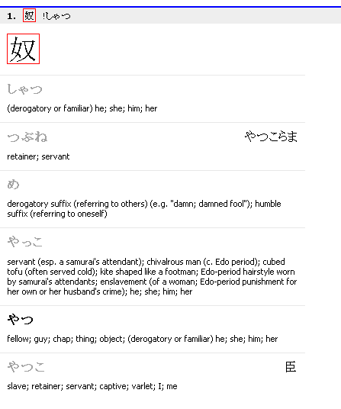
[x] Make sure (P) comes second

[x] ‘dupe in anki’ and ‘dupe in rikai’ shouldn’t be considered ‘errors’ and thus shouldn’t set @error

[x] This will also allow me to have a ‘has error’ subcategory in the report.

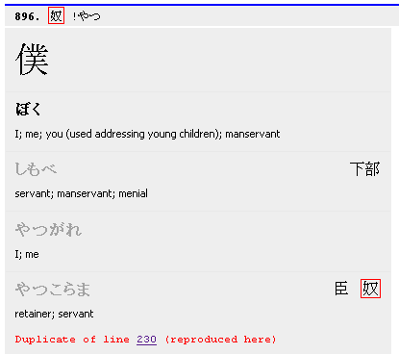

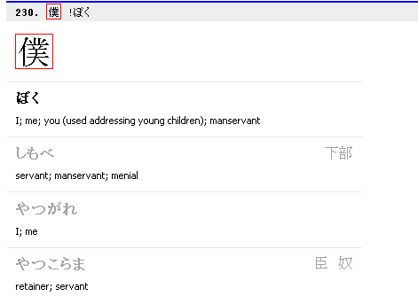
Is this fixed yet?
NO.
This is actually quite weird – note that it’s not !expr so expr is unimportant??
Need to think about this.
[x] refined dupe check to include kana too – iff `!kana’. Seems to work :|

Dupe check still seems fundamentally wrong. A dupe could occur in many places, but I only list the first one. Plus I’m not considering !expr during the dupe check, which feels like I should. But it’s minor and seems to work so far; I’ll hold for now.

[x] also refine to distinguish between ‘dupe in X’ and ‘dupe in X alts’

[x] Change items font to courier new
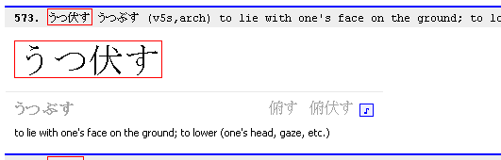
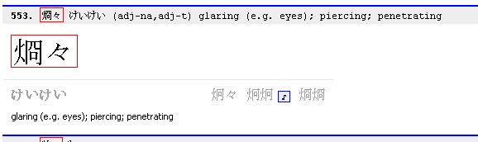
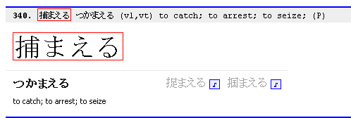

Look at this shit. They didn’t bother to propagate the sound to all alts.
Do this in kanji’s flashcard js!
(if possible...)
I know! At generation time mark the alt expr with a *, kanji/flashcard.js will know to use that one instead of the main expr.
[DONE]

[DONE] fix: don’t actually modify the Word object – the ‘*’ has no business showing up in the kanji deck later.

Make eigo by default invisible and only show on rollover (like kanji deck).

If second, third, etc. reading are (P), enable their audio too, by default.
The recog/prod/answer js files: Kanji dumps them to REPORTDIR, while Vocab locally. Not symmetrical.

Also, need to put some nice Kanji and Vocab modules around those 2. For example, Flashcard is currently a global module (though it belongs to Kanji alone). And apparently generating those Anki js files doesn’t even happen in the main run. Investigate.
no audio for 包む

