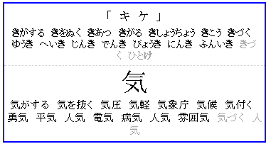
ケ should be grayed out
DONE

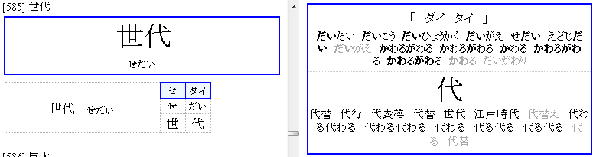

there is no タイ in the word list, do something about preferring the frag yomi somehow.
DONE 374

WTF??
予言 [かねごと] /(n,vs,adj-no) prediction/promise/prognostication/
予言 [よげん] /(n,vs,adj-no) prediction/promise/prognostication/(P)/
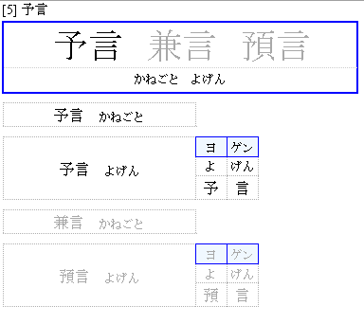
why is kanegoto not gray?
DONE 376

index is cut off if not exact divisor of 6
DONE 377

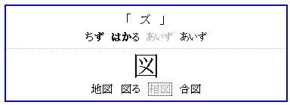
合図 should not be last
DONE

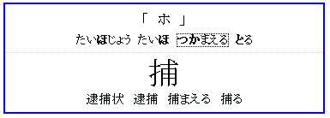
逮捕 should be first (because it's shorter?)

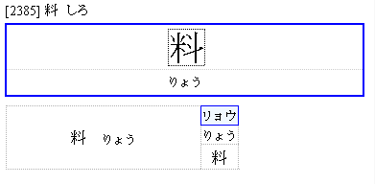
custom spelling is ignored if not already in edict
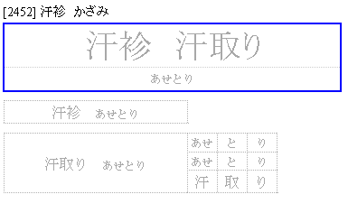
same weirdness, forcing custom spelling does weird things if it's not in edict
DONE 385

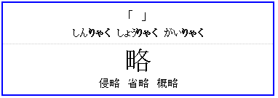
DONE 384

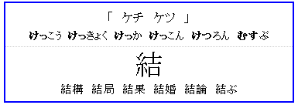
should be just ケツ
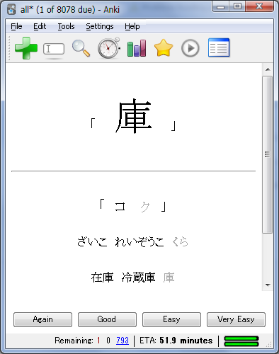
don't allow trailing kana unless vowel

