MAKERERE UNIVERSITY
COLLEGE OF COMPUTING AND INFORMATION SCIENCES
DEPARTMENT OF NETWORKS
BSSE
BSE 2301: RECESS TERM II
SOFTWARE REQUIREMENTS SPECIFICATION
PROJECT NAME: NATIONAL BASKETBALL ASSOCIATION ANALYSIS
SUPERVISOR: Mr. MBABAZI ISAAC
TEAM MEMBERS
NAME | REG No. | STUDENT No.
SAMIR HABIB | 16/U/11334/EVE | 216016914
CHEPKURUI JACOB ISAAC | 16/U/4608/EVE | 216016754
OKOTH BRAIN | 16/U/10926/EVE | 216002929
NIYONSABA ALEX | 16/U/10344/EVE | 216004565

Software Requirements Specification
For
NATIONAL BASKETBALL ASSOCIATION ANALYSIS
Version 1.0
Prepared by Group 21
22nd June 2018
Table of Contents
Table of Contents ii
Revision history iii
1. Introduction 1
1.1 Purpose 1
1.2 Document Conventions 1
1.3 Intended Audience and Reading Suggestions 2
1.4 Product Scope 2
1.5 References 3
2. Overall Description 3
2.1 Product Perspective 3
2.2 Product Functions 3
2.3 User Classes and Characteristics 3
2.4 Operating Environment 4
2.5 Design and Implementation Constraints 4
2.6 User Documentation 4
2.7 Assumptions and Dependencies 4
3. External Interface Requirements 5
3.1 User Interfaces 5
3.2 Hardware Interfaces 6
3.3 Software Interfaces 6
3.4 Communications Interfaces 6
4. System Features 7
4.1 Login 7
4.2 Summarize 8
4.3 Make predictions 9
4.4 Find Relationship 10
4.5 Description and Priority 10
4.6 The purpose of this feature is to allow users (NBA officials and club managers) to plot the relationships between different variables in NBA datasets. This requirement is of high priority. 10
4.7 Make comparisons 10
4.8 Help 11
4.9 Description and Priority 11
4.10 The purpose of this feature is to allow users (NBA officials and club managers) to get help from system administrators. This requirement is of high priority. 11
4.11 Logout 12
5. Other Nonfunctional Requirements 12
5.1 Performance Requirements 12
5.2 Safety Requirements 12
5.3 Security Requirements 13
5.4 Software Quality Attributes 13
5.5 Business Rules 13
6. Other Requirements 14
Glossary 14

Revision history
Name | Date | Reason for changes | Version
Group 21 | 28th June 2018 | Initial version | 1.0

Introduction

Purpose
This System Requirements Specification describes the requirements for NBA analysis system Version 1.0.
The purpose of the document is to collect and analyze all ideas that have come up to define NBA analysis system, its requirements with respect to the stakeholders.

In short, the purpose of this SRS document is to provide a detailed overview of NBA analysis system, its parameters and goals. This document describes the project's target audience and its user interface, hardware and software requirements.

Primarily, the scope pertains to NBA analysis system features. It focuses on NBA statistics and the stakeholder which allows users to describe, predict the outcomes and identify the relationships between data points in NBA datasets.

Document Conventions
This document uses the following conventions
Headings
- Font: Times New Roman
- Face: Bold
- Size : 18
Sub headings
- Font: Times New Roman
- Face: Bold
- Size:14

Other text explanations
- Font: Times New Roman
- Face: Normal
- Size : 12
Line spacing: 1.5

NBA | National Basketball Association
SRS | System Requirements Specification

Intended Audience and Reading Suggestions
Developers:
Project developers have an advantage of quickly understanding the methodology enabled and personalizing the system.

Clients:
The users of the system will get a clear idea of the software and hardware requirements to be engaged.

Product Scope
Goal
- To describe, accurately predicts the outcomes, and identifies the relationships between data points in NBA datasets and to keep track of the players’ biography and their capabilities and strength.

Objectives
- To analyze the data points within the NBA dataset.
- To design the system basing on the problems the project will address.
- To develop the system for NBA from the design that has been formed.

Benefits
- Users will be able to make predictions about which teams is more likely to win.
- Users will be able to view the described and summarized data.
- Users will be able to identify the relationship between the data points.
- Users will be able to compare variables with in the dataset.

References
https://web.cs.dal.ca/~hwakey/3130/srs_template-ieee.doc

Overall Description

Product Perspective
NBA analysis system is a new product. It is a data analysis based system.

Product Functions
- The system should describe and summarize the data.
- It should identify the relationships and differences between variables with in NBA datasets.
- It should compare variables.
- It should predict the outcomes basing on the dataset.
- It should allow users to login and logout.

User Classes and Characteristics
NBA Officials:
These perform detailed analysis about all basketball clubs. They are not expected to have a high educational and proficiency level or technical expertise in data analysis.
Club Managers:
Club Managers can perform detailed analysis about their clubs. These are also not expected to have a high educational and proficiency level or technical expertise in data analysis.
System Administrator:
The system Admin provides access to the system resources. He/she is expected to have a technical expertise in data analysis.

Operating Environment
The System will operate on a computer with either windows or Linux operating Systems. R Studio must be installed.

Design and Implementation Constraints
Memory: the computer will have at least 2GB RAM. Software and dataset cannot exceed this Memory.
Language requirements: The System will be implemented in R.
Security considerations: Users will first login in order to access the system.

User Documentation
- A user manual will be provided.
- Online help via email will also be provided

Assumptions and Dependencies
It is assumed that the system being developed will work correctly with Rstudio since it will be developed in R.

External Interface Requirements

User Interfaces
- The first time user should see the login page. The system is only available to registered users
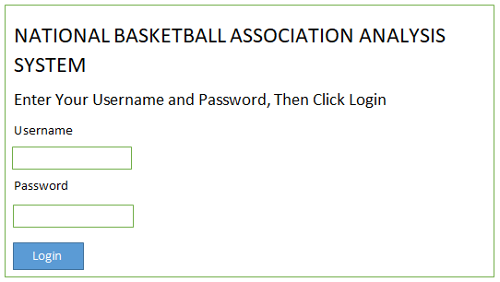

- Registered users, on login will be redirected to the home page.
- The major buttons on the home page include: summary, predictions, relationships, comparisons, help and logout.
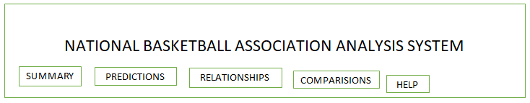
- Summary button, this directs the user to the page that enables him to make summaries about the NBA data.
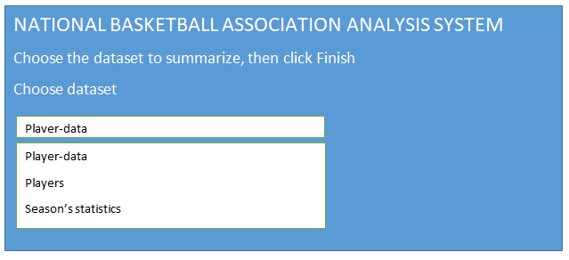
- Predictions button enables the user to make the prediction basing on the NBA statistics.
- Relationships button enables the user to obtain relationships within the datasets.
- Comparisons button enables the user to make comparisons between the datasets.
- Help button directs the user to the instructions and guidelines manual.
- Logout button enable the user to sign out from the system.

Hardware Interfaces
- The system will operate on Windows computer.
- A device with a browser that supports HTML and JavaScript.

Software Interfaces
- The system will work with a MySQL or Oracle database to store the user login details.
- R studio program will be used to implement the system.
- Window Operating system because its user friendly.

Communications Interfaces
The system will be accessed through the web browser by the help of HTTP.
The system will be highly responsive to the user’s commands.

System Features

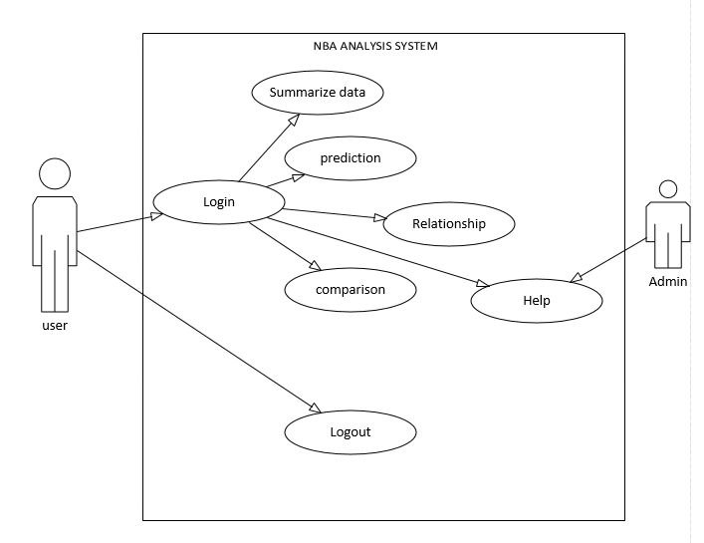

Login

Description and Priority
The purpose of this feature is to allow access of the system to end users (NBA officials and club managers). This requirement is of high priority.

Stimulus/Response Sequences
- User fills the username field.
- User fills the password field.
- User clicks login button.
- The system verifies if he/she is an authorized user and is granted access to the system. Otherwise access is denied.

Functional Requirements
REQ-1: The system shall allow users to sign up.
REQ-2: The system shall provide input fields for username and password.
REQ-3: The system shall provide a login button.
In case the user provides invalid user name or password, the system shall deny his access.

Summarize

Description and Priority
The purpose of this feature is to allow users (NBA officials and club managers) to make a summary NBA datasets. This requirement is of medium priority.

Stimulus/Response Sequences
- User selects which dataset to summarize.
- User clicks Finish button.
- The system will provide a summary of the selected dataset.

Functional Requirements
REQ-1: The system shall allow users to select the dataset.
REQ-2: The system shall provide a finish button.

Make predictions

Description and Priority
The purpose of this feature is to allow users (NBA officials and club managers) to predict forecasts basing on NBA datasets. This requirement is of high priority.

Stimulus/Response Sequences
- User selects the dataset from which the prediction is to be made.
- User specifies the range of the test dataset.
- User clicks Finish prediction.
- The system shall display the prediction results.

Functional Requirements
REQ-1: The system shall allow users to select the dataset.
REQ-2: The system shall provide an input field for a range of a test dataset.
REQ-3: The system shall provide a Finish Prediction button.

Find Relationship

Description and Priority

The purpose of this feature is to allow users (NBA officials and club managers) to plot the relationships between different variables in NBA datasets. This requirement is of high priority.

Stimulus/Response Sequences
- User selects the dataset from which the relation is to be found.
- User selects the variables he/she wants to relate.
- User selects the kind of plot he/she wants.
- User clicks the Find Relationship button.
- The system shall plot the selected graph.

Functional Requirements
REQ-1: The system shall allow users to select the dataset.
REQ-2: The system shall allow users to select the variables within the dataset.
REQ-3: The system shall allow users to select the kind of plot he wants.
REQ-4: The system shall provide a Find Relationship button.

Make comparisons

Description and Priority
The purpose of this feature is to allow users (NBA officials and club managers) to make comparisons between different variables in NBA datasets. This requirement is of medium priority.

Stimulus/Response Sequences
- User selects the dataset from which the comparison is to be made.
- User selects the variables he/she wants to compare.
- User clicks the Make-Comparison button.
- The system shall display the comparison of the selected variables.

Functional Requirements
REQ-1: The system shall allow users to select the dataset.
REQ-2: The system shall allow users to select the variables within the dataset.
REQ-3: The system shall provide a Make-Comparison button.

Help

Description and Priority

The purpose of this feature is to allow users (NBA officials and club managers) to get help from system administrators. This requirement is of high priority.

Stimulus/Response Sequences
User clicks help sub menu.
The help sub menu takes him to the mail App.
User sends his help request as an email to the system administrator.
The system administrator helps the user by replying his email.

Functional Requirements
REQ-1: The system shall provide a help sub menu.
REQ-2: The help submenu shall link to the mail app.

Logout

Description and Priority
The purpose of this feature is to allow users (NBA officials and club managers) to logout. This requirement is of high priority.

Stimulus/Response Sequences
User clicks logout sub menu.
The system destroys the user’s session and redirects him to the login page.

Functional Requirements

REQ-1: The system shall provide a logout sub menu.

Other Nonfunctional Requirements

Performance Requirements
- Throughput: the amount of data the system will execute per given time interval is high. This means that the system can perfume a lot of task at a given time period.
- Response time: the system will respond so fast to a given stimuli provided it’s not over congested with requests.

Safety Requirements
- The data needed for the systems operations will be stored in hard drive of reasonable capacity and some backup data will be available for incase the system faces data loss.
- Access of system data will only be to authorize persons to prevent unnecessary altering of the systems data.
- A strong functional antivirus will be installed on the machines on which the system will run.

Security Requirements
- Any one that should have access to the system will have to login with a username and password that will approve his access to the system
- The computers and other hardware equipment of the system will not be physically accessible to unauthorized persons.
- In case the user session in inactive for 2 minutes the system automatically logs the user out.

Software Quality Attributes
- Install ability: the system is easy to install and can be installed and work on a device that has a windows operating system.
- Integrity: the data in the system can only be altered and added in by the system administrators meaning the system data has fewer bonds to unnecessary changes.
- Usability: the system can be operated and easily understood on how it operates by someone who has the basic computer knowledge.
- Testability, the system should be easy to test
- Serviceability the system should be easy to debug.

Business Rules
- The system interfaces will be designed using R studio and they will not be too colorful and wordy.
- The system implementation and source code is only accessible to those who are granted access using a valid username and password and those are the system developers.
- The system will be developed by a team of 4 members that will follow an agile technique.

Other Requirements
The system will be fully registered with a license and copyright.
Glossary
HTTP: Hyper Text Transfer Protocol. This enables the user to access the system online
NBA: National Basketball Association: This is an association responsible for basketball competitions in the nation.
Non- functional requirements: they are requirements that can be used to judge the operation of a system, rather than the specific behaviors.
REQ: Requirement. It outlines the requirements needed.
Stimulus: an event that evokes a specific functional reaction in an organ or tissue.

