Name: Rithik Sarvesh Bharathiraja

UID: 120395246 (gbr2001@umd.edu)

Course: ENPM634

Task: Homework 1

Kali:

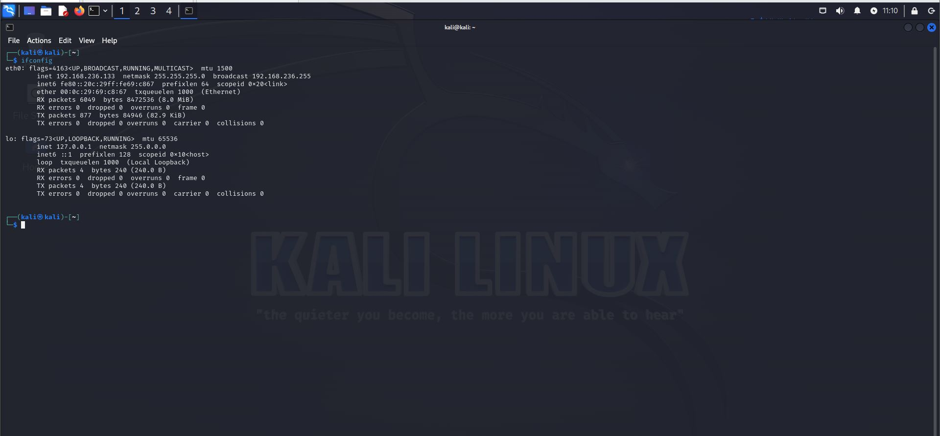

Ubuntu:

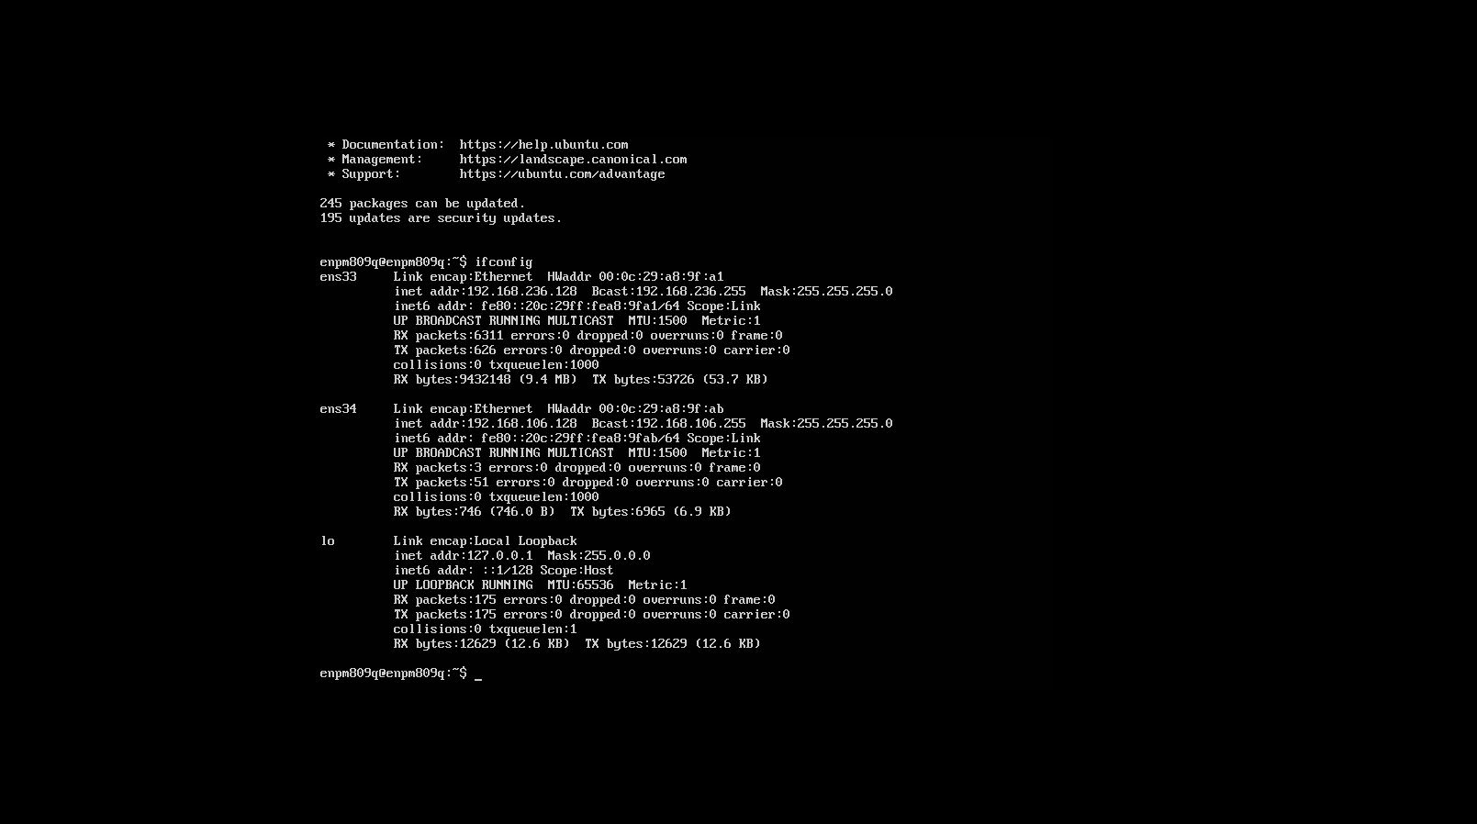

Metasploitable3:

