Name: Rithik Sarvesh Bharathiraja

UID: 120395246 (gbr2001)

Course: ENPM634

Task: Homework2

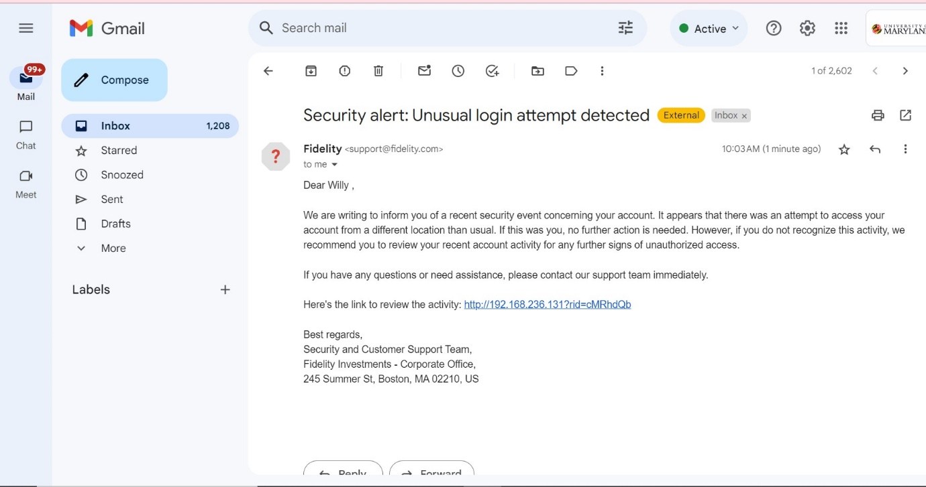

This is the pretext for our beloved CEO of the ENPM634 Memes, Inc. Willy Wonka.

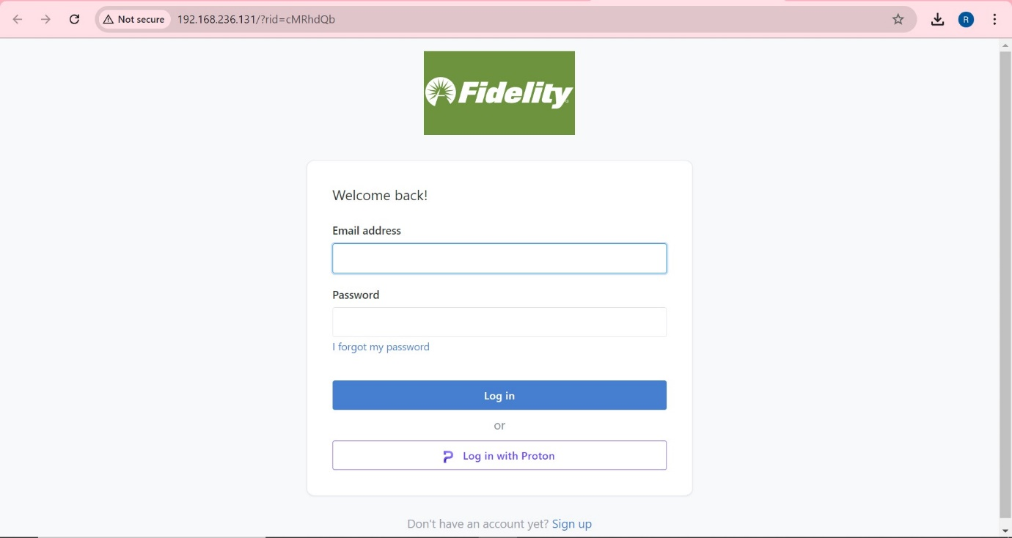

This is the landing page after clicking on the link provided in the phishing email.

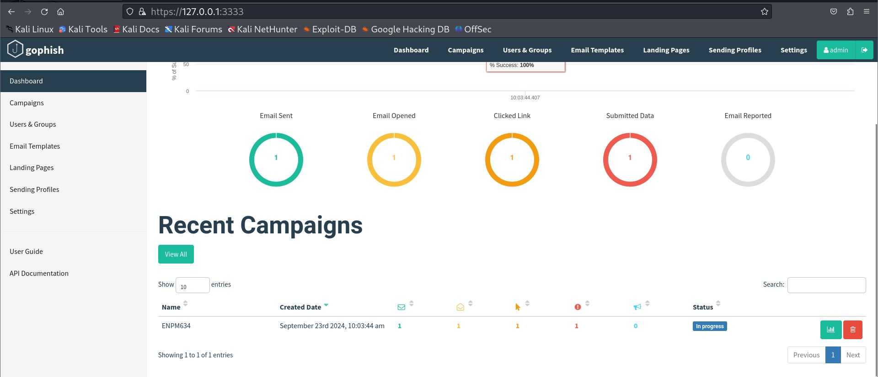

This shows the progress of our campaign.

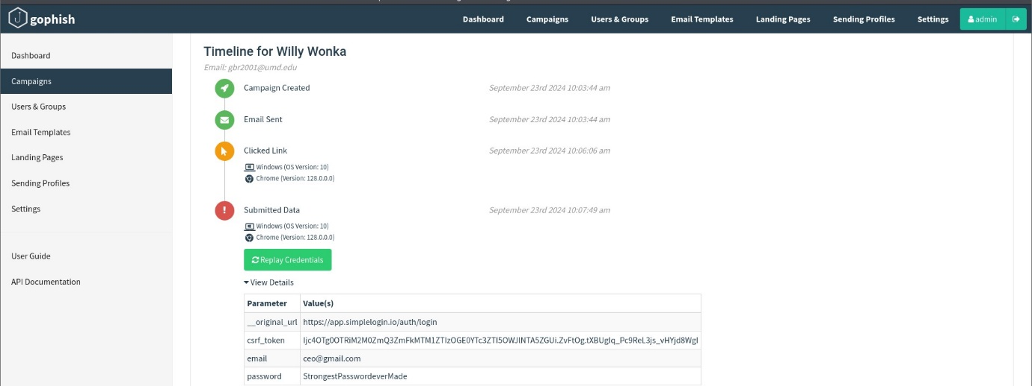

Finally, the credential is harvested through the fake login page.