Name: Rithik Sarvesh Bharathiraja

UID: 120395246

Course: ENPM634

Task: Homework 4

1. NoSQL injection

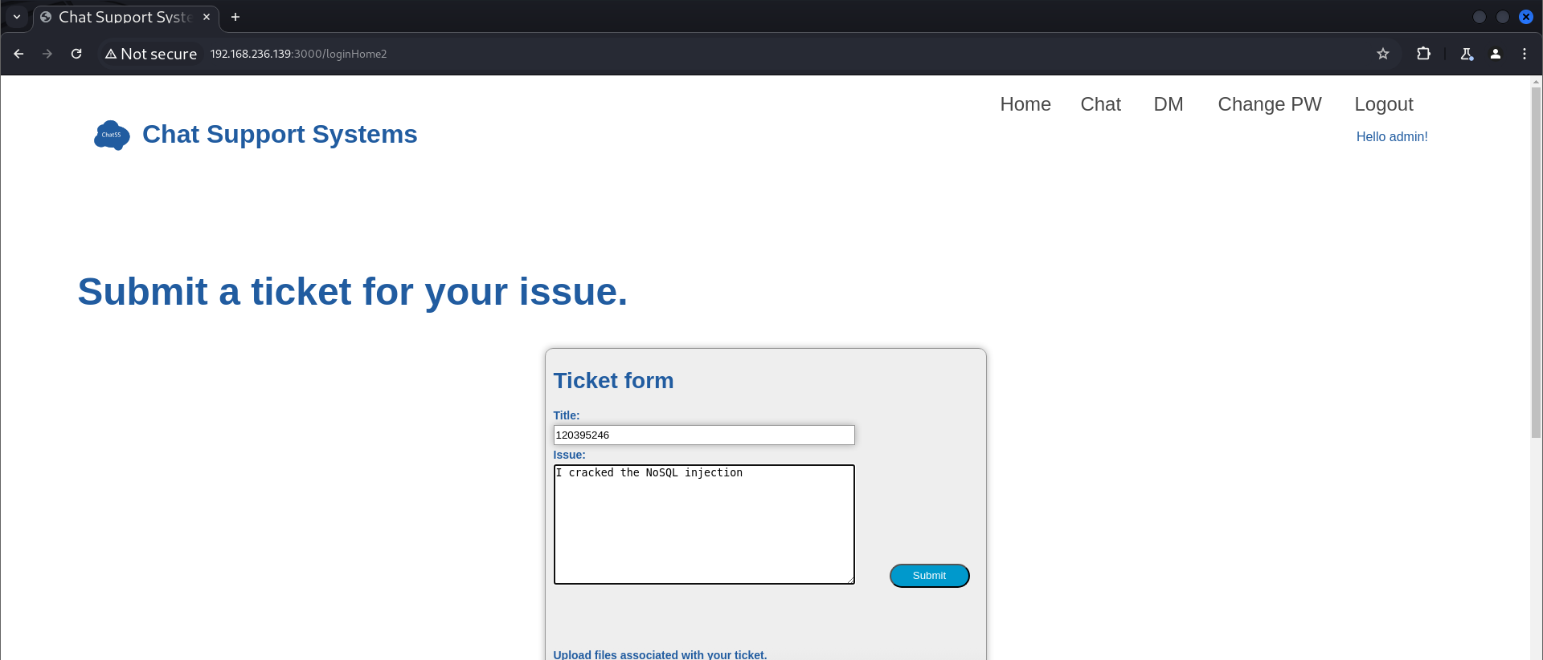

1. Advanced NoSQL injection

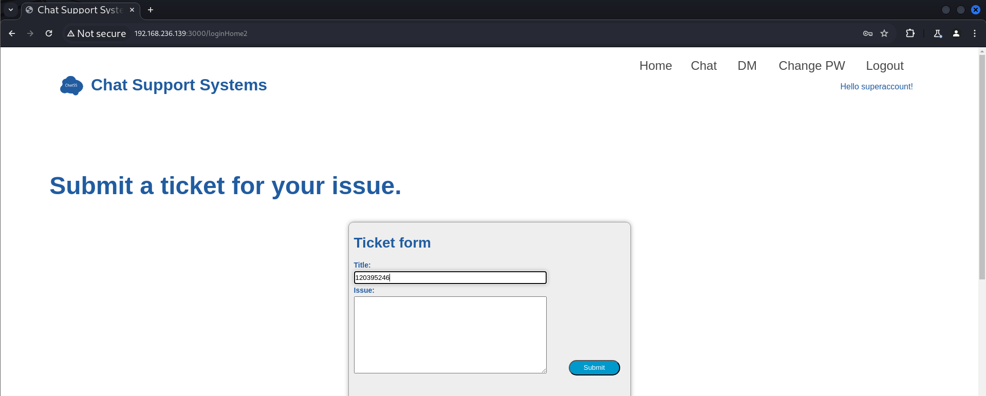

1. User enumeration  
   admin, mike, peter, superaccount. This is the order of the user stored in the NoSQL database found through enumeration by advanced NoSQL injection.
2. Deserialization attack

Payload:

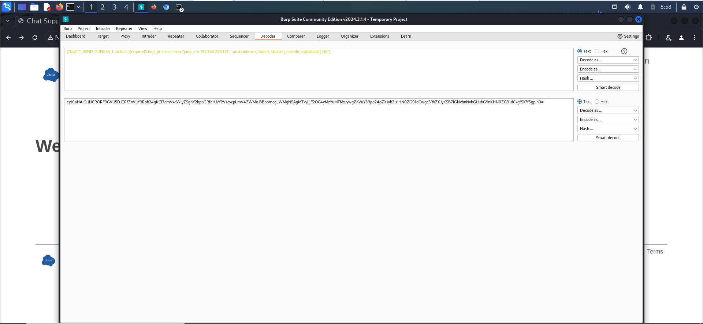

Result:

