HOMEWORK 3 ECE60146
ALEXANDRE OLIVÉ PELLICER

2. Becoming Familiar with the Premier
2.2
Output one_neuron_classifier.py:
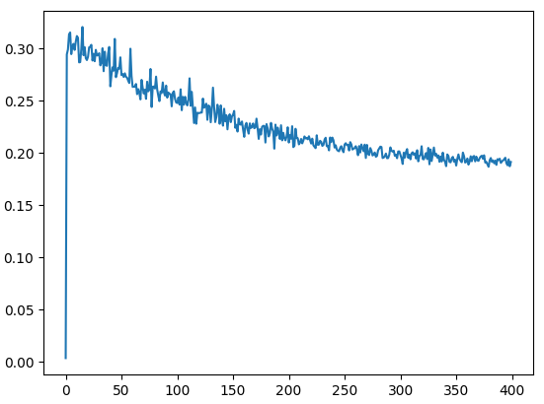
Output multi_neuron_classifier.py:
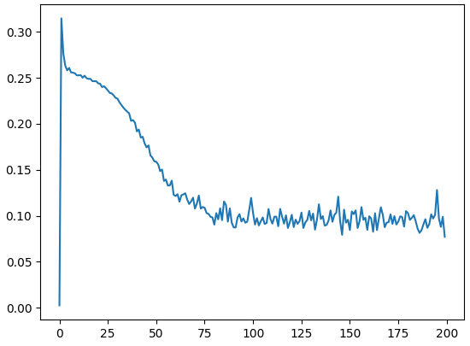

2.3
Output verify_with_torchnn.py comparing to multi_neuron:
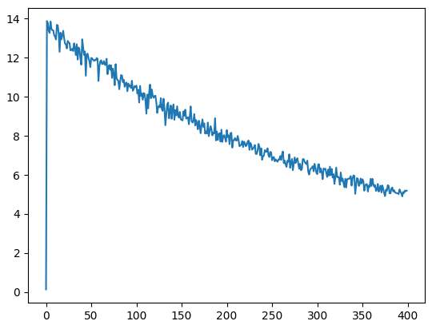
Comparing the obtained graph with the second graph obtained in 2.2 we see that the performance we are obtaining with torch.nn is worse than the performance obtained with the handcrafted network. It is important to mention that the random initialization of the weights affects the performance of the training.
2.4
Output verify_with_torchnn.py comparing to one_neuron learning_rate = 1e-3:
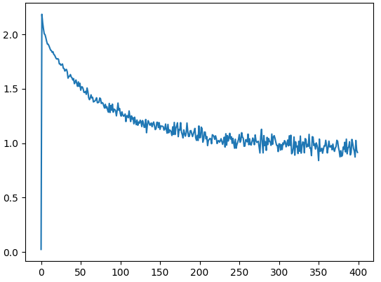
Output verify_with_torchnn.py comparing to one_neuron learning_rate = 5 * 1e-2:
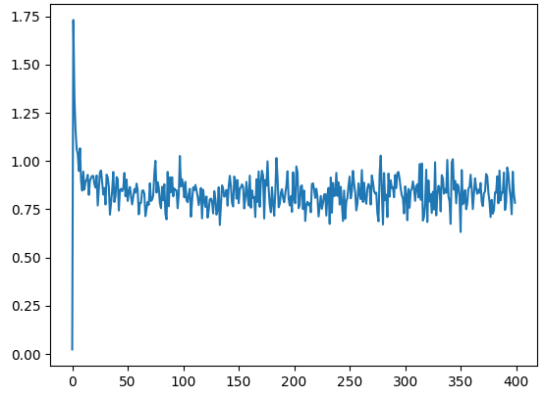
Comparing both obtained graph with the first graph obtained in 2.2 we see that the performance we are obtaining with torch.nn is again worse than the performance obtained with the handcrafted network. It is important to mention that the random initialization of the weights affects the performance of the training.
2.5
The variable I think that corresponds to $μ$ in the torch implementation of SGD is the variable called momentum:
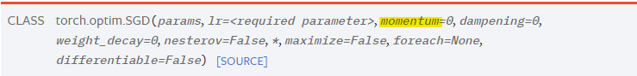
3. Programming Tasks
Description of SGD+
SGD+, also referred to as SGD with momentum, is an extension of the basic SGD method with the addition of momentum. Momentum is introduced to enhance the optimization process by adding a fraction of the previous update to the current update. This helps to smooth out fluctuations in the optimization process and improves convergence.
The update formula is expressed as follows:
$$v_{t+1}= μ* v_{t}+ g_{t+1}$$
$$p_{t+1}= p_{t}-lr* v_{t+1}$$
Where $g_{t+1}$ represents the gradient of the Loss function with respect to the parameters and $μ$ and $lr$ represent the momentum scalar and learning rate respectively.

Description of Adam
Adam is an optimization algorithm that combines ideas from both momentum-based methods and RMSprop. It is known for its efficiency and effectiveness in training deep neural networks.
In Adam, the learning rates are adapted for each parameter individually, based on the first-order moments and second-order moments of the gradients. This adaptability allows Adam to handle sparse gradients.
The update formula is expressed as follows:
$$m_{t+1}= β_{1}* m_{t}+\left(1-β_{1}\right)*g_{t+1}$$
$$v_{t+1}= β_{2}* v_{t}+\left(1-β_{2}\right)*{g_{t+1 }}^{2}$$
$$p_{t+1}= p_{t}-lr* \frac{{\hat{m}}_{t+1}}{\sqrt{{\hat{v}}_{t+1}+ ϵ}}$$
$${\hat{m}}_{t+1}= \frac{m_{t+1}}{1-{β_{1}}^{t+1}}$$
$${\hat{v}}_{t+1}= \frac{v_{t+1}}{1-{β_{2}}^{t+1}}$$

One-neuron classifier plots
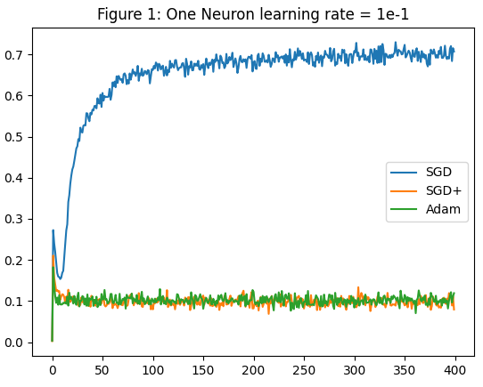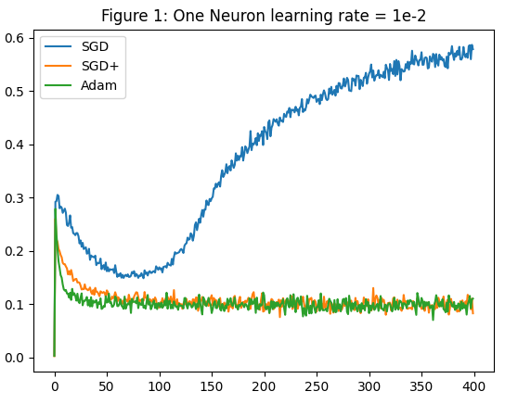
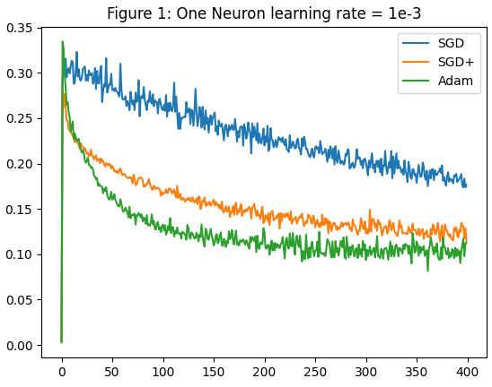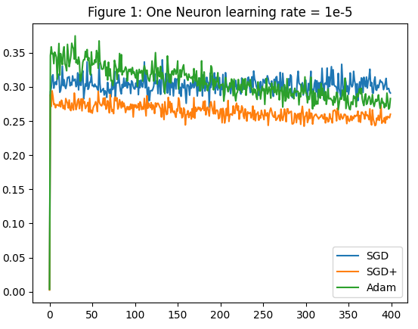
Observations:
With these 3 different plots we can see the influence and the consequences of choosing a specific learning rate for training a model.
We can see that when we use a small learning rate (lr = 1e-5) the steps towards the minimum of the Loss Function are very small. Thus, in the three optimizers we can see that the loss value doesn’t change a lot throughout the different iterations.
When using a learning rate of 1e-3 we can say that we achieve the desired behavior. We can see that SGD+ and Adam optimizers converge to a loss value close to 0.12. The Vanilla SGD also progresses towards this value. We can clearly see that by using SGD+ and Adam the Lost Function converges faster.
Finally, we can also see the consequences of using a high value for the learning rate (lr = 1e-1 and lr = 1e-2). We can see that the Vanillas SGD suffers an exploding loss. This is that SGD overshoots the minimum and starts oscillating or diverging.

Multi-neuron classifier plots
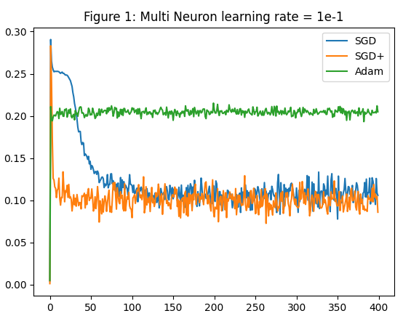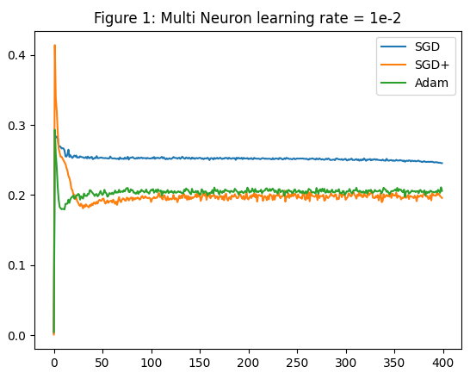
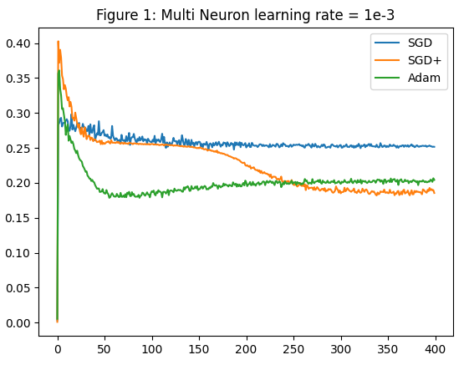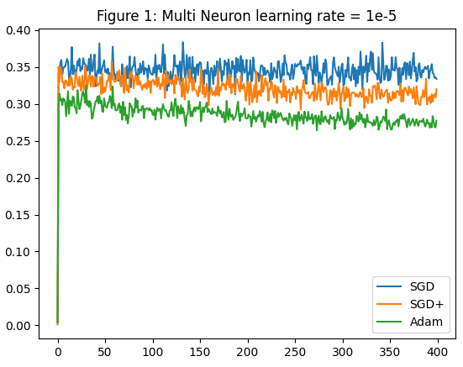
Observations:
From the previous representations we can obtain the following conclusions:
We see that the behavior when using the lr=1e-5 is the same as the one obtained when working with one single neuron.
When using lr=1e-1 we can see that SGD and SGD+ converge towards a value around 0.10. Nevertheless, the Adam optimizer diverges.
When using the lr=1e-2 and lr=1e-3 we see that the 3 optimizers converge to a Loss which is around 0.2. In both cases, we can see that both SGD+ and Adam outperform the Vanilla SGD being SGD+ the one that offers a better performance.

Discussion comparing the performance of the 3 optimizers
From the graphs obtained before we can obtain the following conclusions:
- The 3 optimizers are very sensitive to the value of their hyperparameters. By changing the values of the hyperparameters, the performance can vary a lot.
- When using common values for the learning rates (lr = 0.01 or lr = 0.001) the optimizers SGD+ and Adam always outperform the Vanilla SGD.
- Using learning rates too big or too smalls led to non-desired performances:
  - When the learning rate is very small (1e-5), in the 3 cases the method doesn’t converge to a minimum.
  - When the learning rate is very big (1e-1) we have seen that for the one neuron case the Vanilla SGD diverges and for the multi neuron case, the Adam diverges. Nevertheless, the other optimizers converge.

Discussion comparing the performance of the Adam optimizer under the 9 configurations
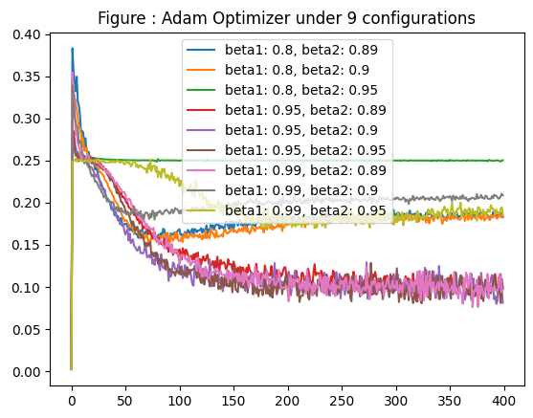
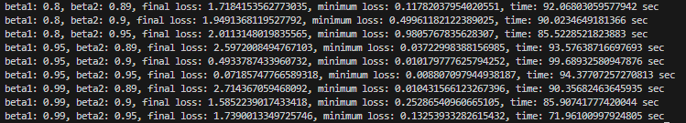
The experiments have been run using:
- Learning rate = 1e-3
- Training iterations = 40000
- Batch size = 8
From the obtained results we can conclude that:
- Again, we can see that the performance of the Adam optimizer is very sensitive to the value of its hyperparameters. We see that changing the value of the betas from 0.8 to 0.99 can lead to a big difference in the performance. Nevertheless, it looks like there are some combinations that offer a similar performance.
- From the obtained results, we see that the best performance is obtained when the values of beta1 and beta2 is the following:
- We can see that there are only 20 seconds of difference between the combination that took more time to train than the one that took less time.

Source code
3 OPTIMIZERS FOR THE ONE NEURON CLASSIFIER
#!/usr/bin/env python

# Code used to evaluate the 3 optimizers for one neuron

import random
import numpy as np
import operator
import matplotlib.pyplot as plt

seed = 0
random.seed(seed)
np.random.seed(seed)

from ComputationalGraphPrimer import *

class NewComputationalGraphPrimer (ComputationalGraphPrimer):
#We override this method for the plot
def run_training_loop_one_neuron_model(self, training_data):
"""
The training loop must first initialize the learnable parameters. Remember, these are the
symbolic names in your input expressions for the neural layer that do not begin with the
letter 'x'. In this case, we are initializing with random numbers from a uniform distribution
over the interval (0,1).
"""
self.vals_for_learnable_params = {param: random.uniform(0,1) for param in self.learnable_params}

self.bias = random.uniform(0,1) ## Adding the bias improves class discrimination.
## We initialize it to a random number.

class DataLoader:
"""
To understand the logic of the dataloader, it would help if you first understand how
the training dataset is created. Search for the following function in this file:

gen_training_data(self)

As you will see in the implementation code for this method, the training dataset
consists of a Python dict with two keys, 0 and 1, the former points to a list of
all Class 0 samples and the latter to a list of all Class 1 samples. In each list,
the data samples are drawn from a multi-dimensional Gaussian distribution. The two
classes have different means and variances. The dimensionality of each data sample
is set by the number of nodes in the input layer of the neural network.

The data loader's job is to construct a batch of samples drawn randomly from the two
lists mentioned above. And it mush also associate the class label with each sample
separately.
"""
def __init__(self, training_data, batch_size):
self.training_data = training_data
self.batch_size = batch_size
self.class_0_samples = [(item, 0) for item in self.training_data[0]] ## Associate label 0 with each sample
self.class_1_samples = [(item, 1) for item in self.training_data[1]] ## Associate label 1 with each sample

def __len__(self):
return len(self.training_data[0]) + len(self.training_data[1])

def _getitem(self):
cointoss = random.choice([0,1]) ## When a batch is created by getbatch(), we want the
## samples to be chosen randomly from the two lists
if cointoss == 0:
return random.choice(self.class_0_samples)
else:
return random.choice(self.class_1_samples)

def getbatch(self):
batch_data,batch_labels = [],[] ## First list for samples, the second for labels
maxval = 0.0 ## For approximate batch data normalization
for _ in range(self.batch_size):
item = self._getitem()
if np.max(item[0]) > maxval:
maxval = np.max(item[0])
batch_data.append(item[0])
batch_labels.append(item[1])
batch_data = [item/maxval for item in batch_data] ## Normalize batch data
batch = [batch_data, batch_labels]
return batch

data_loader = DataLoader(training_data, batch_size=self.batch_size)
loss_running_record_1 = []
i = 0
avg_loss_over_iterations = 0.0 ## Average the loss over iterations for printing out
## every N iterations during the training loop.
for i in range(self.training_iterations):
data = data_loader.getbatch()
data_tuples_in_batch = data[0]
class_labels_in_batch = data[1]
y_preds, deriv_sigmoids = self.forward_prop_one_neuron_model(data_tuples_in_batch) ## FORWARD PROP of data
loss = sum([(abs(class_labels_in_batch[i] - y_preds[i]))**2 for i in range(len(class_labels_in_batch))]) ## Find loss
avg_loss_over_iterations += loss / float(len(class_labels_in_batch))
if i%(self.display_loss_how_often) == 0:
avg_loss_over_iterations /= self.display_loss_how_often
loss_running_record_1.append(avg_loss_over_iterations)
print("[iter=%d] loss = %.4f" % (i+1, avg_loss_over_iterations)) ## Display average loss
avg_loss_over_iterations = 0.0 ## Re-initialize avg loss
y_errors_in_batch = list(map(operator.sub, class_labels_in_batch, y_preds))
self.backprop_and_update_params_one_neuron_model(data_tuples_in_batch, y_preds, y_errors_in_batch, deriv_sigmoids) ## BACKPROP loss
# plt.figure()
# plt.plot(loss_running_record)
# plt.show()
return loss_running_record_1

class SGDPlusComputationalGraphPrimer (ComputationalGraphPrimer):
##MODIFIED CODE---------------------------------------------
#Initialize new atributes
def __init__(self, u=0, *args, **kwargs):
self.u = u
super().__init__(*args, **kwargs)
##END MODIFIED CODE---------------------------------------------

def run_training_loop_one_neuron_model(self, training_data):
"""
The training loop must first initialize the learnable parameters. Remember, these are the
symbolic names in your input expressions for the neural layer that do not begin with the
letter 'x'. In this case, we are initializing with random numbers from a uniform distribution
over the interval (0,1).
"""
self.vals_for_learnable_params = {param: random.uniform(0,1) for param in self.learnable_params}

self.bias = random.uniform(0,1) ## Adding the bias improves class discrimination.
## We initialize it to a random number.
##MODIFIED CODE---------------------------------------------
#We initialize auxiliar variables used to update parameters
self.v_t = {param: 0 for param in self.learnable_params}
self.bias_v_t = 0
##END MODIFIED CODE-----------------------------------------

class DataLoader:
"""
To understand the logic of the dataloader, it would help if you first understand how
the training dataset is created. Search for the following function in this file:

gen_training_data(self)

As you will see in the implementation code for this method, the training dataset
consists of a Python dict with two keys, 0 and 1, the former points to a list of
all Class 0 samples and the latter to a list of all Class 1 samples. In each list,
the data samples are drawn from a multi-dimensional Gaussian distribution. The two
classes have different means and variances. The dimensionality of each data sample
is set by the number of nodes in the input layer of the neural network.

The data loader's job is to construct a batch of samples drawn randomly from the two
lists mentioned above. And it mush also associate the class label with each sample
separately.
"""
def __init__(self, training_data, batch_size):
self.training_data = training_data
self.batch_size = batch_size
self.class_0_samples = [(item, 0) for item in self.training_data[0]] ## Associate label 0 with each sample
self.class_1_samples = [(item, 1) for item in self.training_data[1]] ## Associate label 1 with each sample

def __len__(self):
return len(self.training_data[0]) + len(self.training_data[1])

def _getitem(self):
cointoss = random.choice([0,1]) ## When a batch is created by getbatch(), we want the
## samples to be chosen randomly from the two lists
if cointoss == 0:
return random.choice(self.class_0_samples)
else:
return random.choice(self.class_1_samples)

def getbatch(self):
batch_data,batch_labels = [],[] ## First list for samples, the second for labels
maxval = 0.0 ## For approximate batch data normalization
for _ in range(self.batch_size):
item = self._getitem()
if np.max(item[0]) > maxval:
maxval = np.max(item[0])
batch_data.append(item[0])
batch_labels.append(item[1])
batch_data = [item/maxval for item in batch_data] ## Normalize batch data
batch = [batch_data, batch_labels]
return batch

data_loader = DataLoader(training_data, batch_size=self.batch_size)
loss_running_record_2 = []
i = 0
avg_loss_over_iterations = 0.0 ## Average the loss over iterations for printing out
## every N iterations during the training loop.
for i in range(self.training_iterations):
data = data_loader.getbatch()
data_tuples_in_batch = data[0]
class_labels_in_batch = data[1]
y_preds, deriv_sigmoids = self.forward_prop_one_neuron_model(data_tuples_in_batch) ## FORWARD PROP of data
loss = sum([(abs(class_labels_in_batch[i] - y_preds[i]))**2 for i in range(len(class_labels_in_batch))]) ## Find loss
avg_loss_over_iterations += loss / float(len(class_labels_in_batch))
if i%(self.display_loss_how_often) == 0:
avg_loss_over_iterations /= self.display_loss_how_often
loss_running_record_2.append(avg_loss_over_iterations)
print("[iter=%d] loss = %.4f" % (i+1, avg_loss_over_iterations)) ## Display average loss
avg_loss_over_iterations = 0.0 ## Re-initialize avg loss
y_errors_in_batch = list(map(operator.sub, class_labels_in_batch, y_preds))
self.backprop_and_update_params_one_neuron_model(data_tuples_in_batch, y_preds, y_errors_in_batch, deriv_sigmoids) ## BACKPROP loss
# plt.figure()
# plt.plot(loss_running_record)
# plt.show()
return loss_running_record_2

def backprop_and_update_params_one_neuron_model(self, data_tuples_in_batch, predictions, y_errors_in_batch, deriv_sigmoids):
"""
This function implements the equations shown on Slide 61 of my Week 3 presentation in our DL
class at Purdue. All four parameters defined above are lists of what was either supplied to the
forward prop function or calculated by it for each training data sample in a batch.
"""
input_vars = self.independent_vars
input_vars_to_param_map = self.var_to_var_param[self.output_vars[0]] ## These two statements align the
param_to_vars_map = {param : var for var, param in input_vars_to_param_map.items()} ## the input vars
vals_for_learnable_params = self.vals_for_learnable_params
for i,param in enumerate(self.vals_for_learnable_params):
## For each param, sum the partials from every training data sample in batch
partial_of_loss_wrt_param = 0.0
for j in range(self.batch_size):
vals_for_input_vars_dict = dict(zip(input_vars, list(data_tuples_in_batch[j])))
partial_of_loss_wrt_param += - y_errors_in_batch[j] * vals_for_input_vars_dict[param_to_vars_map[param]] * deriv_sigmoids[j]
partial_of_loss_wrt_param /= float(self.batch_size)

##MODIFIED CODE---------------------------------------------
#Apply SGD+ formulas
#NESTEROV
v_t_plus_1 = self.u * self.v_t[param] + partial_of_loss_wrt_param
step = self.learning_rate * v_t_plus_1
self.vals_for_learnable_params[param] -= step
self.v_t[param] = v_t_plus_1

partial_of_loss_wrt_param=0.0
for j in range(self.batch_size):
#We keep the consistency of using a negative value for the partial_of_loss_wrt_param as given in the initial code for the weights
partial_of_loss_wrt_param += - y_errors_in_batch[j] * deriv_sigmoids[j]
partial_of_loss_wrt_param /= float(self.batch_size)

#Apply SGD+ formulas
#NESTEROV
bias_v_t_plus_1 = self.u * self.bias_v_t + partial_of_loss_wrt_param
step_bias = self.learning_rate * bias_v_t_plus_1
self.bias -= step_bias
self.bias_v_t = bias_v_t_plus_1
##END MODIFIED CODE---------------------------------------------

class AdamComputationalGraphPrimer (ComputationalGraphPrimer):
##MODIFIED CODE---------------------------------------------
#Initialize new atributes
def __init__(self, epsilon, beta1=0, beta2=0, *args, **kwargs):
self.beta1 = beta1
self.beta2 = beta2
self.epsilon = epsilon
super().__init__(*args, **kwargs)
##END MODIFIED CODE---------------------------------------------

def backprop_and_update_params_one_neuron_model(self, data_tuples_in_batch, predictions, y_errors_in_batch, deriv_sigmoids, t):
"""
This function implements the equations shown on Slide 61 of my Week 3 presentation in our DL
class at Purdue. All four parameters defined above are lists of what was either supplied to the
forward prop function or calculated by it for each training data sample in a batch.
"""
input_vars = self.independent_vars
input_vars_to_param_map = self.var_to_var_param[self.output_vars[0]] ## These two statements align the
param_to_vars_map = {param : var for var, param in input_vars_to_param_map.items()} ## the input vars
vals_for_learnable_params = self.vals_for_learnable_params
for i,param in enumerate(self.vals_for_learnable_params):
## For each param, sum the partials from every training data sample in batch
partial_of_loss_wrt_param = 0.0
for j in range(self.batch_size):
vals_for_input_vars_dict = dict(zip(input_vars, list(data_tuples_in_batch[j])))
partial_of_loss_wrt_param += - y_errors_in_batch[j] * vals_for_input_vars_dict[param_to_vars_map[param]] * deriv_sigmoids[j]
partial_of_loss_wrt_param /= float(self.batch_size)

##MODIFIED CODE---------------------------------------------
#Apply Adam formulas
m_t_plus_1 = self.beta1 * self.m_t[param] + (1 - self.beta1) * partial_of_loss_wrt_param
v_t_plus_1 = self.beta2 * self.v_t[param] + (1 - self.beta2) * (partial_of_loss_wrt_param**2)

m_t_plus_1_hat = m_t_plus_1 / (1 - self.beta1**t)
v_t_plus_1_hat = v_t_plus_1 / (1 - self.beta2**t)

step = self.learning_rate * (m_t_plus_1_hat / np.sqrt(v_t_plus_1_hat + self.epsilon))
self.vals_for_learnable_params[param] -= step

self.v_t[param] = v_t_plus_1
self.m_t[param] = m_t_plus_1

partial_of_loss_wrt_param=0.0
for j in range(self.batch_size):
#We keep the consistency of using a negative value for the partial_of_loss_wrt_param as given in the initial code for the weights
partial_of_loss_wrt_param += - y_errors_in_batch[j] * deriv_sigmoids[j]
partial_of_loss_wrt_param /= float(self.batch_size)

#Apply Adam formulas
bias_m_t_plus_1 = self.beta1 * self.bias_m_t + (1 - self.beta1) * (partial_of_loss_wrt_param)
bias_v_t_plus_1 = self.beta2 * self.bias_v_t + (1 - self.beta2) * (partial_of_loss_wrt_param**2)

bias_m_t_plus_1_hat = bias_m_t_plus_1 / (1 - self.beta1**t)
bias_v_t_plus_1_hat = bias_v_t_plus_1 / (1 - self.beta2**t)

bias_step = self.learning_rate * (bias_m_t_plus_1_hat / np.sqrt(bias_v_t_plus_1_hat + self.epsilon))

self.bias -= bias_step

self.bias_v_t = bias_v_t_plus_1
self.bias_m_t = bias_m_t_plus_1
##END MODIFIED CODE---------------------------------------------

def run_training_loop_one_neuron_model(self, training_data):
"""
The training loop must first initialize the learnable parameters. Remember, these are the
symbolic names in your input expressions for the neural layer that do not begin with the
letter 'x'. In this case, we are initializing with random numbers from a uniform distribution
over the interval (0,1).
"""
self.vals_for_learnable_params = {param: random.uniform(0,1) for param in self.learnable_params}

self.bias = random.uniform(0,1) ## Adding the bias improves class discrimination.
## We initialize it to a random number.
##MODIFIED CODE---------------------------------------------
#We initialize auxiliar variables used to update parameters
self.m_t = {param: 0 for param in self.learnable_params}
self.v_t = {param: 0 for param in self.learnable_params}
self.bias_m_t = 0
self.bias_v_t = 0
##END MODIFIED CODE-----------------------------------------

class DataLoader:
"""
To understand the logic of the dataloader, it would help if you first understand how
the training dataset is created. Search for the following function in this file:

gen_training_data(self)

As you will see in the implementation code for this method, the training dataset
consists of a Python dict with two keys, 0 and 1, the former points to a list of
all Class 0 samples and the latter to a list of all Class 1 samples. In each list,
the data samples are drawn from a multi-dimensional Gaussian distribution. The two
classes have different means and variances. The dimensionality of each data sample
is set by the number of nodes in the input layer of the neural network.

The data loader's job is to construct a batch of samples drawn randomly from the two
lists mentioned above. And it mush also associate the class label with each sample
separately.
"""
def __init__(self, training_data, batch_size):
self.training_data = training_data
self.batch_size = batch_size
self.class_0_samples = [(item, 0) for item in self.training_data[0]] ## Associate label 0 with each sample
self.class_1_samples = [(item, 1) for item in self.training_data[1]] ## Associate label 1 with each sample

def __len__(self):
return len(self.training_data[0]) + len(self.training_data[1])

def _getitem(self):
cointoss = random.choice([0,1]) ## When a batch is created by getbatch(), we want the
## samples to be chosen randomly from the two lists
if cointoss == 0:
return random.choice(self.class_0_samples)
else:
return random.choice(self.class_1_samples)

def getbatch(self):
batch_data,batch_labels = [],[] ## First list for samples, the second for labels
maxval = 0.0 ## For approximate batch data normalization
for _ in range(self.batch_size):
item = self._getitem()
if np.max(item[0]) > maxval:
maxval = np.max(item[0])
batch_data.append(item[0])
batch_labels.append(item[1])
batch_data = [item/maxval for item in batch_data] ## Normalize batch data
batch = [batch_data, batch_labels]
return batch

data_loader = DataLoader(training_data, batch_size=self.batch_size)
loss_running_record = []
i = 0
avg_loss_over_iterations = 0.0 ## Average the loss over iterations for printing out
## every N iterations during the training loop.
for i in range(self.training_iterations):
data = data_loader.getbatch()
data_tuples_in_batch = data[0]
class_labels_in_batch = data[1]
y_preds, deriv_sigmoids = self.forward_prop_one_neuron_model(data_tuples_in_batch) ## FORWARD PROP of data
loss = sum([(abs(class_labels_in_batch[i] - y_preds[i]))**2 for i in range(len(class_labels_in_batch))]) ## Find loss
avg_loss_over_iterations += loss / float(len(class_labels_in_batch))
if i%(self.display_loss_how_often) == 0:
avg_loss_over_iterations /= self.display_loss_how_often
loss_running_record.append(avg_loss_over_iterations)
print("[iter=%d] loss = %.4f" % (i+1, avg_loss_over_iterations)) ## Display average loss
avg_loss_over_iterations = 0.0 ## Re-initialize avg loss
y_errors_in_batch = list(map(operator.sub, class_labels_in_batch, y_preds))

### CODE MODIFIED----------------------------------------------------
#We pass the iteration useful to update the parameters with Adam
self.backprop_and_update_params_one_neuron_model(data_tuples_in_batch, y_preds, y_errors_in_batch, deriv_sigmoids, t = i+1) ## BACKPROP loss
### END CODE MODIFIED----------------------------------------------------

# plt.figure()
# plt.plot(loss_running_record)
# plt.show()
return loss_running_record

#Run the training using the 3 optimizers and plotting the results
cgp = NewComputationalGraphPrimer(
one_neuron_model = True,
expressions = ['xw=ab*xa+bc*xb+cd*xc+ac*xd'],
output_vars = ['xw'],
dataset_size = 5000,
learning_rate = 1e-2,
training_iterations = 40000,
batch_size = 8,
display_loss_how_often = 100,
debug = True,
)

cgp.parse_expressions()
training_data_cgp = cgp.gen_training_data()
SGD_loss = cgp.run_training_loop_one_neuron_model( training_data_cgp )

cgp_SGDPlus = SGDPlusComputationalGraphPrimer(
one_neuron_model = True,
expressions = ['xw=ab*xa+bc*xb+cd*xc+ac*xd'],
output_vars = ['xw'],
dataset_size = 5000,
learning_rate = 1e-2,
training_iterations = 40000,
batch_size = 8,
display_loss_how_often = 100,
debug = True,
u = 0.9
)

cgp_SGDPlus.parse_expressions()
training_data_cgp_SGDPlus = cgp_SGDPlus.gen_training_data()
SGD_plus_loss = cgp_SGDPlus.run_training_loop_one_neuron_model( training_data_cgp_SGDPlus )

cgp_Adam = AdamComputationalGraphPrimer(
one_neuron_model = True,
expressions = ['xw=ab*xa+bc*xb+cd*xc+ac*xd'],
output_vars = ['xw'],
dataset_size = 5000,
learning_rate = 1e-2,
training_iterations = 40000,
batch_size = 8,
display_loss_how_often = 100,
debug = True,
beta1 = 0.9,
beta2 = 0.99,
epsilon = 1e-8
)

cgp_Adam.parse_expressions()
training_data_cgp_Adam = cgp_Adam.gen_training_data()
SGD_adam_loss = cgp_Adam.run_training_loop_one_neuron_model( training_data_cgp_Adam )

plt.figure()
plt.plot(SGD_loss)
plt.plot(SGD_plus_loss)
plt.plot(SGD_adam_loss)
plt.legend(["SGD","SGD+","Adam"])
plt.title("Figure 1: One Neuron learning rate = 1e-2")
plt.show()

3 OPTIMIZERS FOR THE MULTI NEURON CLASSIFIER
#!/usr/bin/env python

# Code used to evaluate the 3 optimizers for multi neuron
import random
import numpy as np
import operator
import matplotlib.pyplot as plt

seed = 0
random.seed(seed)
np.random.seed(seed)

from ComputationalGraphPrimer import *

class New_Multi_ComputationalGraphPrimer (ComputationalGraphPrimer):
#We override this method for the plot
def run_training_loop_multi_neuron_model(self, training_data):

class DataLoader:
"""
To understand the logic of the dataloader, it would help if you first understand how
the training dataset is created. Search for the following function in this file:

gen_training_data(self)

As you will see in the implementation code for this method, the training dataset
consists of a Python dict with two keys, 0 and 1, the former points to a list of
all Class 0 samples and the latter to a list of all Class 1 samples. In each list,
the data samples are drawn from a multi-dimensional Gaussian distribution. The two
classes have different means and variances. The dimensionality of each data sample
is set by the number of nodes in the input layer of the neural network.

The data loader's job is to construct a batch of samples drawn randomly from the two
lists mentioned above. And it mush also associate the class label with each sample
separately.
"""
def __init__(self, training_data, batch_size):
self.training_data = training_data
self.batch_size = batch_size
self.class_0_samples = [(item, 0) for item in self.training_data[0]] ## Associate label 0 with each sample
self.class_1_samples = [(item, 1) for item in self.training_data[1]] ## Associate label 1 with each sample

def __len__(self):
return len(self.training_data[0]) + len(self.training_data[1])

def _getitem(self):
cointoss = random.choice([0,1]) ## When a batch is created by getbatch(), we want the
## samples to be chosen randomly from the two lists
if cointoss == 0:
return random.choice(self.class_0_samples)
else:
return random.choice(self.class_1_samples)

def getbatch(self):
batch_data,batch_labels = [],[] ## First list for samples, the second for labels
maxval = 0.0 ## For approximate batch data normalization
for _ in range(self.batch_size):
item = self._getitem()
if np.max(item[0]) > maxval:
maxval = np.max(item[0])
batch_data.append(item[0])
batch_labels.append(item[1])
batch_data = [item/maxval for item in batch_data] ## Normalize batch data
batch = [batch_data, batch_labels]
return batch

## The training loop must first initialize the learnable parameters. Remember, these are the
## symbolic names in your input expressions for the neural layer that do not begin with the
## letter 'x'. In this case, we are initializing with random numbers from a uniform distribution
## over the interval (0,1):
self.vals_for_learnable_params = {param: random.uniform(0,1) for param in self.learnable_params}
## In the same manner, we must also initialize the biases at each node that aggregates forward
## propagating data:
self.bias = {i : [random.uniform(0,1) for j in range( self.layers_config[i] ) ] for i in range(1, self.num_layers)}
data_loader = DataLoader(training_data, batch_size=self.batch_size)
loss_running_record = []
i = 0
avg_loss_over_iterations = 0.0 ## Average the loss over iterations for printing out
## every N iterations during the training loop.
for i in range(self.training_iterations):
data = data_loader.getbatch()
data_tuples = data[0]
class_labels = data[1]
self.forward_prop_multi_neuron_model(data_tuples) ## FORW PROP works by side-effect
predicted_labels_for_batch = self.forw_prop_vals_at_layers[self.num_layers-1] ## Predictions from FORW PROP
y_preds = [item for sublist in predicted_labels_for_batch for item in sublist] ## Get numeric vals for predictions
loss = sum([(abs(class_labels[i] - y_preds[i]))**2 for i in range(len(class_labels))]) ## Calculate loss for batch
loss_avg = loss / float(len(class_labels)) ## Average the loss over batch
avg_loss_over_iterations += loss_avg ## Add to Average loss over iterations
if i%(self.display_loss_how_often) == 0:
avg_loss_over_iterations /= self.display_loss_how_often
loss_running_record.append(avg_loss_over_iterations)
print("[iter=%d] loss = %.4f" % (i+1, avg_loss_over_iterations)) ## Display avg loss
avg_loss_over_iterations = 0.0 ## Re-initialize avg-over-iterations loss
y_errors_in_batch = list(map(operator.sub, class_labels, y_preds))
self.backprop_and_update_params_multi_neuron_model(y_preds, y_errors_in_batch)
# plt.figure()
# plt.plot(loss_running_record)
# plt.show()
return loss_running_record

class SGDPlus_Multi_ComputationalGraphPrimer(ComputationalGraphPrimer):
##MODIFIED CODE---------------------------------------------
#Initialize new atributes
def __init__(self, u=0, *args, **kwargs):
self.u = u
super().__init__(*args, **kwargs)
##END MODIFIED CODE---------------------------------------------

def backprop_and_update_params_multi_neuron_model(self, predictions, y_errors):
"""
First note that loop index variable 'back_layer_index' starts with the index of
the last layer. For the 3-layer example shown for 'forward', back_layer_index
starts with a value of 2, its next value is 1, and that's it.

In the code below, the outermost loop is over the data samples in a batch. As shown
on Slide 73 of my Week 3 lecture, in order to calculate the partials of Loss with
respect to the learnable params, we need to backprop the prediction errors and
the gradients of the Sigmoid. For the purpose of satisfying the requirements of
SGD, the backprop of the prediction errors and the gradients needs to be carried
out separately for each training data sample in a batch. That's what the outer
loop is for.

After we exit the outermost loop, we average over the results obtained from each
training data sample in a batch.

Pay attention to the variable 'vars_in_layer'. These store the node variables in
the current layer during backpropagation.
"""
## Eq. (24) on Slide 73 of my Week 3 lecture says we need to store backproped errors in each layer leading up to the last:
pred_err_backproped_at_layers = [ {i : [None for j in range( self.layers_config[i] ) ]
for i in range(self.num_layers)} for _ in range(self.batch_size) ]
## This will store "\delta L / \delta w" you see at the LHS of the equations on Slide 73:
partial_of_loss_wrt_params = {param : 0.0 for param in self.all_params}
## For estimating the changes to the bias to be made on the basis of the derivatives of the Sigmoids:
bias_changes = {i : [0.0 for j in range( self.layers_config[i] ) ] for i in range(1, self.num_layers)}
for b in range(self.batch_size):
pred_err_backproped_at_layers[b][self.num_layers - 1] = [ y_errors[b] ]
for back_layer_index in reversed(range(1,self.num_layers)): ## For the 3-layer network, the first val for back_layer_index is 2 for the 3rd layer
input_vals = self.forw_prop_vals_at_layers[back_layer_index -1] ## This is a list of 8 two-element lists --- since we have two nodes in the 2nd layer
deriv_sigmoids = self.gradient_vals_for_layers[back_layer_index] ## This is a list eight one-element lists, one for each batch element
vars_in_layer = self.layer_vars[back_layer_index] ## A list like ['xo']
vars_in_next_layer_back = self.layer_vars[back_layer_index - 1] ## A list like ['xw', 'xz']

vals_for_input_vars_dict = dict(zip(vars_in_next_layer_back, self.forw_prop_vals_at_layers[back_layer_index - 1][b]))
## For the next statement, note that layer_params are stored in a dict like
## {1: [['ap', 'aq', 'ar', 'as'], ['bp', 'bq', 'br', 'bs']], 2: [['cp', 'cq']]}
## "layer_params[idx]" is a list of lists for the link weights in layer whose output nodes are in layer "idx"

layer_params = self.layer_params[back_layer_index]
transposed_layer_params = list(zip(*layer_params)) ## Creating a transpose of the link matrix, See Eq. 30 on Slide 77

for k,var1 in enumerate(vars_in_next_layer_back):
for j,var2 in enumerate(vars_in_layer):
pred_err_backproped_at_layers[b][back_layer_index - 1][k] = sum([self.vals_for_learnable_params[transposed_layer_params[k][i]]
* pred_err_backproped_at_layers[b][back_layer_index][i]
for i in range(len(vars_in_layer))])
for j,var in enumerate(vars_in_layer):
layer_params = self.layer_params[back_layer_index][j] ## ['cp', 'cq'] for the end layer
input_vars_to_param_map = self.var_to_var_param[var] ## These two statements align the {'xw': 'cp', 'xz': 'cq'}
param_to_vars_map = {param : var for var, param in input_vars_to_param_map.items()} ## and the input vars {'cp': 'xw', 'cq': 'xz'}

## Update the partials of Loss wrt to the learnable parameters between the current layer
## and the previous layer. You are accumulating these partials over the different training
## data samples in the batch being processed. For each training data sample, the formula
## being used is shown in Eq. (29) on Slide 77 of my Week 3 slides:
for i,param in enumerate(layer_params):
partial_of_loss_wrt_params[param] += pred_err_backproped_at_layers[b][back_layer_index][j] * \
vals_for_input_vars_dict[param_to_vars_map[param]] * deriv_sigmoids[b][j]
## We will now estimate the change in the bias that needs to be made at each node in the previous layer
## from the derivatives the sigmoid at the nodes in the current layer and the prediction error as
## backproped to the previous layer nodes:
for k,var1 in enumerate(vars_in_next_layer_back):
for j,var2 in enumerate(vars_in_layer):
if back_layer_index-1 > 0:
bias_changes[back_layer_index-1][k] += pred_err_backproped_at_layers[b][back_layer_index - 1][k] * deriv_sigmoids[b][j]

##MODIFIED CODE---------------------------------------------
## Now update the learnable parameters. The loop shown below carries out SGD mandated averaging
for param in partial_of_loss_wrt_params:
#We keep the consistency of using a negative value for the partial_of_loss_wrt_param as given in the initial code
#Apply SGD+ formulas
partial_of_loss_wrt_param = - partial_of_loss_wrt_params[param] / float(self.batch_size)

v_t_plus_1 = self.u * self.v_t[param] + partial_of_loss_wrt_param
step = self.learning_rate * v_t_plus_1
self.vals_for_learnable_params[param] -= step
self.v_t[param] = v_t_plus_1

## Finally we update the biases at all the nodes that aggregate data:
for layer_index in range(1,self.num_layers):
for k in range(self.layers_config[layer_index]):
#We keep the consistency of using a negative value for the partial_of_loss_wrt_param as given in the initial code
#Apply SGD+ formulas
bias_v_t_plus_1 = self.u * self.bias_v_t[layer_index][k] - ( bias_changes[layer_index][k] / float(self.batch_size) )
step_bias = self.learning_rate * bias_v_t_plus_1
self.bias[layer_index][k] -= step_bias
self.bias_v_t[layer_index][k] = bias_v_t_plus_1
##END MODIFIED CODE---------------------------------------------

def run_training_loop_multi_neuron_model(self, training_data):

class DataLoader:
"""
To understand the logic of the dataloader, it would help if you first understand how
the training dataset is created. Search for the following function in this file:

gen_training_data(self)

As you will see in the implementation code for this method, the training dataset
consists of a Python dict with two keys, 0 and 1, the former points to a list of
all Class 0 samples and the latter to a list of all Class 1 samples. In each list,
the data samples are drawn from a multi-dimensional Gaussian distribution. The two
classes have different means and variances. The dimensionality of each data sample
is set by the number of nodes in the input layer of the neural network.

The data loader's job is to construct a batch of samples drawn randomly from the two
lists mentioned above. And it mush also associate the class label with each sample
separately.
"""
def __init__(self, training_data, batch_size):
self.training_data = training_data
self.batch_size = batch_size
self.class_0_samples = [(item, 0) for item in self.training_data[0]] ## Associate label 0 with each sample
self.class_1_samples = [(item, 1) for item in self.training_data[1]] ## Associate label 1 with each sample

def __len__(self):
return len(self.training_data[0]) + len(self.training_data[1])

def _getitem(self):
cointoss = random.choice([0,1]) ## When a batch is created by getbatch(), we want the
## samples to be chosen randomly from the two lists
if cointoss == 0:
return random.choice(self.class_0_samples)
else:
return random.choice(self.class_1_samples)

def getbatch(self):
batch_data,batch_labels = [],[] ## First list for samples, the second for labels
maxval = 0.0 ## For approximate batch data normalization
for _ in range(self.batch_size):
item = self._getitem()
if np.max(item[0]) > maxval:
maxval = np.max(item[0])
batch_data.append(item[0])
batch_labels.append(item[1])
batch_data = [item/maxval for item in batch_data] ## Normalize batch data
batch = [batch_data, batch_labels]
return batch

## The training loop must first initialize the learnable parameters. Remember, these are the
## symbolic names in your input expressions for the neural layer that do not begin with the
## letter 'x'. In this case, we are initializing with random numbers from a uniform distribution
## over the interval (0,1):
self.vals_for_learnable_params = {param: random.uniform(0,1) for param in self.learnable_params}
## In the same manner, we must also initialize the biases at each node that aggregates forward
## propagating data:
self.bias = {i : [random.uniform(0,1) for j in range( self.layers_config[i] ) ] for i in range(1, self.num_layers)}
data_loader = DataLoader(training_data, batch_size=self.batch_size)
loss_running_record = []
i = 0
avg_loss_over_iterations = 0.0 ## Average the loss over iterations for printing out
## every N iterations during the training loop.
##MODIFIED CODE---------------------------------------------
#We initialize auxiliar variables used to update parameters
self.v_t = {param: 0 for param in self.learnable_params}
self.bias_v_t = {i : [0 for j in range( self.layers_config[i] ) ] for i in range(1, self.num_layers)}
##END MODIFIED CODE-----------------------------------------

for i in range(self.training_iterations):
data = data_loader.getbatch()
data_tuples = data[0]
class_labels = data[1]
self.forward_prop_multi_neuron_model(data_tuples) ## FORW PROP works by side-effect
predicted_labels_for_batch = self.forw_prop_vals_at_layers[self.num_layers-1] ## Predictions from FORW PROP
y_preds = [item for sublist in predicted_labels_for_batch for item in sublist] ## Get numeric vals for predictions
loss = sum([(abs(class_labels[i] - y_preds[i]))**2 for i in range(len(class_labels))]) ## Calculate loss for batch
loss_avg = loss / float(len(class_labels)) ## Average the loss over batch
avg_loss_over_iterations += loss_avg ## Add to Average loss over iterations
if i%(self.display_loss_how_often) == 0:
avg_loss_over_iterations /= self.display_loss_how_often
loss_running_record.append(avg_loss_over_iterations)
print("[iter=%d] loss = %.4f" % (i+1, avg_loss_over_iterations)) ## Display avg loss
avg_loss_over_iterations = 0.0 ## Re-initialize avg-over-iterations loss
y_errors_in_batch = list(map(operator.sub, class_labels, y_preds))
self.backprop_and_update_params_multi_neuron_model(y_preds, y_errors_in_batch)
# plt.figure()
# plt.plot(loss_running_record)
# plt.show()
return loss_running_record

class Adam_Multi_ComputationalGraphPrimer(ComputationalGraphPrimer):
##MODIFIED CODE---------------------------------------------
#Initialize new atributes
def __init__(self, beta1=0, beta2=0, *args, **kwargs):
self.beta1 = beta1
self.beta2 = beta2
self.epsilon = 1e-8
super().__init__(*args, **kwargs)
##END MODIFIED CODE---------------------------------------------

def backprop_and_update_params_multi_neuron_model(self, predictions, y_errors, t):
"""
First note that loop index variable 'back_layer_index' starts with the index of
the last layer. For the 3-layer example shown for 'forward', back_layer_index
starts with a value of 2, its next value is 1, and that's it.

In the code below, the outermost loop is over the data samples in a batch. As shown
on Slide 73 of my Week 3 lecture, in order to calculate the partials of Loss with
respect to the learnable params, we need to backprop the prediction errors and
the gradients of the Sigmoid. For the purpose of satisfying the requirements of
SGD, the backprop of the prediction errors and the gradients needs to be carried
out separately for each training data sample in a batch. That's what the outer
loop is for.

After we exit the outermost loop, we average over the results obtained from each
training data sample in a batch.

Pay attention to the variable 'vars_in_layer'. These store the node variables in
the current layer during backpropagation.
"""
## Eq. (24) on Slide 73 of my Week 3 lecture says we need to store backproped errors in each layer leading up to the last:
pred_err_backproped_at_layers = [ {i : [None for j in range( self.layers_config[i] ) ]
for i in range(self.num_layers)} for _ in range(self.batch_size) ]
## This will store "\delta L / \delta w" you see at the LHS of the equations on Slide 73:
partial_of_loss_wrt_params = {param : 0.0 for param in self.all_params}
## For estimating the changes to the bias to be made on the basis of the derivatives of the Sigmoids:
bias_changes = {i : [0.0 for j in range( self.layers_config[i] ) ] for i in range(1, self.num_layers)}
for b in range(self.batch_size):
pred_err_backproped_at_layers[b][self.num_layers - 1] = [ y_errors[b] ]
for back_layer_index in reversed(range(1,self.num_layers)): ## For the 3-layer network, the first val for back_layer_index is 2 for the 3rd layer
input_vals = self.forw_prop_vals_at_layers[back_layer_index -1] ## This is a list of 8 two-element lists --- since we have two nodes in the 2nd layer
deriv_sigmoids = self.gradient_vals_for_layers[back_layer_index] ## This is a list eight one-element lists, one for each batch element
vars_in_layer = self.layer_vars[back_layer_index] ## A list like ['xo']
vars_in_next_layer_back = self.layer_vars[back_layer_index - 1] ## A list like ['xw', 'xz']
vals_for_input_vars_dict = dict(zip(vars_in_next_layer_back, self.forw_prop_vals_at_layers[back_layer_index - 1][b]))
## For the next statement, note that layer_params are stored in a dict like
## {1: [['ap', 'aq', 'ar', 'as'], ['bp', 'bq', 'br', 'bs']], 2: [['cp', 'cq']]}
## "layer_params[idx]" is a list of lists for the link weights in layer whose output nodes are in layer "idx"
layer_params = self.layer_params[back_layer_index]
transposed_layer_params = list(zip(*layer_params)) ## Creating a transpose of the link matrix, See Eq. 30 on Slide 77
for k,var1 in enumerate(vars_in_next_layer_back):
for j,var2 in enumerate(vars_in_layer):
pred_err_backproped_at_layers[b][back_layer_index - 1][k] = sum([self.vals_for_learnable_params[transposed_layer_params[k][i]]
* pred_err_backproped_at_layers[b][back_layer_index][i]
for i in range(len(vars_in_layer))])
for j,var in enumerate(vars_in_layer):
layer_params = self.layer_params[back_layer_index][j] ## ['cp', 'cq'] for the end layer
input_vars_to_param_map = self.var_to_var_param[var] ## These two statements align the {'xw': 'cp', 'xz': 'cq'}
param_to_vars_map = {param : var for var, param in input_vars_to_param_map.items()} ## and the input vars {'cp': 'xw', 'cq': 'xz'}

## Update the partials of Loss wrt to the learnable parameters between the current layer
## and the previous layer. You are accumulating these partials over the different training
## data samples in the batch being processed. For each training data sample, the formula
## being used is shown in Eq. (29) on Slide 77 of my Week 3 slides:
for i,param in enumerate(layer_params):
partial_of_loss_wrt_params[param] += pred_err_backproped_at_layers[b][back_layer_index][j] * \
vals_for_input_vars_dict[param_to_vars_map[param]] * deriv_sigmoids[b][j]
## We will now estimate the change in the bias that needs to be made at each node in the previous layer
## from the derivatives the sigmoid at the nodes in the current layer and the prediction error as
## backproped to the previous layer nodes:
for k,var1 in enumerate(vars_in_next_layer_back):
for j,var2 in enumerate(vars_in_layer):
if back_layer_index-1 > 0:
bias_changes[back_layer_index-1][k] += pred_err_backproped_at_layers[b][back_layer_index - 1][k] * deriv_sigmoids[b][j]

##MODIFIED CODE---------------------------------------------
## Now update the learnable parameters. The loop shown below carries out SGD mandated averaging
for param in partial_of_loss_wrt_params:
#We keep the consistency of using a negative value for the partial_of_loss_wrt_param as given in the initial code
partial_of_loss_wrt_param = - partial_of_loss_wrt_params[param] / float(self.batch_size)
#Apply Adam formulas
m_t_plus_1 = self.beta1 * self.m_t[param] + (1 - self.beta1) * partial_of_loss_wrt_param
v_t_plus_1 = self.beta2 * self.v_t[param] + (1 - self.beta2) * (partial_of_loss_wrt_param**2)

m_t_plus_1_hat = m_t_plus_1 / (1 - self.beta1**t)
v_t_plus_1_hat = v_t_plus_1 / (1 - self.beta2**t)

step = self.learning_rate * (m_t_plus_1_hat / np.sqrt(v_t_plus_1_hat + self.epsilon))
self.vals_for_learnable_params[param] -= step

self.v_t[param] = v_t_plus_1
self.m_t[param] = m_t_plus_1

## Finally we update the biases at all the nodes that aggregate data:
for layer_index in range(1,self.num_layers):
for k in range(self.layers_config[layer_index]):
#We keep the consistency of using a negative value for the partial_of_loss_wrt_param as given in the initial code
partial_of_loss_wrt_param = - ( bias_changes[layer_index][k] / float(self.batch_size) )
#Apply Adam formulas
bias_m_t_plus_1 = self.beta1 * self.bias_m_t[layer_index][k] + (1 - self.beta1) * (partial_of_loss_wrt_param)
bias_v_t_plus_1 = self.beta2 * self.bias_v_t[layer_index][k] + (1 - self.beta2) * (partial_of_loss_wrt_param**2)

bias_m_t_plus_1_hat = bias_m_t_plus_1 / (1 - self.beta1**t)
bias_v_t_plus_1_hat = bias_v_t_plus_1 / (1 - self.beta2**t)

bias_step = self.learning_rate * (bias_m_t_plus_1_hat / np.sqrt(bias_v_t_plus_1_hat + self.epsilon))

self.bias[layer_index][k] -= bias_step

self.bias_v_t[layer_index][k] = bias_v_t_plus_1
self.bias_m_t[layer_index][k] = bias_m_t_plus_1
##END MODIFIED CODE---------------------------------------------

def run_training_loop_multi_neuron_model(self, training_data):

class DataLoader:
"""
To understand the logic of the dataloader, it would help if you first understand how
the training dataset is created. Search for the following function in this file:

gen_training_data(self)

As you will see in the implementation code for this method, the training dataset
consists of a Python dict with two keys, 0 and 1, the former points to a list of
all Class 0 samples and the latter to a list of all Class 1 samples. In each list,
the data samples are drawn from a multi-dimensional Gaussian distribution. The two
classes have different means and variances. The dimensionality of each data sample
is set by the number of nodes in the input layer of the neural network.

The data loader's job is to construct a batch of samples drawn randomly from the two
lists mentioned above. And it mush also associate the class label with each sample
separately.
"""
def __init__(self, training_data, batch_size):
self.training_data = training_data
self.batch_size = batch_size
self.class_0_samples = [(item, 0) for item in self.training_data[0]] ## Associate label 0 with each sample
self.class_1_samples = [(item, 1) for item in self.training_data[1]] ## Associate label 1 with each sample

def __len__(self):
return len(self.training_data[0]) + len(self.training_data[1])

def _getitem(self):
cointoss = random.choice([0,1]) ## When a batch is created by getbatch(), we want the
## samples to be chosen randomly from the two lists
if cointoss == 0:
return random.choice(self.class_0_samples)
else:
return random.choice(self.class_1_samples)

def getbatch(self):
batch_data,batch_labels = [],[] ## First list for samples, the second for labels
maxval = 0.0 ## For approximate batch data normalization
for _ in range(self.batch_size):
item = self._getitem()
if np.max(item[0]) > maxval:
maxval = np.max(item[0])
batch_data.append(item[0])
batch_labels.append(item[1])
batch_data = [item/maxval for item in batch_data] ## Normalize batch data
batch = [batch_data, batch_labels]
return batch

## The training loop must first initialize the learnable parameters. Remember, these are the
## symbolic names in your input expressions for the neural layer that do not begin with the
## letter 'x'. In this case, we are initializing with random numbers from a uniform distribution
## over the interval (0,1):
self.vals_for_learnable_params = {param: random.uniform(0,1) for param in self.learnable_params}
## In the same manner, we must also initialize the biases at each node that aggregates forward
## propagating data:
self.bias = {i : [random.uniform(0,1) for j in range( self.layers_config[i] ) ] for i in range(1, self.num_layers)}
data_loader = DataLoader(training_data, batch_size=self.batch_size)
loss_running_record = []
i = 0
avg_loss_over_iterations = 0.0 ## Average the loss over iterations for printing out
## every N iterations during the training loop.
##MODIFIED CODE---------------------------------------------
#We initialize auxiliar variables used to update parameters
self.m_t = {param: 0 for param in self.learnable_params}
self.v_t = {param: 0 for param in self.learnable_params}
self.bias_m_t = {i : [0 for j in range( self.layers_config[i] ) ] for i in range(1, self.num_layers)}
self.bias_v_t = {i : [0 for j in range( self.layers_config[i] ) ] for i in range(1, self.num_layers)}
##END MODIFIED CODE-----------------------------------------

for i in range(self.training_iterations):
data = data_loader.getbatch()
data_tuples = data[0]
class_labels = data[1]
self.forward_prop_multi_neuron_model(data_tuples) ## FORW PROP works by side-effect
predicted_labels_for_batch = self.forw_prop_vals_at_layers[self.num_layers-1] ## Predictions from FORW PROP
y_preds = [item for sublist in predicted_labels_for_batch for item in sublist] ## Get numeric vals for predictions
loss = sum([(abs(class_labels[i] - y_preds[i]))**2 for i in range(len(class_labels))]) ## Calculate loss for batch
loss_avg = loss / float(len(class_labels)) ## Average the loss over batch
avg_loss_over_iterations += loss_avg ## Add to Average loss over iterations
if i%(self.display_loss_how_often) == 0:
avg_loss_over_iterations /= self.display_loss_how_often
loss_running_record.append(avg_loss_over_iterations)
print("[iter=%d] loss = %.4f" % (i+1, avg_loss_over_iterations)) ## Display avg loss
avg_loss_over_iterations = 0.0 ## Re-initialize avg-over-iterations loss
y_errors_in_batch = list(map(operator.sub, class_labels, y_preds))
##MODIFIED CODE---------------------------------------------
#We pass the iteration useful to update the parameters with Adam
self.backprop_and_update_params_multi_neuron_model(y_preds, y_errors_in_batch, t=i+1)
##END MODIFIED CODE-----------------------------------------
# plt.figure()
# plt.plot(loss_running_record)
# plt.show()
return loss_running_record

#Run the training using the 3 optimizers and plotting the results
cgp = New_Multi_ComputationalGraphPrimer(
num_layers = 3,
layers_config = [4,2,1], # num of nodes in each layer
expressions = ['xw=ap*xp+aq*xq+ar*xr+as*xs',
'xz=bp*xp+bq*xq+br*xr+bs*xs',
'xo=cp*xw+cq*xz'],
output_vars = ['xo'],
dataset_size = 5000,
learning_rate = 5e-3,
training_iterations = 40000,
batch_size = 8,
display_loss_how_often = 100,
debug = True,
)

cgp.parse_multi_layer_expressions()
training_data_cgp = cgp.gen_training_data()
SGD_loss = cgp.run_training_loop_multi_neuron_model( training_data_cgp )

cgp_SGDPlus = SGDPlus_Multi_ComputationalGraphPrimer(
num_layers = 3,
layers_config = [4,2,1], # num of nodes in each layer
expressions = ['xw=ap*xp+aq*xq+ar*xr+as*xs',
'xz=bp*xp+bq*xq+br*xr+bs*xs',
'xo=cp*xw+cq*xz'],
output_vars = ['xo'],
dataset_size = 5000,
learning_rate = 5e-3,
training_iterations = 40000,
batch_size = 8,
display_loss_how_often = 100,
debug = True,
u=0.9
)

cgp_SGDPlus.parse_multi_layer_expressions()
training_data_cgp_SGDPlus = cgp_SGDPlus.gen_training_data()
SGD_plus_loss = cgp_SGDPlus.run_training_loop_multi_neuron_model( training_data_cgp_SGDPlus )

cgp_Adam = Adam_Multi_ComputationalGraphPrimer(
num_layers = 3,
layers_config = [4,2,1], # num of nodes in each layer
expressions = ['xw=ap*xp+aq*xq+ar*xr+as*xs',
'xz=bp*xp+bq*xq+br*xr+bs*xs',
'xo=cp*xw+cq*xz'],
output_vars = ['xo'],
dataset_size = 5000,
learning_rate = 5e-3,
training_iterations = 40000,
batch_size = 8,
display_loss_how_often = 100,
debug = True,
beta1 = 0.9,
beta2 = 0.99

)

cgp_Adam.parse_multi_layer_expressions()
training_data_cgp_Adam = cgp_Adam.gen_training_data()
SGD_adam_loss = cgp_Adam.run_training_loop_multi_neuron_model( training_data_cgp_Adam )

plt.figure()
plt.plot(SGD_loss)
plt.plot(SGD_plus_loss)
plt.plot(SGD_adam_loss)
plt.legend(["SGD","SGD+","Adam"])
plt.title("Figure 1: Multi Neuron learning rate = 5e-3")
plt.show()

EVALUATION OF THE 9 COMBINATIONS OF BETAS IN ADAM:
#!/usr/bin/env python

# Code used to evaluate the 9 configurations of the parameteters beta1 and beta2 of the Adam optimizer
import random
import numpy as np
import operator
import matplotlib.pyplot as plt
import time

seed = 100
random.seed(seed)
np.random.seed(seed)

from ComputationalGraphPrimer import *

class Adam_Multi_ComputationalGraphPrimer(ComputationalGraphPrimer):
def __init__(self, beta1=0, beta2=0, *args, **kwargs):
self.beta1 = beta1
self.beta2 = beta2
self.epsilon = 1e-8
super().__init__(*args, **kwargs)

def backprop_and_update_params_multi_neuron_model(self, predictions, y_errors, t):
"""
First note that loop index variable 'back_layer_index' starts with the index of
the last layer. For the 3-layer example shown for 'forward', back_layer_index
starts with a value of 2, its next value is 1, and that's it.

In the code below, the outermost loop is over the data samples in a batch. As shown
on Slide 73 of my Week 3 lecture, in order to calculate the partials of Loss with
respect to the learnable params, we need to backprop the prediction errors and
the gradients of the Sigmoid. For the purpose of satisfying the requirements of
SGD, the backprop of the prediction errors and the gradients needs to be carried
out separately for each training data sample in a batch. That's what the outer
loop is for.

After we exit the outermost loop, we average over the results obtained from each
training data sample in a batch.

Pay attention to the variable 'vars_in_layer'. These store the node variables in
the current layer during backpropagation.
"""
## Eq. (24) on Slide 73 of my Week 3 lecture says we need to store backproped errors in each layer leading up to the last:
pred_err_backproped_at_layers = [ {i : [None for j in range( self.layers_config[i] ) ]
for i in range(self.num_layers)} for _ in range(self.batch_size) ]
## This will store "\delta L / \delta w" you see at the LHS of the equations on Slide 73:
partial_of_loss_wrt_params = {param : 0.0 for param in self.all_params}
## For estimating the changes to the bias to be made on the basis of the derivatives of the Sigmoids:
bias_changes = {i : [0.0 for j in range( self.layers_config[i] ) ] for i in range(1, self.num_layers)}
for b in range(self.batch_size):
pred_err_backproped_at_layers[b][self.num_layers - 1] = [ y_errors[b] ]
for back_layer_index in reversed(range(1,self.num_layers)): ## For the 3-layer network, the first val for back_layer_index is 2 for the 3rd layer
input_vals = self.forw_prop_vals_at_layers[back_layer_index -1] ## This is a list of 8 two-element lists --- since we have two nodes in the 2nd layer
deriv_sigmoids = self.gradient_vals_for_layers[back_layer_index] ## This is a list eight one-element lists, one for each batch element
vars_in_layer = self.layer_vars[back_layer_index] ## A list like ['xo']
vars_in_next_layer_back = self.layer_vars[back_layer_index - 1] ## A list like ['xw', 'xz']
vals_for_input_vars_dict = dict(zip(vars_in_next_layer_back, self.forw_prop_vals_at_layers[back_layer_index - 1][b]))
## For the next statement, note that layer_params are stored in a dict like
## {1: [['ap', 'aq', 'ar', 'as'], ['bp', 'bq', 'br', 'bs']], 2: [['cp', 'cq']]}
## "layer_params[idx]" is a list of lists for the link weights in layer whose output nodes are in layer "idx"
layer_params = self.layer_params[back_layer_index]
transposed_layer_params = list(zip(*layer_params)) ## Creating a transpose of the link matrix, See Eq. 30 on Slide 77
for k,var1 in enumerate(vars_in_next_layer_back):
for j,var2 in enumerate(vars_in_layer):
pred_err_backproped_at_layers[b][back_layer_index - 1][k] = sum([self.vals_for_learnable_params[transposed_layer_params[k][i]]
* pred_err_backproped_at_layers[b][back_layer_index][i]
for i in range(len(vars_in_layer))])
for j,var in enumerate(vars_in_layer):
layer_params = self.layer_params[back_layer_index][j] ## ['cp', 'cq'] for the end layer
input_vars_to_param_map = self.var_to_var_param[var] ## These two statements align the {'xw': 'cp', 'xz': 'cq'}
param_to_vars_map = {param : var for var, param in input_vars_to_param_map.items()} ## and the input vars {'cp': 'xw', 'cq': 'xz'}

## Update the partials of Loss wrt to the learnable parameters between the current layer
## and the previous layer. You are accumulating these partials over the different training
## data samples in the batch being processed. For each training data sample, the formula
## being used is shown in Eq. (29) on Slide 77 of my Week 3 slides:
for i,param in enumerate(layer_params):
partial_of_loss_wrt_params[param] += pred_err_backproped_at_layers[b][back_layer_index][j] * \
vals_for_input_vars_dict[param_to_vars_map[param]] * deriv_sigmoids[b][j]
## We will now estimate the change in the bias that needs to be made at each node in the previous layer
## from the derivatives the sigmoid at the nodes in the current layer and the prediction error as
## backproped to the previous layer nodes:
for k,var1 in enumerate(vars_in_next_layer_back):
for j,var2 in enumerate(vars_in_layer):
if back_layer_index-1 > 0:
bias_changes[back_layer_index-1][k] += pred_err_backproped_at_layers[b][back_layer_index - 1][k] * deriv_sigmoids[b][j]

## Now update the learnable parameters. The loop shown below carries out SGD mandated averaging
for param in partial_of_loss_wrt_params:
partial_of_loss_wrt_param = - partial_of_loss_wrt_params[param] / float(self.batch_size)
# step = self.learning_rate * partial_of_loss_wrt_param
# self.vals_for_learnable_params[param] += step

m_t_plus_1 = self.beta1 * self.m_t[param] + (1 - self.beta1) * partial_of_loss_wrt_param
v_t_plus_1 = self.beta2 * self.v_t[param] + (1 - self.beta2) * (partial_of_loss_wrt_param**2)

m_t_plus_1_hat = m_t_plus_1 / (1 - self.beta1**t)
v_t_plus_1_hat = v_t_plus_1 / (1 - self.beta2**t)

step = self.learning_rate * (m_t_plus_1_hat / np.sqrt(v_t_plus_1_hat + self.epsilon))
self.vals_for_learnable_params[param] -= step

self.v_t[param] = v_t_plus_1
self.m_t[param] = m_t_plus_1

## Finally we update the biases at all the nodes that aggregate data:
for layer_index in range(1,self.num_layers):
for k in range(self.layers_config[layer_index]):
#self.bias[layer_index][k] += self.learning_rate * ( bias_changes[layer_index][k] / float(self.batch_size) )
partial_of_loss_wrt_param = - ( bias_changes[layer_index][k] / float(self.batch_size) )
bias_m_t_plus_1 = self.beta1 * self.bias_m_t[layer_index][k] + (1 - self.beta1) * (partial_of_loss_wrt_param)
bias_v_t_plus_1 = self.beta2 * self.bias_v_t[layer_index][k] + (1 - self.beta2) * (partial_of_loss_wrt_param**2)

bias_m_t_plus_1_hat = bias_m_t_plus_1 / (1 - self.beta1**t)
bias_v_t_plus_1_hat = bias_v_t_plus_1 / (1 - self.beta2**t)

bias_step = self.learning_rate * (bias_m_t_plus_1_hat / np.sqrt(bias_v_t_plus_1_hat + self.epsilon))

self.bias[layer_index][k] -= bias_step

self.bias_v_t[layer_index][k] = bias_v_t_plus_1
self.bias_m_t[layer_index][k] = bias_m_t_plus_1

def run_training_loop_multi_neuron_model(self, training_data):

class DataLoader:
"""
To understand the logic of the dataloader, it would help if you first understand how
the training dataset is created. Search for the following function in this file:

gen_training_data(self)

As you will see in the implementation code for this method, the training dataset
consists of a Python dict with two keys, 0 and 1, the former points to a list of
all Class 0 samples and the latter to a list of all Class 1 samples. In each list,
the data samples are drawn from a multi-dimensional Gaussian distribution. The two
classes have different means and variances. The dimensionality of each data sample
is set by the number of nodes in the input layer of the neural network.

The data loader's job is to construct a batch of samples drawn randomly from the two
lists mentioned above. And it mush also associate the class label with each sample
separately.
"""
def __init__(self, training_data, batch_size):
self.training_data = training_data
self.batch_size = batch_size
self.class_0_samples = [(item, 0) for item in self.training_data[0]] ## Associate label 0 with each sample
self.class_1_samples = [(item, 1) for item in self.training_data[1]] ## Associate label 1 with each sample

def __len__(self):
return len(self.training_data[0]) + len(self.training_data[1])

def _getitem(self):
cointoss = random.choice([0,1]) ## When a batch is created by getbatch(), we want the
## samples to be chosen randomly from the two lists
if cointoss == 0:
return random.choice(self.class_0_samples)
else:
return random.choice(self.class_1_samples)

def getbatch(self):
batch_data,batch_labels = [],[] ## First list for samples, the second for labels
maxval = 0.0 ## For approximate batch data normalization
for _ in range(self.batch_size):
item = self._getitem()
if np.max(item[0]) > maxval:
maxval = np.max(item[0])
batch_data.append(item[0])
batch_labels.append(item[1])
batch_data = [item/maxval for item in batch_data] ## Normalize batch data
batch = [batch_data, batch_labels]
return batch

## The training loop must first initialize the learnable parameters. Remember, these are the
## symbolic names in your input expressions for the neural layer that do not begin with the
## letter 'x'. In this case, we are initializing with random numbers from a uniform distribution
## over the interval (0,1):
self.vals_for_learnable_params = {param: random.uniform(0,1) for param in self.learnable_params}
## In the same manner, we must also initialize the biases at each node that aggregates forward
## propagating data:
self.bias = {i : [random.uniform(0,1) for j in range( self.layers_config[i] ) ] for i in range(1, self.num_layers)}
data_loader = DataLoader(training_data, batch_size=self.batch_size)
loss_running_record = []
i = 0
avg_loss_over_iterations = 0.0 ## Average the loss over iterations for printing out
## every N iterations during the training loop.

self.m_t = {param: 0 for param in self.learnable_params}
self.v_t = {param: 0 for param in self.learnable_params}
self.bias_m_t = {i : [0 for j in range( self.layers_config[i] ) ] for i in range(1, self.num_layers)}
self.bias_v_t = {i : [0 for j in range( self.layers_config[i] ) ] for i in range(1, self.num_layers)}

min_loss = 1000

for i in range(self.training_iterations):
data = data_loader.getbatch()
data_tuples = data[0]
class_labels = data[1]
self.forward_prop_multi_neuron_model(data_tuples) ## FORW PROP works by side-effect
predicted_labels_for_batch = self.forw_prop_vals_at_layers[self.num_layers-1] ## Predictions from FORW PROP
y_preds = [item for sublist in predicted_labels_for_batch for item in sublist] ## Get numeric vals for predictions
loss = sum([(abs(class_labels[i] - y_preds[i]))**2 for i in range(len(class_labels))]) ## Calculate loss for batch
#We save the value of the minimum loss
if loss<min_loss:
min_loss = loss
loss_avg = loss / float(len(class_labels)) ## Average the loss over batch
avg_loss_over_iterations += loss_avg ## Add to Average loss over iterations
if i%(self.display_loss_how_often) == 0:
avg_loss_over_iterations /= self.display_loss_how_often
loss_running_record.append(avg_loss_over_iterations)
print("[iter=%d] loss = %.4f" % (i+1, avg_loss_over_iterations)) ## Display avg loss
avg_loss_over_iterations = 0.0 ## Re-initialize avg-over-iterations loss
y_errors_in_batch = list(map(operator.sub, class_labels, y_preds))
##MODIFIED CODE---------------------------------------------
self.backprop_and_update_params_multi_neuron_model(y_preds, y_errors_in_batch, t=i+1)
# plt.figure()
# plt.plot(loss_running_record)
# plt.show()
return loss_running_record, loss, min_loss
##END MODIFIED CODE-----------------------------------------

beta1 = [0.8, 0.95, 0.99]
beta2 = [0.89, 0.9, 0.95]

loss = []
final_loss = []
minimum_loss = []
time_ = []
beta1_ = []
beta2_ = []

for b1 in beta1:
for b2 in beta2:
start_time = time.time()
cgp = Adam_Multi_ComputationalGraphPrimer(
num_layers = 3,
layers_config = [4,2,1], # num of nodes in each layer
expressions = ['xw=ap*xp+aq*xq+ar*xr+as*xs',
'xz=bp*xp+bq*xq+br*xr+bs*xs',
'xo=cp*xw+cq*xz'],
output_vars = ['xo'],
dataset_size = 5000,
learning_rate = 1e-3,
training_iterations = 40000,
batch_size = 8,
display_loss_how_often = 100,
debug = True,
beta1 = b1,
beta2 = b2,
)

cgp.parse_multi_layer_expressions()

training_data = cgp.gen_training_data()

loss_running_record, last_loss, min_loss = cgp.run_training_loop_multi_neuron_model( training_data )
end_time = time.time()
elapsed_time = end_time - start_time

loss.append(loss_running_record)
final_loss.append(last_loss)
minimum_loss.append(min_loss)
time_.append(elapsed_time)
beta1_.append(b1)
beta2_.append(b2)

legend = []
plt.figure()
for i, _ in enumerate(beta1_):
plt.plot(loss[i])
leg= f"beta1: {beta1_[i]}, beta2: {beta2_[i]}"
legend.append(leg)
plt.legend(legend)
plt.title("Figure : Adam Optimizer under 9 configurations")
plt.show()

for i, _ in enumerate(beta1_):
print(f"beta1: {beta1_[i]}, beta2: {beta2_[i]}, final loss: {final_loss[i]}, minimum loss: {minimum_loss[i]}, time: {time_[i]} sec")

