**Digital Image Processing Laboratory:**

**Image Filtering**

**Alexandre Olivé Pellicer**

**1/19/2024**

**1. C Programing**

**2. Displaying and Exporting Images in Python**

**3. FIR Low Pass Filter**

3.1 A derivation of the analytical expression for

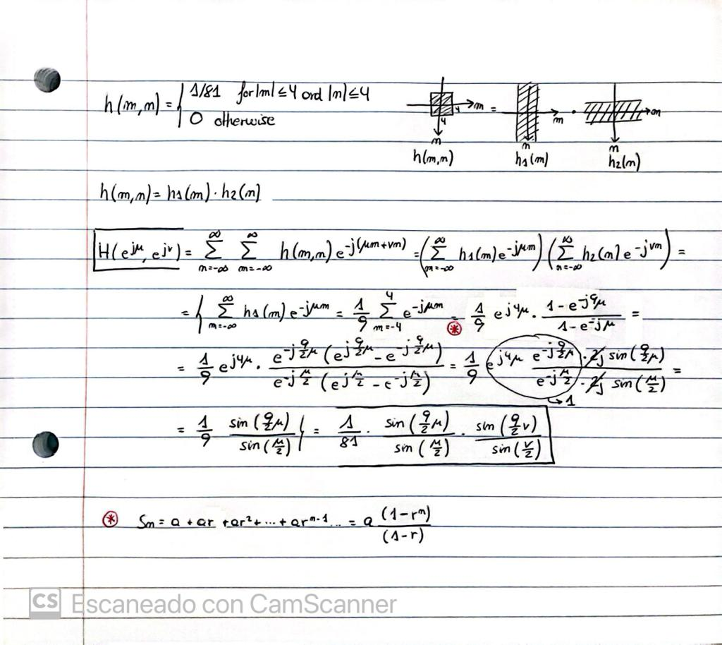

3.2 A plot of

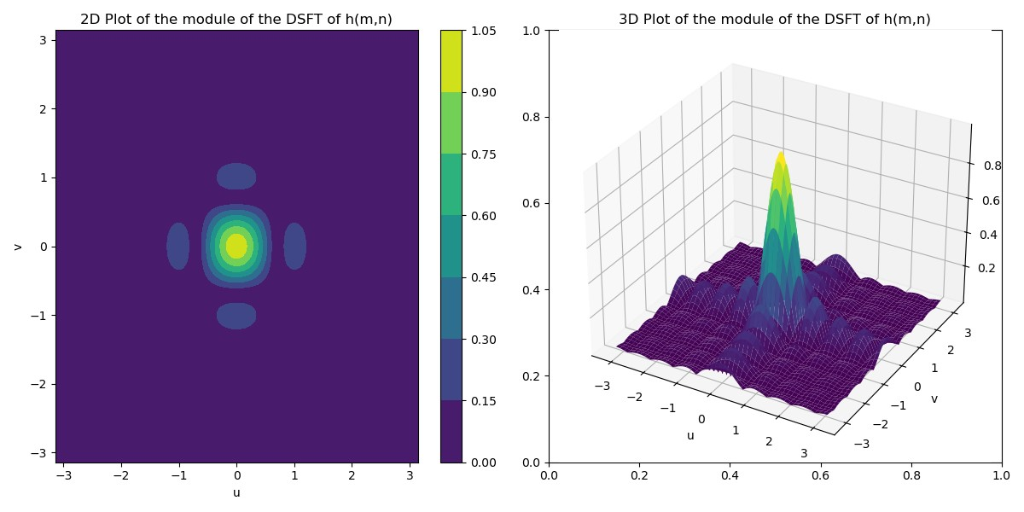

3.3 The color image in *img03.tif*

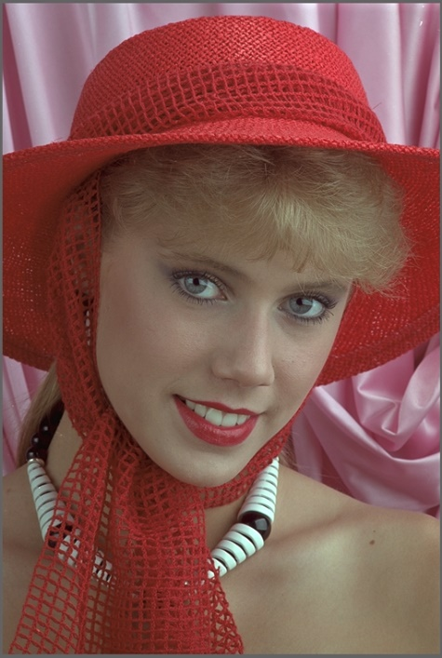

3.4 The filtered color image

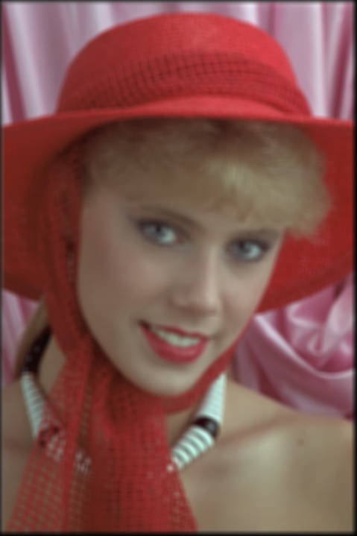

3.5 A listing of my C code

#include <math.h>

#include "tiff.h"

#include "allocate.h"

#include "randlib.h"

#include "typeutil.h"

void error(char *name);

int main(int argc, char **argv)

{

    FILE *fp;

    struct TIFF_img input_img, output_img;

    double **matrix_r, **matrix_g, **matrix_b;

    int32_t i,j,n,m;

    double pix_r, pix_g, pix_b;

    if ( argc != 2 ) error( argv[0] );

    /* open image file */

    if ( ( fp = fopen( argv[1], "rb" ) ) == NULL ) {

        fprintf( stderr, "cannot open file %s\n", argv[1] );

        exit( 1 );

    }

    /* read image */

    if ( read_TIFF( fp, &input_img ) ) {

        fprintf( stderr, "error reading file %s\n", argv[1] );

        exit( 1 );

    }

    /* close image file */

    fclose( fp );

    /* check the type of image data */

    if ( input_img.TIFF_type != 'c' ) {

        fprintf ( stderr, "error:  image must be 24-bit color\n" );

        exit ( 1 );

    }

    /* Allocate image of double precision floats */

    matrix_r = (double **)get_img(input_img.width+8,input_img.height+8,sizeof(double));

    matrix_g = (double **)get_img(input_img.width+8,input_img.height+8,sizeof(double));

    matrix_b = (double **)get_img(input_img.width+8,input_img.height+8,sizeof(double));

    get_TIFF( &output_img, input_img.height, input_img.width, 'c' );

    /* Copy rgb component to double array and expand the bound with 0 */

    for (i = 0; i < input_img.height+8; i++) {

        for (j = 0; j < input_img.width+8; j++) {

            matrix_r[i][j] = 0;

            matrix_g[i][j] = 0;

            matrix_b[i][j] = 0;

        }

    }

    for ( i = 4; i < input_img.height; i++ ){

        for ( j = 4; j < input_img.width; j++ ) {

            matrix_r[i][j] = input_img.color[0][i-4][j-4];

            matrix_g[i][j] = input_img.color[1][i-4][j-4];

            matrix_b[i][j] = input_img.color[2][i-4][j-4];

        }

    }

    /* Filter the image */

    for ( i = 0; i < input_img.height; i++){

        for ( j = 0; j < input_img.width; j++){

            pix_r = 0;

            pix_g = 0;

            pix_b = 0;

            for (m = -4; m<= 4; m++){

                for ( n = -4; n <=4; n++){

                    pix_r = pix_r + (matrix_r[i+4-m][j+4-n])/81;

                    pix_g = pix_g + (matrix_g[i+4-m][j+4-n])/81;

                    pix_b = pix_b + (matrix_b[i+4-m][j+4-n])/81;

                }

            }

            /* Clipping between 0 and 255 */

            output_img.color[0][i][j] = (int)fmin(255, fmax(0, pix_r));

            output_img.color[1][i][j] = (int)fmin(255, fmax(0, pix_g));

            output_img.color[2][i][j] = (int)fmin(255, fmax(0, pix_b));

        }

    }

    /* open output image file */

    if ( ( fp = fopen ( "section3_v2.tif", "wb" ) ) == NULL ) {

        fprintf( stderr, "cannot open file section3.tif\n");

        exit( 1 );

    }

    /* write output image */

    if ( write_TIFF( fp, &output_img ) ) {

        fprintf( stderr, "error writing TIFF file section3.tif\n");

        exit( 1 );

    }

    /* close output image file */

    fclose( fp );

    /* de-allocate memory */

    free_TIFF( &(input_img) );

    free_TIFF( &(output_img) );

    free_img( (void**)matrix_r );

    free_img( (void**)matrix_g );

    free_img( (void**)matrix_b );

    return(0);

}

void error(char *name)

{

    printf("usage:  %s  image.tiff \n\n",name);

    printf("this program reads in a 24-bit color TIFF image.\n");

    printf("It then horizontally filters the green component, adds noise,\n");

    printf("and writes out the result as an 8-bit image\n");

    printf("with the name 'green.tiff'.\n");

    printf("It also generates an 8-bit color image,\n");

    printf("that swaps red and green components from the input image");

    exit(1);

}

**4. FIR Sharpening Filter**

4.1 and 4.2 A derivation of the analytical expression for and the analytical expression for

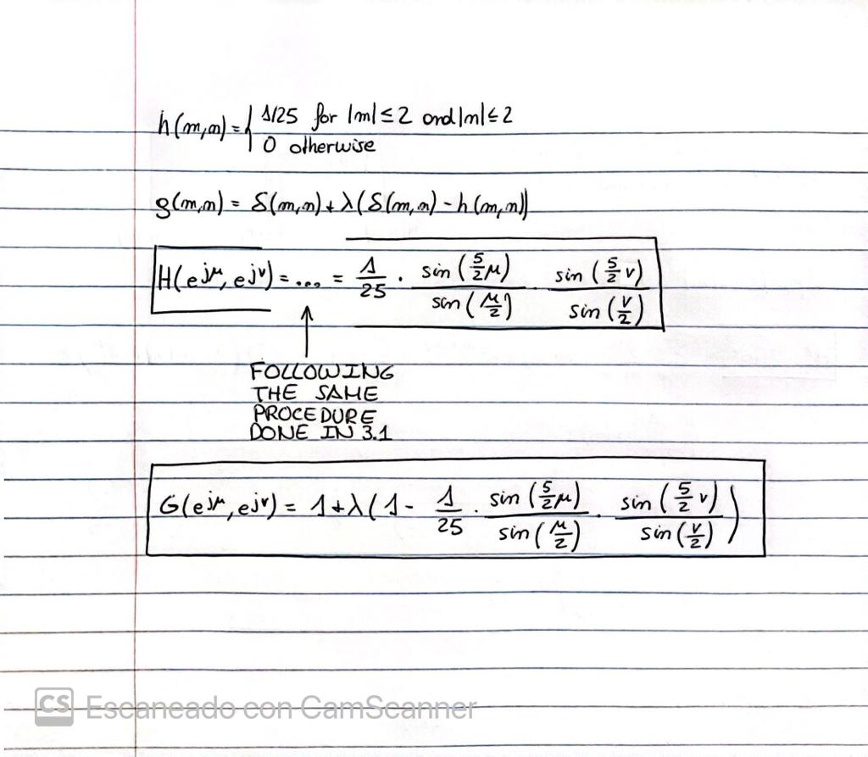

4.3 A plot of

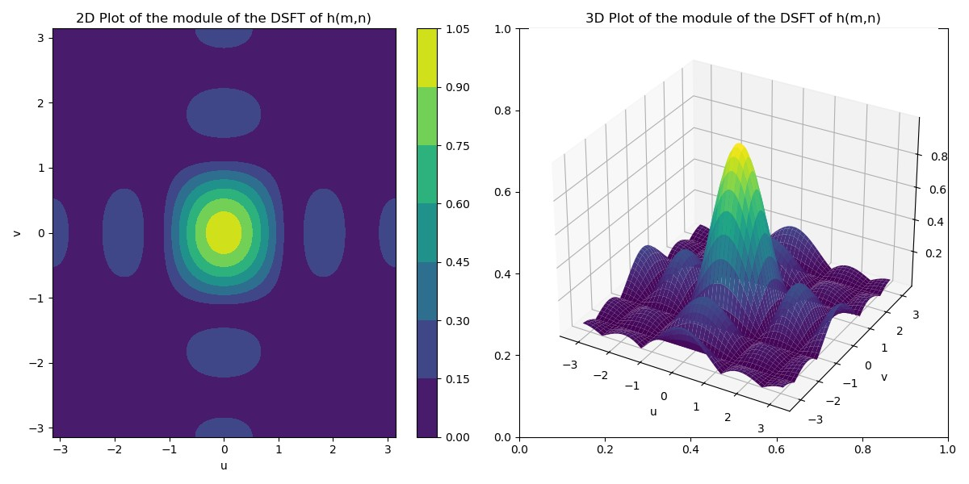

4.4 A plot of for λ = 1.5

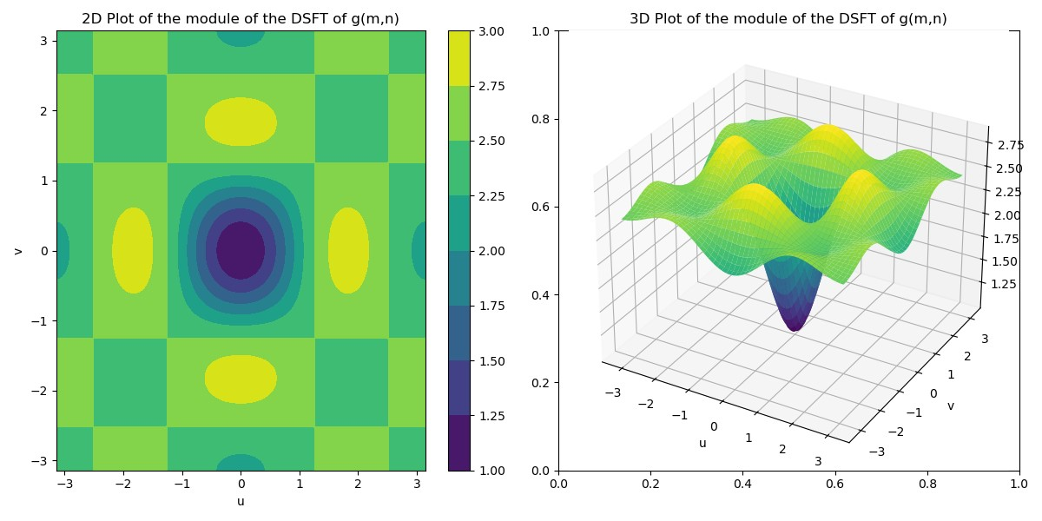

4.5 The input color image *imgblur.tif*

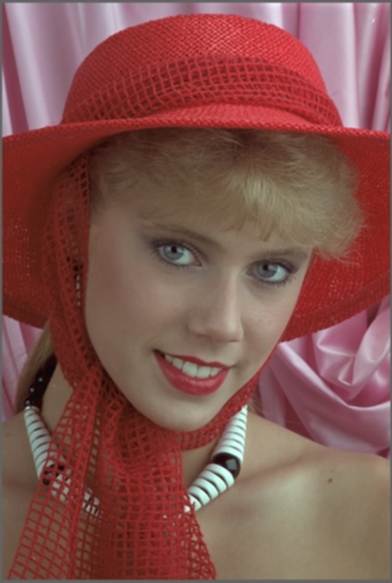

4.6 The output sharpened color image for for λ = 1.5

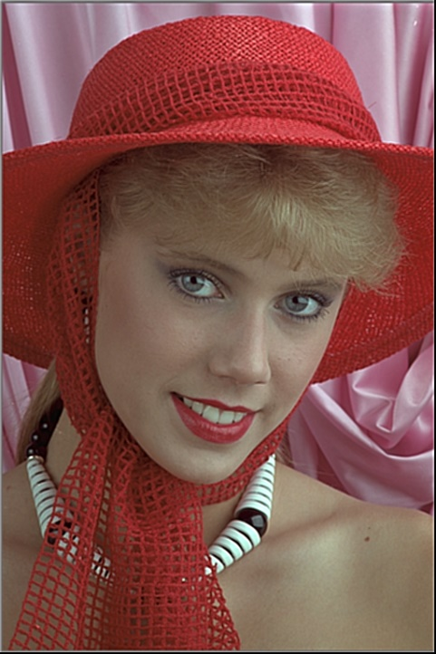

4.7 A listing of my C code

#include <math.h>

#include "tiff.h"

#include "allocate.h"

#include "randlib.h"

#include "typeutil.h"

void error(char *name);

int main(int argc, char **argv)

{

    FILE *fp;

    struct TIFF_img input_img, output_img;

    double **matrix_r, **matrix_g, **matrix_b;

    int32_t i,j,n,m;

    double pix_r, pix_g, pix_b;

    double aux_r, aux_g, aux_b;

    if ( argc != 3 ) error( argv[0] );

    float lambda = atof(argv[2]);

    /* open image file */

    if ( ( fp = fopen( argv[1], "rb" ) ) == NULL ) {

        fprintf( stderr, "cannot open file %s\n", argv[1] );

        exit( 1 );

    }

    /* read image */

    if ( read_TIFF( fp, &input_img ) ) {

        fprintf( stderr, "error reading file %s\n", argv[1] );

        exit( 1 );

    }

    /* close image file */

    fclose( fp );

    /* check the type of image data */

    if ( input_img.TIFF_type != 'c' ) {

        fprintf ( stderr, "error:  image must be 24-bit color\n" );

        exit ( 1 );

    }

    /* Allocate image of double precision floats */

    matrix_r = (double **)get_img(input_img.width+4, input_img.height+4, sizeof(double));

    matrix_g = (double **)get_img(input_img.width+4, input_img.height+4, sizeof(double));

    matrix_b = (double **)get_img(input_img.width+4, input_img.height+4, sizeof(double));

    get_TIFF( &output_img, input_img.height, input_img.width, 'c' );

    /* Copy rgb component to double array and expand the bound with 0 */

    for (i = 0; i < input_img.height+4; i++) {

        for (j = 0; j < input_img.width+4; j++) {

            matrix_r[i][j] = 0;

            matrix_g[i][j] = 0;

            matrix_b[i][j] = 0;

        }

    }

    for ( i = 2; i < input_img.height; i++ ){

        for ( j = 2; j < input_img.width; j++ ) {

            matrix_r[i][j] = input_img.color[0][i-2][j-2];

            matrix_g[i][j] = input_img.color[1][i-2][j-2];

            matrix_b[i][j] = input_img.color[2][i-2][j-2];

        }

    }

    /* Filter the image */

    for ( i = 0; i < input_img.height; i++){

        for ( j = 0; j < input_img.width; j++){

            pix_r = 0;

            pix_g = 0;

            pix_b = 0;

            for (m = -2; m<= 2; m++){

                for ( n = -2; n <=2; n++){

                    pix_r = pix_r + (matrix_r[i+2-m][j+2-n])/25;

                    pix_g = pix_g + (matrix_g[i+2-m][j+2-n])/25;

                    pix_b = pix_b + (matrix_b[i+2-m][j+2-n])/25;

                }

            }

            aux_r = matrix_r[i+2][j+2] + lambda*matrix_r[i+2][j+2]-lambda*pix_r;

            aux_g = matrix_g[i+2][j+2] + lambda*matrix_g[i+2][j+2]-lambda*pix_g;

            aux_b = matrix_b[i+2][j+2] + lambda*matrix_b[i+2][j+2]-lambda*pix_b;

            /* Clipping between 0 and 255 */

            output_img.color[0][i][j] = (int)fmin(255, fmax(0, aux_r));

            output_img.color[1][i][j] = (int)fmin(255, fmax(0, aux_g));

            output_img.color[2][i][j] = (int)fmin(255, fmax(0, aux_b));

        }

    }

    /* open output image file */

    if ( ( fp = fopen ( "section4.tif", "wb" ) ) == NULL ) {

        fprintf( stderr, "cannot open file section4.tif\n");

        exit( 1 );

    }

    /* write output image */

    if ( write_TIFF( fp, &output_img ) ) {

        fprintf( stderr, "error writing TIFF file section4.tif\n");

        exit( 1 );

    }

    /* close output image file */

    fclose( fp );

    /* de-allocate memory */

    free_TIFF( &(input_img) );

    free_TIFF( &(output_img) );

    free_img( (void**)matrix_r );

    free_img( (void**)matrix_g );

    free_img( (void**)matrix_b );

    return(0);

 }

 void error(char *name)

{

    printf("usage:  %s  image.tiff \n\n",name);

    printf("this program reads in a 24-bit color TIFF image.\n");

    printf("It then horizontally filters the green component, adds noise,\n");

    printf("and writes out the result as an 8-bit image\n");

    printf("with the name 'green.tiff'.\n");

    printf("It also generates an 8-bit color image,\n");

    printf("that swaps red and green components from the input image");

    exit(1);

}

**5. IIR Filter**

5.1 A derivation of the analytical expression for

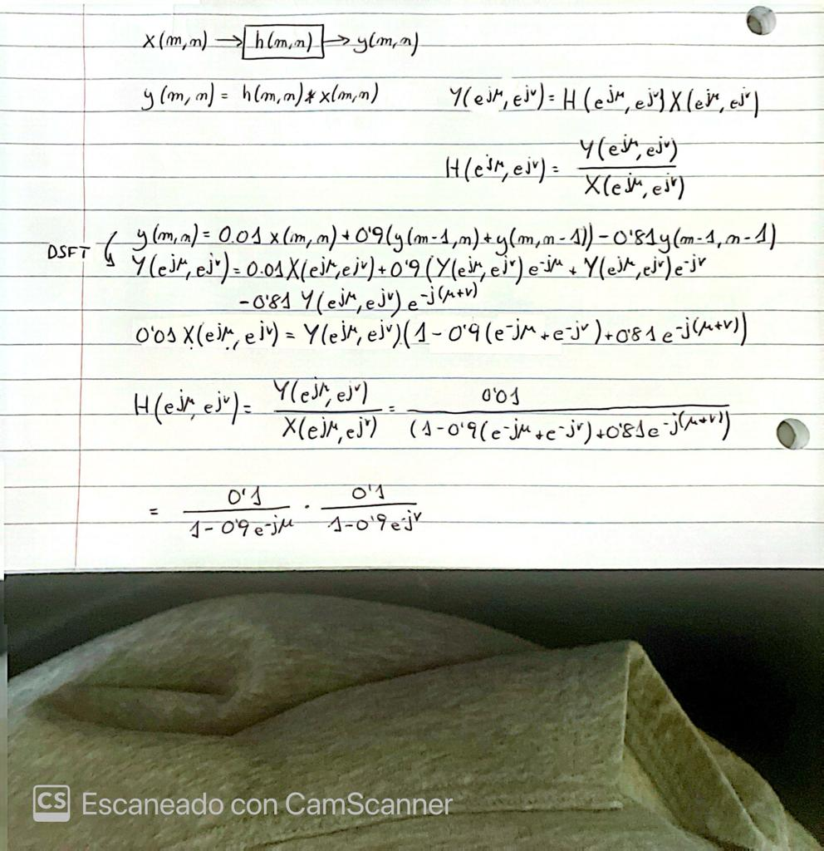

5.2 A plot of

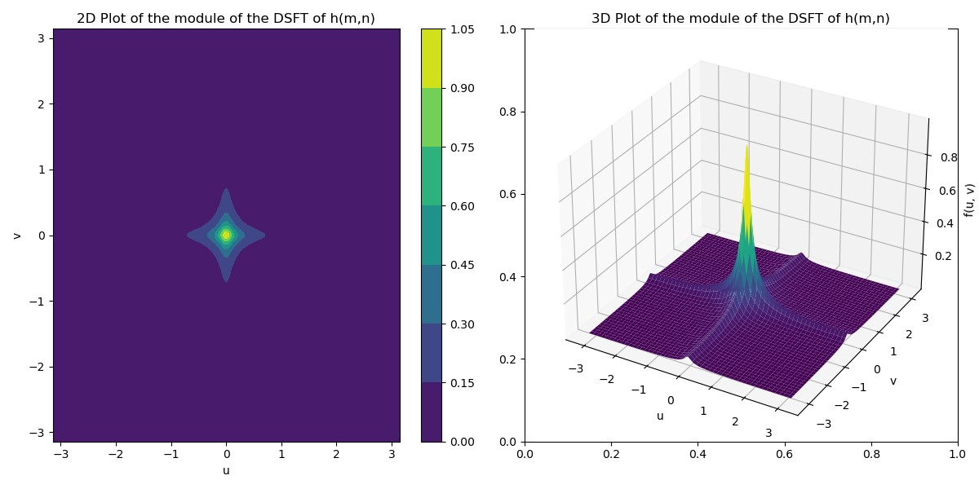

5.3 An image of the point spread function.



5.4 The filtered output color image.



5.5 A listing of my C code

#include <math.h>

#include "tiff.h"

#include "allocate.h"

#include "randlib.h"

#include "typeutil.h"

void error(char *name);

int main(int argc, char **argv)

{

    FILE *fp;

    struct TIFF_img input_img, output_img;

    double **matrix1_r, **matrix1_g, **matrix1_b, **matrix2_r, **matrix2_g, **matrix2_b;

    int32_t i,j;

    if ( argc != 2 ) error( argv[0] );

    /* open image file */

    if ( ( fp = fopen( argv[1], "rb" ) ) == NULL ) {

        fprintf( stderr, "cannot open file %s\n", argv[1] );

        exit( 1 );

    }

    /* read image */

    if ( read_TIFF( fp, &input_img ) ) {

        fprintf( stderr, "error reading file %s\n", argv[1] );

        exit( 1 );

    }

    /* close image file */

    fclose( fp );

    /* check the type of image data */

    if ( input_img.TIFF_type != 'c' ) {

        fprintf ( stderr, "error:  image must be 24-bit color\n" );

        exit ( 1 );

    }

    /* Allocate image of double precision floats */

    matrix1_r = (double **)get_img(input_img.width+2, input_img.height+2, sizeof(double));

    matrix1_g = (double **)get_img(input_img.width+2, input_img.height+2, sizeof(double));

    matrix1_b = (double **)get_img(input_img.width+2, input_img.height+2, sizeof(double));

    matrix2_r = (double **)get_img(input_img.width+2, input_img.height+2, sizeof(double));

    matrix2_g = (double **)get_img(input_img.width+2, input_img.height+2, sizeof(double));

    matrix2_b = (double **)get_img(input_img.width+2, input_img.height+2, sizeof(double));

    get_TIFF ( &output_img, input_img.height, input_img.width, 'c' );

    /* Copy rgb component to double array and expand the bound with 0 */

    for ( i = 0; i < input_img.height+2; i++ ){

        for ( j = 0; j < input_img.width+2; j++ ) {

            matrix1_r[i][j] = 0;

            matrix1_g[i][j] = 0;

            matrix1_b[i][j] = 0;

            matrix2_r[i][j] = 0;

            matrix2_g[i][j] = 0;

            matrix2_b[i][j] = 0;

        }

    }

    for ( i = 1; i < input_img.height; i++ ){

        for ( j = 1; j < input_img.width; j++ ) {

            matrix1_r[i][j] = input_img.color[0][i-1][j-1];

            matrix1_g[i][j] = input_img.color[1][i-1][j-1];

            matrix1_b[i][j] = input_img.color[2][i-1][j-1];

        }

    }

    /* Filter the image */

    for ( i = 0; i < input_img.height; i++ ){

        for ( j = 0; j < input_img.width; j++ ) {

            matrix2_r[i+1][j+1] = 0.01*matrix1_r[i+1][j+1] + 0.9*(matrix2_r[i][j+1]+matrix2_r[i+1][j])-0.81*matrix2_r[i][j];

            matrix2_g[i+1][j+1] = 0.01*matrix1_g[i+1][j+1] + 0.9*(matrix2_g[i][j+1]+matrix2_g[i+1][j])-0.81*matrix2_g[i][j];

            matrix2_b[i+1][j+1] = 0.01*matrix1_b[i+1][j+1] + 0.9*(matrix2_b[i][j+1]+matrix2_b[i+1][j])-0.81*matrix2_b[i][j];

            /* Clipping between 0 and 255 */

            output_img.color[0][i][j] = (int)fmin(255, fmax(0, matrix2_r[i+1][j+1]));

            output_img.color[1][i][j] = (int)fmin(255, fmax(0, matrix2_g[i+1][j+1]));

            output_img.color[2][i][j] = (int)fmin(255, fmax(0, matrix2_b[i+1][j+1]));

        }

    }

    /* open output image file */

    if ( ( fp = fopen ( "section5.tif", "wb" ) ) == NULL ) {

        fprintf( stderr, "cannot open file section5.tif\n");

        exit( 1 );

    }

    /* write output image */

    if ( write_TIFF( fp, &output_img ) ) {

        fprintf( stderr, "error writing TIFF file section5.tif\n");

        exit( 1 );

    }

    /* close output image file */

    fclose( fp );

    /* de-allocate memory */

    free_TIFF ( &(input_img) );

    free_TIFF ( &(output_img) );

    free_img( (void**)matrix1_r );

    free_img( (void**)matrix1_g );

    free_img( (void**)matrix1_b );

    free_img( (void**)matrix2_r );

    free_img( (void**)matrix2_g );

    free_img( (void**)matrix2_b );

    return(0);

 }

 void error(char *name)

{

    printf("usage:  %s  image.tiff \n\n",name);

    printf("this program reads in a 24-bit color TIFF image.\n");

    printf("It then horizontally filters the green component, adds noise,\n");

    printf("and writes out the result as an 8-bit image\n");

    printf("with the name 'green.tiff'.\n");

    printf("It also generates an 8-bit color image,\n");

    printf("that swaps red and green components from the input image");

    exit(1);

}