**Digital Image Processing Laboratory**

**2-D Random Processes**

**Alexandre Olivé Pellicer**

**01/26/2024**

1. **Power Spectral Density of an Image**
   1. The gray scale image *img04g.tif*

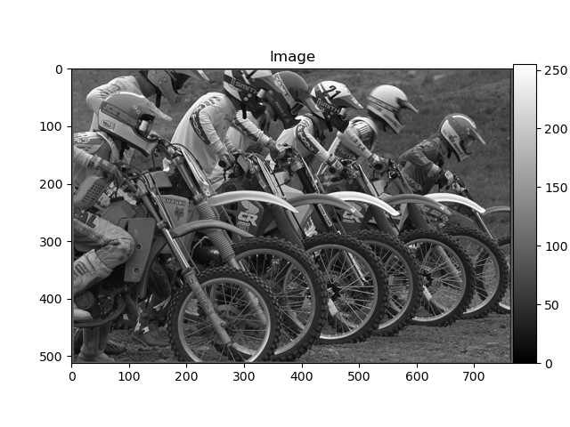

* 1. The power spectral density plots for block sizes of 64 x 64, 128 x 128, and 256 x 256.

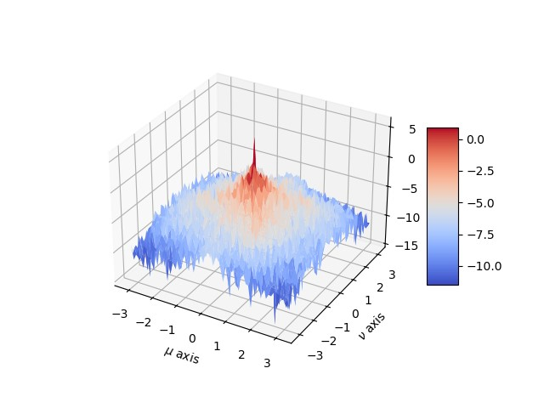

Energy Spectrum over a 64 x 64 window of the image

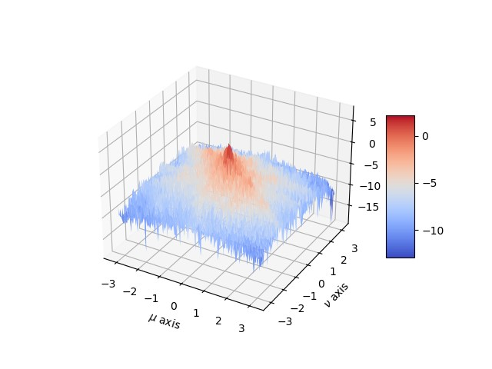

Energy Spectrum over a 128 x 128 window of the image

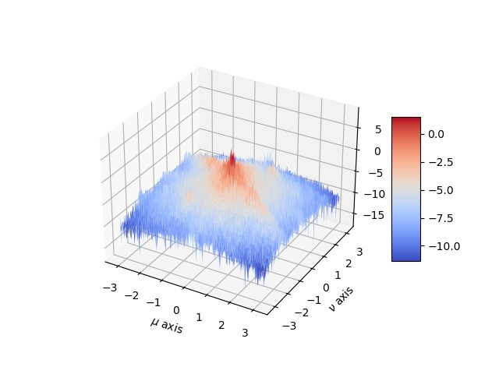

Energy Spectrum over a 256 x 256 window of the image

* 1. The improved power spectral density estimate

* 1. Your code for *BetterSpecAnal(x)* function.

1. def BetterSpecAnal(x):
2. # We apply a square of 5x5 non-overlapping filters. The center of the centered filter is in the center of the image
3. N = 64 #window size
4. #Getting the coordinates of the pixel where the first filter will be applied
5. height, width = x.shape
6. i = int(height/2 - 5*N/2)
7. j = int(width/2 - 5*N/2)
9. W = np.outer(np.hamming(64), np.hamming(64))
11. Z = np.zeros((N,N))
13. for _ in range(5):
14. for _ in range(5):
15. z = x[i:N+i, j:N+j] * W
16. # Compute the power spectrum for the NxN region.
17. Z = Z + (1/N**2)*np.abs(np.fft.fft2(z))**2
18. j = j + N
20. i = i + N
21. j = int(width/2 - 5*N/2) #reset j
22. # Use fftshift to move the zero frequencies to the center of the plot.
23. Z = np.fft.fftshift(Z)
25. # Compute the average between the 25 filters
26. Zabs_avg = Z / 25
28. # Compute the logarithm of the Power Spectrum.
29. Zabs_avg_log = np.log(Zabs_avg)
31. return Zabs_avg_log
32. **Power Spectral Density of a 2-D AR Process**
    1. The image 255 * (x + 0.5)

* 1. The image y + 127

* 1. A mesh plot of the function

* 1. A mesh plot of the log of the estimated power spectral density of y using *BetterSpecAnal(y)*

