**Digital Image Processing Laboratory:**

**Pointwise Operations and Gamma**

**Alexandre Olive Pellicer**

1. **Histogram of an Image**
   1. Hand in the two images and their labeled histograms.

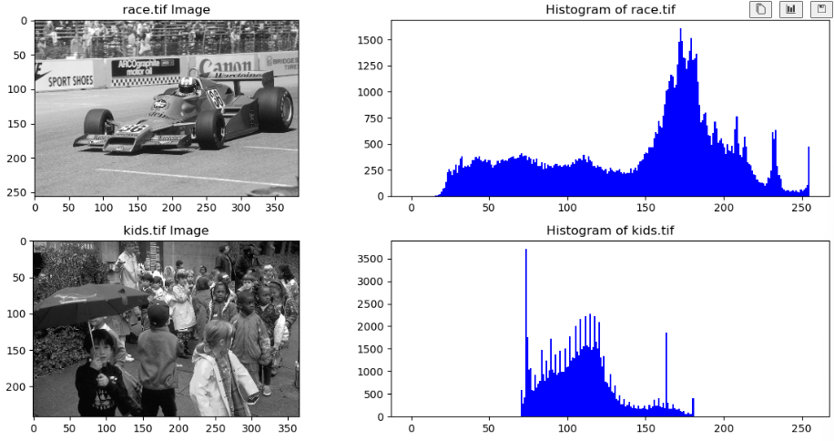

Fig 1: Image race.tif Fig 2: Histogram of race.tif



Fig 3: Image kids.tif Fig 4: Histogram of kids.tif

1. **Histogram Equalization**
   1. Hand in the function equalize.m
2. def equalize(X):
3. # Compute histogram
4. h, bins = np.histogram(X, bins=256, range=[0, 255])
5. # Cumulative sum of histogram
6. Y = np.cumsum(h) / np.sum(h)
7. # Normalize values to [0, 1]
8. Ymax = Y[X.max()]
9. Ymin = Y[X.min()]
10. Z = np.uint8(255 * ((Y[X] - Ymin) / (Ymax - Ymin)))
11. plt.figure(figsize=(8, 4))
13. # Display CDF
14. plt.subplot(1, 2, 1)
15. plt.plot(range(256), Y, color='blue')
16. plt.xlabel('Pixel Intensity')
17. plt.ylabel('Cumulative Distribution Function (CDF)')
18. plt.title('Cumulative Distribution Function')
19. # Display histogram of equalized image
20. plt.subplot(1, 2, 2)
21. plt.hist(Z.flatten(), bins=256, range=[0, 255], color='blue')
22. plt.xlabel('Pixel Intensity')
23. plt.ylabel('Number of Pixels')
24. plt.title('Histogram of Equalized Image')
26. plt.tight_layout()
27. plt.show()
    1. Hand in a labeled plot of for the image kids.tif

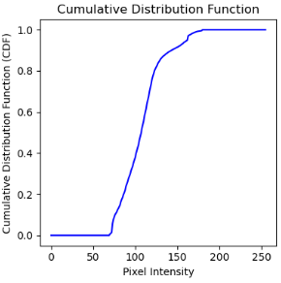

Fig 5: Plot of for the image kids.tif

* 1. Hand in a labeled plot of the of the equalized image’s histogram.

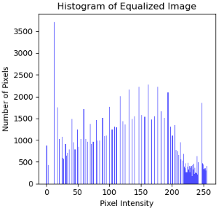

Fig 6: Histogram of the equalized image

* 1. Hand in the equalized image.

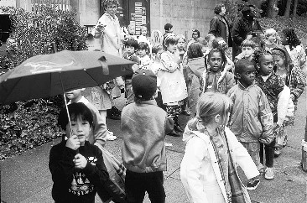

Fig 7: Equalized image

1. **Contrast Stretching**
   1. Hand in your code for stretch.
2. def stretch(input, T1, T2):
3. rol, col = input.shape
4. output = np.zeros((rol, col), dtype=np.uint8)
5. for i in range(rol):
6. for j in range(col):
7. if input[i, j] > T2:
8. output[i, j] = 255
9. elif T1 < input[i, j] < T2:
10. output[i, j] = np.uint8((input[i, j] - T1) * (255 / (T2 - T1)))
11. return output
    1. Hand in the transformed image and its histogram

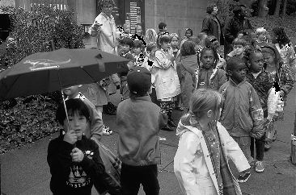

Fig 8: Transformed image

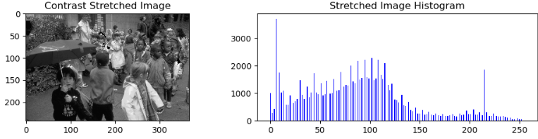

Fig 9: Histogram of the transformed image

1. **Gamma**
   1. Setting the Black Level and Picture of Your Monitor
   2. Determining the Gamma of Your Computer Monitor
      1. Hand in your image corresponding to the matching gray level.

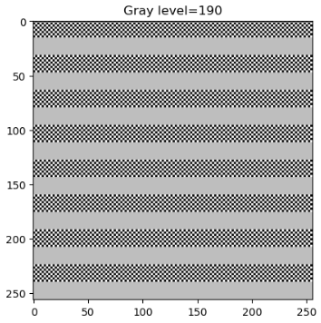

Fig 10: Image with matching gray level 190

* + 1. Hand in a derivation of the expression which relates the matching gray level to the value of γ.

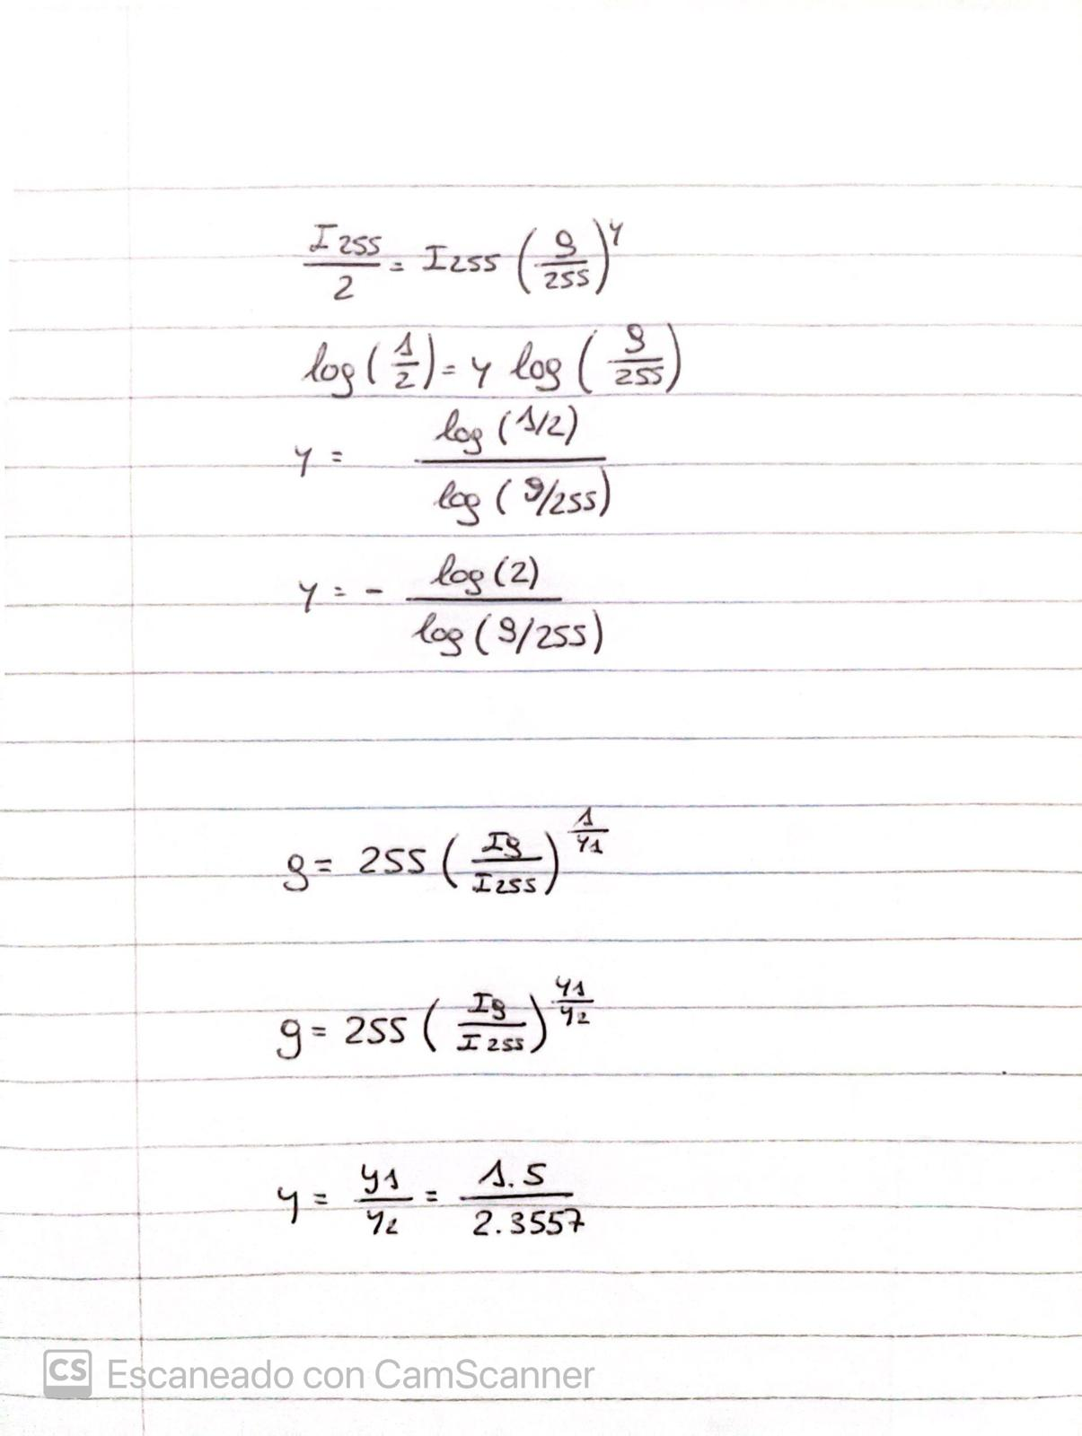

* + 1. Hand in the values of the measured gray level and the measured γ.

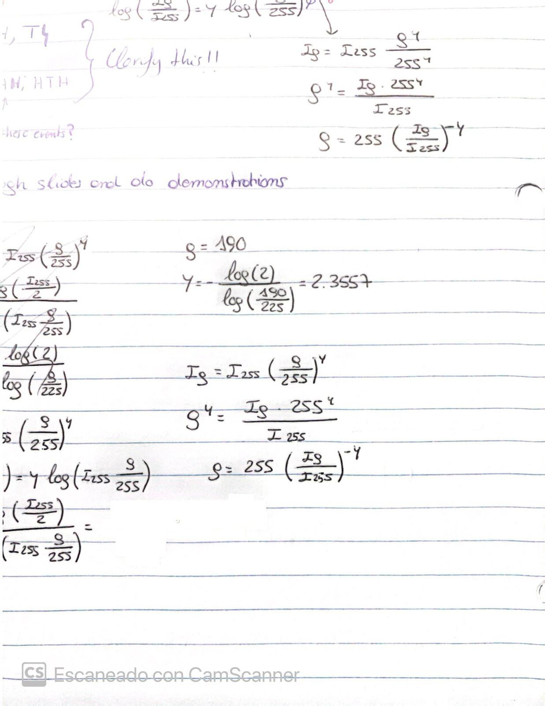

* 1. Gamma Correction
     1. Hand in the original and corrected images. Label them and indicate the value of gamma that was used to correct the image.

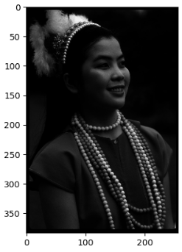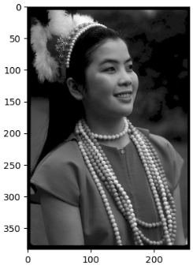

Fig 11: Original image Fig 12: Corrected image with = 2.3557

4.3.2 Hand in the formula you used to transform the original image.



4.3.3 Hand in the corrected image. Be sure it is labeled in the report.

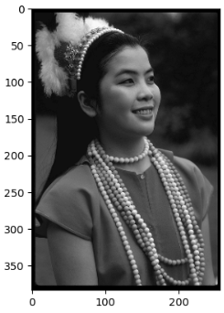

Fig 13: Corrected image of gamma15.tif with = 1.5/2.3557

4.3.4 Document the procedure you used to change the gamma correction of the original image.

The given image has already suffered a gamma correction with

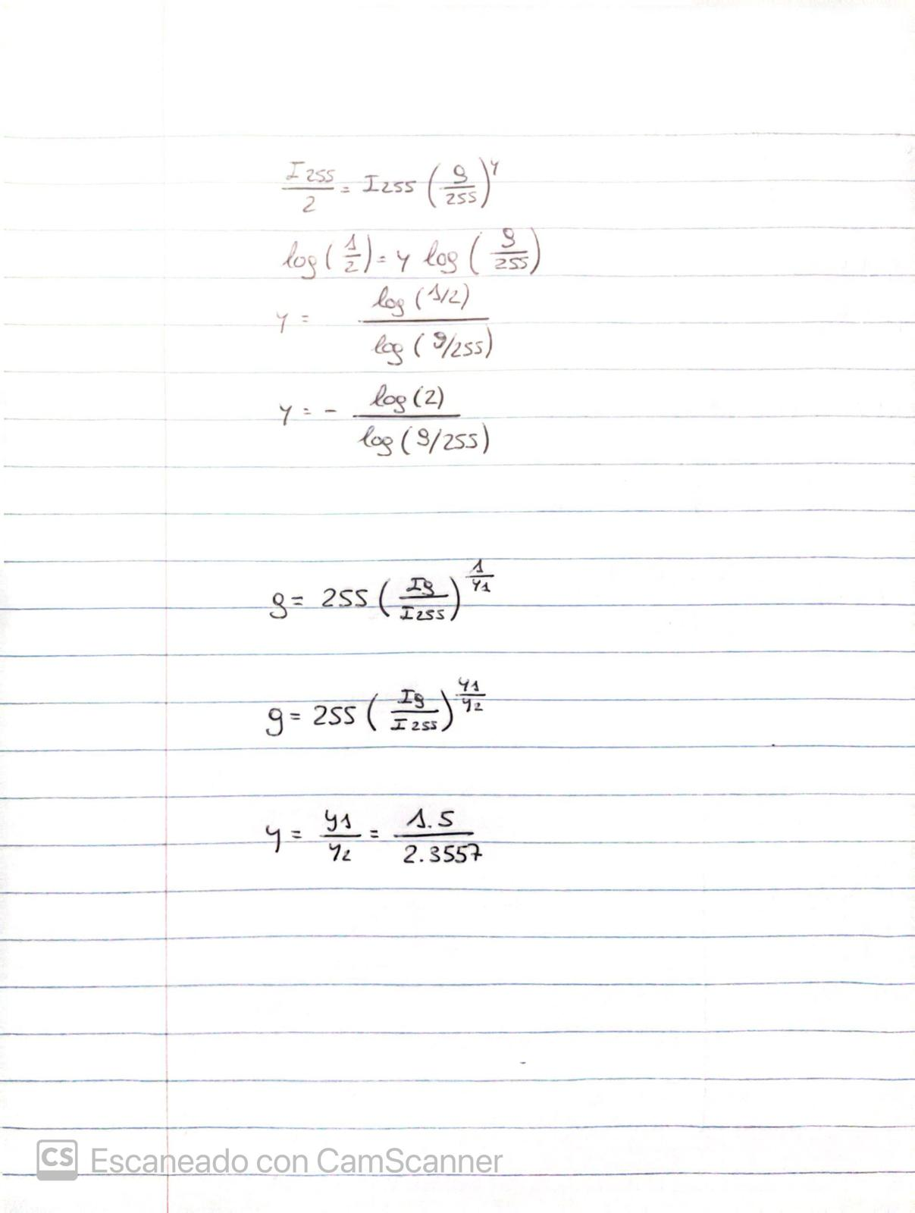

And we want to correct it with



We combine both so that is:

