**HOMEWORK 5:**

**EIGEN-DECOMPOSITION OF IMAGES**

**ALEXANDRE OLIVE PELLICER**

**Section 2.1**

1. Hand in your scatter plots for and

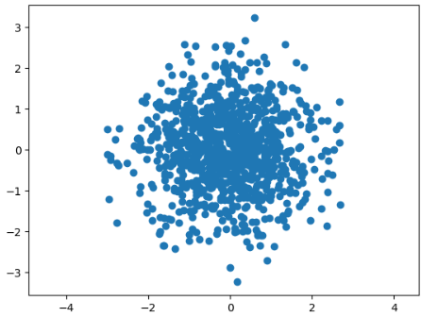

Fig 1: Plots for $W, \tilde{X}$ and $X$

**Section 2.2**

1. Hand in the theoretical value of the covariance matrix, $R_{X}$. (Hint: It is given in equation (14).)
$$R_{X}=\left[\begin{matrix}2 & -1.2 \\ -1.2 & 1\end{matrix}\right]$$

2. Hand in a numerical listing of your covariance estimate ${\hat{R}}_{X}$
$${\hat{R}}_{X}=\left[\begin{matrix}2.0691 & -1.2617 \\ -1.2617 & 1.0373\end{matrix}\right]$$

3. Hand in your scatter plots for and

Fig 2: Plots for ${\tilde{X}}_{i}$ and $W_{i}$

1. Hand in a numerical listing of the covariance estimate ${\hat{R}}_{W}$

$${\hat{R}}_{w}=\left[\begin{matrix}1.000 e+00 & 9.324 e-17 \\ 9.324 e-17 & 1.000 e+00\end{matrix}\right]= \left[\begin{matrix}1.000 & 0.000 \\ 0.000 & 1.000\end{matrix}\right]$$

**Section 4**

1. Hand in the figure with the first 12 eigenimages.

Fig 3: First 12 eigenimages

1. Hand in the plots of projection coefficients vs eigenvector number.

Fig 4: Plots of projection coefficients vs eigenvector number

1. Hand in the original image, and the 6 resynthesized versions.

Fig 5: Original image

Fig 6: 6 resynthesized versions

**Section 5**

Submit a 2-column table showing for each mis-classified input image: (1) the input character, and (2) the output from the classifier.

|  |  |
| --- | --- |
| Input | Output |
| d | a |
| j | y |
| l | i |
| n | v |
| p | e |
| q | a |
| u | a |
| y | v |

For each modification, submit a 2-column table showing for each mis-classified input image: (1) the input character, and (2) the output from the classifier.

|  |  |
| --- | --- |
| $$B_{k}= Λ_{k}$$ | |
| Input | Output |
| i | l |
| y | v |

|  |  |
| --- | --- |
|  | |
| Input | Output |
| g | q |
| y | v |
|  |  |
| $$B_{k}= Λ$$ | |
| Input | Output |
| f | t |
| y | v |

|  |  |
| --- | --- |
|  | |
| Input | Output |
| f | t |
| g | q |
| y | v |

1. Which of the above classifiers worked the best in this experiment?

The classifiers that worked the best are $B_{k}= Λ_{k}$, $B_{k}= R_{wc}$ and $B_{k}= Λ$ since they misclassified the lower number of inputs. They misclassified 2 inputs.

1. In constraining the covariance, what is the trade off between the accuracy of the data model and the accuracy of the estimates?

In constraining the covariance, we enhance the accuracy of estimates at the cost of reducing the accuracy of the data model.