**GENERATION OF SINUSOIDAL PULSE WIDTH MODULATION USING MATLAB**

Sinusoidal Pulse Width Modulation is one of techniques used to produce the firing pulses for the power electronic switches of the inverters. Instead of maintaining the width of all pulses the same as in case of multiple pulse width modulation, the width of each pulse is varied in proportion to the amplitude of a sine wave evaluated at the centre of the same pulse. The distortion factor and lower order harmonics are reduced significantly. The gating signals are generated by comparing a sinusoidal reference signal with a triangular carrier wave of frequency *fc*. The frequency of reference signal *fm*, determines the inverter output frequency and its peak amplitude *Am*, controls the modulation index *MI*, and rms output voltage *VO*. The number of pulses per half cycle depends on carrier frequency .In SPWM, amplitudes of the triangular wave (carrier) and sine wave (modulating) are compared to obtain PWM waveform as shown in Fig.1. Two factors are important for the operation of the SPWM inverters.

*1. Modulation Index*

$M_{I}=\frac{A_{M}}{A_{C}}$ (1)

Where

$M_{I}$ Modulation Index

$A_{M}$ Amplitude of the modulating waveform

$A_{C}$ Amplitude of the carrier waveform



Fig. 1. Sinusoidal Pulse Width Modulation with Normalized Value

The output voltage (fundamental) and the input voltage are related by

$${V_{1}=M}_{I}V_{dc}$$

*2. Modulation Ratio*

$M_{R}=\frac{f_{C}}{f_{M}}$ (2)

Where

$M_{R}$ Modulation Ratio

$f_{M}$ Frequency of the modulating waveform

$f_{C}$ Frequency of the carrier waveform

The output harmonics are decided by the modulation ratio.

$$f=k M_{R }f_{M}$$

**Writing MATLAB program:**

Program for SPWM involves:

1) Generation of a triangular (carrier) wave.

2) Generation of a sine (modulating) wave.

3) Generation of PWM by comparing the triangular and sine wave.

4) Plotting of all the waveforms.

Let the carrier frequency be 1kHz and the modulation index 0.5.

***MATLAB Program:***

close all;clear all;clc;

% Inputs

fc=input('Carrier frequency in Hz:')

Tc=1/fc;

Ac=1;% Amplitude of carrier wave

m=Ac/(Tc/4);

Am=0.5;% Amplitude of modulating wave

Vdc=1;

fm=50% Frequency of modulating wave

Tm=1/fm;

w=2*pi*fm;

Mi=Am/Ac% Modulation index

Mr=Tm/Tc% Modulation ratio

% *****************************************

% Single Triangular waveform

t1=0:Tc/100:(Tc/4)-(Tc/100);

V1=m*t1;

t2=(Tc/4):Tc/100:(Tc*3/4)-(Tc/100);

V2=-m*t2+2;

t3=(Tc*3/4):Tc/100:Tc;

V3=m*t3-4;

t=[t1 t2 t3];

Vc=[V1 V2 V3];

% Plotting of triangular carrier waveform

tt=0:Tc/100:Mr*Tc;

Vic=Vc;

for i=1:Mr-1

Vic=[Vic Vc(1:end-1)];

end

subplot 411

plot(tt,Vic)

title('Carrier wave')

ylabel('Amplitude')

% Modulating waveform

tm=0:Tm/(Mr*100):Tm;

Vm=Am*sin(w*tm);

subplot 412

plot(tm,Vm)

title('Modulating wave')

ylabel('Amplitude')

% PWM waveform

tf=0:Tm/(Mr*100):Tm;

p=find(Vic>=Vm);

Vg(p)=-Vdc;

q=find(Vic<Vm);

Vg(q)=Vdc;

subplot 414

plot(tf,Vg)

title('PWM waveform')

xlabel('Time(sec)')

ylabel('Amplitude')

% Plotting Carrier wave & Modulating wave

subplot 413

plot(tf,Vic,tm,Vm)

title('Carrier wave & Modulating wave')

ylabel('Amplitude')

***Waveform:***

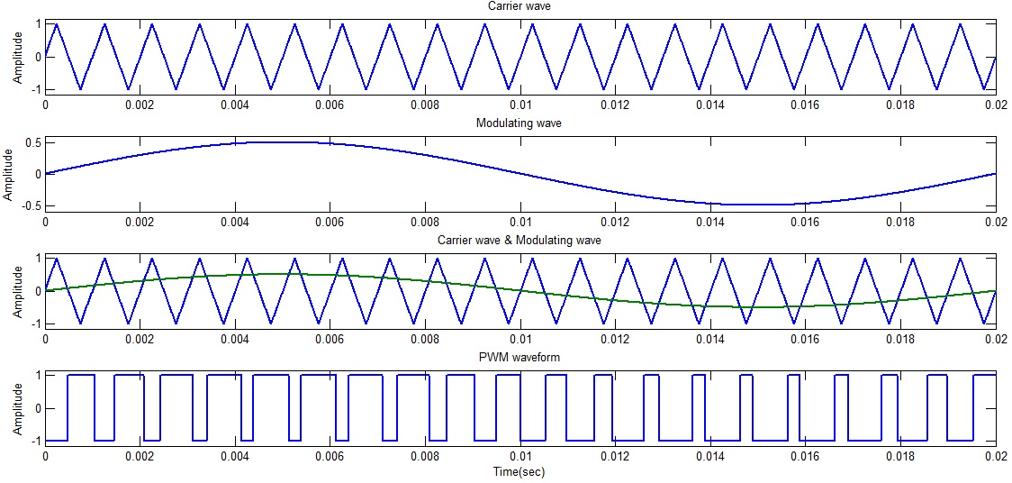

***In Command Window:***

Carrier frequency in Hz:1000

fc =

1000

fm =

50

Mi =

0.5000

Mr =

20

>>

**Applications of PWM:**

## PWM is employed in a wide variety of applications, ranging from measurement and communications to power control and conversion. The PWM controllers have varied applications in today’s world of electronics. Some of them are mentioned below:

**Telecommunications:**

In the field of telecommunications, the widths of the different pulses generally correspond to specific values of the data encoded at one end as well as decoded at the other. There are various lengths of the pulses and the information will be sent after regular intervals.

**Power delivery:**

PWM controller can be used to minimize the total quantity of power that is delivered to a load without any loss that normally incurs when power sources are suppressed by resistive means. This happens because the average power is proportional to duty cycle of the modulation. With an adequately high value of modulation rate, the passive electronic filters can make smooth the pulse train and get back the average analog waveform.

**Voltage regulation:**

A PWM controller is also used in the efficient voltage regulators. If voltage is switched to the load with an appropriately tuned duty cycle, a desired level of the voltage at the output can be approximated. The switching noise is filtered with the help of a capacitor and an inductor.

**PWM or chopper drives**

PWM controls use pulse width modulation to regulate the current sent to the motor. Unlike SCR controls which switch at line frequency, PWM controls produce smoother current at higher switching frequencies, typically between 1 and 20 kHz. At 20 kHz, the switching frequency is inaudible to humans, thereby eliminating the hum which switching at lower frequency produces. However, some motor controllers for radio controlled models make use of the motor to produce audible sound, most commonly simple beeps.