Probabilistic Decline Curve Analysis Report

# 1. Overview

This report summarizes the results of the probabilistic decline curve analysis, including model fitting, probabilistic forecasts, and estimated ultimate recovery (EUR) analysis.

# 2. Initial Production Data & Outlier Detection

## Initial Production Data with LOF Outlier Detection

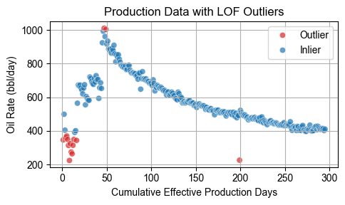

# 3. Marginal Posterior Probabilities of Models

## Model Posterior Probabilities

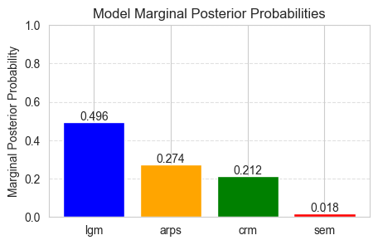

# 4. Model-Specific EUR Statistics

## Per Model EUR Summary

|  |  |  |  |  |
| --- | --- | --- | --- | --- |
| Model | p10 | p50 | mean | p90 |
| arps | 857,501 | 860,673 | 860,526 | 863,385 |
| sem | 676,201 | 688,371 | 712,954 | 776,327 |
| crm | 476,172 | 493,445 | 494,115 | 513,190 |
| lgm | 618,564 | 749,456 | 739,082 | 846,714 |

# 5. Combined EUR Statistics

## Combined Model EUR Summary

|  |  |  |  |
| --- | --- | --- | --- |
| p10 | p50 | mean | p90 |
| 631,396 | 769,090 | 751,871 | 846,281 |

# 6. Conclusion

The analysis demonstrates the range of production forecasts and uncertainties associated with the selected decline curve models. Multi-model probabilistic forecasts provide a robust outlook for future production.