Probabilistic Decline Curve Analysis Report

# 1. Overview

This report summarizes the results of the probabilistic decline curve analysis, including data cleaning, outlier detection, Monte Carlo sampling, model fitting, hindcast testing, and estimated ultimate recovery (EUR) analysis.

Four models were fit to each synthetic sample:  
- **Arps** (Exponential/Hyperbolic)  
- **Stretched Exponential Model (SEM)**  
- **Logistic Growth Model (LGM)**  
- **Capacitance-Resistance Model (CRM)**

# 2. Initial Production Data & Outlier Detection

## Initial Production Data with LOF Outlier Detection

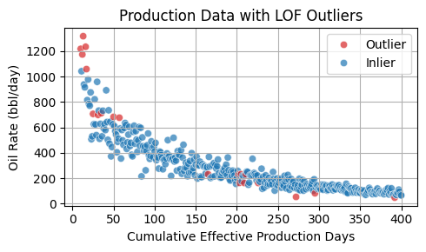

## 2a. Monte Carlo Sampling

## Sampled N Sorted Data Sets

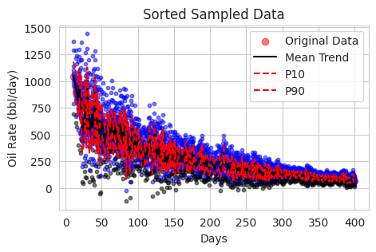

# 3. Marginal Posterior Probabilities of Models

## Model Posterior Probabilities

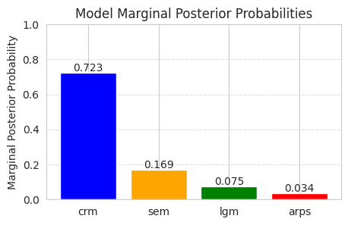

## 3a. Training Fit per Model

## Training Fit — ARPS

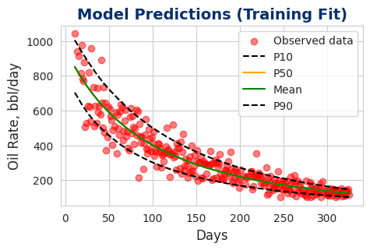

## Training Fit — SEM

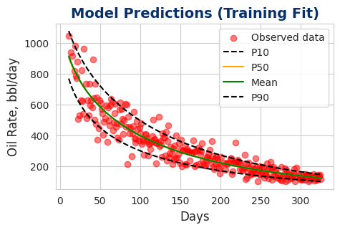

## Training Fit — CRM

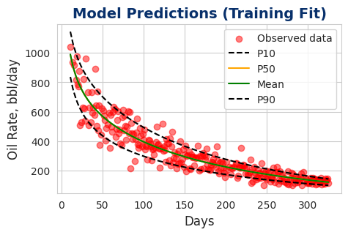

## Training Fit — LGM

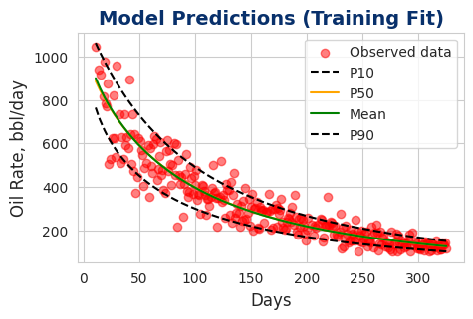

## 3b. Hindcast Test per Model

## Hindcast Test — ARPS

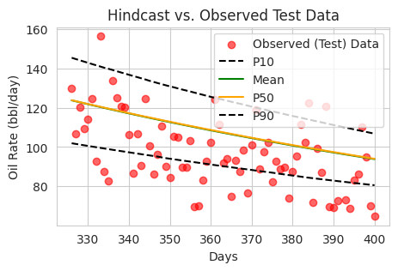

## Hindcast Test — SEM

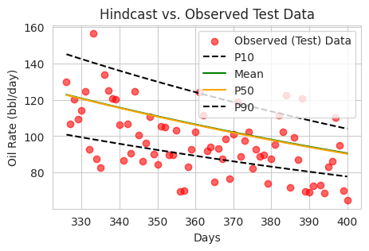

## Hindcast Test — CRM

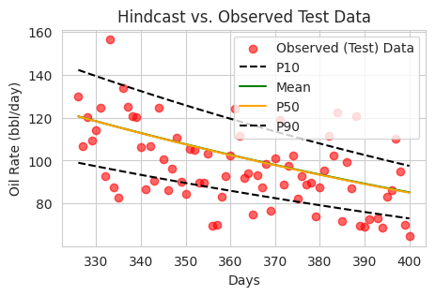

## Hindcast Test — LGM

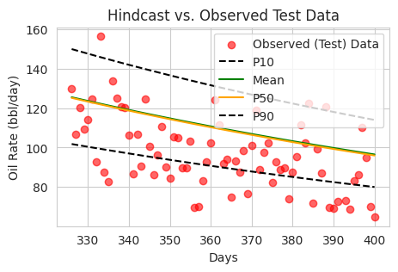

# 4. Model-Specific EUR Statistics

## Per Model EUR Summary

|  |  |  |  |  |
| --- | --- | --- | --- | --- |
| Model | p10 | p50 | mean | p90 |
| arps | 151,596 | 160,734 | 162,664 | 177,200 |
| sem | 139,413 | 140,735 | 141,913 | 145,638 |
| crm | 131,511 | 131,795 | 132,188 | 132,811 |
| lgm | 162,863 | 164,999 | 166,458 | 172,448 |

# 5. Combined EUR Statistics

## Combined Model EUR Summary

|  |  |  |  |
| --- | --- | --- | --- |
| p10 | p50 | mean | p90 |
| 132,749 | 134,315 | 137,355 | 146,059 |

## 5a. Multi‑Model EUR Boxplot

## Boxplot of Multimodel Probabilistic EUR

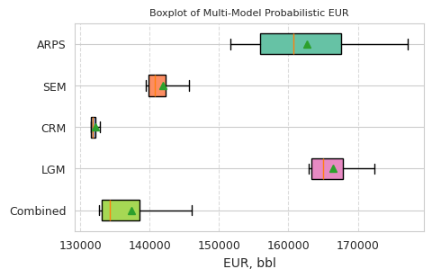

**Note: Expected 15-yr cumulative oil production from Pan-CRM model (synthetic data): ~130,000 bbl.**

# 6. Conclusion

The analysis demonstrates the range of production forecasts and uncertainties associated with the selected decline curve models. Multi‑model probabilistic forecasts provide a robust outlook for future production.

