Probabilistic Decline Curve Analysis Report

# 1. Overview

This report summarizes the results of the probabilistic decline curve analysis, including model fitting, probabilistic forecasts, and estimated ultimate recovery (EUR) analysis.

# 2. Initial Production Data & Outlier Detection

## Initial Production Data with LOF Outlier Detection

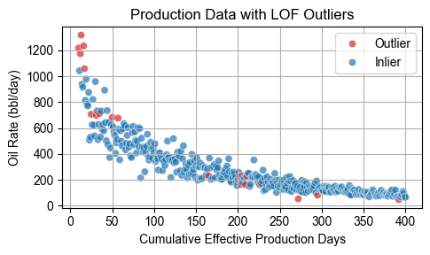

# 3. Marginal Posterior Probabilities of Models

## Model Posterior Probabilities

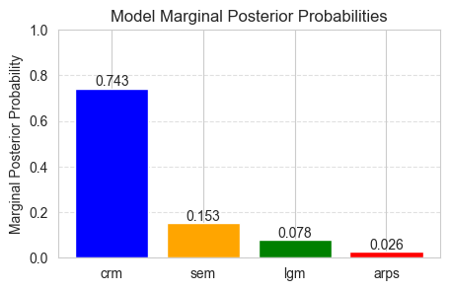

# 5. Model-Specific EUR Statistics

## Per Model EUR Summary

|  |  |  |  |  |
| --- | --- | --- | --- | --- |
| Model | p10 | p50 | mean | p90 |
| arps | 151,596 | 160,734 | 162,664 | 177,200 |
| sem | 139,413 | 140,735 | 141,913 | 145,638 |
| crm | 131,511 | 131,795 | 132,188 | 132,811 |
| lgm | 162,863 | 164,999 | 166,458 | 172,448 |

# 4. Combined EUR Statistics

## Combined Model EUR Summary

|  |  |  |  |
| --- | --- | --- | --- |
| p10 | p50 | mean | p90 |
| 132,840 | 134,160 | 137,217 | 146,696 |

# 6. Conclusion

The analysis demonstrates the range of production forecasts and uncertainties associated with the selected decline curve models. Multi-model probabilistic forecasts provide a robust outlook for future production.