Keras Importer to Scade One
This manual explains how to install the Keras Importer globally, open its graphical interface in a web page, load a trained neural network in .h5 or .keras format, visualize the transformation, generate the Scade One model, and review the resulting .sproj project in Scade One.


Requirements
- Windows 11.
- Any of the following supported Scade One installation:
  - Scade One Student V261
  - Scade One V261
  - Scade OneV271
- The complete importer distribution, including install_global_AnyVersion.bat, open_importer.bat, src, keras, and s1_api.
- A trained Keras model in .h5 or .keras format containing both the model architecture and the trained weights.
- Internet access during the first installation.

Important: The distribution is delivered ready to use. Do not modify app_keras_importer.py, internal paths, or Python imports.

Global Installation
- Double-click install_global_AnyVersion.bat in the root of the importer distribution
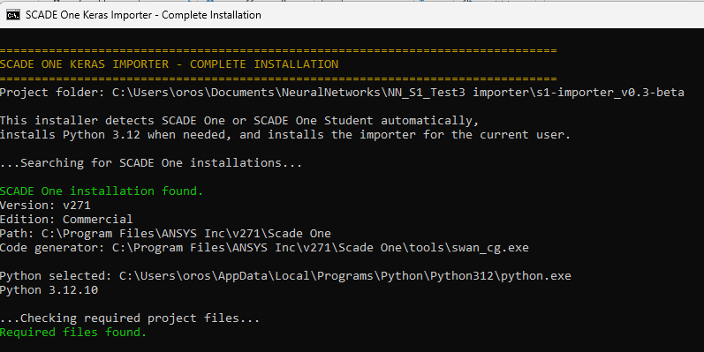
- The installer detects a valid Scade One installation, installs Python 3.12 if needed, and installs the required packages for the current Windows user.

- Wait for the successful installation and verification message.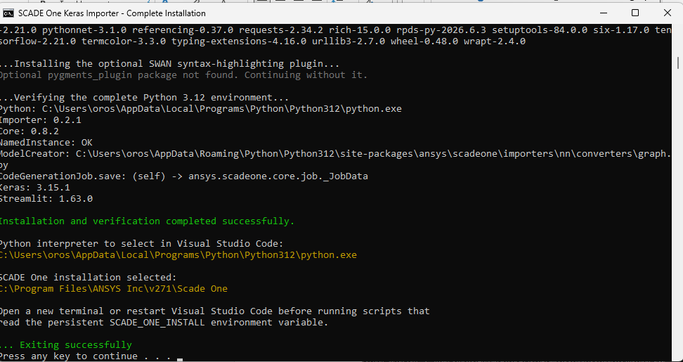

2.1 What is installed in the install_global_AnyVersion.bat
install_global_AnyVersion.bat installs the following components for the current Windows user:
- Python 3.12, if it is not already installed.
- An updated version of pip.
- The Keras Importer requirements.
- The Streamlit application requirements.
- The API for the importer ansys-scadeone-importers-nn version 0.2.1.
- A compatible version of ansys-scadeone-core.
- Keras, NumPy, NetworkX, and Streamlit.
- The optional SWAN syntax-highlighting plugin, when available.

After installation, the script verifies:
- Python 3.12.
- ansys-scadeone-importers-nn version 0.2.1.
- A compatible ansys-scadeone-core installation.
- The NamedInstance, ModelCreator, and CodeGenerationJob.save() APIs.
- Keras, NumPy, NetworkX, and Streamlit.
- The Scade One installation detected and its Swan Code Generator.
- The Python interpreter and Scade One installation path selected for the workflow.

Open the importer
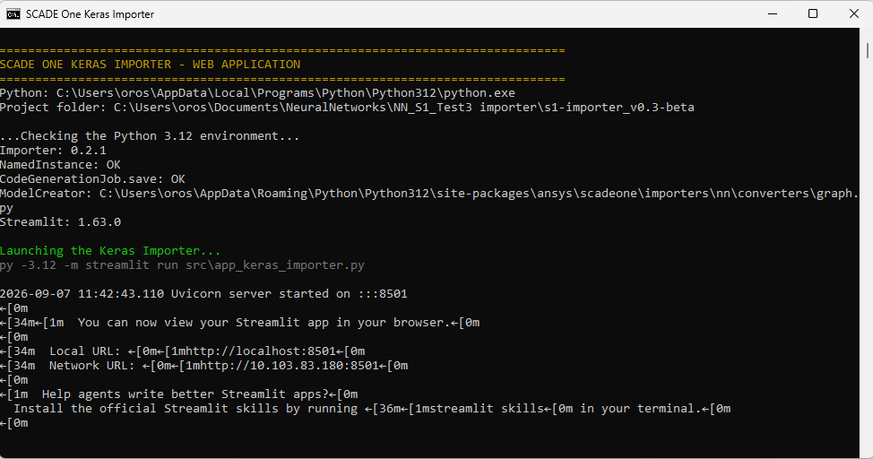
- Double-click open_importer.bat.

- On the first Streamlit launch, leave the Email field empty and press Enter if the prompt appears.
- If the browser does not open automatically, use the Local URL shown in the console, normally http://localhost:8501
- Keep the console window open while using the application.
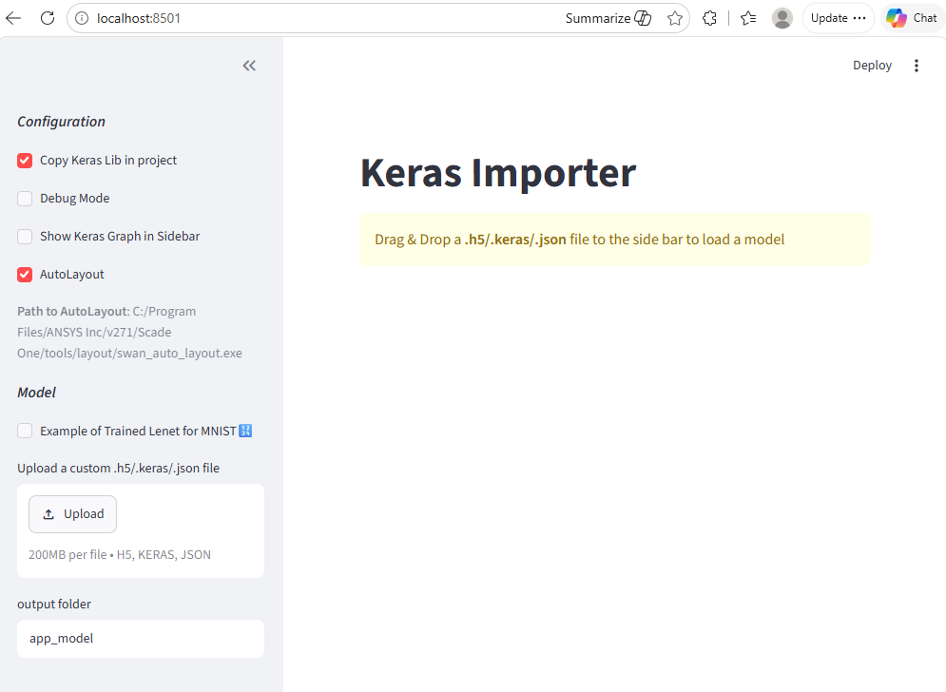

3.1 What open_importer.bat does
- open_importer.bat locates Python 3.12
- validates the installed environment
- reduces TensorFlow startup messages
- starts the Streamlit application from the correct folder.
It does not train or modify the uploaded model.
py -3.12 -u -m streamlit run "src\app_keras_importer.py"

4. Load and visualize the model
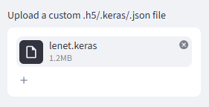
- Upload the .h5 or .keras file from the sidebar.

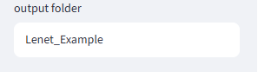
- Set the output folder.

- Review Graph of Model (Keras).
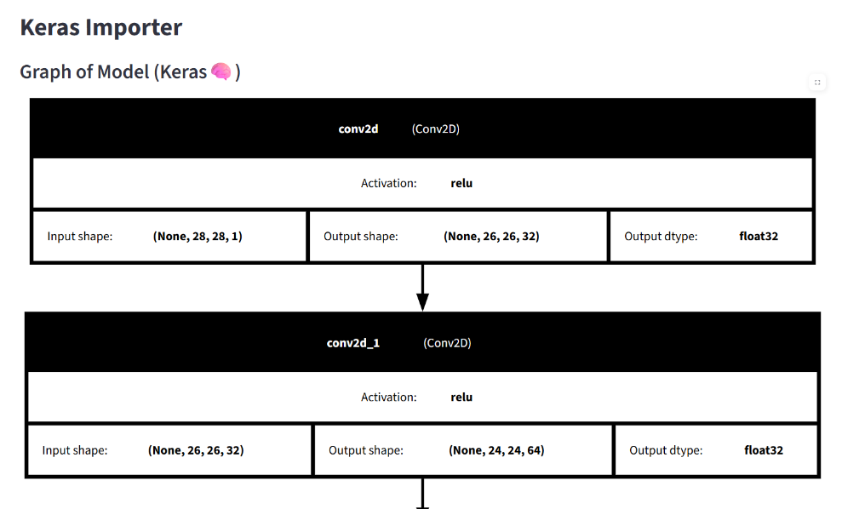

- Review Graph of Transformed Model (Networkx).
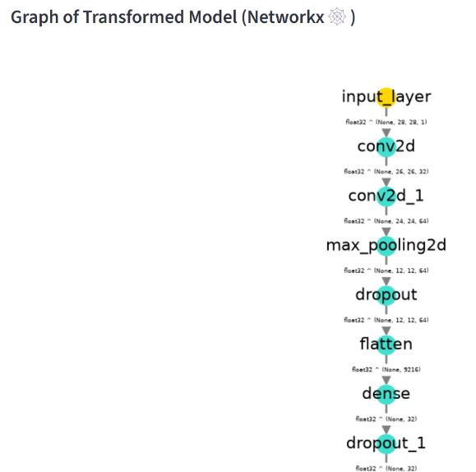

- Review the SWAN code displayed by the application.
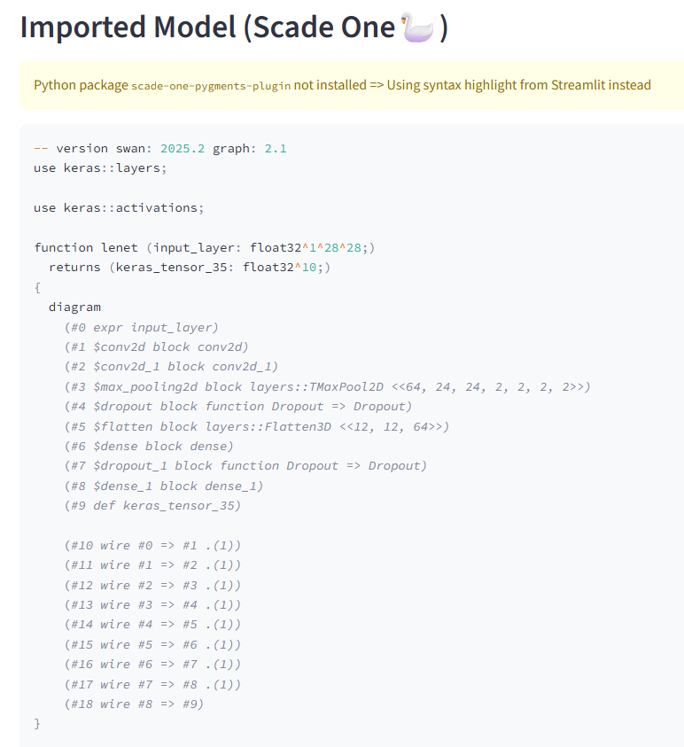

Generate the project
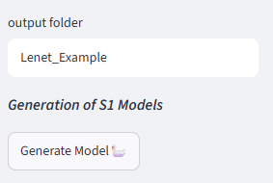
- Select Generate Model.

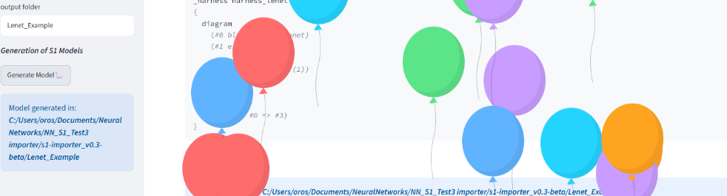
- Wait for the Model generated in confirmation.

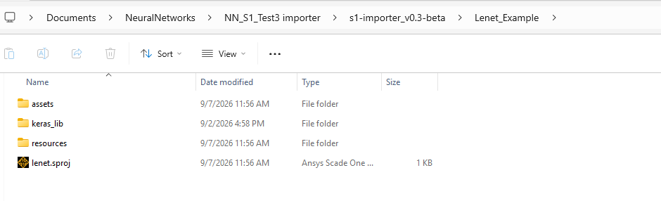
- Open the output folder displayed by the application.

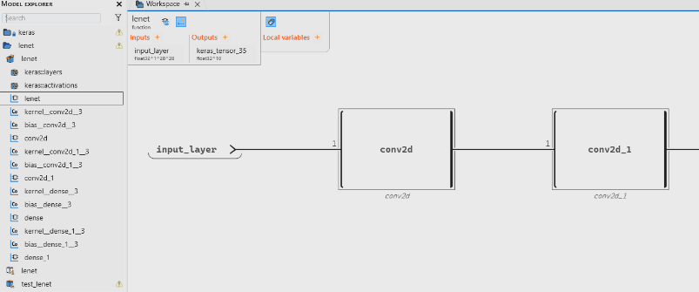
- Confirm that <model_name>.sproj exists

Import with Python.
The Keras Importer can also be executed directly from a Python script, without using the Streamlit graphical interface.
This method is useful when the import process must be:
- Automated.
- Repeated consistently.
- Integrated into another Python workflow.
- Executed from Visual Studio Code.
- Extended to create a SCADE One Code Generation Job automatically.

The Python workflow performs the following operations:
- Locates the trained Keras model.
- Locates the Keras SWAN library.
- Creates the SCADE One project.
- Generates the SWAN model.
- Exports the trained constants.
- Copies the Keras SWAN library into the generated project.
- Creates a Code Generation Job.
- Verifies the generated project and job.

The model can use either of the following formats:
- .keras
- .h5
The model must contain:
- The complete neural-network architecture.
- The trained weights and biases.
A weights-only .h5 file cannot be imported directly because the importer needs the complete model architecture.

6.1 Configuration variables
(With **** with the selected name)
- ROOT_DIR = Path(__file__).resolve().parent: Folder containing the Python import script.

- MODEL_FILE = ROOT_DIR / "****.keras": Complete trained .keras or compatible .h5 model to import.
- OUTPUT_DIR = ROOT_DIR / "ProjectNameFolder": Folder where the Scade One project will be generated.
- PROJECT_FILE = OUTPUT_DIR / "****.sproj": Path and filename of the generated .sproj project.
- KERAS_LIB = ROOT_DIR / "keras": Location of the Keras SWAN library used by the importer.
- SCADE_ONE_INSTALL = Path(r"C:\Program Files\ANSYS Inc\v271\Scade One"): Detected SCADE One installation folder containing tools.
- CODE_GENERATION_JOB = "Job****": Logical name assigned to the Code Generation Job.
- INPUT_SWAN_FILE = "assets/****.swan": SWAN model file used as input by the job.
- ROOT_OPERATOR = "****::****": Fully qualified SWAN operator selected as the code-generation root.

6.2 Model import
creator = ModelCreator( MODEL_FILE,
sproj_or_outdir=PROJECT_FILE,
keras_lib_path=KERAS_LIB,
copy_keras_lib=True,
exists_ok=True,
importer_version="0.2.1",
)
creator.create_module()
creator.write(auto_layout=False)

creator.create_module(), this operation:
- Analyzes the Keras architecture.
- Builds the intermediate graph.
- Converts supported layers to SWAN operators.
- Creates the SWAN module representation.
creator.write(auto_layout=False), this operation writes the generated project to disk, including:
- <project>.sproj
- assets/<model>.swan
- resources/constants.c
- keras_lib/
The option: auto_layout=False, disables automatic graphical layout during project generation.

6.3 Code generation job creation
The Code Generation Job is created with:
job = CodeGenerationJob(name=CODE_GENERATION_JOB, sproj=project)

The SWAN input file is configured with:
job.input_paths = [INPUT_SWAN_FILE]

The root operator is configured with:
job.root_declarations = [ROOT_OPERATOR]

The job is physically saved with:
job.save()

6.4 Code generation job creation
The script currently includes:
if OUTPUT_DIR.exists():
print("\nRemoving existing generated project:", OUTPUT_DIR)
shutil.rmtree(OUTPUT_DIR)
This means that every execution removes the previous generated project before creating a new one.

6.5 Expected output
With imput lenet.keras
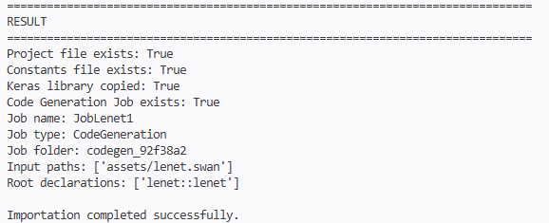
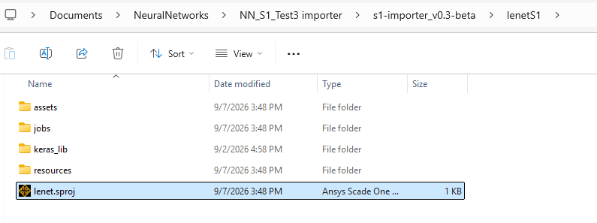

Note
Run ImportWithPython.py only after install_global_AnyVersion.bat has completed successfully. The script must be executed with Python 3.12 using the following command:
py -3.12 .\ImportWithPython.py

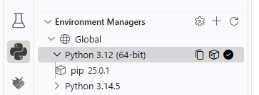
Or selecting on Visual Studio in python extension the Python 3.12 version.

Compatibility with Keras

Supported Layers
- Dense (maximum 2 dimensions)
- MaxPool2D
- Flatten
- Conv2D
- Dropout
- Activation (ReLU, Sigmoid, Tanh, Softmax)
- Add
- ZeroPadding2D
- BatchNormalization

Known Limitations
- Nested models (i.e. a model inside the model) are not supported yet.

