UNIVERSIDAD DE LAS FUERZAS ARMADAS - ESPE

- Object Oriented Programming -

< SMELL CODE >

TEAM #3

Inspection of Team #2

1. UNCOMMUNICATIVE NAMES

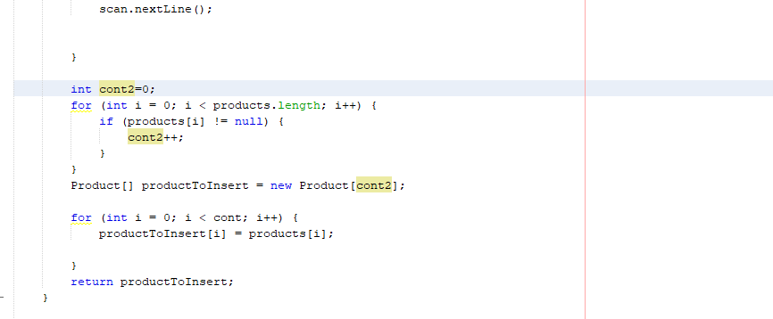

// The variable cont2 is a name that does not communicate what it does.

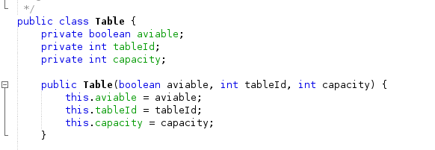

// This class name does not give any information about its utility.

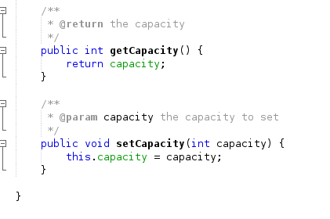

// This names don’t specify the things capacity that get or set.

1. INCONSISTENT NAMES

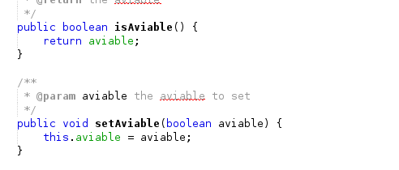

// The correct form of write is AVALIABLE, not AVIABLE.

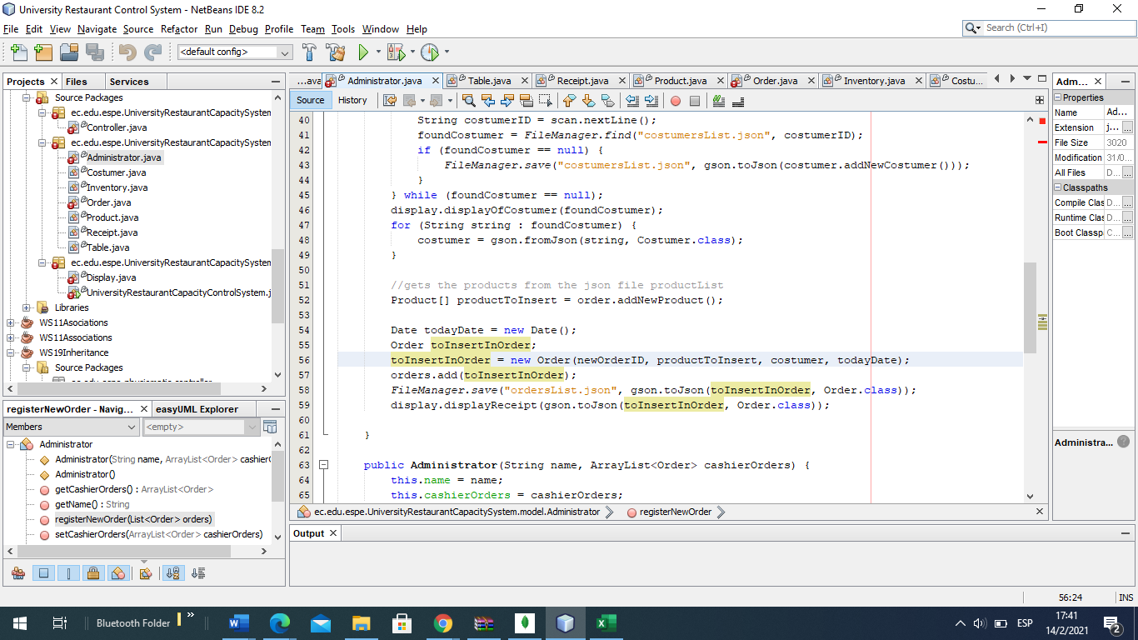

// The name for the object must be a noun. And in this case the name is a verb.

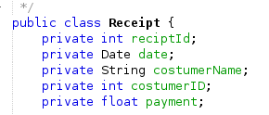

// reciptID variable name is not consistent with the class name. Also, Receipt class should be called Bill.

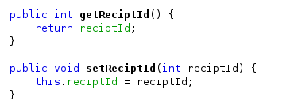

// This methods names are not consistent with the class name.. ReciptId - Receipt

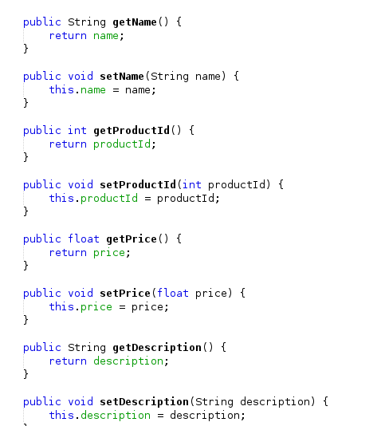

// All methods should specify its class in name, (EX: getProductDescription, setProductPrice, etc.) or contrary, method setProductId should be called only setID.

1. TYPES EMBEDDED IN NAMES.
2. LONG METHODS
3. DUPLICATE CODE
4. LONG MESSAGE CHAINS
5. CLASS EXPLOSION
6. LARGE MESSAGE CHAINS
7. LARGE CLASSES
8. CONDITIONAL COMPLEXITY
9. ODDBALL SOLUTION
10. REDUNDANT OR MEANINGLESS COMMENTS
11. DEAD CODE
12. SPECULATIVE GENERALITY
13. TEMPORARY FIELD
14. REFUSED BEQUEST
15. INAPPROPIATE INTIMACY
16. FEATURE ENVY

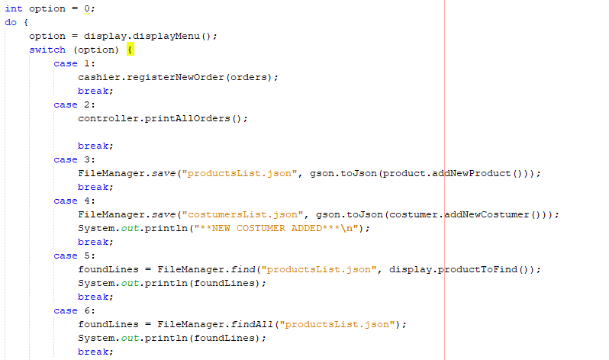

// There should be no file manager code in main.