Smart home music player

Palko Adrian-Alexandru
Popescu Mihai-Cristian

  - User needs
The project has a leisure aspect to it. The user who lives in a multi-room house or apartment may want to listen to music or some other audio while sitting in his/her living room. At some point he/she may want to leave the room but continue hearing the music (let’s say they are cleaning around the house and have music playing to make the task less tedious). In a more traditional method, they would need to use headphones or move their laptop around with them. With the smart house music player the music would follow them wherever they go in the house.
  - Description of the solution
The project uses sensors to detect when somebody is in a room. The user is provided with an application which enables him/her to turn on the music at will. Then the music will start playing through the speaker in the room where the user is found. When the user moves from the room, the music starts playing in the new room and stops in the last. The audio files are stored in a database which will be deployed on firebase. The application to the user will make calls to the database to retrieve songs and play them.
2.1 User requirements
The system consists of a couple of sensors that will be placed in different rooms around the house. Based on these sensors the user will be able to listen to a playlist of his/her choice wherever he/she is in his/her house.
The user will be able to control the system through a web application. They will be able to start/stop the music. Add/remove songs inside their music library.
In addition the user can set a certain playlist to play in a specific room. And if he/she is in that room that specific playlist will start to play.

2.2 System architecture
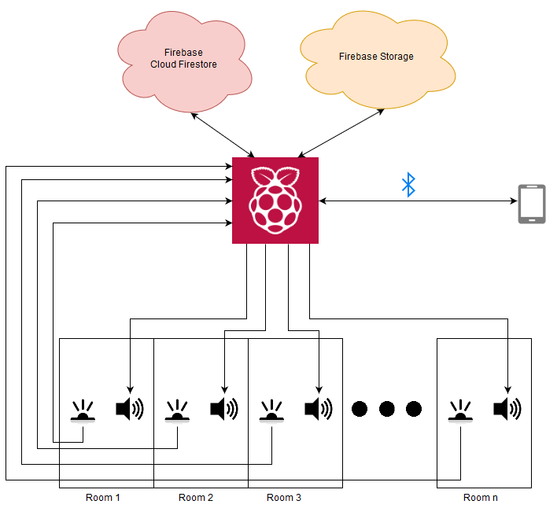

2.3 Hardware Overviews
As attached bellow, the system consists of a raspberry pi 3 b+, 3 carriers with sharp digital sensors, 2 with the range of 0.5-5cm and one with 2-10 cm and 3 speakers connected through usb(to jack adapter) and jack.
The project provides an example of an environment, which is separated in 3 different room. Each room comes with a sensor and a speaker. Through a mobile application, each room will have a song mapped to it and if the sensor detects something, the song corresponding to the room will start playing, overriding the current playing song.
Sensors: https://www.pololu.com/product/1134
Usb adapter: https://www.emag.ro/adaptor-audio-sound-card-usb-2-0-stereo-3d-7-1-ch-astrum-sc080-as03107181516/pd/DHB6RSBBM/
Speakers: Generic speakers
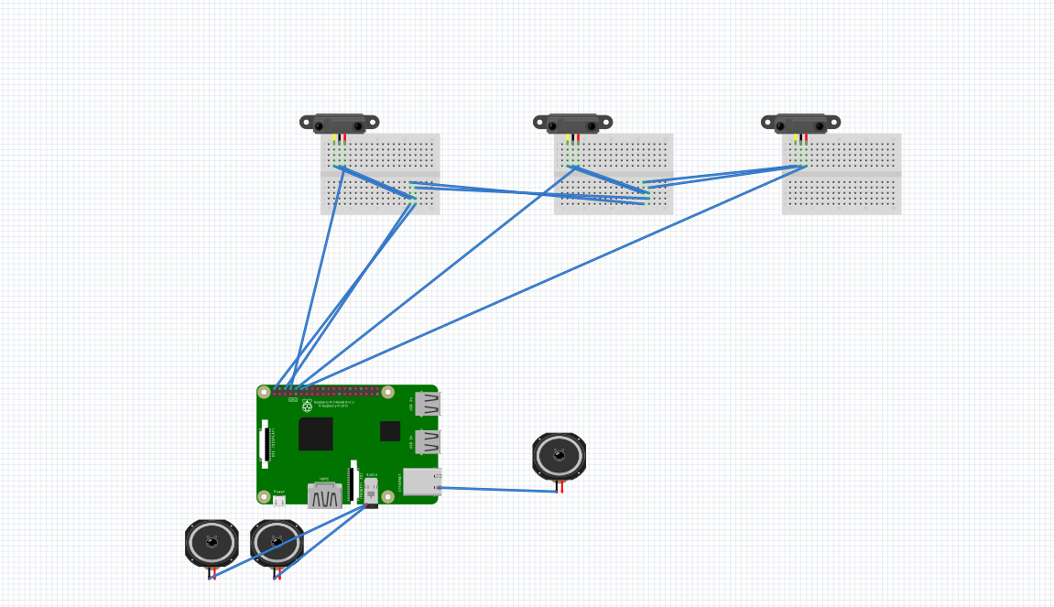
2.4 Software Overviews
The user will control the music player through an android application written in Kotlin with Android Studio. Communication between the android device and the RaspberryPi will happen by sending and receiving JSON formatted strings through Bluetooth.
The UI represents an android application written in Kotlin using Android Studio. The application presents the user with functionalities for finding and connecting to a Bluetooth compatible device, create and manage an account, as well as a music library from which the user can acquire audio material for playing in his/her house.
Communication through the application and the RaspberryPi is made through a Bluetooth connection. Both the application and the Raspberry send, request and await for data from the other one in the form of a JSON format string.
The database used Is Cloud Firestore by Firebase and all songs are stored using Firebase Storage.
The RaspberryPi contains instructions that check she status of a sensor. When it is decided that a sensor is active, it means that the speaker of the room the sensor is in must play audio.
Audio is played using the python vlc library, in its own process. The audio source represents a collection of Firebase Storage urls – a playlist, mapped to a specific room.

