Kiwi Trail

Final Project Report
Student Name: Alex Pan
Course: 570 Programming Project
Date: June 2026

1. Project Description
Kiwi Trail is a fully completed web application designed for planning outdoor activities across New Zealand. The core problem this project solves is the fragmentation of New Zealand outdoor data. Currently, users have to switch between multiple websites—such as the Department of Conservation (DOC) for tracks, Land Information New Zealand (LINZ) for maps, and NIWA for weather forecasts—making trip planning slow and frustrating.
In addition to data fragmentation, existing commercial outdoor software presents two major pain points for users: they often charge high subscription fees, and they generally fail to utilize New Zealand's local data effectively. Kiwi Trail addresses these gaps by offering a free, centralized platform tailored specifically to the New Zealand environment.
With this completed application, users can easily find places nearby, filter outdoor locations by region and difficulty, and plan their entire trip in one place with a clean, map-based interface. The target audience includes local Kiwis planning weekend hikes, international visitors exploring the outdoors, and casual campers looking for nearby campsites and reliable weather forecasts. To achieve this within the required course timeframe, I utilized industry-standard frameworks and technologies that are highly popular in the local tech market, ensuring both rapid development and professional system performance.

2. System Architecture and Technologies Used
The Kiwi Trail application is built using a modern, decoupled three-tier architecture to ensure performance, scalability, and maintainability. To meet the project requirements within the given timeframe, I utilized industry-standard frameworks that are highly popular in the local tech market.

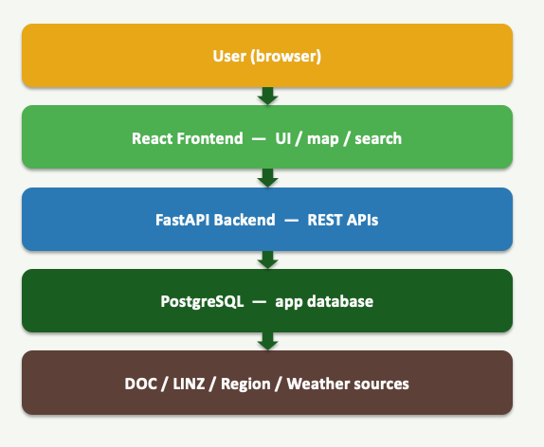
Figure 2.1 Project Architecture
- Frontend (React): The client-side is a single-page application built with React. It provides a clean, modern map-based user interface optimized for both desktop and mobile browsers. The React frontend manages the interactive map view (both 2D and 3D), the search and filter panel, the item detail pages featuring the integrated NIWA weather widget, and the user comments section with a 5-star rating system. The frontend is hosted and automatically deployed using Vercel.
- Backend (FastAPI): The backend server is developed using FastAPI (Python), which exposes REST API endpoints for the frontend. It handles the core business logic, including region and difficulty filters, fuzzy search logic, and processing user comments and favorites. The backend also manages the data standardization pipeline, which cleans and unifies the raw data collected from multiple external sources like DOC and LINZ.
- Database (PostgreSQL & PostGIS): The application relies on a PostgreSQL database to securely store records for tracks, huts, campsites, regions, users, comments, favorites, and ratings. Because the system processes a massive amount of geographical information, the PostGIS extension was integrated to enable efficient spatial queries, such as the 15 km nearby search feature. It also stores pre-processed 'LineStringZ' geoJSON data containing elevation details to ensure fast rendering of the 3D maps.
- DevOps & Deployment: The backend application and the PostgreSQL database are containerized using Docker and deployed on DigitalOcean Droplets for a stable production environment. GitHub is utilized for remote code management, version control, and continuous integration.

3. Completed Functionality
The application successfully integrates multiple datasets and provides the following core functionalities:
- User Authentication & Accounts: Users can log in, log out, view their account information, and access their saved favorite items.
- Interactive Mapping: A 2D map showing the exact position of selected items, alongside a 3D map feature that allows users to check track elevation, drag to rotate, and scroll to zoom in and out.
- Advanced Search & Filter: A dedicated search panel allowing users to select a region, filter by track difficulty, filter by category (tracks, huts, campsites), and use fuzzy search for location names.
- Spatial Queries: A nearby search feature capable of finding locations within a 15 km radius.
- Item Detail Pages: Comprehensive pages for tracks, huts, and campsites that include quick links for Google Maps directions.
- Weather Integration: A live NIWA weather widget providing a 6-day forecast for the specific location.
- User Interaction (UGC): A comments section where users can add comments, leave a 5-star rating, and upload up to three pictures.

4. Future Work
While the core web application is fully operational, several features are planned for future iterations to make the app production-ready:
- Professional Data Integration: I planned to transition from self-collected data to industry APIs (such as the Google Places API) to provide rich imagery and higher-quality address searches. This feature was planned but not started.
- Data Expansion & Crowdsourcing: I planned to leverage Google Maps data to fill existing gaps in track data and implement User-Generated Content (UGC) capabilities for trails. The database is prepared to handle this, but the automatic fetching from Google Maps was not completed due to time constraints.
- New Outdoor Verticals: Expanding the platform to include fishing zones and real-time tide information for coastal activities. This feature is currently in the conceptual phase.
- User-Driven Optimization: Refining the UI/UX based on ongoing user behavioral observations and feedback.

5. User Journey
The user journey for Kiwi Trail is carefully designed to be intuitive and highly efficient, guiding users seamlessly from broad exploration to detailed trip planning within a single platform. The following step-by-step scenario illustrates a typical interaction flow for a user, such as a local Kiwi planning a weekend hike or a tourist exploring New Zealand outdoors.
- Access and Authentication: The user opens the Kiwi Trail web application. To access personalized features, they click the user icon to open the navigation menu and log into their account securely.
- Discovery and Filtering: On the Home Page, the user utilizes the comprehensive Search Panel on the left side. They select a specific target area from the region dropdown (e.g., Waikato Region or Auckland) and apply specific filters to show only "Tracks" or "Huts" matching their desired difficulty level. If they already know the name of a place, they can type it into the "Fuzzy Search" box to find it instantly.
- Interactive Map Exploration: As the filters are applied, the interactive background map dynamically updates to display pins for all matching locations. The user can use the on-screen controls to change map layers, zoom in, and zoom out to explore the geographical distribution of the outdoor activities.
- Detailed Trip Planning: The user clicks a specific pin on the map, such as the "Karioi Track". The Item Detail Panel slides open, and the track's route is immediately highlighted in red on the 2D map. Here, the user can read the detailed description, check the estimated duration, and utilize a quick link for Google Maps directions to the starting point.
- Weather and Safety Checks: Within the same detail panel, the user scrolls down to check the integrated NIWA weather widget, which provides a reliable 6-day weather forecast specific to that track's coordinates to ensure a safe trip.
- 3D Terrain Visualization: To get a realistic sense of the physical challenge, the user interacts with the 3D map component. They drag the map to rotate it 360 degrees and scroll to zoom in, clearly visualizing the track's elevation changes and steepness before they go.
- Community Interaction and Saving: After completing the track, the user returns to the application's Comments section to share their experience. They leave a 5-star rating, type a short review, and upload up to three pictures of the scenery. Finally, they click the "Favourite" button to save the track to their personal "My saved items" list for future reference, and then securely sign out.
By integrating discovery, environmental data, topography, and community feedback into one continuous flow, this user journey successfully eliminates the frustrating process of switching between multiple fragmented websites, fulfilling Kiwi Trail's core objective of making trip planning fast and convenient.

6. Testing
To ensure the reliability and stability of the Kiwi Trail application, I conducted thorough testing across both the backend and frontend using different methodologies.Backend Testing (Automated Test Scripts):
- For the FastAPI backend and PostgreSQL database, I wrote dedicated test scripts to validate the core business logic and REST API endpoints. These scripts were used to automatically verify that the data standardization pipeline worked correctly when processing raw data. Furthermore, the scripts rigorously tested the complex database interactions, ensuring that the fuzzy search logic and the PostGIS spatial queries (such as the 15 km nearby search) accurately returned the expected JSON data without errors. Frontend Testing (Use Case Testing):
- For the React frontend, I applied the use case testing method to evaluate the application from an end-user's perspective. I designed specific user scenarios (use cases) to manually test the complete interaction flows. For example, I tested the use case of a user logging in, selecting a region, applying track difficulty filters, and verifying that the correct items appeared on the map. I also tested the interaction with the 2D and 3D maps, the loading of the NIWA weather widget, and the process of submitting a 5-star rating with images. This approach ensured that the user interface was intuitive, responsive, and functioned correctly under real-world usage conditions.

7. Challenges and Solutions
During the development of Kiwi Trail, I encountered three major technical challenges:
- Data from multiple sources: The raw data collected from DOC and LINZ used completely different measurements and formats. Solution: I built a data standardization pipeline to clean and unify all the data into a single PostgreSQL database schema, which made querying much easier.
- User-friendly Design: Because Kiwi Trail is a single-page application, it was easy for the screen to become cluttered with too many elements. Solution: I iterated through multiple design versions and layouts to finally achieve a clear, user-friendly interface that users can understand at a glance.
- Rendering 3D Maps: Displaying a 3D map requires processing massive amounts of precise DEM (elevation) and spatial data, which can slow down web rendering. Solution: I pre-processed the spatial data by generating a 'LineStringZ' geoJSON—which embeds the elevation data directly into the track coordinates—and stored it in the database for fast retrieval.

8. References
- Department of Conservation (DOC) - Data for tracks, huts, and campsites.
- Land Information New Zealand (LINZ) - Map tiles and gazetteer data.
- NIWA (National Institute of Water and Atmospheric Research) - Weather forecasting widget.
- React, FastAPI, and PostgreSQL official documentation.

9. Screenshots / Visuals
(Note: Please insert the corresponding images from your presentation into this section before submitting)
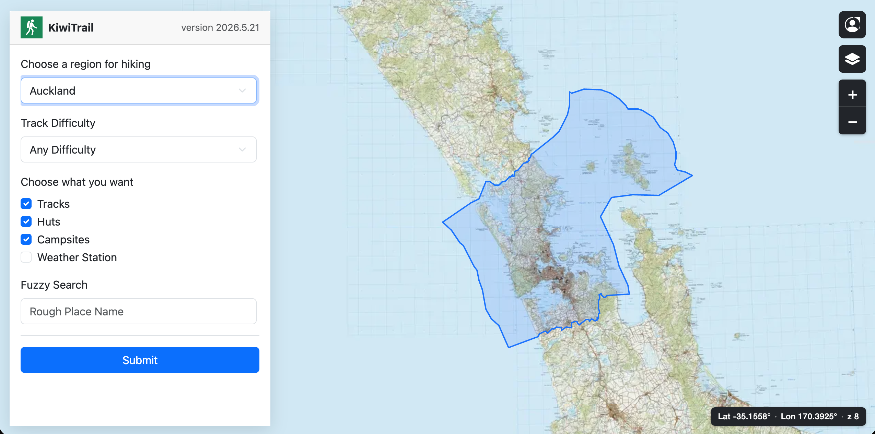
Figure 1: Home Page showing the Map and Search Panel.
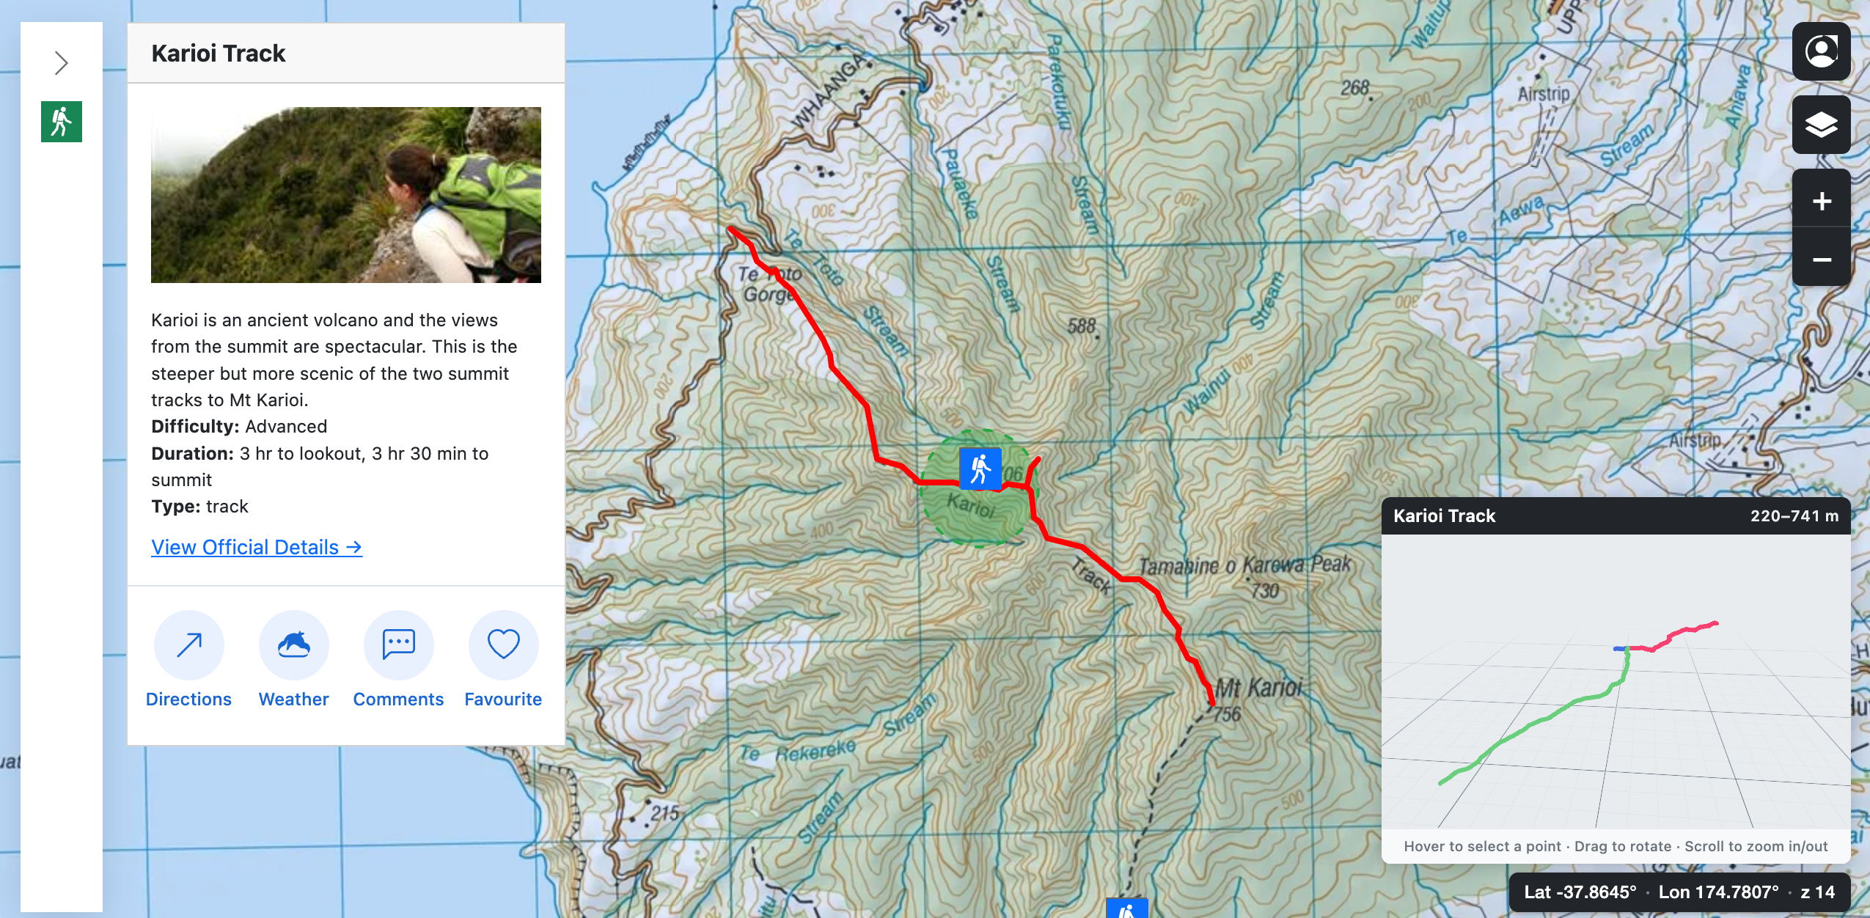
Figure 2: Selected Item Details (Karioi Track) showing the 2D path highlighted in red.

Figure 3: The interactive 3D map component rendering the 'LineStringZ' elevation data.
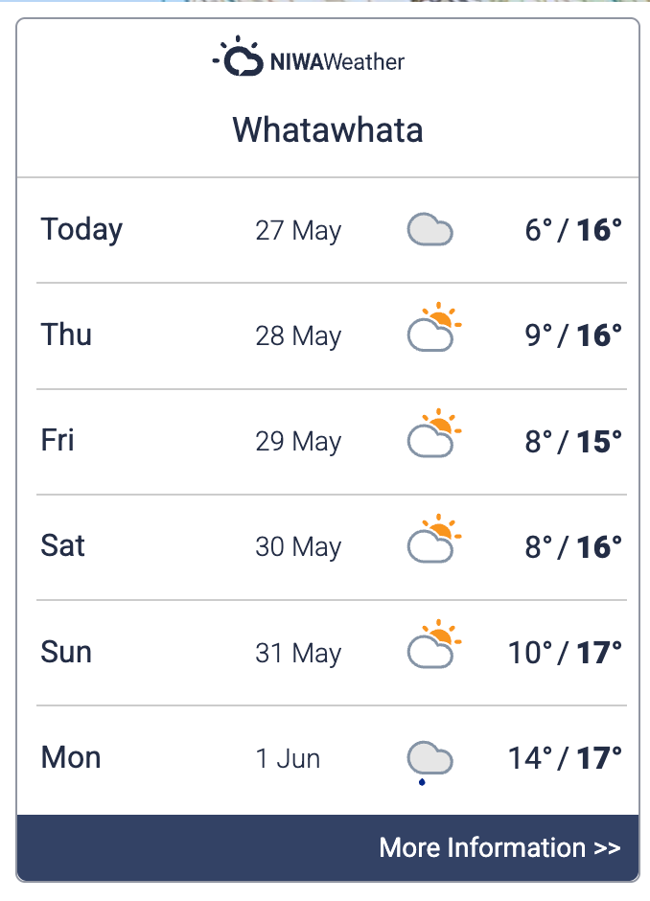
Figure 4: The NIWA Weather Widget displaying a 6-day forecast.
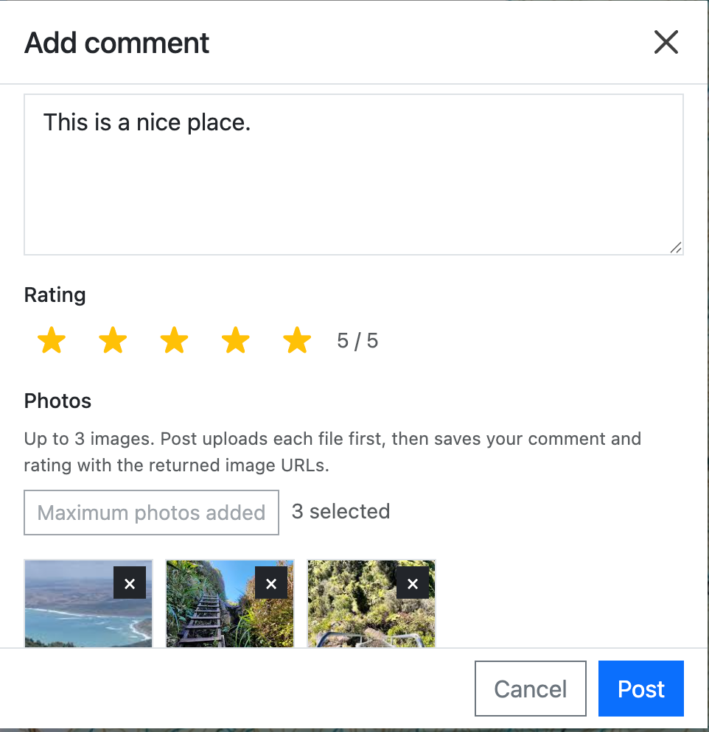
Figure 5: The User Comments module showing the 5-star rating system and picture upload UI.
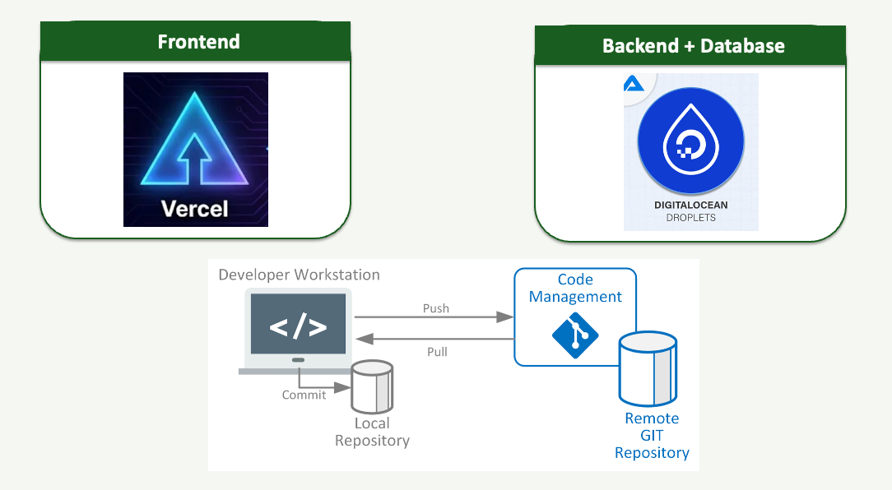
Figure 6: The DevOps deployment architecture showing Vercel, GitHub, and DigitalOcean integrations.

