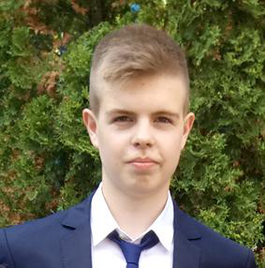**Parkhomenko Oleksandr**

Date of Birth: 22.06.2000

Location: Ukraine, Kyiv

Phone: +380958040276

Email: [shasha.parh@gmail.com](mailto:shasha.parh@gmail.com)

LinkedIn: [www.linkedin.com/in/alexandr-parkhomenko](http://www.linkedin.com/in/alexandr-parkhomenko/)

**Technical skills**

* .NET Framework, C#
* WinForms, WPF, ASP.NET Web Forms
* HTML, CSS
* MSSQL, MySQL
* GitHub
* Scripts for UNIX (bash, python, perl)
* Knowledge of the main sections of higher mathematics

**Education**

* Since 2017, KNU, Faculty of Radiophysics, Electronics and Computer Systems.

**Additional education**

* Cisco IT Essential Course

**Languages**

* Ukrainian, Russian – native
* English – Intermediate (B1)

**Personal qualities**

* Responsible
* Sociable
* Attentive to the details