**INGENIERÍA DE LA SALUD**

**Base Toxicológica**

**REALIZADO POR:**

**CARLOS BELTRÁN LÓPEZ**

**ALEJANDRO PASCUAL MELLADO**

**TUTORIZADO POR:**

**ISMAEL NAVAS DELGADO**

**DEPARTAMENTO DE LENGUAJES**

**Y CIENCIAS DE LA COMUNICACIÓN UNIVERSIDAD DE MÁLAGA**

**ÍNDICE**

1. **INTRODUCTION**

It is going to implement a data base to manage the toxicology information needed for the study of the different toxic agents in different zones where one or more researching centres take part in.

1. Interfaz de usuario gráfica, Diagrama

   Descripción generada automáticamente**DESIGN AND DATA IMPLEMENTATION**

Different tables have been developed in order to build the structure of the database.

Description of each one:

Venenos: table in which the id of the toxic will be saved as primary key, accompanied by its type, mortality degree (1-10) being 10 the most dangerous.

Animal: animal which originates that specific poison.

Zona: it specifies the weather. It has a 1:N relation with Centro_de_Investigacion class (one zone could have more than one investigation center) and a relation N:N with animal which is the table Habita.

Centro_de_Investigacion: the organisation that studies and develop the antidotes of each toxic agent it can be either public or private.

Investigador: table which saves the professionals working on each centre and general information about them.

Antídoto: the antidote associated to a specific poison which was created in a date and which have an id acting as a PK.

All this logical model was designed with mysql, from this, a sql file was generated and the data was inserted manually in it with the function insert.

Now it is possible to make queries, functions, triggers…

1. **QUERY DESIGN**

*For each researching centre with three or more researchers, show it name and the zone it belongs to.*

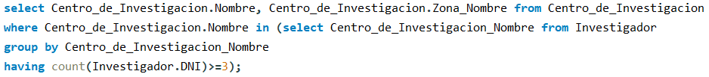



*Show the antidotes that have been developed in researching centres from a specified zone*

**



*Show the poisons and its antidotes if it exists*



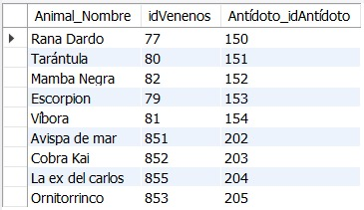

*Access the name of the animals in the animals table and their area of ​​the inhabits table that do not inhabit a specific zone*



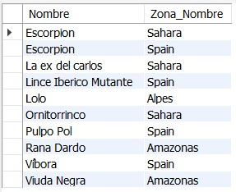

1. **QUERY OPTIMIZATION**

Tuplas devueltas / Tuplas examinadas

|  |  |  |
| --- | --- | --- |
|  | **Sin Índice Añadido** | **Centro de Investigación.Nombre** |
| **Q1** | 1/9 | 1/9 |

|  |  |  |
| --- | --- | --- |
|  | **Sin Índice Añadido** | **Centro de Investigación.Nombre** |
| **Q2** | 1/2 | 1/2 |

|  |  |
| --- | --- |
|  | **Sin Índice Añadido** |
| **Q3** | 9/9 |

|  |  |  |
| --- | --- | --- |
|  | **Sin Índice Añadido** | **Nada** |
| **Q4** | 10/36 | 10/36 |

**It is not possible to improve the performance of the queries with new indexes because the database is already using indexes created by foreign keys.**