<project_name>

Analysis and Design Document : Assignment 1

Student: Asaftei Alexandru-Petru
Group: 30431

Table of Contents
Contents
1. Requirements Analysis 3
1.1 Assignment Specification 3
1.2 Functional Requirements 3
1.3 Non-functional Requirements 3
2.Use-Case Model 4
3.System Architectural Design 4
4.Class Design 5
5.Data Model 6

1. Requirements Analysis

Assignment Specification
The objective of this project is to develop a full-stack application for managing a system of persons, products, and orders. The application focuses on implementing a robust backend with Spring Boot and a dynamic frontend using Angular, ensuring data integrity through advanced validations and error handling.

Functional Requirements
The application has the following functional requirements:
- Person Management: Allow users to create, view, edit, and delete entries for people in the system.
- Input Validation: Implement strict validation for all inputs, including name, email format, and password strength, to adhere to the specified system format.
- Duplicate Prevention: Ensure that business logic prevents edge cases, such as creating multiple accounts with the same email address.
- Error Visibility: Provide clear, user-friendly error messages in the frontend when a request fails due to validation or server errors.

Non-functional Requirements

The application has the following non-functional requirements:
- Layered Architecture: Use a layered architecture (Controller, Service, Repository) for better organization and separation of concerns.
- ORM Integration: Use Spring Data JPA (ORM) to handle all database interactions and entity mapping.
- Dependency Injection: Use a DI container to manage component life cycles and dependencies.
- Global Exception Handling: Implement a centralized exception handler to capture business logic failures and map them to appropriate HTTP responses.

Use-Case Model

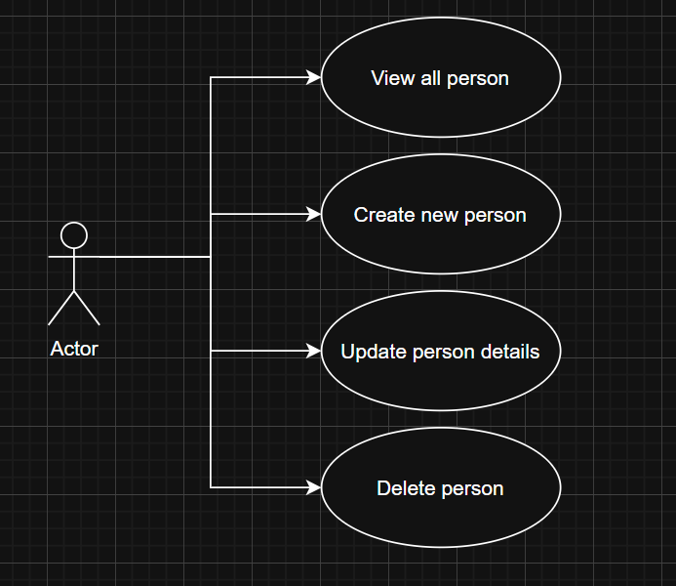
Description of the “Create Person” use-case:
- Use case goal: To allow the administrator to add a new person to the system after validating their credentials.
- Primary actor: The user of the application.
- Main success scenario: The user fills in the Name, Age, Email, and Password correctly. The system validates the data, saves it to the database, and the new entry appears in the list.
- Extensions (Alternate scenario): The database is empty. After creating the first person, the "No entries" message is replaced by the data table.
- Failure: The user enters an existing email or an invalid password format. The system blocks the save operation and displays a specific error message (e.g., "must be a well-formed email address").

System Architectural Design

Architectural Pattern Description

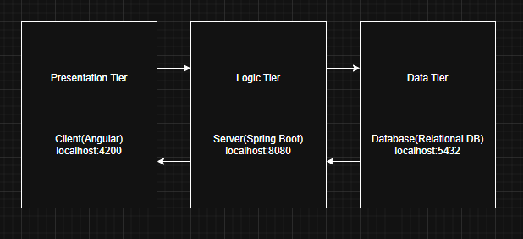

- Presentation Tier (Client): Implemented as a dynamic frontend using Angular. It handles user interactions, sends requests to the backend, and displays clear, user-friendly error messages when a request fails due to validation or server errors.
- Logic Tier (Server): Implemented as a robust backend with Spring Boot. This tier manages the core application logic, relying on a Dependency Injection (DI) container to manage component life cycles. It enforces strict input validation and features a centralized Global Exception Handler to capture business logic failures and map them to appropriate HTTP responses.
- Data Tier (Database): Uses a relational database integrated with Spring Data JPA (ORM) to handle all database interactions and entity mapping.

Diagrams

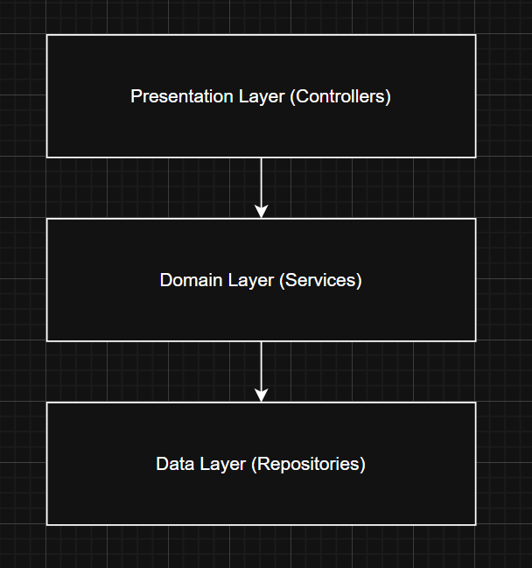
- Presentation Layer (Controllers): This layer acts as the entry point for REST API requests. It is responsible for handling routing, enforcing initial input validation using @Valid, and working alongside the Global Exception Handler to return consistent error responses.
- Domain Layer (Services): This layer holds the business logic. It ensures data integrity and prevents edge cases, such as creating multiple accounts with the same email address or assigning invalid relationships.
- Data Layer (Repositories): This layer provides data access. Using Spring Data JPA, it abstracts standard SQL operations into simple interfaces for seamless database manipulation and entity mapping.

Class Design

Package + Class Diagram
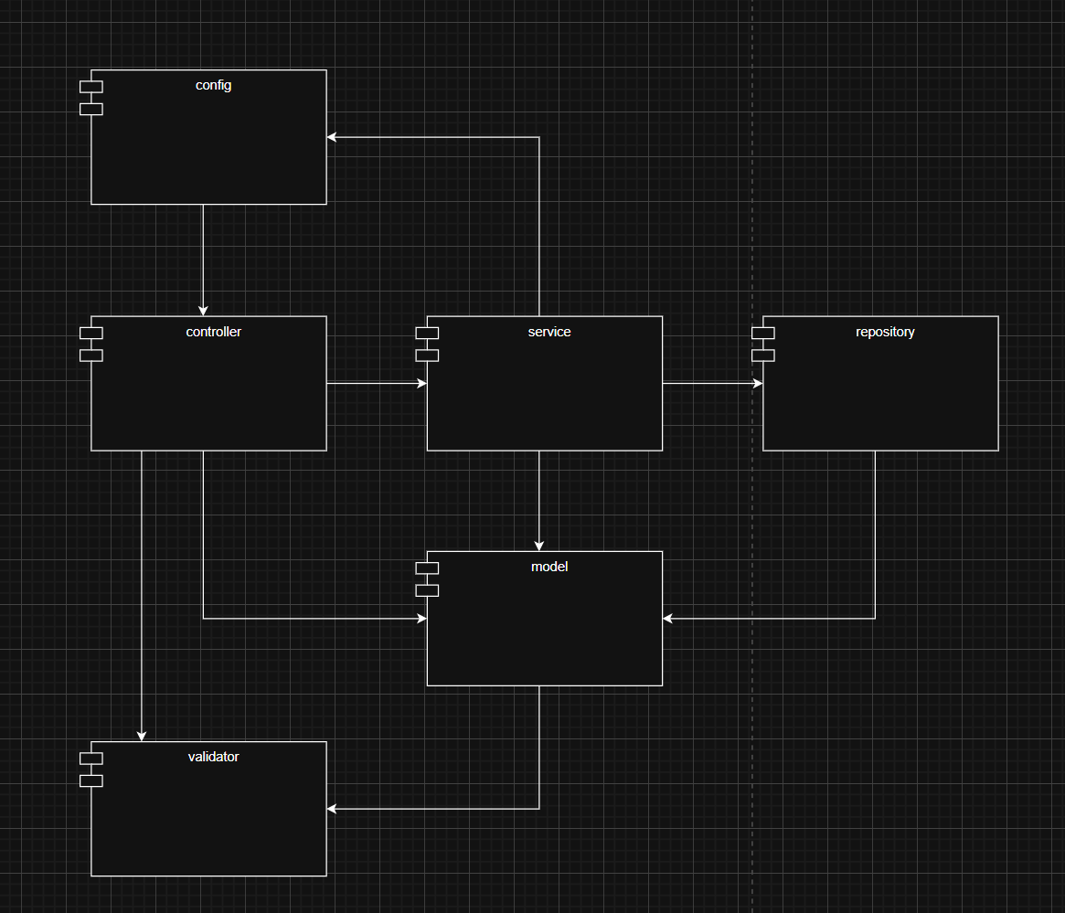
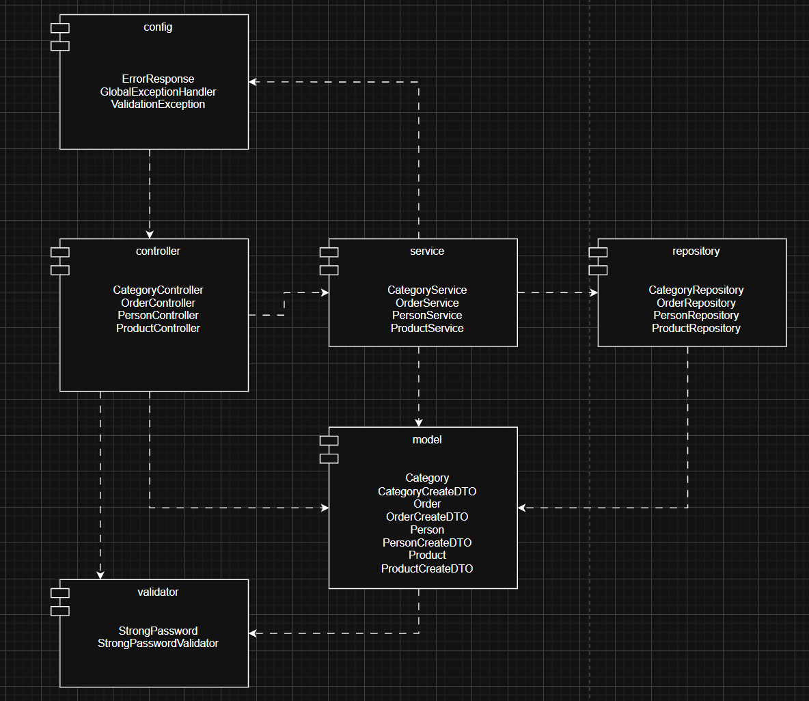

Data Model

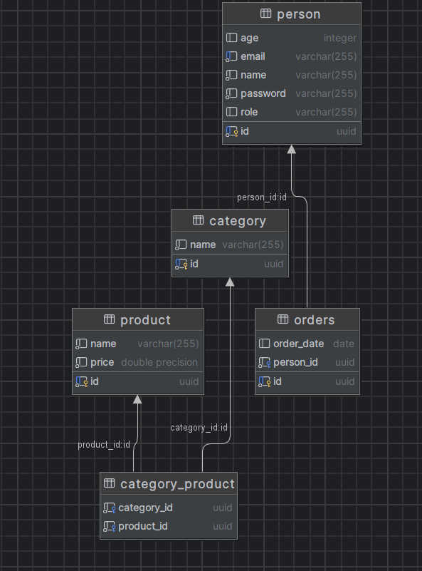
The data model is mapped to a relational database using Spring Data JPA and Hibernate. The architecture consists of four primary entities and one junction table to resolve complex relationships:
- Person: The main entity storing user credentials and details (UUID, name, email, password, age, and role).
- Orders: Represents user purchases. There is a One-to-Many (1:M) relationship between person and orders. A person can place multiple orders, managed by the person_id foreign key inside the orders table.
- Product & Category: These tables store the application's catalog items. They share a Many-to-Many (M:M) relationship (a product can be in multiple categories, and a category contains multiple products).
- Category_Product: Because relational databases cannot handle M:M relationships directly, a junction table named category_product is used. It contains the foreign keys category_id and product_id to link the two entities together.

