Tables and figures

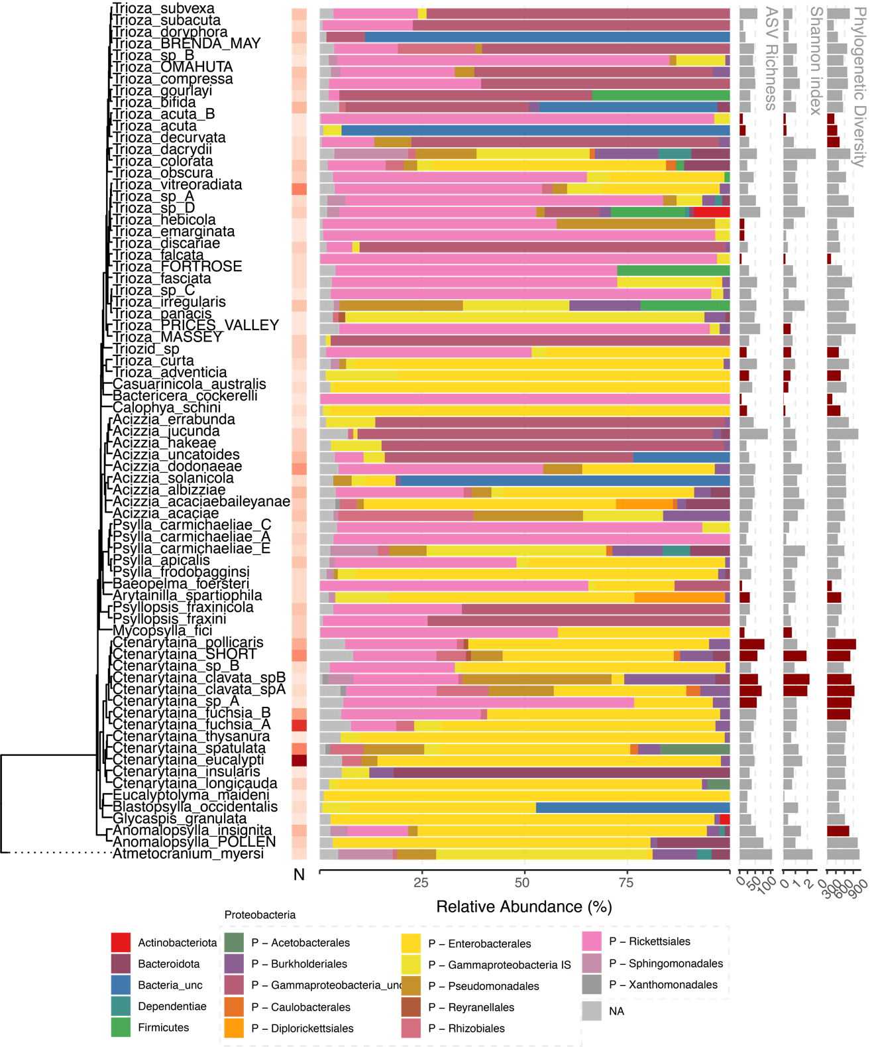

Fig 1 – Overview of microbiome results by species

Fig 2 Phylosymbiosis – Results of Mantel tests, partial Mantel tests, and beta diversity through time analysis.

Fig3 - Phylogenetic congruence between psyllid species and microbiome. Links and taxa coloured according to their contribution to global fit.

Fig4 - Phylogenetic congruence between psyllid species and carsonella ASVs. Links and taxa coloured according to their contribution to global fit.

Fig5 - Phylogenetic congruence between psyllid species and hostplant species. Links and taxa coloured according to their contribution to global fit.

Fig6 - Phylogenetic congruence between Trioza species and hostplant species. Links and taxa coloured according to their contribution to global fit.

# Supplementary information

Summary of hierarchical taxonomic assignment using IDTAXA

Rarefaction curves showing sequencing depth for each sample. All samples below 1000 sequence reads were removed

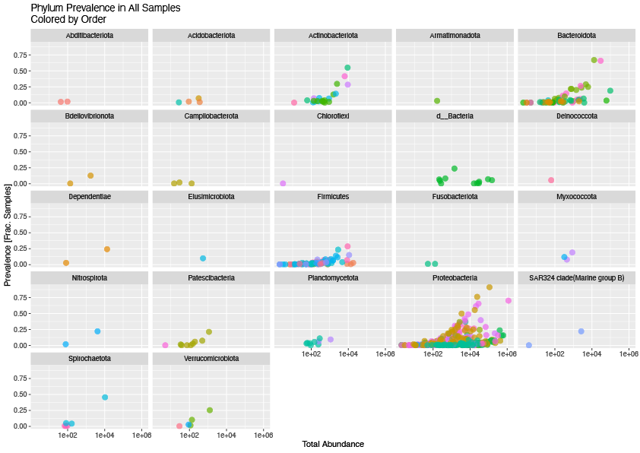

Abundance and prevalence of different bacterial phyla across the entire dataset after filtering

PCA plot of Aitchison distance between microbial communities coloured by psyllid phylogenetic cluster.

PCA plot of Aitchison distance between microbial communities coloured by hostplant phylogenetic cluster.

PCA plot of Aitchison distance between microbial communities coloured by UPGMA cluster of spatial distance

Collection locations of NZ psyllid samples

Adonis results for different distance measures

|  |  |  |  |  |  |  |  |
| --- | --- | --- | --- | --- | --- | --- | --- |
| ­ | term | df | SumsOfSqs | MeanSqs | F.Model | R2 | p.value |
| Bray | psyllid_spp | 74 | 75.9719275 | 1.02664767 | 4.49700625 | 0.65279035 | 0.001 |
| Bray | hostplant_spp | 55 | 54.5869929 | 0.99249078 | 3.14804707 | 0.46903986 | 0.001 |
| Jaccard | psyllid_spp | 74 | 43.4323434 | 0.58692356 | 2.04770318 | 0.46123647 | 0.001 |
| Jaccard | hostplant_spp | 55 | 32.9151396 | 0.59845708 | 1.9150663 | 0.3495474 | 0.001 |
| Aitchison | psyllid_spp | 74 | 142965.303 | 1931.96356 | 2.19311858 | 0.47832357 | 0.001 |
| Aitchison | hostplant_spp | 55 | 108585.661 | 1974.28475 | 2.03339208 | 0.36329851 | 0.001 |
| Unifrac | psyllid_spp | 74 | 25.7110859 | 0.34744711 | 2.01199508 | 0.45686801 | 0.001 |
| Unifrac | hostplant_spp | 55 | 20.3455383 | 0.36991888 | 2.01785367 | 0.36152598 | 0.001 |
| WUnifrac | psyllid_spp | 74 | 25.7206748 | 0.34757669 | 5.3239992 | 0.69000445 | 0.001 |
| WUnifrac | hostplant_spp | 55 | 20.412656 | 0.3711392 | 4.31366712 | 0.54760708 | 0.001 |

Mantel results for different distance measures

|  |  |  |  |  |  |
| --- | --- | --- | --- | --- | --- |
| dist | mantelr | pval | llim.2.5% | ulim.97.5% | dist1 |
| Bray | 0.18157003 | 0.001 | 0.16818337 | 0.22324658 | phylo.dist |
| Bray | 0.18921805 | 0.001 | 0.17482358 | 0.20832634 | plant.dist |
| Bray | 0.09517944 | 0.001 | 0.0825982 | 0.1080083 | spat.dist |
| Jaccard | 0.04946199 | 0.072 | 0.036153 | 0.08002391 | phylo.dist |
| Jaccard | 0.13591112 | 0.001 | 0.11255801 | 0.15800243 | plant.dist |
| Jaccard | 0.02287177 | 0.436 | 0.00238033 | 0.045936 | spat.dist |
| Aitchison | 0.22976035 | 0.001 | 0.15992586 | 0.25201626 | phylo.dist |
| Aitchison | 0.04756532 | 0.156 | 0.02038544 | 0.07000935 | plant.dist |
| Aitchison | 0.04123014 | 0.429 | 0.00338496 | 0.0788697 | spat.dist |
| Unifrac | 0.0578 | 0.078 | 0.0464187 | 0.07798872 | phylo.dist |
| Unifrac | 0.12409659 | 0.001 | 0.10298463 | 0.14371115 | plant.dist |
| Unifrac | 0.00937781 | 0.805 | -0.007235 | 0.02648686 | spat.dist |
| WUnifrac | 0.08395321 | 0.026 | 0.06615729 | 0.09472239 | phylo.dist |
| WUnifrac | 0.09855466 | 0.001 | 0.07975156 | 0.11531844 | plant.dist |
| WUnifrac | -0.0577221 | 0.129 | -0.068447 | -0.0421818 | spat.dist |

Partial mantel results for different distance measures

|  |  |  |  |  |  |  |  |
| --- | --- | --- | --- | --- | --- | --- | --- |
| dist | mantelr | pval | llim.2.5% | ulim.97.5% | dist1 | dist2 | dist3 |
| Bray | 0.13411929 | 0.001 | 0.12223275 | 0.16200041 | phylo.dist | plant.dist | spat.dist |
| Bray | 0.10493659 | 0.001 | 0.09449539 | 0.11547555 | spat.dist | phylo.dist | plant.dist |
| Bray | 0.1523537 | 0.001 | 0.1331613 | 0.17044173 | plant.dist | spat.dist | phylo.dist |
| Jaccard | 0.01076958 | 0.722 | 4.06E-05 | 0.03349455 | phylo.dist | plant.dist | spat.dist |
| Jaccard | 0.03001003 | 0.32 | 0.00920232 | 0.05010296 | spat.dist | phylo.dist | plant.dist |
| Jaccard | 0.12876763 | 0.001 | 0.107261 | 0.14463066 | plant.dist | spat.dist | phylo.dist |
| Aitchison | 0.22504417 | 0.001 | 0.14889203 | 0.24836672 | phylo.dist | plant.dist | spat.dist |
| Aitchison | 0.03957756 | 0.475 | 0.00228897 | 0.07970439 | spat.dist | phylo.dist | plant.dist |
| Aitchison | -0.0166416 | 0.66 | -0.0474116 | 0.00697877 | plant.dist | spat.dist | phylo.dist |
| Unifrac | 0.02337332 | 0.512 | 0.01444681 | 0.03792453 | phylo.dist | plant.dist | spat.dist |
| Unifrac | 0.01543671 | 0.658 | -0.0019277 | 0.03447449 | spat.dist | phylo.dist | plant.dist |
| Unifrac | 0.11319137 | 0.001 | 0.09170898 | 0.13328527 | plant.dist | spat.dist | phylo.dist |
| WUnifrac | 0.06000782 | 0.091 | 0.03684844 | 0.06989536 | phylo.dist | plant.dist | spat.dist |
| WUnifrac | -0.0543991 | 0.147 | -0.0653216 | -0.0395205 | spat.dist | phylo.dist | plant.dist |
| WUnifrac | 0.07514953 | 0.008 | 0.05857711 | 0.09637918 | plant.dist | spat.dist | phylo.dist |

Adonis results – No Gammaproteobacteria

|  |  |  |  |  |  |  |  |
| --- | --- | --- | --- | --- | --- | --- | --- |
| dist | term | df | SumsOfSqs | MeanSqs | F.Model | R2 | p.value |
| Bray | psyllid_spp | 74 | 56.2319176 | 0.75989078 | 2.55442109 | 0.51642933 | 0.001 |
| Bray | hostplant_spp | 55 | 40.8846547 | 0.74335736 | 2.14257626 | 0.37548132 | 0.001 |
| Jaccard | psyllid_spp | 74 | 39.4183321 | 0.53268016 | 1.76508244 | 0.42460749 | 0.001 |
| Jaccard | hostplant_spp | 55 | 30.2606138 | 0.55019298 | 1.72336084 | 0.32596212 | 0.001 |
| Aitchison | psyllid_spp | 74 | 53131.3574 | 717.991316 | 2.01192424 | 0.45685927 | 0.001 |
| Aitchison | hostplant_spp | 55 | 40202.5091 | 730.954711 | 1.8827532 | 0.34568831 | 0.001 |
| Unifrac | psyllid_spp | 74 | 27.3303761 | 0.36932941 | 1.87192149 | 0.43902519 | 0.001 |
| Unifrac | hostplant_spp | 55 | 21.4381932 | 0.38978533 | 1.87184593 | 0.34437532 | 0.001 |
| WUnifrac | psyllid_spp | 74 | 44.7501597 | 0.60473189 | 3.52677772 | 0.59587339 | 0.001 |
| WUnifrac | hostplant_spp | 55 | 33.2964558 | 0.60539011 | 2.83842287 | 0.44336092 | 0.001 |

Mantel results – No Gammaproteobacteria

|  |  |  |  |  |  |
| --- | --- | --- | --- | --- | --- |
| dist | mantelr | pval3 | llim.2.5% | ulim.97.5% | dist1 |
| Bray | 0.10173472 | 0.001 | 0.09201224 | 0.1176122 | phylo.dist |
| Bray | 0.07645643 | 0.001 | 0.06441567 | 0.08987944 | plant.dist |
| Bray | 0.09653493 | 0.002 | 0.08178993 | 0.10992345 | spat.dist |
| Jaccard | 0.03645645 | 0.187 | 0.02358766 | 0.06218962 | phylo.dist |
| Jaccard | 0.12640614 | 0.001 | 0.10635685 | 0.14563726 | plant.dist |
| Jaccard | 0.02559136 | 0.395 | 0.00438016 | 0.04697594 | spat.dist |
| Aitchison | 0.20948266 | 0.001 | 0.14641777 | 0.23061167 | phylo.dist |
| Aitchison | 0.02414901 | 0.456 | 1.86E-04 | 0.04296708 | plant.dist |
| Aitchison | 0.06152691 | 0.256 | 0.02348832 | 0.08935163 | spat.dist |
| Unifrac | 0.03015174 | 0.395 | 0.01846147 | 0.04835 | phylo.dist |
| Unifrac | 0.11288769 | 0.001 | 0.09217884 | 0.13477319 | plant.dist |
| Unifrac | 0.00385297 | 0.926 | -0.0165861 | 0.02090566 | spat.dist |
| WUnifrac | 0.09073475 | 0.001 | 0.08066551 | 0.10155848 | phylo.dist |
| WUnifrac | 0.05882365 | 0.008 | 0.04310485 | 0.07589714 | plant.dist |
| WUnifrac | 0.11339481 | 0.001 | 0.09604389 | 0.12953364 | spat.dist |

Partial mantel – No Gammaproteobacteria

|  |  |  |  |  |  |  |  |
| --- | --- | --- | --- | --- | --- | --- | --- |
| dist | mantelr | pval3 | llim.2.5% | ulim.97.5% | dist1 | dist2 | dist3 |
| Bray | 0.08179899 | 0.001 | 0.07196513 | 0.09433957 | phylo.dist | plant.dist | spat.dist |
| Bray | 0.09936836 | 0.001 | 0.08502017 | 0.11450454 | spat.dist | phylo.dist | plant.dist |
| Bray | 0.05567498 | 0.012 | 0.04057298 | 0.06855663 | plant.dist | spat.dist | phylo.dist |
| Jaccard | -1.42E-04 | 0.998 | -0.0103766 | 0.01664303 | phylo.dist | plant.dist | spat.dist |
| Jaccard | 0.03246953 | 0.278 | 0.01111876 | 0.05395916 | spat.dist | phylo.dist | plant.dist |
| Jaccard | 0.12278456 | 0.001 | 0.1037497 | 0.14295823 | plant.dist | spat.dist | phylo.dist |
| Aitchison | 0.21038406 | 0.002 | 0.14867445 | 0.23540317 | phylo.dist | plant.dist | spat.dist |
| Aitchison | 0.05930987 | 0.233 | 0.02892096 | 0.08613387 | spat.dist | phylo.dist | plant.dist |
| Aitchison | -0.034298 | 0.345 | -0.064394 | -0.0148972 | plant.dist | spat.dist | phylo.dist |
| Unifrac | -0.0022051 | 0.952 | -0.0120048 | 0.01022506 | phylo.dist | plant.dist | spat.dist |
| Unifrac | 0.00985356 | 0.815 | -0.0098981 | 0.0288481 | spat.dist | phylo.dist | plant.dist |
| Unifrac | 0.10923405 | 0.001 | 0.08943142 | 0.1282031 | plant.dist | spat.dist | phylo.dist |
| WUnifrac | 0.07515898 | 0.016 | 0.06345529 | 0.08680397 | phylo.dist | plant.dist | spat.dist |
| WUnifrac | 0.1153887 | 0.002 | 0.10134501 | 0.13202448 | spat.dist | phylo.dist | plant.dist |
| WUnifrac | 0.04136585 | 0.09 | 0.02314086 | 0.05837275 | plant.dist | spat.dist | phylo.dist |