**Temperature Performance Curves using *Tetrahymena pyriformis***

**Introduction**

Protists are eukaryotic organisms. They are not plants or animals, just a single cell, but they DO contain a nucleus, unlike bacteria and archaea. Most are found in wet areas like lakes or ponds. Some are even found in moss or tree bark. In our lab, we use protists as model organisms to create complex food webs that fit in a jar. This allows us to get an up-close look at the mechanics of food webs, and lets us study which biotic and abiotic factors have the greatest influence on food web health.

Today, you are going to run a TPC (temperature performance curve) on *Tetrahymena pyriformis*. This species of protists is commonly used in medical and ecological labs, as it is easy to grow and has a wide range of tolerated temperatures.

**What you need to know**

* The goal of this portion of the experiment is to practice different counting methods commonly used in microbiology.
* A temperature performance curve is a powerful conceptual tool used to predict an organism’s response to climate change, because it captures the performance of an individual across a temperature gradient. We typically keep our protists at 22oC (average global temperature), and we will be exposing them to ±5oC to test their response to increasing and decreasing temperatures.
* You will need to calculate the growth rate (R) using the following formula

$$R=\frac{ln⁡(\frac{final density}{initial density})}{Time in days}$$

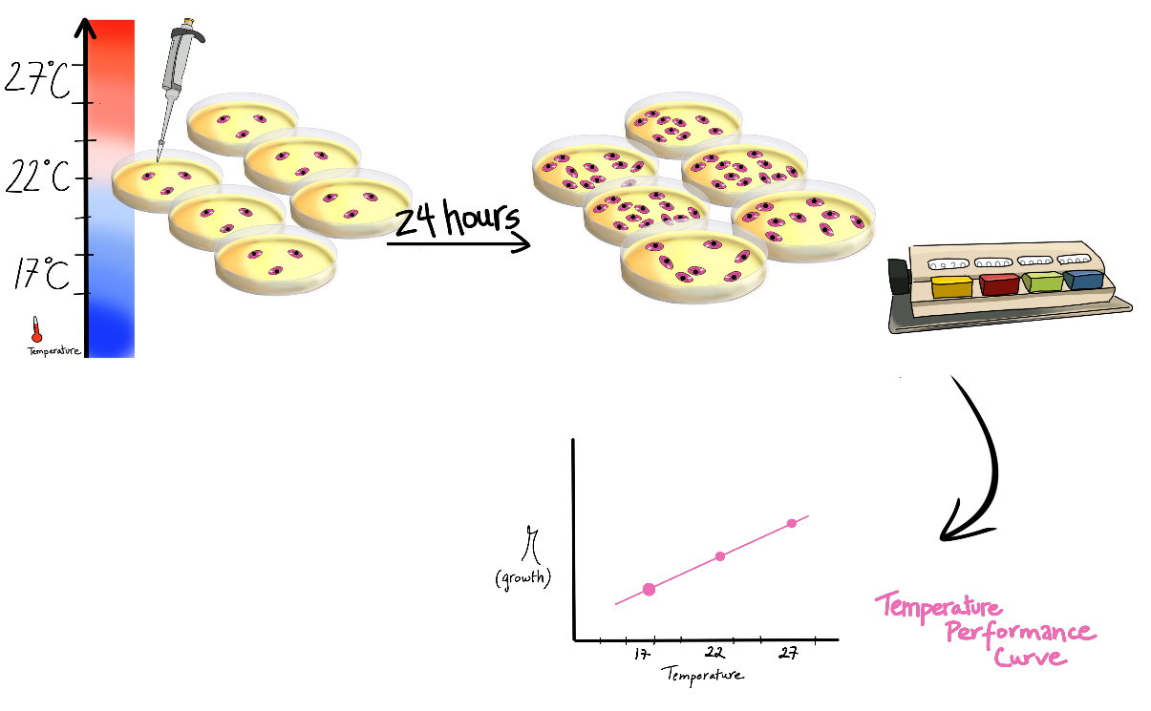**Experimental Setup**

**Results**

|  |  |  |  |  |  |
| --- | --- | --- | --- | --- | --- |
| **Temperature** | **Replicate** | **Count** | **Volume Sampled** | **Density (individuals/ml)** | **Growth**  **R** |
|  |  |  |  |  |  |
|  |  |  |  |  |  |
|  |  |  |  |  |  |
|  |  |  |  |  |  |
|  |  |  |  |  |  |
|  |  |  |  |  |  |
|  |  |  |  |  |  |
|  |  |  |  |  |  |
|  |  |  |  |  |  |
|  |  |  |  |  |  |
|  |  |  |  |  |  |
|  |  |  |  |  |  |
|  |  |  |  |  |  |
|  |  |  |  |  |  |
|  |  |  |  |  |  |

1-Describe the experimental setup to conduct a Temperature Performance Curve:

2- What is the hypothesis your experiment is testing? How does it test the hypothesis?

3- You should have used two different types of counting methods: counting on a grid, and subsampling. Compare and contrast the two – specifically the advantages and disadvantages of each method.

Based on the hypothesis, what do you predict the temperature performance curves will look like? Draw a sketch. Typically, TPCs are plotted with temperature (the independent variable) on the x-axis and growth factor R (the dependent variable) on the y-axis.