**Bioscreen Experiment Protocol**

Below is the complete process for setting up a growth experiment in the Schmid lab, using our Bioscreen C plate reader. Members of the Schmid lab will have prepared the media, and gotten the strains ready for when you join us on Wednesday. The particular steps will be marked with a checked box. You will be joining us on **Day 7**, to set up the plates and start the growth experiments. Read through the entire protocol to prepare.

**Day 0:**

* Design your experiment:
  + Identify strains & growth media.
  + Design the plate layout (Done by Schmid Lab members)
    - Determine the number of biological and technical replicates

|  |
| --- |
| **Notes on your group’s experimental design:** |

**Day 1:**

* Streak the strains needed onto rich media plates.
* Put plates in Ziploc bag and incubate at 42C until colonies are visible (~5-6 days)

**Sketch your streak pattern:**

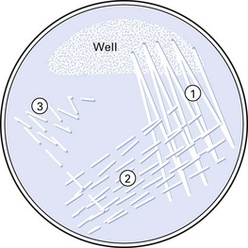

Figure 1: streaking to single colonies. Source: reddit.com

**Day 6:**

* Remove plates from incubator, check for single colonies.
* Label glass test tubes with strain and biological replicate info
* Add 5mL preculture media to labeled glass test tubes.
* Using a pipette tip or toothpick, pick a small amount of single colony and inoculate it in to the appropriate tube.
* Place tubes in 42C shaking incubator for 24hrs.

**Day 7:**

Plate set up (can be done several hours before):

* make media with 2x the amount of carbohydrate (e.g. if you want a final concentration of 25mM, make a 50mM stock)
* Print out your plate layout.
* 100ul of plain HvCa to blank wells
* Add 100ul of media to the appropriate bioscreen wells
* Cover plates and carefully set aside

Measure preculture OD:

* Set up spectrophotometer cuvettes (1 blank + 2x # of cultures). Typically, a 1:50 dilution is appropriate (980ul:20ul).
* Remove preculture tubes from incubator.
* Add 20ul culture to each preset up spec cuvette. Vortex briefly before measure optical density. **Record OD in table below.**

|  |  |  |  |
| --- | --- | --- | --- |
| Tube/strain/biorep | ODspec | Dilution factor (df) | ODtube (ODspec * df) |
|  |  |  |  |
|  |  |  |  |
|  |  |  |  |
|  |  |  |  |
|  |  |  |  |
|  |  |  |  |
|  |  |  |  |
|  |  |  |  |

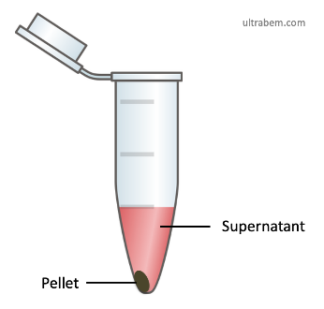Wash cultures:

* Add 1mL of culture to a labeled 2mL tube.
* Collect cells in centrifuge at 2,500g for 3 minutes
* Remove supernatant. Resuspend cells with 1mL HvCa media, gently pipetting up and down with a p1000.
* Repeat wash step once more. Resuspend pellet in 500ul HvCa.
* Measure OD of washed cells, using remaining set of spectrophotometer cuvettes. **Record OD in table below.**

|  |  |  |  |  |
| --- | --- | --- | --- | --- |
| Tube/strain/biorep | ODspec | Dilution factor (df) | ODtube  (ODspec * df) | ul needed to dilute to 0.1 OD in 1.8mL |
|  |  |  |  |  |
|  |  |  |  |  |
|  |  |  |  |  |
|  |  |  |  |  |
|  |  |  |  |  |
|  |  |  |  |  |
|  |  |  |  |  |
|  |  |  |  |  |

Dilute washed cells:

* Label new set of 2mL tubes and add 1.5mL HvCa to each.
* Use dilution formula (C1V1 = C2V2) to calculate to amount of each washed culture needed for an OD of 0.1 in the fresh 2mL tubes. **Record in table above.**
* For each sample, remove the calculated amount of HvCa from the fresh tube (with 1.5mL HvCa). Then add the same volume of washed cells.
  + remember to vortex the washed cells before pipetting.

|  |
| --- |
| Notes/observations: |

Finishing plate set up:

* Using the plate layout, add 100ul of diluted cells to the appropriate wells
* Cover plates and prepare to load the bioscreen machine.
* Start the bioscreen run:

|  |
| --- |
| Observations/reflections/questions about the overall protocol: |