LittlePay Code Test – Solution Details

**Environment Detail**

1. Java 8
2. Eclipse Oxygen

**Package Structure**

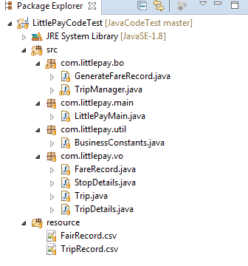

**Program Input**

FairRecord.csv – This is an input file, which has fare details between different stops. This file is used to create a FareMap loaded in FairRecod object. This object is referred to charge the cards for different trips as per the trip TapON and TapOFF stops.

TripRecord.csv - This is an input file for all the trip details and card numbers.

These two files in resources folder are provided as input to the main program.

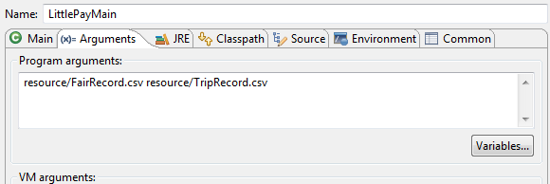

**Package and Classes details**

|  |  |  |
| --- | --- | --- |
| **Package** | **Class** | **Details** |
| com.littlepay.main | LittlePayMain | This is the class with main method. The main function calls relevant classes to calculate and charge fare for trips and provide the trips details. |
| com.littlepay.bo | GenerateFareRecord | This class has relevant functions to generate a FareMap as per the input files. This faremap is used to charge each trips. |
| com.littlepay.bo | TripManager | This is the class related to trips. Trips are charged and segregated by the relevant functions in this class. |
| com.littlepay.vo | FareRecord | This is a value object which is populated using the fair record input and referred by TripManager to charge different trips. |
| com.littlepay.vo | Trip | This is a value object for each Trip. |
| com.littlepay.vo | TripDetails | This is value object which has different collections to report different types of trips. |

**Program Execution Result**

