Next Generation Cellular Networks and Their Potential

Alexander R. Ramsey

UMUC ITEC 626

November 24, 2016

Abstract

Demand for greater wireless connectivity is on the rise and eyes are looking forward onto 2020, the speculative year of 5G (5GPPP of EU, 2016). This paper addresses the need, expectations, proposed technical innovations, and barriers to market for the upcoming development and implementation of a Fifth-Generation Cellular Network.

Introduction

Cellular Network adoption is skyrocketing as evidenced by The World Bank’s latest statistics, that per 100 people there are now 98 cellular network subscriptions (Mobile cellular subscriptions (per 100 people), 2015). In population-dense areas like Hong Kong, the statistics claim that for every 100 people there are more than 230 cellular network subscriptions. The World Bank’s statistics account for prepaid and subscription services and ultimately represent the greater demand for mobile connected devices. This level of saturation in the marketplace indicates a strong demand for increased speed, network bandwidth, and connectivity capability. A report by Forbes Insights and Huawei Technologies echoes these findings in the business communities, stating that more than one-third of executives interviewed agree that they have outgrown their cellular network capabilities. Additionally, the report states that a need for education and adoption plans are necessary among most executives who believe that 5G will bring market disruption via newly connected technologies and capabilities (Bruce Rogers, 2016).

The State of the Art for the next generation of cellular networks presents significant opportunity for businesses and consumers. However, industry driven regulation and limited competition also represent a potential lost opportunity for the impactful market adoption of these next generation networks. The next generation, classified as 5G, has yet to be defined as a specification in technical detail. Industry players including original equipment manufacturers (OEMs), standards defining organizations, and cellular network carriers have offered marketing and investment oriented language to advertise the future potential of 5G. Much of the industry implies 5G capability with promises like multi-gigabit transfer speeds, increased bandwidth capability, lower latency, and fewer instances of packet loss. An infographic provided by the 5G 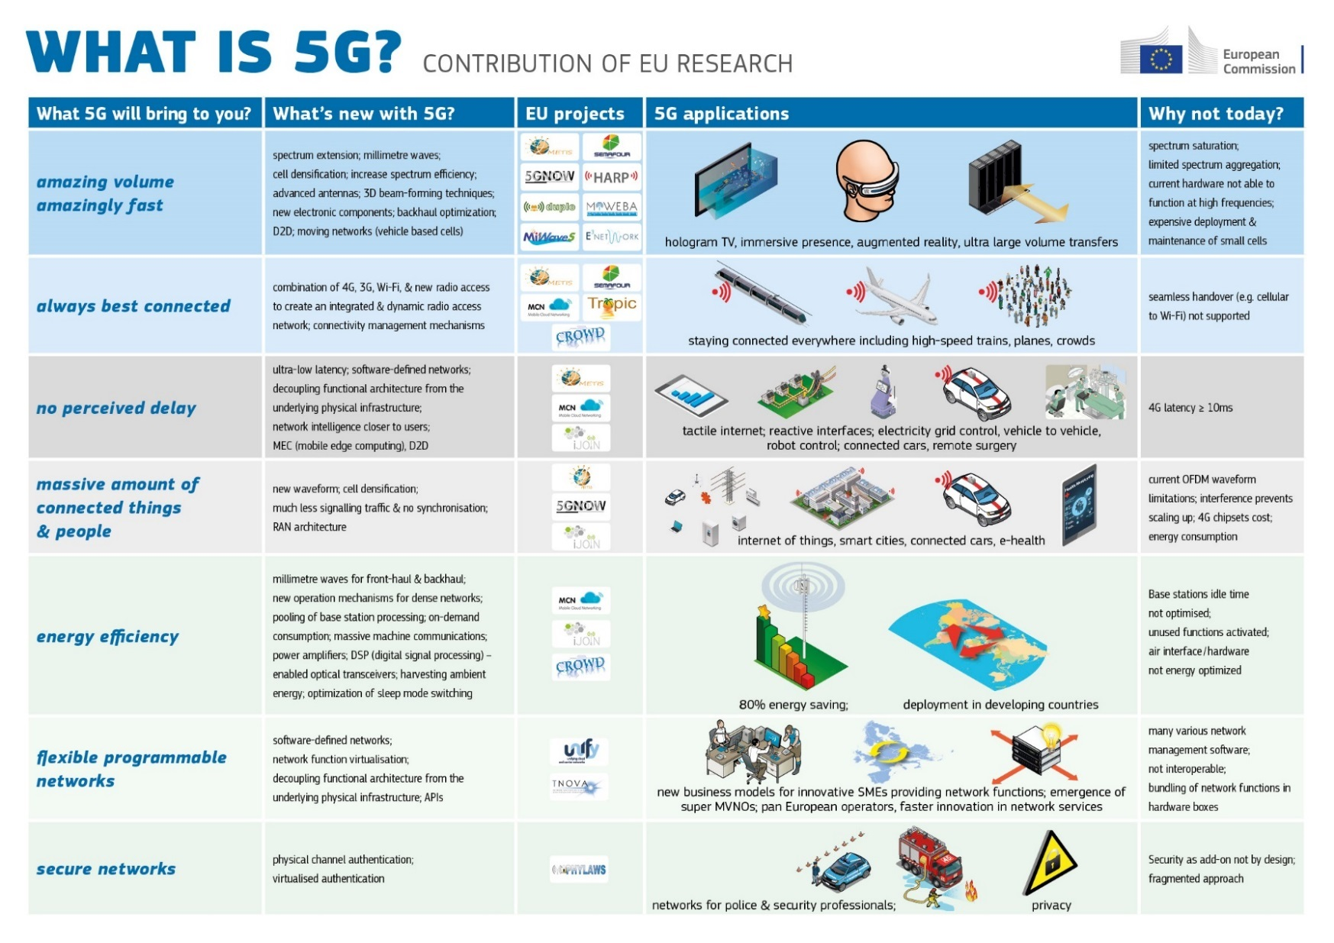Infrastructure Public Private Partnership of Europe displays the technical expectations for a fully developed 5G network. An interesting column in this infographic titled, “Why not today?” represents the capability of current networks to be used as a platform for the next generation with some adaptation; some speculation paints 5G as being a convergence of existing technologies (Chávez-Santiago, 2015).

Figure 1 Infographic detailing the technical possibilites for 5G. (5GPPP of EU, 2016)

Cellular Network infrastructure is a young field with development cycles ranging from 3-5 years for specification development and 3-5 years for market adoption. The International Mobile Telecommunications-Advanced specification (commonly called 4G LTE) was first outlined in 2008, with much of the industry successfully deploying 4G and 4G LTE networks by 2012. Now, 4G LTE represents the latest market adopted specification for limited areas, with rapid growth toward majority market adoption likely to occur by 2020 (Chávez-Santiago, 2015).

5G Expectations and Implementation

Greater Speed.

Increasing demand for high resolution video and cloud connected services are causing 4G and 4G LTE networks to be pushed to their limits. A lossless HD video can require multi-gigabit speeds for successful transmission (Chávez-Santiago, 2015). Current LTE specifications dictate speeds in the range of up to a Gigabit, with most actual capability still well below 100 megabits per second. The expectations for 5G are that speeds will exceed the single gigabit mark, allowing for up to 10 gigabit downlink speeds (5GPPP of EU, 2016).

Achieving these speed improvements will require the addition of spectrums beyond current capabilities, as extensions to the current communications channels. Base Stations in the 60 GHz spectrum will serve as backhaul providers for existing 3-4 GHz 4G and LTE networks. A proposed spectrum addition in the 1 GHz range will be added for rural areas, while higher frequencies in the 5 GHz range will be added for higher capacity networks in population dense areas (Chávez-Santiago, 2015).

This movement toward developing new networks and adding onto existing networks will occur “… in two simultaneous phases: (1) [with] the enhancement of current cellular networks compliant with 3GPP standards, and (2) [with] the integration of evolved cellular networks [alongside] complementary wireless communication systems based on standards released by the IEEE and other standardization bodies.” 5G will evolve by using existing physical expansion techniques from previous generations while combining them with modern cognitive radio, software defined radio technology, and software defined networks (Chávez-Santiago, 2015).

* Cognitive Radio (CR): A smart radio technology that allows for adaptive channel switching to address reception and transmission issues, while utilizing existing untapped & unlicensed frequency bands. “The CR technology is now at an advanced stage and real-world trials and evaluations are being carried out. As an example, an experimental trial of CR and the dynamic spectrum access technology using the TVWS spectrum is being carried out in Ireland. This Irish research testbed is assessing the feasibility of taking an opportunistic spectrum usage approach in the 700 MHz band to establish an 18.3 km TVWS link connecting the Trinity College Dublin in Dublin city center to Intel Labs Europe (Ireland) based in Leixlip, Co. Kildare. Demonstrating the spectrum agility and the ability to avoid interference to incumbents in order to provide a robust link suitable for the support of new services is the key objective of this trial” (Chávez-Santiago, 2015).
* Software Defined Radio: Radio technology that allows for spectrum control and more universal capability for transmission. “As 5G systems will need to exploit underutilized frequency bands to avoid the foreseen spectrum crunch, CR implementation on SDR platforms should consider the cooperation and interoperation of multiple radio technologies, e.g., through common radio resource management (CRRM). This implies that a reconfigurable platform must be capable to operate at different power levels, channel bandwidths and frequencies, modulation and coding schemes, modifying transmission parameters and characteristics according to the particular constraints of the radio technology standards in use; these constraints include unwanted emission in the operating band, AFLR, or intermodulation products. Promising SDR development initiatives include the GNU Radio (http://gnuradio.org/), an open-source software development toolkit for SDR implementation on various programmable platforms like the Universal Software Radio Peripheral (USRP) boards (http://www.ettus.com/), and the Open Base Transceiver Station (OpenBTS), which was recently used to demonstrate the implementation of a software-based Global System for Mobile Communications (GSM) base station on the Raspberry PI hardware platform…” (Chávez-Santiago, 2015).
* Software Defined Networking (SDN): The capability for network administrators to control low level network control functions by utilizing software to increase agility and adaptiveness to changing demands as applied to cellular network base station infrastructure. “The revolutionary concept of software defined networking (SDN) aims at providing a coordinator that has a global view of the network infrastructure, thereby facilitating a number of networking functionalities. [The] SDN concept consists in decoupling the forwarding plane and the control plane…In this approach, the core devices […] do not make decisions on how and where to forward a given data packet; instead, the decision is taken by a central coordinator referred to as the controller” (Chávez-Santiago, 2015).

Seamless Connectivity.

As demand across wireless networks increases, so does the possibility for network interoperability. By designing networks to seamlessly transition, changes in load and bandwidth can be better managed. Traffic Offloading strategies must be employed to manage bandwidth heavy fluctuations. A Traffic Offloading strategy “consists [of] complementary radio access networks to deliver data originally intended for mobile cellular systems, thereby decreasing the congestion on each individual radio link and respective backbone connection” (Chávez-Santiago, 2015).

A strategy already employed for a limited market is the use of at home, backhaul internet connected base stations and microcell systems. These systems allow cell phone subscribers to take advantage of their existing internet connection to make phone calls from home. Many of these systems were created as a quick fix add-on and have not been fully integrated into network infrastructures as a hardened solution. These base stations, referred to as Femtocells will allow greater expansion of cellular networks by private industry in commercial building deployments as well as for private home use (Russell Ford, 2016).

An alternative to this strategy is with the use of existing Wi-Fi networks and hotspots in public areas to eliminate the need for Femtocell systems and complex backhaul conversion. By employing VoIP handoffs, traditionally expensive network frequencies could be avoided, allowing carriers to save on deployments of Femtocell’s to their clients. “One major challenge is to increase the system spectral efficiency by allowing more concurrent users on Wi-Fi networks, ideally for both best-effort and voice traffic. A possible way of achieving this is to implement Wi-Fi frequency reuse plans with slightly overlapping channels” (Chávez-Santiago, 2015). Deploying such strategies would require a market shift in the current configuration of WiFi routers and access points to allow specific Media Access Control (MAC) address whitelisting for mobile devices. This technology may evolve into a combination of femtocells and wireless local area networks.

Additionally, opportunity exists for Device to Device communication (D2D), “… [which] can also help diminish traffic congestion on the cellular core network. D2D communication is an underlay to cellular networks in licensed frequency bands, contrasting with mobile ad-hoc networks (MANETs), which operate similarly but in the unlicensed spectrum” (Chávez-Santiago, 2015).

Lower Latency.

Improving latency delay will allow transmission technology to enter new market segments including remote surgery, power grid control, and remote vehicles (5GPPP of EU, 2016). Proposed latency improvements will bring current 4G and 4G LTE time from greater than 10ms to 1ms response time. “To deliver very low-latency services, gateway nodes and network points of attachment [must] be moved closer to the network edge. Hence, there is not only a need for the [Radio Access Network] RAN to become more dense to improve coverage but also for core network entities to become more distributed and located closer to the end-user” (Russell Ford, 2016).

Higher Security.

In April of 2016, a meeting at the Global Standards Collaboration (GSC) conference discussed ways of tackling the growing need for security with upcoming advancements in IoT, 5G, and the connected devices space. “GSC members recognized the need, in an increasingly ubiquitous digital environment, to integrate Security and Privacy (Trust) early in the innovation process, by design rather than by mere afterthought. This requires widely understood principles to be used [relating to] identity, which are then applied to the particular technology areas. Further concerted global dialogue and standardization across verticals and across SDOs was highlighted as an urgent priority, with a view to developing consistent and harmonized standards” (Telecom Standards Newsletter, 2016).

Addressing Barriers to Market

Perhaps the most pressing issue in the development and adoption of 5G technology lies in the barriers to market. Large scale investments will be required for market entry & adoption with spectrum requiring huge initial investments to best regulatory control. Recently, the FCC Chairman, Tom Wheeler, addressed the CTIA conference in Las Vegas, NV stating that the objective of the agency was to allow competition in the marketplace. This summer, the FCC and the U.S. Government approved spectrums in the higher bands for market adoption in preparation of 5G development (Springham, 2016).

Per a news release by the FCC, “These new rules open up nearly 11 GHz of high-frequency spectrum for flexible, mobile and fixed use wireless broadband – 3.85 GHz of licensed spectrum and 7 GHz of unlicensed spectrum. The rules adopted today creates a new Upper Microwave Flexible Use service in the 28 GHz (27.5-28.35 GHz), 37 GHz (37-38.6 GHz), and 39 GHz (38.6-40 GHz) bands, and a new unlicensed band at 64- 71 GHz” (Federal Commuications Commission, 2016).

Wheeler continued by addressing the need for additional infrastructure improvements, “Regardless of the spectrum allocation, 5G will require a lot more cells, particularly at the higher frequencies. These small cell sites will need to be connected, so we’ll need a lot more backhaul. In many areas, competition in the supply of backhaul remains limited, and that can translate into higher costs for wireless networks, higher prices for consumers, and an adverse impact on competition” (Springham, 2016). He ended stating that backhaul prices must be fair, which he hopes will be an accomplished task through a regulated partnership with the FCC and participating carrier corporations.

Mr. Wheeler continued speaking on the challenge of establishing antennas and new sites for cellular network expansion. He stated that communities must understand the benefits of such sites as providing a revolution in mobile technology, “Let’s paint the picture of how 5G will unleash immersive education and entertainment industries, and how 5G will unlock new ways for local employers to grow, whether it’s a small specialty shop or a large factory, creating new jobs and improving services for the community” (Springham, 2016).

Concluding Remarks

5G remains in early stages of development, with expected first release of specification matching technology for the year 2020. The greatest barrier to entry for the market will ultimately be the cost of deploying new hardware, altering existing hardware, and deploying new consumer connected devices to take advantage of new network technology. The range of cost for deployment of 4G towers was $75,000 to $200,000 (Yanjiao Chen, 2015). Based on this data, we can predict that 5G will most likely be a costly endeavor as well. Cost estimates for 5G networks have yet to be published and the cost to the consumer has yet to be estimated, as devices designed to work with testbed 5G networks have yet to be scaled to a mobile platform.

Despite the cost of adoption, the growing rally of 5G and its role on the future development of technology promises to provide significant changes since the dawn of mobile data. Increased connections, faster response time, and greater speed provide for a powerful and disruptive combination for the future of connected devices. The future vision of 5G utilization is that fully mobile, fully integrated, and fully converged technology platforms will provide greater services for an increasingly connected and virtual world.

# References

5GPPP of EU. (2016). Retrieved from Infographic: : https://5g-ppp.eu/wp-content/uploads/2015/03/WHAT-IS-5G%EF%80%A5-infographics-A3-v3.jpg

Bruce Rogers, e. a. (2016). The Mobile Industrial Revolution. *Forbes Insights*.

Chávez-Santiago, R. S. (2015). The Covergence of Wireless Communications. *Wireless Personal Communications*, pp. 83(3), 1617-1642.

Federal Commuications Commission. (2016, July 14). *FCC TAKES STEPS TO FACILITATE MOBILE BROADBAND AND NEXT*. Retrieved from https://apps.fcc.gov/edocs_public/attachmatch/DOC-340301A1.pdf

International Telecommunication Union, World Telecommunication/ICT Development Report and database. (2015). *Mobile cellular subscriptions (per 100 people)*. Retrieved from The World Bank: http://data.worldbank.org/indicator/IT.CEL.SETS.P2?year_high_desc=true

Russell Ford, S. M. (2016). Achieving Ultra-Low Latency in 5G Millimeter Wave Cellular Networks.

Springham, J. (2016, September 07). *FCC chairman tackles three barriers to 5G success*. Retrieved from Mobile World Live: http://www.mobileworldlive.com/ctia-2016-articles/fcc-chairman-tackles-three-barriers-to-5g-success/

Telecom Standards Newsletter. (2016). *IoT, 5G, security and privacy focus of the 20th Global Standards Collaboration meeting.* Retrieved from http://bi.galegroup.com.ezproxy.umuc.edu/essentials/article/GALE%7CA453916690/af1604225af9843111877cada5ca8705?u=umd_umuc

Yanjiao Chen, L. D. (2015). *Financial Analysis of 4G Network Deploymen*. Retrieved from 2015 IEEE Conference on Computer Communications (INFOCOM): http://iqua.ece.toronto.edu/ychen/Materials/papers/infocom15.pdf