Adobe Illustrator as a Graphics Design Educator

Interface Analysis & Redesign Assignment

Alexander Ramsey

University of Maryland, University College

October 9, 2016

Abstract

Adobe Illustrator, a popular graphic design and illustration program is analyzed using a Heuristic scale to determine its refinement in user interface interactivity. It is found that Illustrator assumes a large amount of knowledge by the user. The program does not include a fundamental user interface feature (tooltips) that may be helpful for a large portion of its market share.

Interface Analysis & Redesign

Introduction

Adobe Illustrator is approaching its 20-year anniversary next Fall of 2017. It operates on Mac and Windows with the same user interface across both operating systems. Illustrator is often overlooked by its popular image manipulation brother, Photoshop. Seen in the screen capture below, (Figure 1) Photoshop’s user interface is to the left and Illustrator’s is to the right. They share many similarities in design, layout, and imagery. The dark theme has become a standard of the Creative Cloud family of products. Photoshop allows users to manipulate images while Illustrator allows users to generate vector graphical elements with more control. In both programs, you can generate text, draw basic shapes, and apply effects to graphical elements. What differentiates these programs the most is how the elements are rendered. Illustrator can generate Scalable Vector Graphics, while Photoshop is primarily used to manipulate existing image files that have a set resolution.

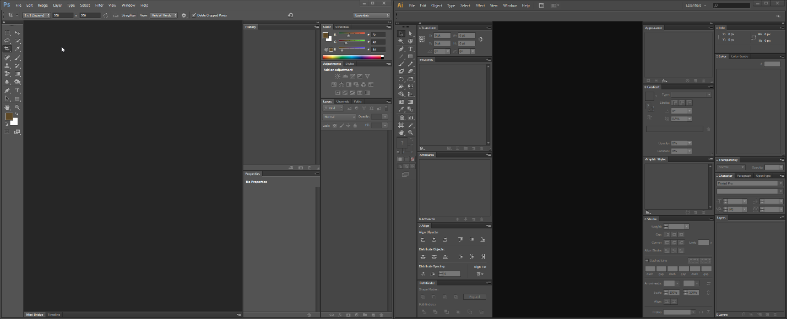

Figure 1Adobe Photoshop (left) and Adobe Illustrator (right) share common user interface design and layout.

Interface Example 01. New Document Dialog Box

On initial load of Illustrator and execution of the File > New command, there is a dialog that provides options for setting the page format (Figure 2. Initial File > New Dialog for setting page format).

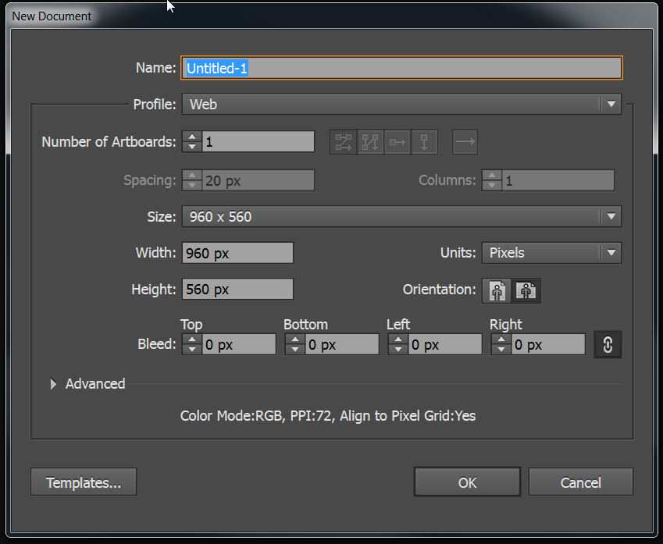

Figure 2 Initial File >New Dialog for setting page format.

This dialog allows users to set the name of their project file, the number of artboards, the size of the document, unit of measure used to size, and the bleed for print purposes. Information is shown to indicate the current set Color Mode, Pixel Density (PPI), and Alignment to the Pixel Grid. These settings are a reflection of what is default by choice under the Advanced drop down in the dialog (Figure 3).

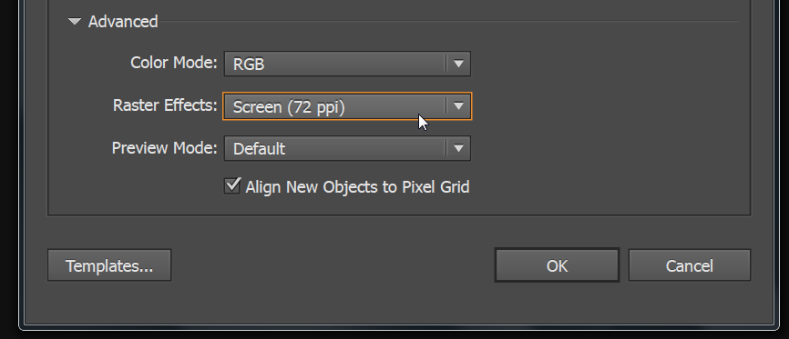

Figure 3 Advanced drop down for document setup.

A Templates button at the bottom left allows for the creation of a new file based upon a Template file. All of the information in this dialog is presented without additional tool tips or mouse over events to educate the user to the details of each setting. In a way, it seems that there is a sizeable amount of assumed knowledge for page setup.

*Nielsen Heuristics model applied to the Interface Example 01. New Document Dialog Box*

|  |  |
| --- | --- |
| Heuristics Criterion | Analysis |
| Visibility of system status | Not applicable. |
| Match between system and the real world | The dialog provides page setup options that allow the user to cater their project to their specific illustration use, whether deployed to the web, or printed in a publication. |
| User control and freedom | User can cancel the current dialog before proceeding. In addition, artboards can be edited later in the program using the Artboard tool. |
| Consistency and standards | The key terms used in the dialog are commonplace in the graphic design realm. |
| Error prevention | The dialogs display validation when entering incorrect values and parameters. |
| Recognition rather than recall | Specific measurements are required for the user to enter, which may cause some confusion due to a lack of preview of the document setup. |
| Flexibility and efficiency of use | Document templates are provided to speed up the process of specifying options for common document setups. A default folder is provided containing many helpful print projects. |
| Aesthetic and minimalist design | The Bleed settings are rarely needed for anything but professionally printed publications, yet they remain when selecting the web and device profiles in addition to the print profile. |
| Help users recognize, diagnose, and recover from errors | There is guidance in the setup of dimensions for each document based upon the profile selected. This allows users to select precisely measured artboard sizes for their projects without needing to know the exact dimensions off hand. For example, the Print profile has common printer page sizing. |
| Help and documentation | There are no tool tips or mouse over events that display helpful hints for each setting in the dialog. This would be a beneficial add-on. There are Help Topics located in the top menu bar. |

*Recommended Changes in Functionality for Example 01: New Document Dialog Box*

Migrate bleed options to the advanced area. Provide mouseover feedback to indicate the functionality of each option in the dialog. Allow users to easily store and recall often used profiles. Below (Figure 4) is the image mockup for these recommendations in Axure RP:

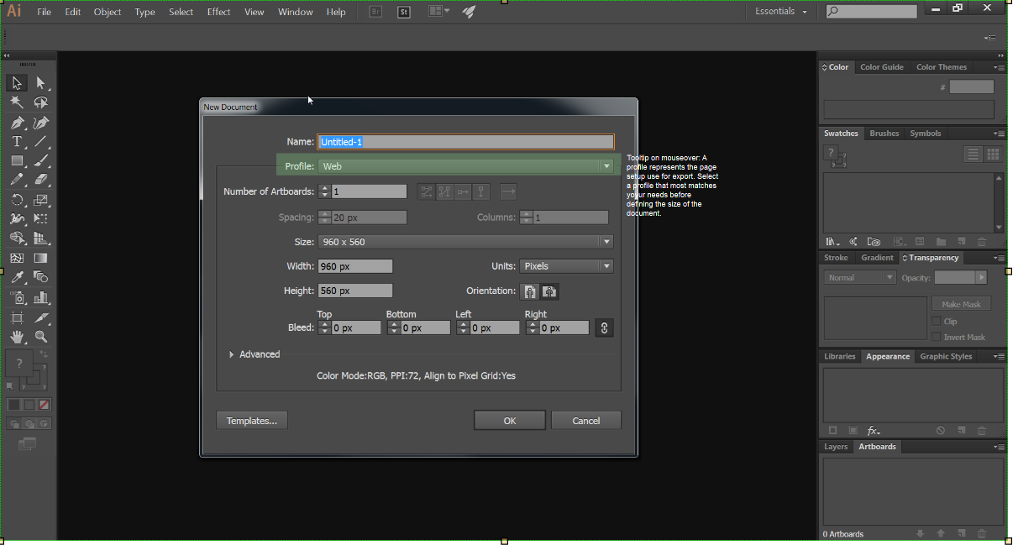

Figure 4 Axure RP Recommendations

Interface Example 02. The Workspaces Feature

Once a New Document is setup, at the first launch of Illustrator, the default workspace is loaded (Figure 4). Workspaces are a feature of Illustrator that allows the user to customize each of the panels in the application. These panels can be moved with a drag and drop of the mouse (Figure 5). Additional panels can be added, removed, and expanded by using the controls at the top of each panel (Figure 6). Once the user customizes the workspace with the placement and movement of these panels, they can save it to a file and import it into Illustrator should they move computers or want to switch Workspaces depending on the task at hand. Workspaces can be managed under the Window drop down menu at the top of the screen (Figure 5). The tools panel is located on the left side of the screen. It contains many of the most used functions in Illustrator including creating Text boxes, Lines, Squares, and Path elements (Figure 6). Tools in the tool panel that have an icon with an arrow in the lower right corner hint to the user of more sub tools in each tool selection (Figure 7). Advanced options like Gradient, Stroke, and Color settings for these tools are located on the right side of the screen in collapsed menu buttons, where they can be expanded or hidden (Figure 8). The workflow begins on the left side of the screen with the user generating an element and ends on the right side of the screen with the user customizing an attribute of the element (Figure 9).

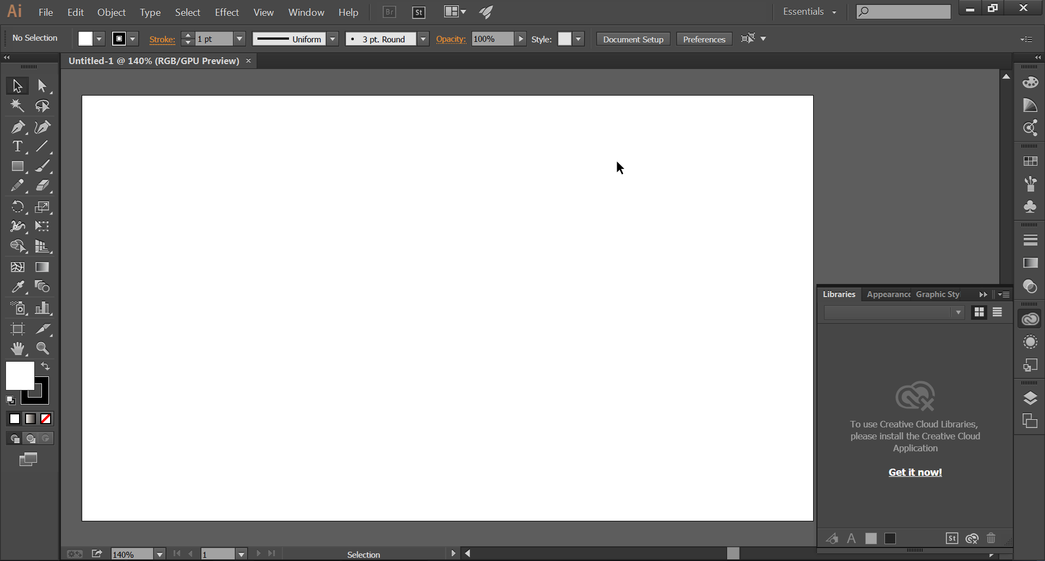

Figure 5 The default Workspace in Adobe Illustrator CC.

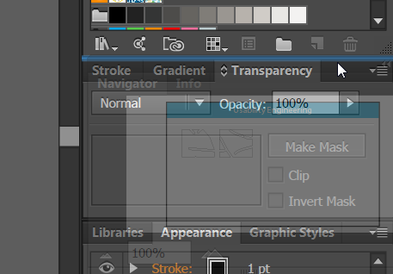

Figure 6 A drag and drop render assists the user while moving panels.

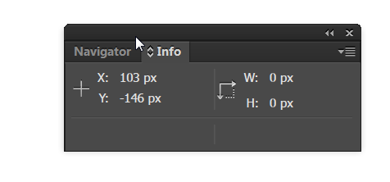

Figure 7 Panel controls are located at the top left. A double left arrow indicates to the user that they can minimize the panel. An X indicates the close function. The top bar of the panel can be used to drag the panel around. Also notice the labels on each tab.

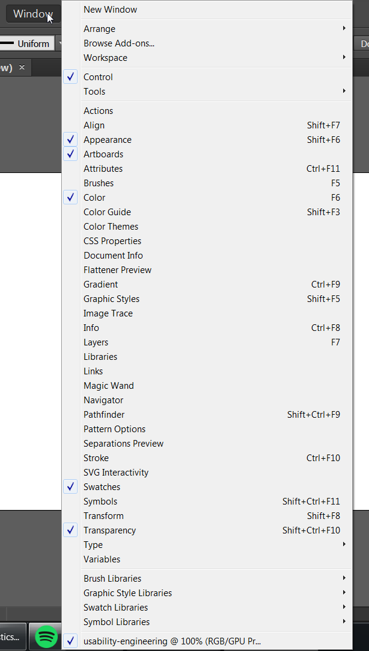

Figure 8 Window menu expanded to display the available panels for use. In addition, options for Workspaces are seen at the top of this menu.

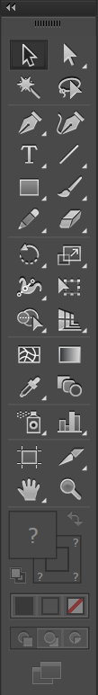

Figure 9 The tools palate provides a variety of the most used functions in Illustrator. Small arrows in the bottom right corner hint to the user that an expansion of each tool can display more related sub tools.

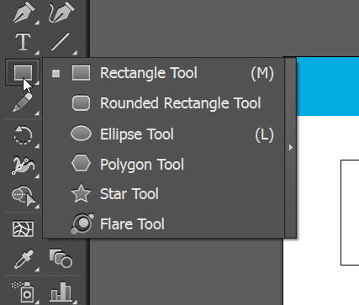

Figure 10 A small arrow in the lower left of each tool picker hints to the user of additional options. They are within an extra mouse click but are hidden away in groupings based upon relevancy.

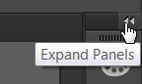

Figure 11 Panels can be expanded to display or hide information, allowing the user to save valuable screen real estate used during the design process.

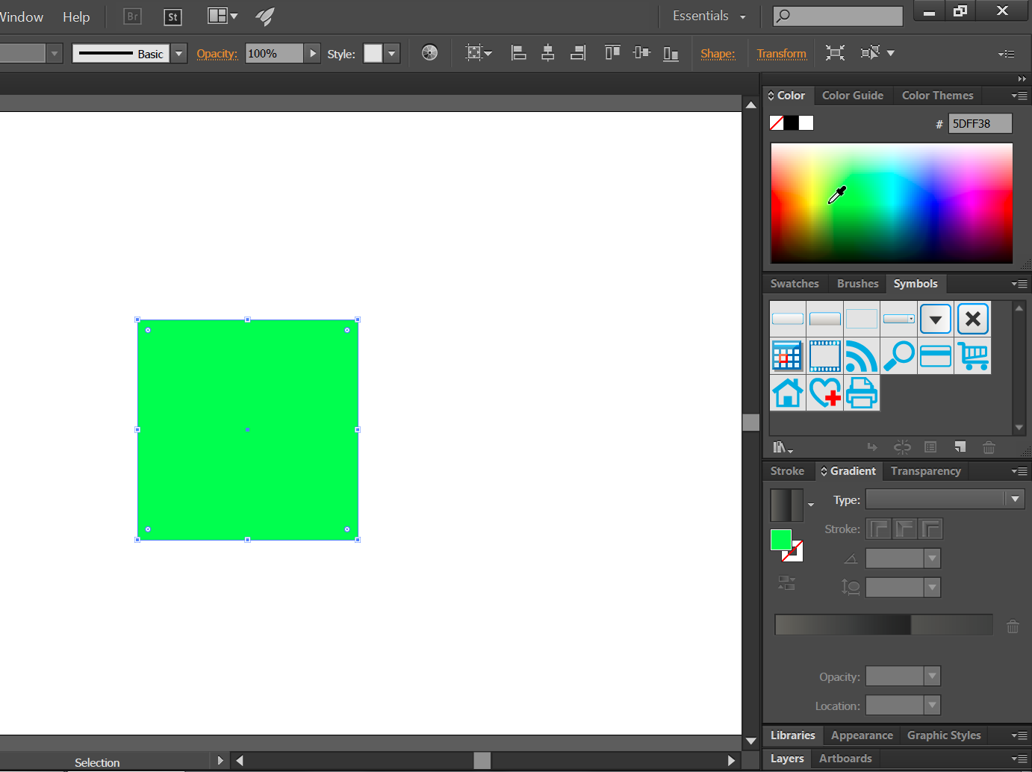

Figure 12 A square is colored green with the expanded color picker options panel.

*Nielsen Heuristics model applied to the Interface Example 02. The Workspaces Feature*

|  |  |
| --- | --- |
| Heuristics Criterion | Analysis |
| Visibility of system status | A page info and document overlay panel are available for use under the Window menu. This panel displays a cursor pixel position output. Other status display is not typical of Illustrator due to the nature of the program. |
| Match between system and the real world | The drag and drop functionality is familiar to the user. |
| User control and freedom | The workspace feature allows the user to tailor their setup of the program to suit their needs. In addition, Illustrator allows for the user to save the workspace they have created for later use. |
| Consistency and standards | The workspace interaction is consistent across each panel and the overall functionality remains the same across operating systems. |
| Error prevention | A user can easily remove a panel and save the workspace. |
| Recognition rather than recall | The Window menu lists a rather long roster of available tools and does not display any additional explanation to a new user what each panel option adds in terms of functionality. |
| Flexibility and efficiency of use | There is redundancy in the program for every interaction with the tool panels. A list of menu options is available and the user can always remove a panel quite easily. Preexisting workspaces are provided to meet the users needs in a hurry. They are accessible in a quick menu drop down outside of the Window menu, saving time to switch workspaces. |
| Aesthetic and minimalist design | Small arrows and areas for dragging are denoted by arrows and lines throughout each panel. They are quite small, but are out of the way of the panel content and tools. |
| Help users recognize, diagnose, and recover from errors | If a panel is removed there is no lasting feedback. Just poof and it is gone, leaving them to wonder what panel they need to reopen in the Window menu dropdown should they accidentally close it. |
| Help and documentation | Documentation on how to use each panel is included under the Help menu option. In program pointers or popovers with hints are not included. The Workspace manager has no text or prompts to indicate to the user how to use it. |

*Recommended Changes in Functionality for Example 02. The Workspaces Feature*

Provide mouse over descriptions for each panel option in the Window menu. Provide a notification to the user when a panel is removed for a short duration after. Provide some text or tool hints in the workspace manager dialog. Seen below (Figure 13) is the recommendations from Axure RP.

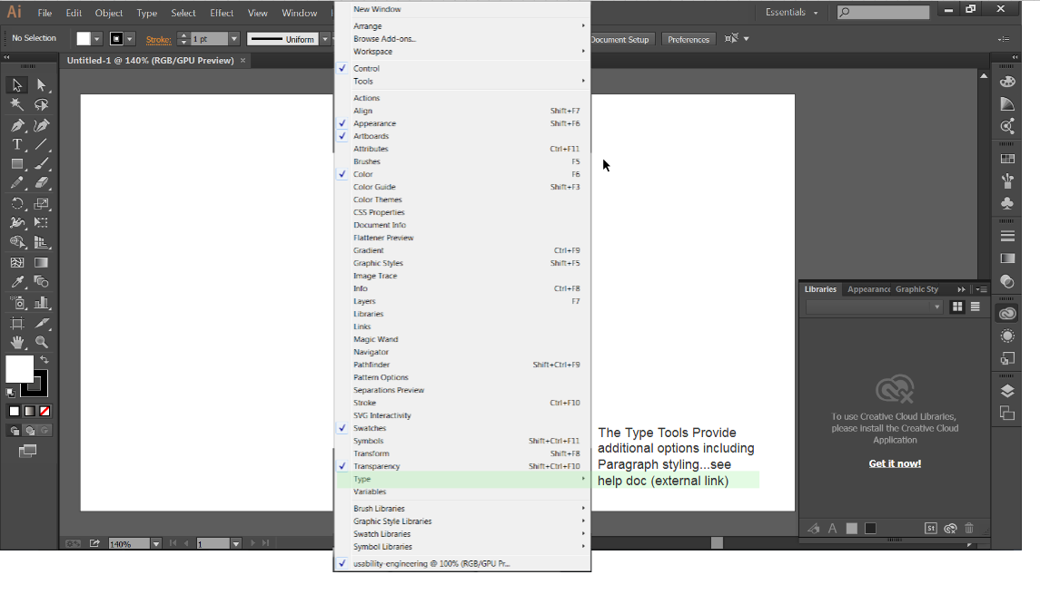

Figure 13 Axure RP recommendations.

Example 03: Typography Functionality

Typography is a major part of the design process in Illustrator. In fact, Illustrator was originally created for the intended purpose of manipulating typography. Now Illustrator has become more a manager of existing Typescript font files. It provides a number of options for the user to manipulate fonts by making them into path elements (Figure 12). Illustrator also provides for a few formatting area types (Figure 13). In addition, a user can create Type that is placed onto a path or shape edge (Figure 14). Type can be manipulated using the Type options panel in the Window menu (Figure 15). Once text is created using the Type tool, there are a number of additional formatting options available to the user. They are accessible by clicking on the Window drop down menu and by navigating to the Type option (Figure 16). A user can select a font by using the drop down menu at the top of the screen or by selecting it from the Paragraph tools panel (Figure 17).

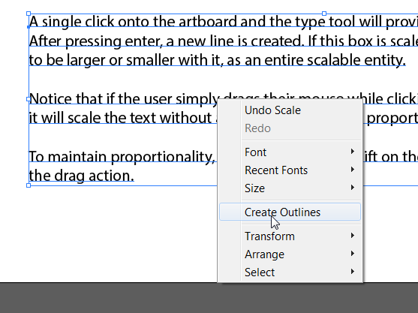

Figure 14 Text can be manipulated as a path element by right clicking and selecting Create Outlines. From here it is no longer editable by the text tool. This is how typography can be edited.

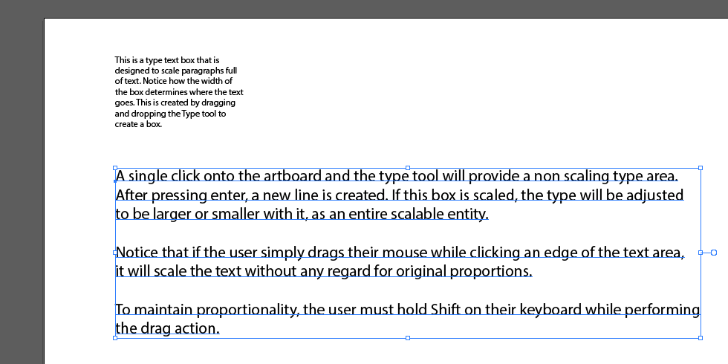

Figure 15 In this image, text is created using differing methods. On the top is a text box that maintains the area like a bounding box. Below it is a text freeform object that only breaks lines when the user presses enter.

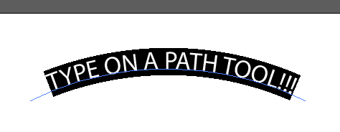

Figure 16 By selecting the type on a path tool, seen in the next figure image of the type panel, a user can crate interesting curved and shaped text elements.

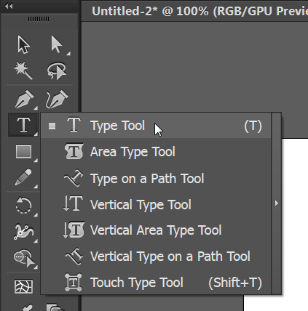

Figure 17 Pressing and holding the type tool in the Tool panel on the left hand side of the screen allows the user to see a variety of type options including the type on path tool.

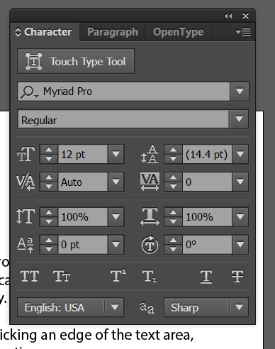

Figure 18 The full length of the Character, Paragraph, and OpenType panels are grouped together when clicking on any of the Type options in the Window menu. This box can be expanded or contracted. It provides a variety of text manipulation options for the user.

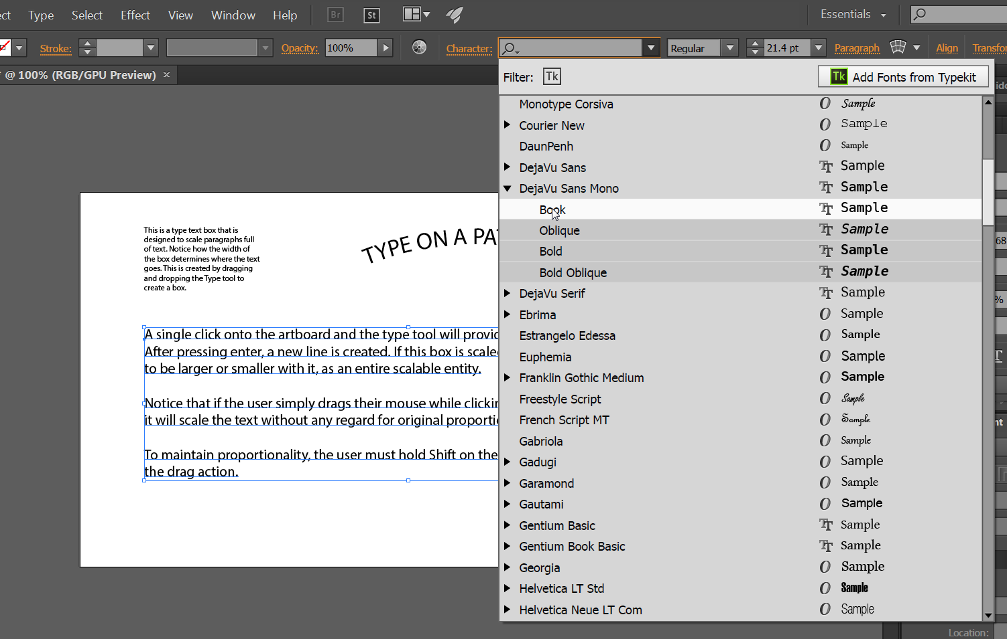

Figure 19 Selectable fonts are provided in a large menu that may obstruct the users view of the artboard area. When dragging your mouse over the available fonts, the user can see a sample. Real-time updates of the selected text in the highlighted font do not occur.

*Nielsen Heuristics model applied to the Interface Example 03. The Typography Functionality*

|  |  |
| --- | --- |
| Heuristics Criterion | Analysis |
| Visibility of system status | Not applicable. |
| Match between system and the real world | The typography options are familiar to the user, once found in the window menu. |
| User control and freedom | The user can generate many different styles of layout for the text, but it can be difficult to understand how too, due to the minor differentiations in the shortcut keys and mouse interaction. |
| Consistency and standards |  |
| Error prevention | Alignment and movement guides provide the user with the ability to snap the text objects to areas within the artboard. |
| Recognition rather than recall | Selecting a font face from the drop down menu does not provide the user a preview that may be big enough to differentiate the styles. A live preview update may be a helpful feature for the user. |
| Flexibility and efficiency of use | Holding shift allows the user to expand or contract text proportionally when created a freeform type object. |
| Aesthetic and minimalist design | Detailed icons denote differing options for the expanded Character Window panel. |
| Help users recognize, diagnose, and recover from errors | Undo and redo allows the user to move back and forth from making changes to the textual elements. |
| Help and documentation | Documentation on how to use the Type tool is included under the Help menu option. The Workspace manager has no text or prompts to indicate to the user how to use it. |

*Recommended Changes in Functionality for Example 03. The Typography Functionality*

There is a wealth of typography options in Illustrator for the user. Many of the options feel buried or are keyboard shortcuts that are not readily available to the user. In addition, the type on path tool presents some mystery for user manipulation. It would be helpful to include some tool tips that occur as the user drags text objects that are freeform. In addition, it would be helpful if the font selection drop down menu provided a better preview, changing the text on artboard with real-time updates as to what it would look like with the highlighted typeface. Below (Figure 20) is a screenshot from the Axure RP prototyping tool. Notice the tool tip to the top right of the drag action.

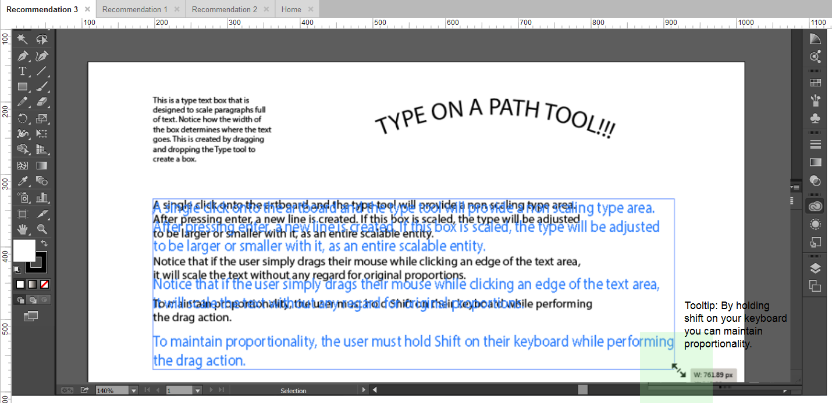

Figure 20 Axure RP recommendations.

Concluding Statements

Illustrator provides a width breadth and depth of capability to the user. When approaching the product as a novice user, it may be difficult to understand much of the interactivity that it is capable of understanding due to a lack of on screen documentation. Tool tips may seem like a relatively simple and benign resolution to any problem, but they present a world of usefulness even for an avid user. They should be tailored to fit the needs of every user based upon their preference. Advanced tool tips should be included to appear after an initial action is completed successfully. There is already a small grey box in many of the cursor interactions that displays the pixel width and height of an object. Perhaps these areas could be adapted to handle a small tool tip that would appear on initial use.

After searching online, I found it surprising that Illustrator did not include any tool tip feature with the software. After 20 versions, they must just assume that professionals know and understand how to effectively use the application. Their website provides a number of help videos on getting started, but these often feel lengthy and make the user recall rather than recognize the process of using the program. This may impede the user’s ability to be interactive and creative with the program.

Illustrator is sold as a professional suite of creative programs with versions and discounts available for students and those in the higher education realm. This selling tactic is a wonderful way for people to be introduced to the program, potentially growing Adobe market share. The trouble with Illustrator, though, is that it may steer some users away because of its daunting amount of functionality. Illustrator’s value proposition must convey the use of a creative and engaging environment that actively educates the user. If Adobe was able to refine the learning process on an already feature rich program, they may be able to grow their market share and keep this product alive and responsive to the demands of the marketplace.

References

Nielsen, J. (1995). 10 Heuristics for User Interface Design: Article by Jakob Nielsen. Retrieved October 09, 2016, from https://www.nngroup.com/articles/ten-usability-heuristics/