Alexander R Ramsey  
UMUC SWEN 603  
06/06/2016

The Scrum Software Development Methodology

In the game of Rugby, a Scrum is a tightly packed group of people who actually fight over the ball to reinitiate the game. In SDLC, a Scrum is a way of describing an iterative, process driven management lifecycle where players of the team share in the responsibility to achieve the end goal, Sprinting to the finish between meetings, discussions, and client feedback. So, in some ways, relating to a Rugby Scrum is not a completely accurate way of describing the Scrum SDLC and its methods. A more accurate way of describing Scrum as an SDLC is to relate it to a relay race where the players involved are software engineers, guided by a coach who would be the project manager or Scrum Master.

Many consider Scrum to be a derivative of Agile, with the key difference being that Scrum is described as a more tightly defined iterative process. Scrum clearly defines a process for team discussion and project planning. This process works by breaking down the key areas of program development into User Stories. These stories are placed onto a chart and are related to the user outcomes of a program. For example, “The user should have authentication ability,” being a story to achieve. Sub tasks to achieve this story are then placed to the right in a three column status area. The status area categories are, 1) To Do, 2) In Progress, and 3) Done. In educational environments, each student studying the Scrum framework would have their own Storyboard. In a real world project environment, a team may share a board and the board would be updated and facilitated by all members of the group. This log of stories is also sometimes called the backlog. The backlog can be graphed and represented using dates to show progress over time on a graph often called the Burndown chart. The below graphic represents an example of the high level overview of the project management process:



Sprint Review

Finished Work

Iterative Releases

Stand Up Meeting

SCRUM Master  
Manages Team/  
Bottlenecks

Daily Goal

One Month  
Development Sprint/Release Goal

Sprint Planning Meeting

Developer Collaboration

Customer Input

Product Backlog   
(Stories or Tasks)

The customer provides input to the development team, which generates a backlog of user stories and requirements which are broken down during the discussion and collaboration phase. These meetings form the framework for the sprints to be performed over time. Each sprint is managed by the Scrum Master. The project development is broken into iterative releases, which are provided to the client for feedback. At this stage, the client can either approve progress or request changes. Any changes are then proposed during the standup meeting, where stories and timelines are modified.

The benefit of this process is that teams are placed into a more rigid structure which has expectations and a timeline for completion, which drives productivity. The Scrum Master guides the team through the stand-up meetings, which help to facilitate a formal planning process. A disadvantage of the Scrum process is that it requires such close contact of the development team, often not lending well to virtual work environments. In addition, Scrum lends itself well to a team of developers who share skillsets and an understanding of the project. Projects with external dependency on other teams and resources may have a negative impact on the expected timeline because of communication barriers. For example, if a project is to be deployed by a separate I.T. department, it may experience delays due to the hand off process involved. Scrum may also not lend itself well when quality is a requirement for the project due to the short sprint times and limited room for testing. Testing in a Scrum environment is generally done on the fly during Sprints to ensure that the next Story task can be accomplished.

Scrum is very well documented and has become a broadly adopted SDLC methodology throughout the industry. Interest for Scrum as a Google search has steadily increased since 2005, as shown by the below Google Trends chart:  
  
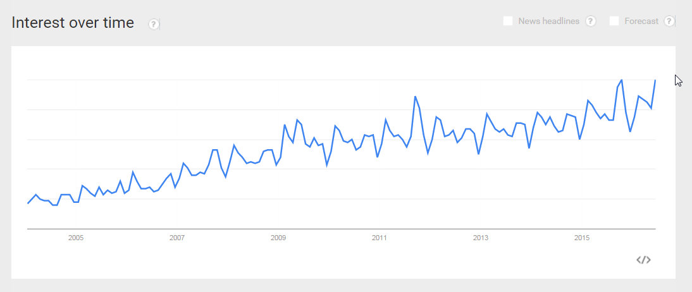

References:

Ken Schwaber, Jeff Sutherland. "The Scrum Guide" (PDF). Scrum.org. Retrieved January 4, 2016.