Alexander Ramsey  
SWEN 603  
July 26, 2016

Crystal Clear Development Process

Crystal Clear development methodology stands to be more of a study than a methodology. Alistair Cockburn headed the study of many software development projects from the early-1990s and beyond, while analyzing how structure and group interaction affected the overall success of the project. His goal was to develop a methodology that would work more consistently among group environments, with final delivery to IBM. Crystal Clear addresses less of the process related concerns found in most methodologies and more of the people aspect and group dynamics of a project. It has a few guiding principles, 7 total, with the first 3 being mandatory for compliance with the methodology.

The first of the three principles is the Frequent Delivery of code to clientele. This ensures that the team is motivated to provide code on a continuing basis, while conforming to a schedule. The second guiding principle is that the people of the development team share in reflective self-improvement and analysis. This allows the group to clearly articulate what they have accomplished and how it might be better for the future. The third principle is referred to as information osmosis. This implies that the group is willing to communicate and be in an active listening state so that information can be disseminated and shared easily amongst them. By digesting information in a there but not completely tuned in state, the group can be more synergistic in their thinking.

All of these guiding principles serve as the formal process for implementing Crystal. Alistair has some other thoughts on his website which he classifies as the “Genetic Code” of Crystal (Cockburn, 2007). He classifies this Genetic Code into a few areas: 1. Mindset, 2. Design Priorities, 3. Project Properties, 4. Design Principles, 5. Key Techniques, and 6. Samples. He describes the mindset of software development to be a cooperative, finite, and goal-directed game. This is what describes the mindset of programming, as a process that is built on community and the exchange of ideas within this frame of reference. Alistair puts it best when he states in his presentation, “Share more experiences, write less! Share less, write more!”. He is describing the value of communication, where the more people that share the mindset of programming, the more productivity will occur.

He continues this discussion, stating that communication is the basis for success in an environment where results are expected. Open communication and smart work areas can contribute large cost savings to an organization. The elimination of data silos and the sharing of information can keep everyone together and in the mindset of thinking about the project and less about other workplace noise that may crop up from a separation of resources. Within this presentation, he provides a top down layout of an office space. He describes thought centers as radiators, where employees can share in their thoughts and feelings about a problem.

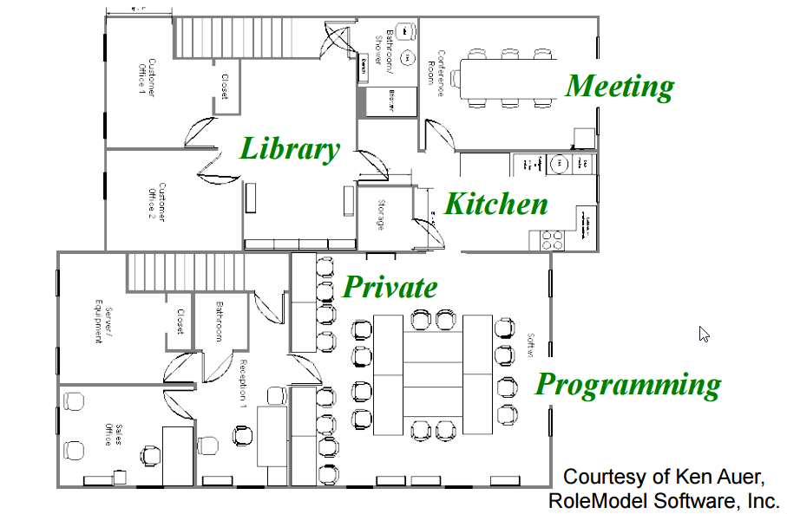

Alistair then shares that people are generally weak in motivation, discipline, following instructions, and in changing bad habits. But, people are strong communicators, good copiers, and are good at being self-aware. People are most motivated by their personal pride in their work, their own knowledge, and their social support groups. Harnessing this can be a powerful tool in a workplace that demands the best while maintaining a positive working environment. An excellent term provided is “Amicability”, the ability to maintain a positive attitude while communicating ideas and information.

Describing the projects design principles, Alistair cites the need for design efficiency. This can be related to the use of design patterns, like those described by the Gang of Four. In addition, he cites the need for safety in ensuring that discussions about approaching a problem can be met with friendly disagreement. This is important due to the fact that any programming problem can be solved in a potentially infinite number of ways.

Crystal Clear methodology is a powerful process that addresses the most important part of an organization, the people. Ensuring that people can work well together can contribute significantly to the probability of success in a project.

References:

Cockburn, A. (2007). Making Your Methodology Crystal Clear and More. Retrieved 2016, from http://alistair.cockburn.us/get/3606