Alexander Ramsey  
SWEN 603  
August 08, 2016

Dynamic Systems Development Model

The Dynamic Systems Development Model (DSDM) is an agile variant that provides open source guidelines published by its parent organization, The DSDM Consortium. Originally created in 1994, the DSDM aimed to pool the best resources of the industry provided by vendors and other stakeholders interested in sharing best practices. These stakeholders included British Airways, American Express, Oracle, and Logica (DSDM, n.d.).

The latest version of DSDM is called Atern and provides eight basic principles:

* Focus on the business need
* Deliver on time
* Collaborate
* Never compromise quality
* Build incrementally from firm foundations
* Develop iteratively
* Communicate continuously and clearly
* Demonstrate control

Core techniques of DSDM include Timeboxing, MoSCoW, Prototyping, Testing, Workshop, Modeling, and Configuration Management.

* Timeboxing is similar to storyboarding in Agile in that is provides a fixed unit of development task to accomplish a single goal. This task is fixed in resources and time so that an expectation is set for the development team.
* MoSCoW is short for Must, Should, Could, Wont and represents a technique for prioritizing items. Each word represents the priority of items to be included in the confines of the scope of the product requirements set forth by the client.
* Prototyping is a technique designed to identify unforeseen complications early on in the project development process.
* Testing is a technique employed by DSDM just as any other methodology would employ it. DSDM states that the testing method used should be chosen by the development team.
* Workshop is a meeting to facilitate brainstorming and testing with all of the project stakeholders, sometimes including the client.
* Modeling is the technique employed by DSDM to ensure that visual graphical models represent well the defined business domains of the project.
* Following other SDLC principles, maintaining accurate configuration management is an essential part of the DSDM process.

In addition to providing techniques, the DSDM outlines many roles for project stakeholders to fulfill:

* Executive sponsor – Provides overall decision making and funding oversight.
* Visionary – Can supervise, provide encouragement, and new ideas focused on the scope of the business problem.
* Ambassador user – Similar to Advisor User, provides community and marketing perspective.
* Advisor user – Client focused/centric product user
* Project Manager – Overall I.T. manager or project management personnel
* Team Leader – For sub teams on larger projects
* Facilitator – Manages workshops
* Scribe – Records requirements

The DSDM framework provides a very well thought out method for implementing project management oversight in a modern software development environment. Due to its verbosity though, it may cause some organizations to spend too much time on the process than on the actual development of product code.

The model below describes the phases of the latest framework version, Atern:

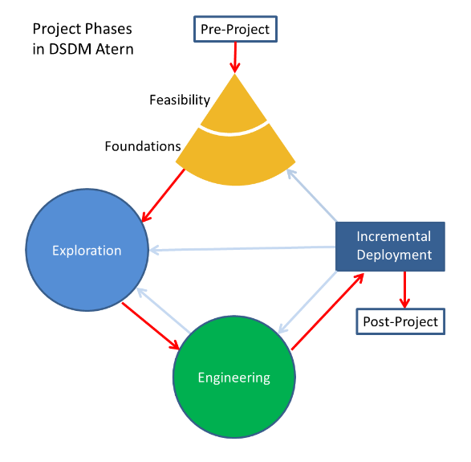   
*Image credit: Wikimedia Commons, 2011*

References:

"Terms and Conditions of Community Membership" (PDF). DSDM Consortium. Retrieved 8 August 2016 at <http://www.dsdm.org/wp-content/uploads/2013/01/Terms-Conditions-Community-Membership-Jan-2013.pdf>

Wikimedia Commons. 2011. Retrieved from https://upload.wikimedia.org/wikipedia/commons/c/c3/DSDM_Atern_Project_Phases.png