1. Tell us about a technical book or article you read recently, why you liked it, and why I should read it.
2. Something for a good morning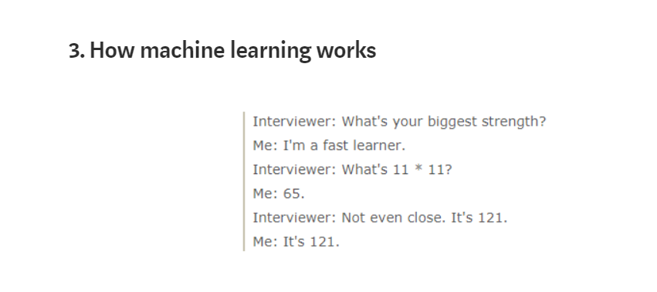
3. migrate to java 9

<https://blog.joda.org/2018/09/from-java-8-to-java-11.html>

1. WegSphere

<https://www.reddit.com/r/programming/comments/7zb7jt/ibm_java_cto_devs_shouldnt_have_to_learn_docker/>

1. What’s your proudest achievement? This can be a personal project or something you’ve worked on professionally. Just a short paragraph is fine, but we would love to know why you’re proud of it.