Traffic Lights, assignment 3/4/5

Contents

1. Requirements 2

2. Design 2

2.1 Considerations 2

2.2 Idea preview 2

2.3 Technology overview 4

2.4 DB structure 5

# Requirements

3.Write a small java program, based on the spring stack, to simulate a single set of traffic lights, along with state transitions. The state transition should happen automatically every two seconds. To display the state, you can use log4j statements or other means. Please include a test suite and treat as if this is production code

4.Write a simple HTML page a single button and 3 divs, red, orange and green. User clicking the button, steps through the traffic light sequence by changing the brightness of the divs so it behaves like a traffic light. Try to make it pretty 😊

5.Enhance solution from 3 "traffic lights" to operate from an in-memory database, for example H2. The enhanced program should include a programmable duration of light phases based on time of day, and day of week. Please include a test suite and treat as if this is production code.

Note: You can complete either Question 4 or 5 above, if you lean more towards front end development or backend development, or you complete both if you feel equally proficient. We won’t hold it against you either way.

# Design

## Considerations

1. What do you mean by “single set of traffic lights”.

Is it 1 semaphore with lights: red/yellow/green

Or set of semaphores in crossroad

I assumed, this is about set of semaphores in crossroad,

as this task looked more difficult :P

I will leave the other one for juniors

MainStreet + SideStreet have Semaphore instances connected,

There is a couple of programs configured in database

Together with steps for each program

## Idea preview

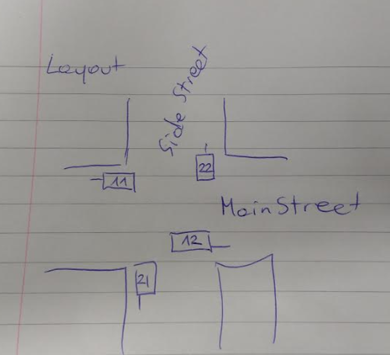

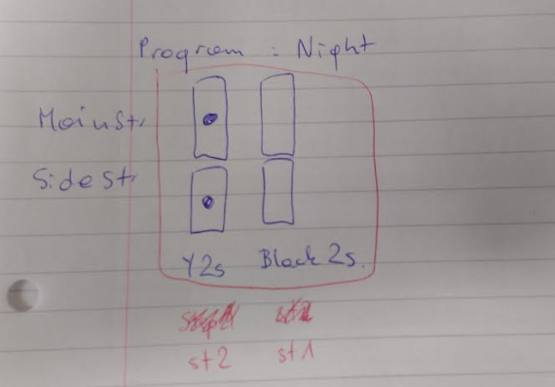

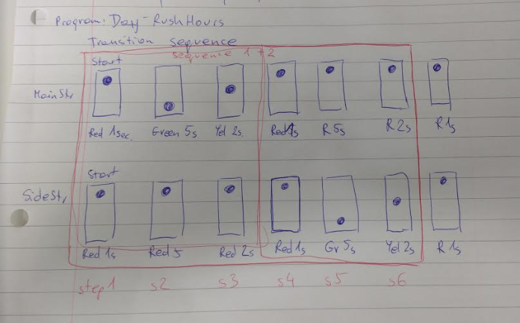

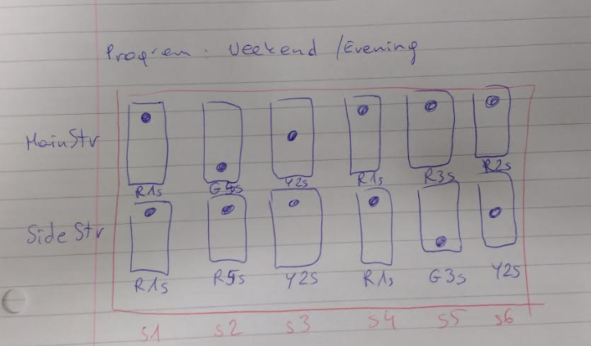

## Technology overview

* Spring Boot with Tomcat
* Full configuration in database H2-server
* Configuration is loaded in **StartUpInit** class
* Semaphore instances are registered in **SemaphoreRegistry**
* Light change is maintained in **LightManager**, pushed to semaphore instances using Observer pattern, implemented by **PropertyChangeListener**
* Current light status is printed to logs independently, configured in **SemaphoreVisitor**, using Visitor pattern

## Run application

1. To run application use scripts prepared:

1_runDatabase.bat

2_runTrafficLightsApp.bat

This should run without any changes, as checked out from repository.

Keep database running in background

1. Configuration can be modified in database

jdbc:h2:tcp://localhost/c:/iwona/trafficlight/h2_database/dbcontent

Then run TrafficlightsApplication class

## DB structure

Full configuration is kept in database.

Please review the table structure, it should be intuitive.

**Testing different options:**

1. To configure new program, populate Program + Config + Steps accordingly.

(Configuration validation will be added in Phase2).

1. Add Schedule record with priority.

