Shirt Seller Updates

1. ~~Color patterns – I think you are already working on this. But the pattern file needs to reflect in the image.~~
2. ~~When you change the colors the image in the layer tab should also change.~~
3. The width of the layer tab can be a little smaller. Too much white space on the right.
4. ~~I believe the new layers should also be inserted instead of appended in the layer tab. I would think the top layer would be on the top if that makes sense.~~
5. ~~If you send backward on the bottom layer it moves it behind the grid and you cannot access it anymore.~~
6. ~~Can we move the “add text, add clip art, upload image” above the table on the right where we edit the colors. I’m not sure how to put it, but I think it would be better up there.~~
7. Design Placements

I’ll try to explain what I’m looking for here. The design that we are created in the grid will go on a shirt in one of the placements I have. I have a procedure that pulls all of the placements.

function listPlacement() {

var xml = "<request><sessionid>" + sessionid + "</sessionid></request>";

$.ajax({

type: "POST",

url: url + "/Site.svc/PlacementList",

contentType: "application/json; charset=utf-8",

data: JSON.stringify($.xml2json(xml)),

dataType: "json",

success: function (response) {

var r = response.PlacementListResult;

if (r.isSuccessful == false) {

alert(r.ErrorDescription + "(" + r.ErrorNumber + ")");

return;

} else {

var data = eval(r.Data);

for (var i = 0; i < data.length; i++) {

var p = data[i];

console.log('[' + p.Width + ',' + p.Height + '] - ' + p.Overlap);

$("#dPlacement").append("<div style='float:left;'><IMG src='http://api.thetshirtguylv.com/image/placement/" + p.PreviewImage + "'/><br/>" + p.Name + "</div>");

}

}

}

});

}

Each placement has a width and a height. I would like to show that in the grid. Maybe a light gray square on the grid showing the width and height of that placement. The person would then create a design for that placement.

A person can create a shirt with multiple placements. So we need to keep track of what placement goes with which clipart/text/locations/colors.

Now the tricky part. Some of the placements cannot be overlapped. Here’s an example.

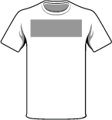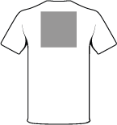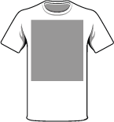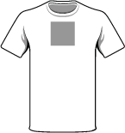

If a user picks one of these placements then the others become invalid because we can’t overlap designs like that. So you can see in my procedure there is an Overlap property that has the IDS of the placements that cannot be used with that particular placement. Hopefully that makes sense.

So I’m thinking where you have the shirt icon when you click on it, it would pop up a window that has the shirt placements on it with the unavailable ones (overlapped) grayed out.

1. I want to be precise when we draw the grid and how much room the person has to design. Each of the placements has a width and height attached to them. I would like to do something like this:

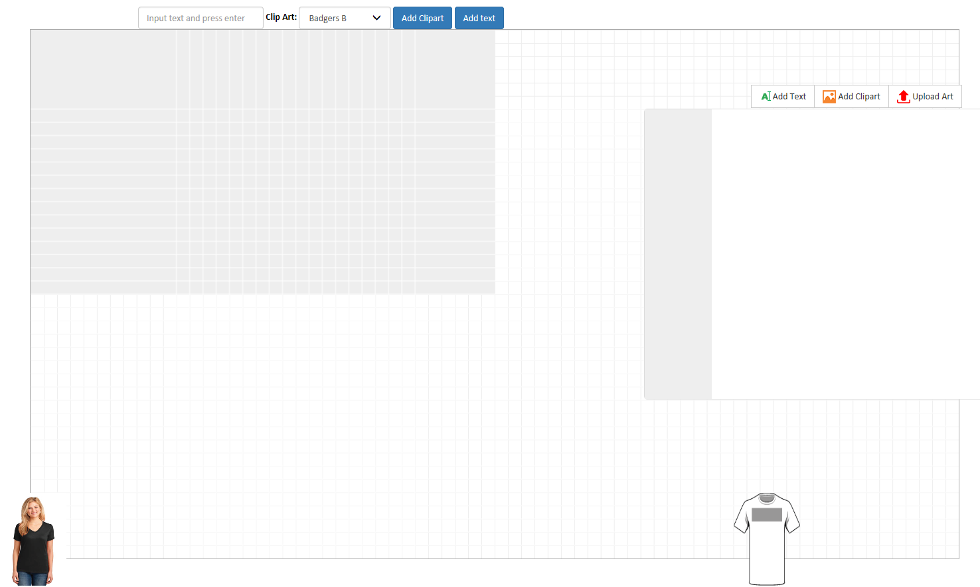

I know my grid isn’t the greatest. I tried to manipulate your code to do what I want but it only half worked. First off I expanded the canvas to 1200 x 800. That fits most of the placements. The grayed area with the inverted white grid should be in the center of the white/gray grid. We should constrain our images to that section but I would like to show the whole white/gray grid because I think it looks better. Keep in mind the gray/white grid will change depending on what placement is selected. So the whole grid is 12”x8” so all I’ve done is multipled by 100 to give a pixel amount. When we pull over the images and the fonts we want to keep to this ratio. Now the harder part. If the placement is larger than 12x8 I want to be able to shrink the ratio so that it fits. For example the Full Front is 12x14. The ratio needs to change to fit the full 14” into the grid.

1. I would like to shrink the right hand side box to fit in the white section. I would rather not have it overlapping on the grid.
2. The small image in the layer section matches the color perfectly but it doesn’t distort the image like what is selected. The width, height, and rotation should also match.

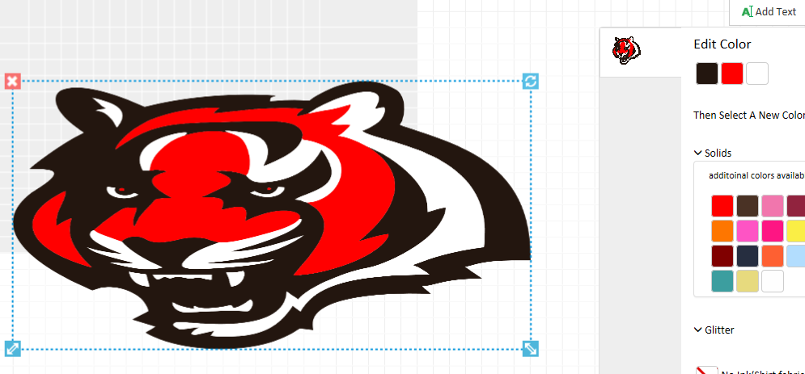

1. ~~Color palette. I’m not sure where those 6 white squares come from. I believe I only have 29 items under that color group. Are they being padded somewhere? You can also remove “additional patterns available”. No need for that. Just put the colored icons.~~
2. Can you make this more of an accordion control. So when one is open the other closes down. Instead of the red X to close can we make it so once they click on the color again it closes down. If they click off of the clipart that is selected just close it down as well. so they would need to click on the color to open it back up. right now it remembers that it’s opened.

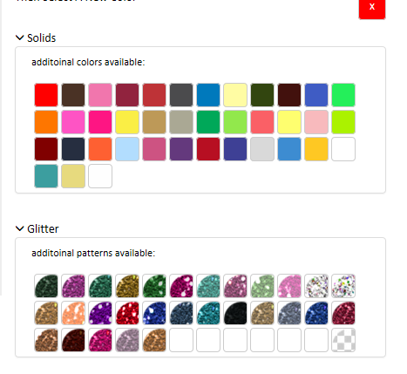

1. When you add a clipart and then add text, only the text options show. You cannot click on the clipart and have the options show.
2. When you add text and move the width or height it is not locked by default. It should lock the size ratio.
3. Let’s get rid of the top box that says “Add Text” with the drop down and text box. When you click on the “Add Text” button in the right hand side menu it should show the text options. You can type in the text in the box you have shown and it should draw the text out. You should be able to change the font and color (in addition to the other options you already have).
4. When you move the layers (either forward or back) it doesn’t seem to move the clipart items on the grid.
5. When you adjust the text or the clipart on the grid it should move the sliders in the options box.
6. Product + Designs

This is what I’m thinking about as far as an object to store everything in. So when the page loads we would create a Product objects and Add a Design with the Full Front placement. Then if someone opens up the placement icon and selects a new placement we would create a new Design object and add it to Product Designs. This way we can keep track of each of the designs for a product. They can create more than one design on a product.

Product

ID

Name

Designs (List of Design Objects)

ID

Name

PreviewImage

PlacementID

Shapes (List of Shape Objects)

Type (ClipArt or Font)

1. Placements. When this screen loads, I would like to highlight all of the ones that are currently on the Product above. Keep in mind we have that Overlap property on the Placement object. This tells us which placement cannot be used with other placements. For example, the first six placements cannot be used together as they would overlap. If you have a better idea on this just let me know. We will also need some way to either move or copy a design onto another placement, plus the ability to delete designs.

