Here are 10 questions and answers about the laws of physics.

1. What is Newton's First Law of Motion?
Newton's First Law states that an object at rest stays at rest and an object in motion stays in motion with the same speed and in the same direction unless acted upon by an unbalanced force. This law is often called the law of inertia.

Experiment | Initial State | Action | Result | Explanation
1 | Book on table | No action | Book remains stationary | No unbalanced force acts on the book
2 | Car moving at 60 km/h | No action (on smooth, flat road) | Car continues at 60 km/h | No significant unbalanced force acts on the car
3 | Ball rolling on smooth surface | No action | Ball continues rolling, gradually slowing | Small friction force eventually stops the ball

2. Explain the concept of conservation of energy.
The law of conservation of energy states that energy cannot be created or destroyed in an isolated system. Energy can be converted from one form to another, but the total amount of energy remains constant. For example, when a ball falls, its potential energy is converted to kinetic energy.

3. What is Archimedes' principle?
Archimedes' principle states that the upward buoyant force exerted on a body immersed in a fluid, whether fully or partially, is equal to the weight of the fluid that the body displaces.

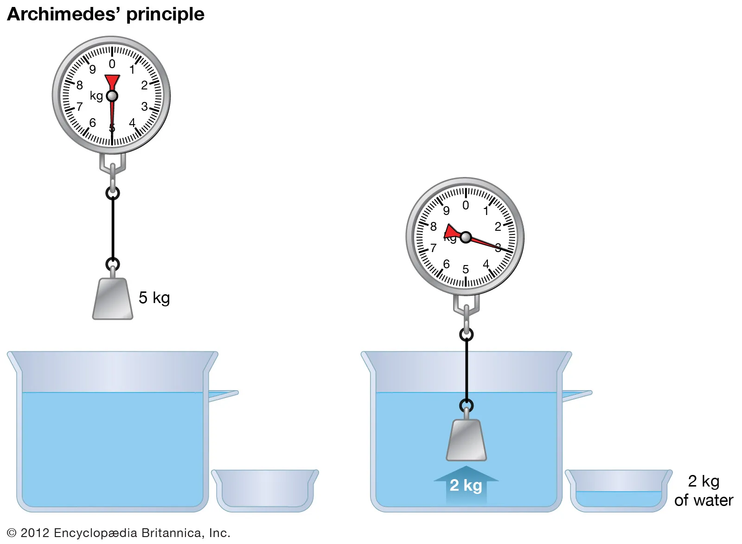

4. State the Second Law of Thermodynamics.
The Second Law of Thermodynamics states that the total entropy of an isolated system can never decrease over time. In simpler terms, heat always flows from hot to cold, and the universe tends towards increasing disorder.

5. What is Coulomb's Law?
Coulomb's Law describes the electrostatic force between electrically charged particles. It states that the magnitude of the force is directly proportional to the product of the charges and inversely proportional to the square of the distance between them.

6. Explain Faraday's Law of Electromagnetic Induction.
Faraday's Law states that the induced electromotive force (EMF) in a closed loop is directly proportional to the rate of change of magnetic flux through the loop. This principle is the basis for many electrical generators and transformers.

7. What is the Doppler Effect?
The Doppler Effect is the change in frequency or wavelength of a wave for an observer moving relative to its source. It explains why the pitch of a siren changes as it passes by you.

8. State Boyle's Law.
Boyle's Law states that the pressure of a gas tends to increase as the volume decreases, and vice versa, when the temperature is held constant. Mathematically, it's expressed as P₁V₁ = P₂V₂.

9. What is the Heisenberg Uncertainty Principle?
The Heisenberg Uncertainty Principle states that it's impossible to simultaneously know both the exact position and the exact momentum of a particle. The more precisely one quantity is measured, the less precisely the other can be determined.

10. Explain Snell's Law.
Snell's Law describes the relationship between the angles of incidence and refraction when light passes through a boundary between two different transparent media. It's expressed mathematically as n₁sin(θ₁) = n₂sin(θ₂), where n is the refractive index of each medium.

